المحاضره الثامنه
Elements of the Class
- Countable & Non-Countable Nouns
- Many, much, few, a few, little, a little etc.
- Reading Passage
- Vocabulary
- ----------------------------------------------------------------------

- Accountable and Unaccountable
- or Mass Nouns
-----------------------------------------------------------------------
There are 2 kinds of noun in English:
Countable
Things you can count (singular or plural)
One apple, two apples, three apples…
Uncountable
Things you can´t count (they can’t be plural)
Butter, meat…
Some nouns can be countable or uncountable but the meaning is different.
Example: chocolate
In English, the distinction into countable and uncountable (mass) nouns is basic.
Countable nouns take definite and indefinite articles and admit a plural form:
I would like to buy a book.
Here’s the book I’ve told you about.
There are many books on that shelf

Uncountable nouns take zero article, as well as definite and indefinite
quantifiers, but do not really admit a plural form.
There is wine on the table.
This wine is sour.
Please, take some wine!

Sometimes, an unaccountable noun like bread can be reclassified as
an accountable noun meaning “type of bread”:
What breads have you got today?

A / AN / SOME / ANY

Type of sentence | Countable | Uncountable
+ We need | an apple  some apples | some butter  some milk
- We don’t need | a tomato  any tomatoes | any rice  any sugar
? Do we need | a tomato?  any tomatoes? | any rice?  any sugar?
Use a / an with singular countable nouns.
Use some with plural countable nouns and uncountable nouns in + sentences.
Use any with plural countable nouns and uncountable nouns in – or ? sentences.
We can also use some in ? to ask for and offerings:
Can I have some coffee?
Do you want some biscuits?
How much / how many…?
Use How much…? with uncountable nouns.
How much water do you drink?
Use How many…? with plural countable nouns.
How many students do you have?
Possible answers:
I drink a lot of water.
I drink quite a lot.
I don’t drink much water. (not much)
I don’t drink any water.
None.
Not many (students).
Use of some – many/much – few/little
with accountable and unaccountable nouns:
Would you like some apples? (plural)
Would you like some water? (partitive – a glass of water)
There are many things I would like to tell you.
There is much trouble in this house.

There are few people I can trust.
There was little food in the fridge.

Note the differences between little/a little, few/a few:

Note the differences between little/a little, few/a few:
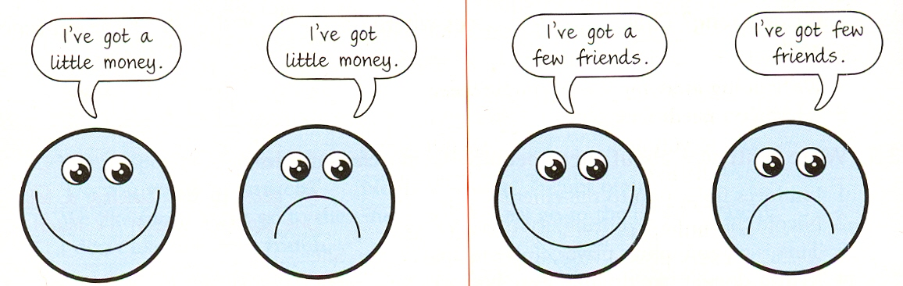
Using ( many/much/ a few/ a little, some, several…etc )
page 195
A. Many, a few , few, some, several = Used before countable nouns
( Countable nouns ( nouns that can be singular and plural
e.g [ boy- car – door – page – girl – houses…….etc ]
B. Much, a little, little, some= Used before uncountable nouns
Uncountable nouns ( nouns that don’t have singular or plural forms)
e.g [ water – sugar – snow – money – food – milk, ……etc ]
C. A, An , Each & Every = used before singular nouns
D. Any= used in negative and questions.
E. Some= used when we offer something
--------------------------------------------------------------------------------------------
a little / a few
1. Have you got any money? Yes, I have got ________.
2. Have you got many envelopes? No, I’ve got just ________.
3. Does your friend speak English? Yes, he speaks ________.
4. Do you want sugar in your coffee? Yes, I would like ________.
5. We are going away for ________ days.
very little / very few
1. Your English is very good. You make ______________.
2. I drink ______________. I don’t like it.
3. Hurry up. We’ve got _______________.
4. I am sad and lonely. I’ve got _______________.
5. I’m afraid I won’t be able to buy that, I’ve got
much / many
1. Do you drink _______ coffee?
2. I stay at home most of the time. I don’t go out ________.
3. I’ve seen _______ films with Brad Pitt.
4. How _________ photos did you take?
5. Do you eat ________ chocolate?
------------------------------------------------------------------------------------ Vocabulary Previewing ( pages 107 110/ 113
Adverbs | Adjectives | Verbs |  |  | Nouns | No.
however | awake | wonder |  |  | evidence | 1
 | anxious | Fix |  |  | hormone | 2
 | familiar | Happen |  |  | psychologist | 3
 | complicated | Wish |  |  | emotions | 4
 |  | travel |  |  | symbols | 5
 |  | realize |  |  | vision | 6
 |  | Make sense |  |  | logic | 7
 |  |  |  |  | Reason |  | 8
 |  |  |  |  | Opinions |  |  | 9
Vocabulary Exercise
Fill in the following blank space with the most appropriate answer a, b, c or d:-
1. To ask oneself and think means:_____________________
a. prefer b. wonder c. repair d. enjoy
2. “________” has the same meaning as “ proof”.
a. essence b. similarity c. evidence d. reference
3. The word that has the same meaning as “ a chemical that helps us to grow” is______ .
a. germs b. sugar c. bacteria d. hormone
4. “ __________________” the same meaning as “ nevertheless”.
a. however b. because c. since d. as
5. something we use to refer to another thing is a _____________________
a. book b. pen c. symbol d. sheet
6. __________ is the opposite of sleeping.
a. Dreaming b. Awake c. Running d. Active
----------------------------------------------------------------------------------------
Vocabulary Exercise
7. Wishes means:_____________________
a. wonders b. desires c. dreams d. studies
8. “________” has the same meaning as “ repair”.
a. fix b. damage c. prepare d. concern
9. The word that has the same meaning as “ reason” is___________ .
a. question b. purpose c. basic d. season
10. The word that means “period of time” is___________ .
a. areas b. project c. stage d. sense
11. “ __________________” the same meaning as “ happens”.
a. occurs b. finishes c. starts d. enjoys
12. The word that means “go places” is _____________________
a. swim b. leave c. travel d. look
13. “__________” is the opposite of easy.
a. make sense b. complicated c. normal d. expensive

-----------------

Scan and Skim the reading passage( page 108/ 109)
Many people wonder: Why do we sleep? Why do we dream? They ask themselves the purpose, or reason. There are many theories, or opinions about this , but scientists don’t know if these ideas are correct.
One theory of sleep says that during the day, we need sleep to make new chemicals and repair, or fix, our bodies. This theory is called the “ Repair Theory”. One piece of evidence for this theory is that our bodies produce more of growth hormone while we sleep.
Another theory is that the purpose of sleep is to dream. Dreaming occurs only during one stage , or period, of sleep ( Rapid Eye movement- REM )sleep. REM sleep occurs about 90 minutes and last for about 20 minutes. Some scientists believe that REM sleep helps us to remember things, but others don’t believe and don’t agree.
Sample questions ( page 108/ 109)
1. The underlined pronoun “ themselves” refers to:_________________________
A. purposes B. dreams
C. many people D. reasons
2. The underlined pronoun “ this ” Line 2 refers to____________________
A. theories B. purpose of dreaming & sleepimg
C. many people D. scientists
3. Who don’t know if these ideas are correct or no? ___________________
A. many people B. theories
C. dreams D. scientists
4. Why do we need sleep according to “ Repair Theory” ________________________
A. to dream B. to fix or repair our bodies
C. take rest D. to help our friend sleep
5. The underlined word “ evidence ” line 6 means ____________________.
A. proof B. chemicals C. dream D. repair
Sample questions ( page 108/ 109)
6. How long does REM sleep last? _________________________
A. 20 minutes B. 90 minutes
C. the whole night D. 2 minutes
7. how many theories about sleep and dream are in the passage?____________________
A. One theory B. many theories
C. Two theories D. Three theories
8. What does REM sleep help us to do? ___________________
A. To dream B. To remember things
C. To make chemicals D. to last for a long time
9. The underlined word “ occurs” means ________________________
A. dreams B. helps
C. happens D. sleeps
10. The underlined word “ others ” refers to____________________.
A. theories B. chemicals C. scientists D. many people
Sample Questions
( many/much/ a few/ a little, some, several…etc )
page 195
1. I was very hungry. I ate ______________ food .
a. many b. little c. much d. a few
2. _________ students will pass the test. It is vey easy.
a. Few b. Some c. A few d. Many
3. Fortunately, _______________ people died in the terrible accident.
a. Many b. Some c. Few d. A few
4. He was very happy . He won ____________ money in the project.
a. many b. much c. little d. a few
5. _______ student should have the textbooks.
a. many b Some c. Every d. All
6. I didn’t like the food. I ate ______________
a. much b. many c. little d. few
7. I read ______________books about English literature.
a. a little b. several c. much d. every
8. I haven’t seen ________students at university on Friday.
a, many b. some c. any d. a few

