مع خالص تحياتي لكم بالتوفيق والنجــاح ,,,

Write the names of the pictures

1
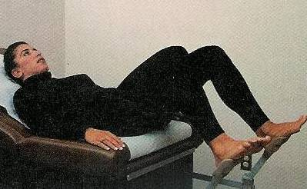

2
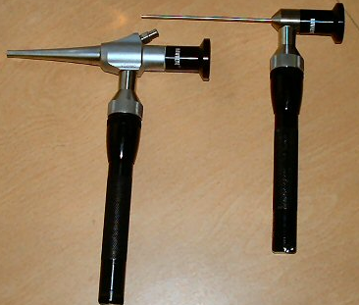

رهينو سكوب حق الانف

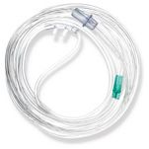
هدا نيزل كانيولا

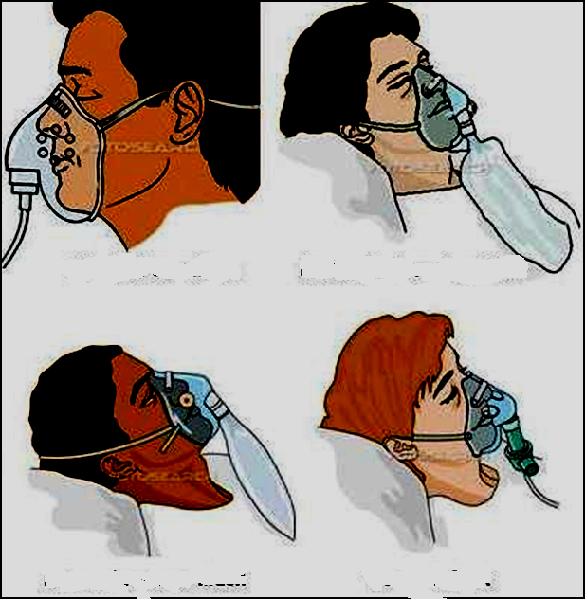

*فيس مآسك ينقسم لأربع انواع
* اليسار اللي فوق سيمبل فآيس مآسك
*و اللي تحته نن ريبريثينق شوفي فيه فتحه في المآسك

*و اللي فوق من اليمين ري بريثينق شوفي الماسك كله مقفل مافيه ولآ فتحه
*و اللي تحته فنتيولر

3

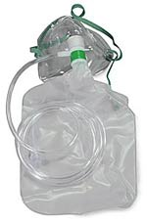

4

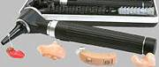

اوتو اسكوب حق الاذن

5

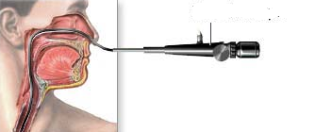
برونكيو سكوب
الارينجو سكوب من الفم
6
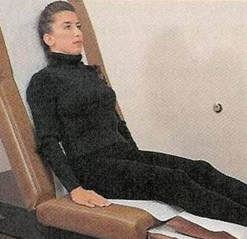

1. Signs of dehydration :-
A. Loss of skin turgor
B. Low body temperature
C. High body temperature
D. Sweating

2.Patient's position when administering enema is :
a. lateral
b. sim's or left lateral
c. semi setting position
d. sim's or setting lateral

3. Skin layers that are involved in 2nd degree burn is/are :
a. epidermis only
b. dermis and epidermis
c. all skin layers
d. epidermis, dermis and subcutaneous .

4. Stat means :
a. give medication when needed (when necessary )
b. give medication once only
c. give medication tow times a day
d. Immediately

5. A diabetic pt came to ER complaining of signs of hypoglycemia , nursing interventions include :
a. give insulin 10 IU SC .
b. give pt carbohydrates .
c. give pt high fat diet
d. give pt fluids in vitamin C

6. Before giving penicillin you should ….
a.Do allergy test .
b.CBC
c.pt and ptt
d.Blood chemistry

7. A diabetic pt came to ER complaining of signs of hyprglycemia , nursing interventions include :
a. Give the pt insulin .
b. giv the pt carbohydrates
c. give pt high fat diet
d. give pt fluids in vitamin C

8. Carbohydrates storage form in the body is :
a. vitm K
b. glucose
c. glycogen
d. normal saline

9.. you feed a baby with cleft lip by :
a. NGT
b. bottle feeding
c. breast feeding
d. IVF

10- You should insert the enema tube for adult :
a.7.5 – 10 cm in the rectum
b.2.5-5 cm in the rectum
c.11-14 cm in the rectum
d. 11-12 cm in the rectum

11. The first vital sign to assess for the pt after transferring from operation room is :
a. temperature
b. respiration
c. blood pressure
d. heart rate

12. To help pregnant woman complains of leg cramp during night , you instruct her to :
a. elevate the leg above heart level
b. dosoflix the leg
c. assume prone position
d. use hot compresses over the affected leg

13. A pt brought to ER with Burns , the suitable IVF is :
a. glucose water
b. lactated ringer
c. normal saline 0.9 %
d. glucose saline

14. the most method used for sterilizing hospital equipment to be free of spores infection is :-
A. applying steam under pressure in an autoclave
B. washing and drying it thoroughly after use
C. Send to the center of sterilization
D. Send them to the container, yellow

15.When they are The first dose of Polio myelitis..
a.second month
b.The first month
c.First week
d.The sixth month

16. The third dose of hepatitis vaccine is given after :
a. 6 months
b. 2 months
c. 4 months
d. 20 weeks

17. The sharp container color is :
a. red
b. yellow
c. black
d. green

18. Pt with respiratory rate 4 b/ min developed to cessation of respiration this case called :
a. cardiac arrest
b. respiratory arrest
c. pulmonary embolism
d. tachypnea

19.After starting hemodialysis ,your pt starts complaining of abdominal pain , you should :
a. stop – discontinue – dialysis
b. continue dialysis
c. put pt on supine position
d. give pt diuretics and continue dialysis
*naxolan Narcan = *وكلهآ مضادات المورفين
*بروبرا نول = اندرال

*وارفارين = كومادين
*بيتيدين = مورفين
*دايجوكسين = دجتالس
*فورساميد = لازكس

20. Priority of nursing care for pt with bleeding is :
a. stoop bleeding
b. prevent infection
c. maintain intravenous fluids
d. decrease level of anxiety

21.Diet for diabetic pt is :
a. High fat ,high protein diet
b. High carbohydrate , low fat diet
c. low fat , low carbohydrate diet
d. low salt high fat diet

22. A burned pt with redness and tender skin and edema , the degree of this burn is :
a. 1st stage
b.2nd stage
c.3rd stage
d. 4th stage

23.After open airway for uncurious pt ,with head tilt chin lift maneuver ,you should then :
a. give 2 breaths
b. begin CPR
c. perform finger sweep
d. perform abdominal thrust

24-When the patient is diaphoretic , there is tachycardia and decrease blood pressure , he is experiencing :
a. Neurogenic shock.
b. Hypovolemic shock
c. Hypothermia
d. Septicemia

atient's best position after gastrectomy is :
a. High fowler
b. Low fowler
c. semi fowler
d. supine

26. The best position for a pt having burn in his head and neck is :
a. High fowler
b. pron
c. semi fowler
d. supine

27. A diabetic pt who have had influenza 2 days ago ,not taken his insulin. The nurse would expect which of the following signs and symptoms experienced by pt :
a. Frequent urination. And Loss of appetite.
b. Difficulty breathing.and polyuria
c.

d. all of the above

28..The nurse noticed that hand of a pt with obsession compulsion is dry ,because of frequent hand washing with soap, your response should be :
a. give pt lotion for his hand
b. stop washing your hand it is clean
c. if I were you I would stop washing my hand like you do
d. walk with me am going to widing room

29. The child would be able to make his/her first small words at:
a. school age
b. preschool
c. adolescent
d. adult

30.. Insulin administration method for a diabetic child…..:
a.SC
b.IM
c.IV
d.ID

31. After debridement surgery ,the nurse should focus on :
a. result of wound culture
b. check for bleeding
c. pressure dressing on wound site
d. check for elevated temperature

23. Precautions that should be taken when dealing with hepatitis A pt , are :
a. wear gloves when carrying ( taking ) bedpan
b. wear gloves , gown , face mask
c. be careful when give the pt his food
d. prevent spread of air droplet

33.To help pregnant woman complains of leg cramp during night , you instruct her to :
a. elevate the leg above heart level
b. dosoflix the leg
c. assume prone position
d. use hot compresses over the affected leg

34.. Ensure the effectiveness of atropine administration to a preoperative patient you should check :
a. pulse rate
b. dryness of the mouth
c. blood pressure
d. pupil constriction

35-In caring for the client with hepatitis B ,which of the following situations would most likely expose the nurse to the virus :

a. contact with fecal material
b. a blood splash into the nurse's eyes
c. touching the client's arm with ungloved hands while taking blood pressure
d. disposing of syringes without recapping

36.A mother of seven years child with type 1 DM asking why she can't use an oral hypoglycemic agent instead of insulin ? your answer depend on :
a. he can change insulin after 2 months
b. how much he can tolerate tab
c. your doctor instructions
d. this type of DM must be controlled with insulin only

37.The nurse irrigates client's colostomy , if the client complains of abdominal cramping after receiving about 150 ml of solution during the colostomy irrigation , the nurse should temporarily :
a. stop the flow of solution
b. have the client sit up in the bed
c. insert the cone or the tube further into the colon
d. remove the irrigating cone or tube

38-Normal pulse is :
a. 20-60
b. 60/100
c. 70-180
d. 120/80

39-Normal Respirationof a newborn is
a.16-20
b,20-25
c.30-50
d.50-100
40.What is the first nursing intervention for the MI patients
a.Morpgine aspirin
b,Morphine
c.Morphine oxygen
d.Aspirin
41.patient with esophageal varicosities is at risk
a.Bleeding
b.Dizziness
c. Anemia
d. Cardiac arrest
42. nurse knows that the antidote of Morphine is :
a. Naloxone
b.Sodium
c.Oxygen
e.Aspirin

43.Which of the following observations would indicate that the intravenous solution has infiltrated at the intravenous insertion site :
a. hotness at the insertion site
b. puffiness proximal to the needle
c. redness proximal to the infusion site
d. blood return in the tubing

44- The most accurate temperature is:
a. rectal
b. axillary
c. orally
e. Subcutaneous

46-Position for unconscious patient ? ….
A)recovery position or
b) sitting position
c) standing position
d) non of them

47 .Position for patient with haemorrhoids ?

A)prone position
b) sitting position
c) standing position
d) non of them

48. Position for ( pt with asthma ) for adult and child ?

A) sitting position( upright position)
b) prone position
c) standing position
d) supine positions

49. Position for burned patient in head and neck :

A) fowler with head and neck slightly extended
b) prone position
c) standing position
d) sitting position

50.Patient’s position post tonsillectomy ?
A)prone position
b) sitting position
c) standing position
d) supine positions

51.Position for pt with appendicitis pre and post appendectomy
A) non infected side
b) sitting position( upright position)
c) standing position
d) supine positions

..
52.What is the first priority to do in a patient with burn?
a.check pulse
b. check breathing
c. Open the airway
d. Intravenous fluids
e coverage of the patient

53. The nurse should position pt receiving from general anesthesia
a.Supine position with face lateral
b.Supine
c High-fowler's position
d.Trendelenburg position

54.The technique used in catheter insertion is
a)Sterile technique .
b) poor aseptic technique
c) clean technique

65. What technique should be used to insert a Foley catheter?

a)Sterile technique .
b) poor aseptic technique
c) clean technique
d. d. all of the above

66- Atropine is given pre-operative to :
a. relax the patient
b. decrease the secretion
c. prevent intra-operative bleeding
d. all of the above

67- When you assess the patient, the first thing you will do is:
a. opening airway
b. check LOC
c. check breathing
d. check circulation

68- Which of the following medications is not given to the patient with pulmonary embolism
a. Heparin
b. Warfarin
c. Streptokinase
d. Digoxin

69- The device that used for measuring blood pressure is called
a. thermometer
b. spirometer
c. sphygmomanometer
d. hammer

70- The priority for nursing care for epileptic pt is …
a.safety and protection.
b.Health promotion
c.Skin integrity
d.CT scan

