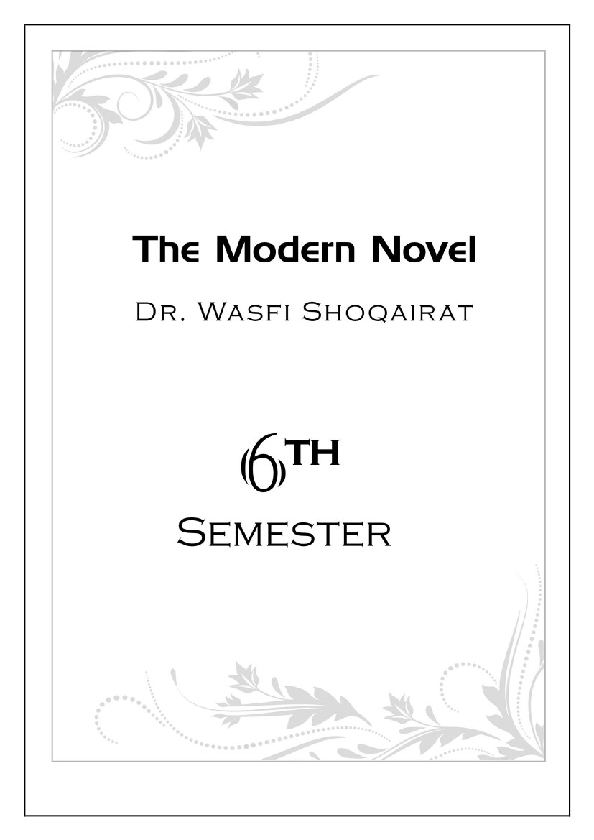


Lecture
Social and Historical Background
1
❖ The Novel: Definitions and Distinctions
•
•
•
•
Genre: Fiction and Narrative
Style: Prose
Length: Extended
Purpose: Mimesis or Verisimilitude
• “The Novel is a picture of real life and manners, and of the time in which it is written. The Romance,
in lofty and elevated language, describes what never happened nor is likely to happen.”
Clara Reeve, The Progress of Romance, 1785
❖ Verisimilitude
Refers to the illusion that the novel is a representation of real life. Verisimilitude results from:
• a correspondence between the world presented in the novel and the real world of the reader
• Recognizable settings and characters in real time what Hazlitt calls, “ the close imitation of men and
manners… the very texture of society as it really exists.”
• The novel emerged when authors fused adventure and romance with verisimilitude and heroes that
were not supermen but ordinary people, often, insignificant nobodies
❖ Precursors to the Novel
• Heroic Epics Gilgamesh, Homer’s Iliad and Odyssey, Virgil’s Aeneid, Beowulf, The Song of Roland
• Ancient Greek and Roman Romances and Novels An Ephesian Tale and Chaereas and Callirhoe,
Petronius’s Satyricon, Apuleius’s The Golden Ass
• Oriental Tales A Thousand and One Nights
• Medieval European Romances: Arthurian tales culminating in Thomas Malory’s Morte Darthur
• Elizabethan Prose Fiction: Gascoigne’s The Adventure of Master F. J, Robert Greene’s Pandosto: The
Triumph of Time, Thomas Nashe’s The Unfortunate Traveller, Deloney’s Jack of Newbury
• Travel Adventures: Marco Polo, Ibn Batuta, More’s Utopia, Swift’s Gulliver’s Travels, Voltaire’s
Candide
• Novelle: Boccaccio’s Decameron, Margurerite de Navarre’s Heptameron
• Moral Tales: Bunyan’s Pilgrim’s Progess, Johnson’s Rasselas
❖ The First Novels
• Don Quixote (Spain, 1605-15) by Miguel de Cervantes
• The Princess of Cleves (France, 1678) by Madame de Lafayette
• Robinson Crusoe (England, 1719), Moll Flanders (1722) and A Journal of the Plague Year (1722) by
Daniel DeFoe
• Pamela, or Virtue Rewarded (England, 1740-1742) by Samuel Richardson
• Joseph Andrews (England, 1742) and Tom Jones (1746) by Henry Fielding
1

❖ Types of Novels
1.
2.
3.
4.
5.
6.
Picaresque
Epistolary
Sentimental
Gothic
Historical
Psychological
7. Regional
8. Social
9. Mystery
10 .Science Fiction
11.Magical Realism
12.Realistic/Naturalistic
❖ Don Quixote by Miguel de Cervantes (1547-1616)
First European novel: part I - 1605; part II - 1615
A psychological portrait of a mid-life crisis
Satirizes medieval romances, incorporates pastoral, picaresque, social and religious commentary
What is the nature of reality?
❖ The Princess of Cleves - Madame de Lafayette
First European historical novel – recreates life of 16th c. French nobility at the court of Henri II
First roman d'analyse (novel of analysis), dissecting emotions and attitudes
❖ The Rise of the English Novel
• The Restoration of the monarchy (1660) in England after the Puritan Commonwealth (1649-1660)
encouraged an outpouring of secular literature
• Appearance of periodical literature:
− journals and newspapers
− Literary Criticism
− Character Sketches
− Political Discussion
− Philosophical Ideas
• Increased leisure time for middle class: Coffee House and Salon society
• Growing audience of literate women
❖ England’s First Professional Female Author:
❖ Aphra Behn 1640-1689 Novels
•
•
•
•
•
Love Letters between a Nobleman and his sister (1683)
The Fair Jilt (1688)
Agnes de Castro (1688)
Oroonoko (c.1688)
She also wrote many dramas
Daniel Defoe
Master of plain prose and powerful narrative
Journalistic style: highly realistic detail
Travel adventure: Robinson Crusoe, 1719
Contemporary chronicle: Journal of the Plague Year , 1722
Picaresques: Moll Flanders, 1722 and Roxana
•
•
•
•
•
2
❖ Picaresque Novels
• The name comes from the Spanish word picaro: a rogue
• A usually autobiographical chronicle of a rascal’s travels and adventures as s/he makes his/her way
through the world more by wits than industry
• Episodic, loose structure
• Highly realistic: detailed description and uninhibited expression
• Satire of social classes
• Contemporary picaresques: Jack Kerouac’s On the Road
❖ Epistolary Novels
• Novels in which the narrative is told in letters by one or more of the characters
• Allows the author to present the feelings and reactions of the characters, and to bring immediacy to
the
• plot, also allows multiple points of view
• Psychological realism
• Contemporary epistolary novels: Alice Walker’s The Color Purple.
❖ Pioneers of the English Novel
•
•
•
•
•
•
•
•
•
•
•
Samuel Richardson 1689-1761
Pamela (1740) and
Clarissa (1747- 48)
Epistolary
Sentimental
Morality tale: Servant resisting seduction by her employer
Henry Fielding ( 1707-1754 )
Shamela (1741)
Joseph Andrews (1742),
and Tom Jones (1749)
Picaresque protagonists
“comic epic in prose”
Parody of Richardson
❖ The Novel of Manners:
•
•
•
•
•
Jane Austen
Novels dominated by the customs, manners, conventional behavior and habits of a particular social
class
Often concerned with courtship and marriage
Realistic and sometimes satiric
Focus on domestic society rather than the larger world
Other novelists of manners: Anthony Trollope, Edith Wharton, F. Scott Fitzgerald, Margaret Drabble
3

•
•
•
•
•
•
Gothic Novels
Novels characterized by magic, mystery and horror
Exotic settings – medieval, Oriental, etc.
Originated with Horace Walpole’s Castle of Otranto (1764) William Beckford: Vathek, An Arabian
Tale (1786)
Anne Radcliffe: 5 novels (1789-97) including The Mysteries of Udolpho
Widely popular genre throughout Europe and America: Charles Brockden Brown’s Wieland (1798)
Contemporary Gothic novelists include Anne Rice and Stephen King
Frankenstein by Mary Shelley ( 1797-1851 )
One of the most famous gothic novels
Inspired by a dream in reaction to a challenge to write a ghost story
Published in 1817 (rev. ed. 1831)
Influenced by the Greek myth of Promotheus
Frankenstein is also considered the first science fiction novel
•
•
•
•
•
❖ Novels of Sentiment
• Novels in which the characters, and thus the readers, have a heightened emotional response to
events
• Connected to emerging Romantic movement
• Laurence Sterne: Tristram Shandy (1760-67)
• Johann Wolfgang von Goethe: The Sorrows of Young Werther (1774)
• Francois Rene de Chateaubriand: Atala (1801) and Rene (1802)
• The Brontës: Anne Brontë Agnes Grey (1847) Emily Brontë, Wuthering Heights (1847), Charlotte
Brontë, Jane Eyre (1847)
4
Lecture
Emergence and Evolution of the Novel
❖ The Brontës
Charlotte (1816-55), Emily (1818-48), Anne (1820-49)
• Wuthering Heights and Jane Eyre transcend sentiment into myth-making
• Wuthering Heights plumbs the psychic unconscious in a search for wholeness, while Jane Eyre
narrates the female quest for individuation
2
❖ Historical Novels
• Novels that reconstruct a past age, often when two cultures are in conflict
• Fictional characters interact with with historical figures in actual events
• Sir Walter Scott (1771-1832) is considered the father of the historical novel: The Waverly Novels
(1814-1819) and Ivanhoe (1819)
❖ Realism
•
•
•
•
•
•
Middle class
Pragmatic
Mimetic art
Objective, but ethical
Sometimes comic or satiric
How can the individual live within and
influence society?
• Honore Balzac, Gustave Flaubert, George
Eliot, William Dean Howells, Mark Twain,
LeoTolstoy, -George Sand
❖ Naturalism
•
•
•
•
•
•
Middle/Lower class
Scientific
Investigative art
Objective and amoral
Often pessimistic, sometimes comic
How does society/the environment impact
individuals?
• Emile Zola, Fyodor Dostoevsky, Thomas Hardy,
Stephen Crane, Theodore Dreiser
❖ Social Realism
• Social or Sociological novels deal with the nature, function and effect of the society which the
characters inhabit – often for the purpose of effecting reform
• Social issues came to the forefront with the condition of laborers in the Industrial Revolution and
later in the Depression: Dickens’ Hard Times, Gaskell’s Mary Barton; Eliot’s Middlemarch; Steinbeck’s
Grapes of Wrath
• Slavery and race issues arose in American social novels: Harriet Stowe’s Uncle Tom’s Cabin, 20th c.
novels by Richard Wright, Ralph Ellison, etc.
• Muckrakers exposed corruption in industry and society: Sinclair’s The Jungle, Steinbeck’s Cannery
Row
• Propaganda novels advocate a doctrinaire solution to social problems: Godwin’s Things as They Are,
Rand’s Atlas Shrugged
5
❖ Charles Dickens ( 1812-1870 )
• By including varieties of poor people in all his novels, Dickens brought the problems of poverty to the
attention of his readers:
• “It is scarcely conceivable that anyone should…exert a stronger social influence than Mr. Dickens
has…. His sympathies are on the side of the suffering and the frail; and this makes him the idol of
those who suffer, from whatever cause.”
• Harriet Martineau, The London Times called him "pre-eminently a writer of the people and for the
people . . . the 'Great Commoner' of English fiction."
• Dickens aimed at arousing the conscience of his age. To his success in doing so, a Nonconformist
preacher paid the following tribute:
• "There have been at work among us three great social agencies: the London City Mission; the novels
of Mr. Dickens; the cholera."
❖ The Russian Novel
• Russia from 1850-1920 was a period of social, political, and existential struggle.
• Writers and thinkers remained divided: some tried to incite revolution, while others romanticized
the past as a time of harmonious order.
• The novel in Russia embodied those struggles and conflicts in some of the greatest books ever
written.
• The characters in the works search for meaning in an uncertain world, while the novelists who
created them experiment with modes of artistic expression to represent the troubled spirit of their
age.
−
−
−
−
Leo Tolstoy (1828-1910):
The Cossacks
Anna Karenina
War and Peace
Resurrection
Fyodor Dostoevsky (1821-1881)
The Gambler
Crime and
Punishment
Notes from Underground
The Brothers Karamazov
−
−
−
−
−
6
Lecture
Social and Historical Background
❖ The Novel: A Definition
According to M.H. Abrams:
“The term novel is now applied to a great variety of writings that have in common only the attribute
of being extended works of fiction written in prose. *…+ Its magnitude permits a greater variety of
characters, greater complication of plot (or plots), ampler development of milieu, and more
sustained exploration of character and motives than do the shorter, more concentrated modes.”
3
❖ The emergence of the novel
The emergence of the novel was made possible by many factors.The most important are:
1. The development of the printing press: which enables mass production of reading material.
2. The emergence of a middle class (“middle station”) with the leisure to read.
❖ Popular Taste
• When the novel appeared in the 18th century, it was not considered a literary genre.
• Daniel Defoe was a literary merchant and he took advantage of an emerging market and an
emerging reading public
• Defoe was more concerned with pleasing the tastes of the public (the average reader). He was not
concerned with pleasing the tastes of the critics.
• He referred to his audience as “honest meaning ignorant persons.”
❖ Language and Popular Taste
• Defoe did not write his first novel, Robinson Crusoe, until he was 59. Until then, he was a journalist
and a political pamphleteer, and his style was influenced by journalism.
• Other factors that influenced language at the time:
• The desire to keep language close to the speech of artisans and merchants because they were the
new economic and financial agents of England.
❖ Socio-Historical Background
• Worldwide travels, the establishment of colonies in the Americas, the international slave trade,
industrialization
• Europe, especially England, is now in control of international trade routes and owns the bulk of the
international trade.
• The new economic realities produce a middle class in England, people who used to be serfs working
the lands of aristocrats can now be entrepreneurs, slave traders, adventurers, colonists in America.
Their children can now be educated.
• The new markets also demand a new type of worker: skilled and literate. The establishment of
grammar schools..
7

❖ The Development of Prose Fiction
• In the 17th and 18th centuries, prose was still not recognized as a literary form. Only Greek and Latin
and English verse were considered “high culture.” English prose was what lower or middle class
people read and wrote.
• The economic wealth created in the 18th century a middle class that has a good income and leisure
time. They cannot read Greek or Latin and formal literature, but they can read simple stories in
prose.
• The first novels were published as serial stories in newspapers. Travel stories published in episodes
telling the English public of adventures in far away lands.
• The establishment of colonies, worldwide travel and international trade made people in England
curious about the new lands they were traveling to. This is how stories began to be published in
newspapers in prose about travel adventures in exotic and far away lands.
• These stories were a success and people began to buy and read them.
• The popularity of these travel stories made publishers realize that there was a market and this is how
novels in book format began to be published.
❖ The Impact of Printing on Literature
• Printing affected the way literature produced and the way it circulated.
• Literature was no more a public act, a performance where a poet delivers his poetry directly to the
public or a play performed in front of an audience. Literature is now a book that is read by a reader
in the comfort of his/her home.
• Still, bookshops, coffeehouses, salons and reading rooms provided new gathering places where
people discussed literature
8
Lecture
Early Novels and Novelists – Robinson Crusoe 1
❖ Daniel Defoe
• Born in 1660 in London
• His mother and father, James and Mary Foe, were Presbyterian dissenters. James Foe was a middle-
class wax and candle merchant.
• He witnessed two of the greatest disasters of the seventeenth century: a recurrence of the plague
and the Great Fire of London in 1666.
• He was an excellent student, but as a Presbyterian, he was forbidden to attend Oxford or Cambridge.
He entered a dissenting institution called Morton’s Academy
• Defoe developed a taste for travel that lasted throughout his life
• His fiction reflects this interest; his characters Moll Flanders and Robinson Crusoe both change their
lives by voyaging far from their native England.
• He became a successful merchant and married into a rich family, but his business failed later on and
he had money troubles for the rest of his life.
• He worked as a merchant, a poet, a journalist, a politician and even as a spy, and wrote around 500
books and pamphlets.
4
❖ Defoe’s Writing
• Defoe published his first novel, Robinson Crusoe, in 1719, when he was around 60 years old.
• The novel attracted a large middle-class readership. He followed in 1722 with Moll Flanders, the
story of a tough, streetwise heroine whose fortunes rise and fall dramatically.
• Both works straddle the border between journalism and fiction.
❖ Robinson Crusoe
• Robinson Crusoe was based on the true story of a shipwrecked seaman named Alexander Selkirk and
was passed off as history in the South Pacific Ocean.
• Focus on the actual conditions of everyday life and avoidance of the courtly and the heroic made
Defoe a revolutionary in English literature and helped define the new genre of the novel.
• Stylistically, Defoe was a great innovator. Instead of the ornate style of the upper class, Defoe used
the simple, direct, fact-based style of the middle classes, which became the new standard for the
English novel.
• With Robinson Crusoe’s theme of solitary human existence, Defoe paved the way for the central
modern theme of alienation and isolation.
• Defoe died in London on April 24, 1731, of a fatal “lethargy”—an unclear diagnosis that may refer to
a stroke.
❖ Plot Summary
• Crusoe sets on a sea voyage in August 1651, against the wishes of his parents, who want him to stay
at home and pursue a career, possibly in law.
• After a tumultuous journey that sees his ship wrecked in a storm, his lust for the sea remains so
strong that he sets out to sea again. This journey too ends in disaster and Crusoe becomes the slave
of a Moor (Muslims in Northwest Africa)
9
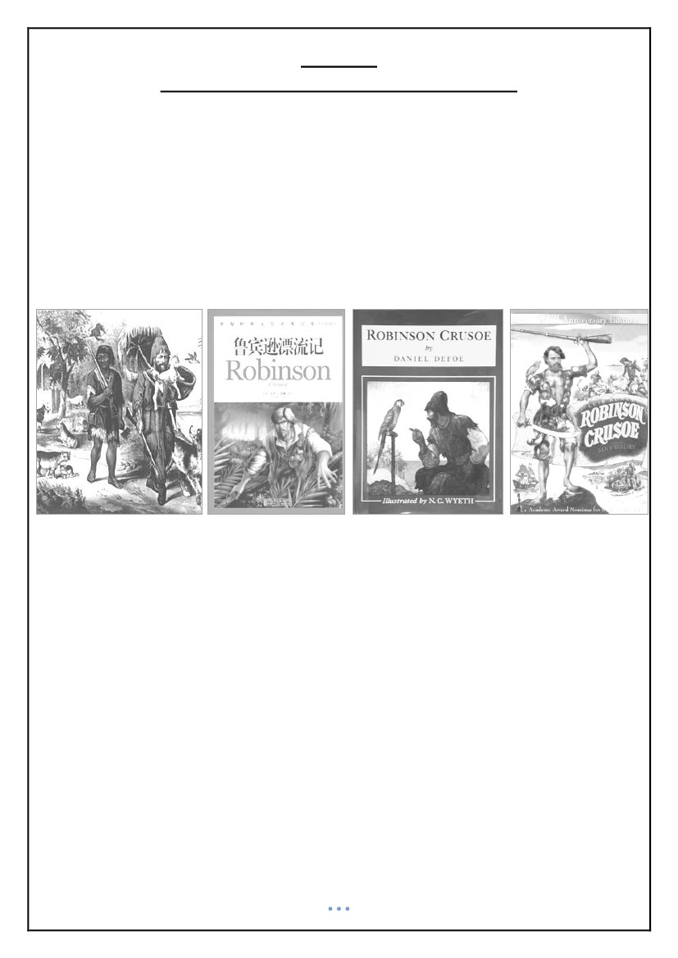
• After two years of slavery, he manages to escape and is rescued and befriended by the Captain of a
Portuguese ship off the west coast of Africa. The ship is en route to Brazil. There, with the help of the
captain, Crusoe becomes owner of a plantation.
• Years later, he joins an expedition to bring slaves from Africa, but he is shipwrecked in a storm about
forty miles out to sea on an island (which he calls the Island of Despair) on September 30, 1659.
• His companions all die, save himself, and three animals who survived the shipwreck, the captain's
dog and two cats. Having overcome his despair, he fetches arms, tools and other supplies from the
ship before it breaks apart and sinks. He proceeds to build a fenced-in habitation near a cave which
he excavates himself.
• He keeps a calendar by making marks in a wooden cross which he has built. He hunts, grows corn
and rice, dries grapes to make raisins for the winter months, learns to make pottery and raises goats,
all using tools created from stone and wood which he harvests on the island. He also adopts a small
parrot. He reads the Bible and becomes religious, thanking God for his fate in which nothing is
missing but human society.
• Years later, he discovers native cannibals who occasionally visit the island to kill and eat prisoners. At
first he plans to kill them but later realizes that he has no right to do so as the cannibals do not
knowingly commit a crime. He dreams of obtaining one or two servants by freeing some prisoners;
when a prisoner manages to escape, Crusoe helps him, naming his new companion “Friday” after the
day of the week he appeared. Crusoe then teaches him English and converts him to Christianity.
• After another party of natives arrives to partake in a cannibal feast, Crusoe and Friday manage to kill
most of the natives and save two of the prisoners. One is Friday's father and the other is a Spaniard,
who informs Crusoe that there are other Spaniards shipwrecked on the mainland. A plan is devised
wherein the Spaniard would return with Friday's father to the mainland and bring back the others,
build a ship and sail to a Spanish port.
• Before the Spaniards return, an English ship appears; mutineers have taken control of the ship and
intend to maroon their former captain on the island. Crusoe and the ship's captain strike a deal in
which he helps the captain and the loyal sailors retake the ship from the mutineers, whereupon they
intend to leave the worst of the mutineers on the island. Before they leave for England, Crusoe
shows the former mutineers how he lived on the island and states that there will be more men
coming.
• Crusoe leaves the island December 19, 1686 and arrives in England on June 11, 1687. He learns that
his family believed him dead and there was nothing in his father's will for him.
• Crusoe departs for Lisbon to reclaim the profits of his estate in Brazil, which has granted him a large
amount of wealth. In conclusion, he takes his wealth overland to England to avoid traveling at sea.
Friday comes with him and along the way they endure one last adventure together as they fight off
hundreds of famished wolves while crossing the Pyrenees.
10
Lecture
Early Novels and Novelists – Robinson Crusoe 2
❖ Reception
•
•
•
•
published on April 25, 1719
Before the end of the year, this first volume had run through four editions.
Within years, it had reached an audience as wide as any book ever written in English.
By the end of the 19th century, no book in the history of Western literature had had more editions,
spin-offs and translations than Robinson Crusoe, with more than 700 such alternative versions,
including children's versions with mainly pictures and no text.
5
❖ versions
• The term "Robinsonade" was coined to describe the genre of stories similar to Robinson Crusoe.
• Defoe went on to write a lesser-known sequel, The Farther Adventures of Robinson Crusoe.
• It was intended to be the last part of his stories, according to the original title-page of its first edition
but a third part, Serious Reflections of Robinson Crusoe was written; it is a mostly forgotten series of
moral essays with Crusoe's name attached to give interest.
❖ Themes: colonialism
• Robinson Crusoe is the true symbol of the British conquest: The whole Anglo-Saxon spirit is in
Crusoe.
• Crusoe attempts to replicate his own society on the island: application of European technology,
agriculture, and even a rudimentary political hierarchy.
• The idealized master-servant relationship between Crusoe and Friday.
• Crusoe represents the “enlightened European.” Friday is the “savage” who can only be redeemed
from his supposedly barbarous way of life through the assimilation into Crusoe's culture.
• Nevertheless, within the novel Defoe also takes the opportunity to criticize the historic Spanish
conquest of South America.
11

❖ Themes: Religion
• Robinson is not a hero, but an everyman--a wanderer to become a pilgrim, building a promised land
on a desolate island.
• Robinson becomes closer to God, not through listening to sermons in a church but through spending
time alone amongst nature with only a Bible to read.
• Defoe's central concern is the Christian notion of Providence.
❖ Themes: The Importance of Self-Awareness
• Crusoe’s arrival on the island does not make him revert to a brute existence controlled by animal
instincts, and, unlike animals, he remains conscious of himself at all times. Indeed, his island
existence actually deepens his self-awareness as he withdraws from the external social world and
turns inward.
12
Lecture
The Development of the Modern Novel
❖ The Anti-Novel Campaign
• In the 1850s it was still common to find people who forbid their families from reading novels
• To tell stories, especially fiction, was still considered by some to be a sin. This only made people
more curious and desiring to read narratives and stories.
• By the 1880s, the prohibition was softened. As Anthony Trollope records in his Autobiography
(1883): “Novels are read right and left, above stairs and below, in town houses and in country
parsonages, by young countesses and by farmers’ daughters, by old lawyers and by young students.”
6
❖ Why did the novel become such a dominant literary form in the Victorian period?
• The audience for the novel grew enormously during the nineteenth century. In part, this was due to
economic factors:
− The growth of cities, which provided bigger markets
− The development of overseas readership in the colonies
− Cheaper production costs both for paper and for print processes
− Better distribution networks
− The advertising and promotion work
• Add to that, the spread of literacy, the increase in wealth, the development of a middle class with
leisure time, etc…
❖ “A novel is a splendid thing after a hard day’s work”
• “A novel is a splendid thing after a hard day’s work, a sharp practical tussle with the real world”
This is how one of the characters in Mary Braddon’s The Doctor’s Wife (1864) described the novel.
Reading fiction is a way of relaxing or winding down after a day of hard work for both men (working
outside) and for women (doing housework).
❖ Novel Writers
• Novel writers were told in the Saturday Review 1887 that the average reader of novels is not a
critical person, that he/she cares little for art for art’s sake, and has no fixed ideas about the duties
and responsibilities of an author: “all he asks is that he may be amused and interested without taxing
his own brains.”
• Eventually, a distinction developed between novels that were intellectually, psychologically and
aesthetically demanding and ones that served primarily as a means of escapism and entertainment.
• In the final decades of the Victorian era, a firm division was established between the artist or serious
novelist and the masses of readers.
13

❖ Happy Endings
• Until the end of the 19th century, there were palpable demands on novel writers to make their novels
have a happy ending.
• Dickens is known to have changed the ending of some of his novels to please the reader with a
happy ending.
• George Eliot is know to have opposed the idea. She demanded that the readers should curb their
desire for fiction to provide the exceptional and romantic (fairy tales) and learn rather of the
importance of the ordinary, the everyday, the commonplace
❖ Novels and Romance
• The issue of happy endings was essentially a question about the place of romance in the novel.
Romances have a history of providing escapism. John Ruskow writes:
• “The best romance becomes dangerous, if, by its excitement, it renders the ordinary course of a life
uninteresting, and increases the morbid thirst for useless acquaintance with scenes in which we shall
never be called upon to act.” (Sesame and Lilies, 1865)
❖ Sources
For more information, see
Kate Flint, “The Victorian Novel and Its Readers,” in The Cambridge Companion to the Victorian Novel,
Deirdre David ed., (Cambridge University Press, 2001): pp. 17-35.
14
Lecture
Realism and the Novel
❖ The Development of Realism
• The foundations of early bourgeois realism were laid by Daniel Defoe and Jonathan Swift, but their
novels, though of a new type and with a new hero, were based on imaginary voyages and adventures
supposed to take place far from England.
• Gradually the readers’ tastes changed. They wanted to find more and more of their own life
reflected in literature, their everyday life of a bourgeois family with its joys and sorrows.
• These demands were satisfied when the great novels of Samuel Richardson, Henry Fielding, Tobias
Smollet appeared one after another.
7
❖ Sympathy for the Common Man
• The greatest merit of these novelists lies in their deep sympathy for the common man, the man in
the street, who had become the central figure of the new bourgeois world.
• The common man is shown in his actual surroundings, which makes him so convincing, believable,
and true to life.
❖ Realism in the Victorian Novel
• Realist writers sought to narrate their novels from an objective, unbiased perspective that simply
and clearly represented the factual elements of the story.
• They became masters at psychological/ sentimental characterization, detailed descriptions of
everyday life in realistic settings, and dialogue that captures the idioms of natural human speech.
• The realists endeavored to accurately represent contemporary culture and people from all walks of
life.
• Thus, realist writers often addressed themes of socioeconomic conflict by contrasting the living
conditions of the poor with those of the upper classes in urban as well as rural societies.
• Realist writers are widely celebrated for their mastery of objective, third-person narration.
• Many realist novels are considered to be reliable sociocultural documents of nineteenth-century
society.
• Critics consistently praise the realists for their success in accurately representing all aspects of
society, culture, and politics contemporary to their own.
• Realism has exerted a profound and widespread impact on many aspects of twentieth-century
thought, including religion, philosophy, and psychology.
15

❖ Characteristics of the Realist Novel
•
•
•
•
•
•
The linear flow of narrative
The unity and coherence of plot and character and the cause and effect development
The moral and philosophical meaning of literary action
The advocacy of bourgeois rationality
Rational, public, objective discourse
The Realist novel of the nineteenth century was written in opposition to the Romance of medieval
times
• Representation of “real life” experiences and characters versus ideal love, ideal moral codes ideal
characters (nobility), and fixed social values
❖ Sources and Further Reading
• Raymond Williams, ‘Realism’, in Keywords (1976)
16
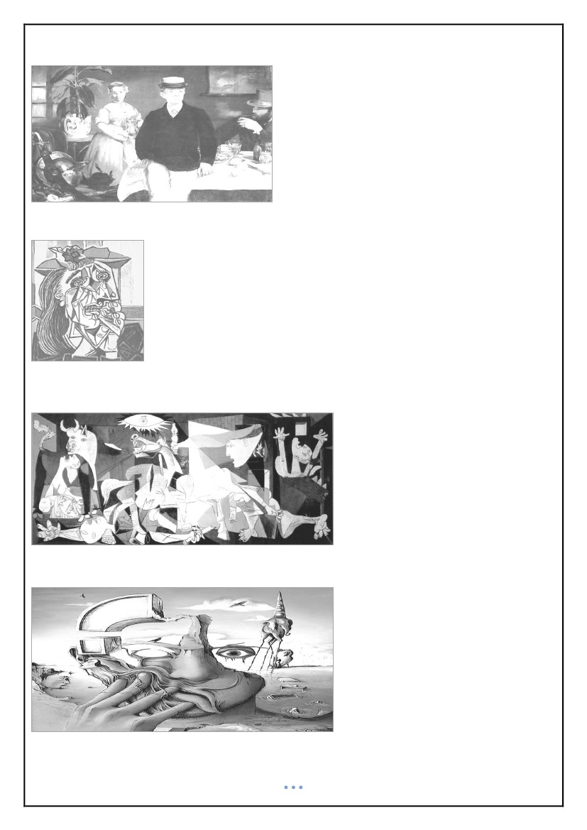
Lecture
Modernism and the Novel
❖ Modernism: Background
• By the end of the 19th century, artists and novelists were already becoming unsatisfied with realism.
• Rejection of Realism and Naturalism became common.
• A wide range of experimental and avant-garde trends (all the –isms: dadaism, surrealism,
expressionism, futurism, etc.)
• A reaction to the modern, urban experience
• A rejection of the bourgeois values
8
❖ Discontinuity and Fragmentation
• Realism stressed the role of art as a mirror of social reality, the values of bourgeois society, and
notions of progress.
• Modernism questioned art’s capability to reflect reality, questioned the coherence of that reality, the
bourgeois values of society and the notions of progress and happiness.
• Life and reality are not coherent or simple and it is an illusion to think that the novel or art in general
can simply depict them like a mirror.
• Bourgeois values and morality are fake and superficial
❖ What modernism stressed instead was:
•
•
•
•
•
Discontinuity and fragmentation
Juxtaposition and multiple points of view
Emphasis on individualism
“Self” is seen as artificial, a social fiction
The individual is stripped of the traditional defining categories of personhood
❖ Modernist fiction
•
•
•
•
•
•
•
•
•
•
Stressed:
Crisis rather than coherent reality
Attempts to represent multiple truths as reflected in consciousness and the psyche
Rejection of external, unitary, coherent appearance of realist conventions
Stresses a lack of causality (chaos)
Insufficiency of language (incapability to represent)
Oppositional relations between the individual and the social, (the alienation of the individual in
his/her social environment)
Antibourgeois (because bourgeois values and lifestyle are fake and superficial)
Uses first person narrator, and he/she is often unreliable, reflecting the difficulty to represent reality
Reflects a sense of urban dislocation and alienation
Works by male writers tend to be misogynistic
17

❖ Compare: Édouard Manet, “Breakfast in the Studio” (Realist Art)
❖ With: Picasso “Weeping Woman” (Modernist Art)
• Discontinuity and fragmentation
• Juxtaposition and multiple points of view
• “Self” is seen as artificial, a social fiction of undetermined status
• Individual is stripped of the traditional defining categories of personhood
❖ Or Picasso’s famous Guernica 1937
❖ Or any of Salvador Dali’s work
18
Lecture
Heart of Darkness: Background
❖ Joseph Conrad: 1857-1924
•
•
•
•
born Józef Teodor Conrad Korzeniowski in Russian occupied Ukraine
1874 joined French merchant marines, later the British
1886 became British citizen
1890 traveled to Congo
9
❖ Major works:
•
•
•
•
•
The Nigger of the Narcissus (1897)
Lord Jim (1900)
Nostromo (1904)
The Secret Agent (1907)
The Secret Sharer (1909)
❖ Heart of Darkness (1899, 1902)
• According to Conrad, it is based on real events–
• Conrad is "Marlow" in the novella.
• Conrad, born in Russia of Polish parents, did not learn to speak English until he was in his late 20s,
yet he wrote Heart of Darkness in English and is considered to be a British novelist and one of the
best prose writers in the English language.
❖ Heart of Darkness: background
•
•
•
•
•
Heart of Darkness is set in the Congo at the time of the Belgian colonization
Africa was the last continent to be overtaken by Europeans.
There was a big push to colonize by Britain, France, Germany, Netherlands, and Belgium.
There was no regard for the native inhabitants.
Millions of Africans were killed and maimed or worked to death.
❖ KING LEOPOLD II of Belgium
• Leopold II became king of Belgium in 1865
• He was greedy, inept, and unscrupulous.
• Leopold had an inferiority complex due to his small stature and because Belgium was small and
weak.
• He wanted to acquire colonies and compete politically with the big powers like France and England
❖ The Colonization of the Congo
• In 1876 [Leopold] organized a private holding company disguised as an international scientific and
philanthropic association.
• In 1879, under the auspices of the holding company, he hired the famous explorer Henry Morton
Stanley to establish a colony in the Congo region”
• Leopold II financed exploration of the Congo area, laid claim to it, and made it his private colony.
• It belonged to the man, not to the country of Belgium. It was therefore called a "crown colony."
• Profits from the area went into his own pocket, not into the treasury of Belgium.
19
❖ The Congo Free State
•
•
•
•
•
•
•
•
•
•
•
•
•
Belgian Congo area was larger than Britain, France, Spain, Italy and Germany combined.
Leopold called it the "Congo Free State."
Later it became known as Zaire and is now called Democratic Republic of Congo
Congo Free State is called by Adam Hochschild, author of the book King Leopold’s Ghost, "the world's
only colony claimed by one man”
The Belgian Congo under Leopold’s rule became an example of how terrible colonial rule can be.
The native people were treated as commodities, and atrocities were committed against them
Leopold hired the famous explorer Henry Morton Stanley to get control of the Congo.
Stanley cut a deal with the chiefs of the native tribes and got economic control.
Leopold realized that huge profits rely on forced labor, so it became illegal to pay an African for his
work
Leopold ordered Stanley to purchase as much land as possible and to acquire power among the
chiefs from the mouth of the Congo River as far into the interior as possible.
Stanley gained control by offering the chiefs bribes.
An 1884 treaty signed by Stanley and the chiefs (a piece of cloth in exchange for all of their
waterways, roads, game, fishing, mining rights, and freedom– FOREVER).
Once the land was acquired, Leopold imposed taxes on the roads, waterways, etc. Natives were
allowed to use them, but they had to pay a tax to do so.
❖ Rubber and Ivory
• Leopold declared a monopoly on rubber and ivory.
• His agents in the Congo were given the freedom to use as much force as necessary to get the rubber
and ivory.
• Their profits were based on the total amount extracted, so it was to their advantage to work the
natives mercilessly.
• Leopold set up a mercenary force called the Force Publique - 19,000 members, most of them
Africans. They controlled Congo Free State for Leopold for 23 years between 1885 and 1908, and
helped him extract rubber and ivory from the area
❖ Forced Labor
• The Force Publique took over native villages in areas where there was rubber or ivory to be
harvested.
• They made the natives work for them but did not pay them--it was illegal to pay an African for his
work. This is called “forced labor.”
• The only difference between forced labor and slavery is that the workers in forced labor situations
are not actually owned by other people.
• Forced labor is even worse than slavery because in slavery, the “owner” is anxious to protect his
“property” and has to feed and clothe him. In forced labor, the workers work for free and are
responsible for their own food etc.
20

❖ Leon Rom and Kurtz
• The head of the Force Publique was Leon Rom, a ruthless and cruel man who decorated his yard with
a fence featuring human skulls on posts and a garden with human skulls of dead natives
• Rom kept a gallows permanently erected in his station to intimidate the workers
• The character Kurtz in the novella is based on Leon Rom.
• The Force Publique went into villages and captured the natives for forced labor.
• The women and children were separated from the men and held hostage until the men brought in
their quota of rubber or ivory.
• If a worker didn't meet his quota, sometimes the Force Publique would motivate him by cutting off
the hand or foot of one of his children
• The Men wore a numbered metal disk on a string around their necks. An accountant kept track of
how much ivory or rubber each worker brought in.
• The Force Publique sold the women back to the natives when they were finished in the area.
• Leopold claimed that his goal was ultimately humanitarian-
• In 1908, Leopold, realizing that his reign in the Congo had come to an end, had all the archives of the
Belgian government burned to destroy the evidence of the atrocities. The fire burned for eight days
and nights
• Leopold II was responsible for the deaths of between ten and eleven million people in the Belgian
Congo.
❖ Heart of Darkness
• Conrad, author of Heart of Darkness, said that Heart of Darkness is a documentary--the things
described in it really happened.
• Conrad actually did go to the Congo and was the captain of a steamboat on the Congo River. Heart of
Darkness is a record of his experience.
• Marlow in the novella = Joseph Conrad
• Kurtz in the novella = Leon Rom, head of the Force Publique
❖ Further Reading
To find out more, Read King Leopold's Ghost, by Adam Hochschild
21
Lecture
Heart of Darkness One
❖ Heart of Darkness: Part I
• The novel begins on a yacht called the Nellie at the mouth of the river Thames in London. The yacht
is waiting for the tide to go out.
• Five men relax on the deck of the ship: the Director of Companies, who is also the captain and host,
the Lawyer, the Accountant, Marlow, and the unnamed Narrator.
• The five men, old friends held together by “the bond of the sea,” are restless yet meditative, as if
waiting for something to happen. As darkness begins to fall, and the scene becomes “less brilliant
but more profound,” the men recall the great men and ships that have set forth from the Thames on
voyages of trade and exploration, frequently never to return..
• Suddenly Marlow remarks that this very spot (London, the Thames) was once “one of the dark places
of the earth.”
• He notes that when the Romans first came to England, it was a great, savage wilderness to them. He
imagines what it must have been like for a young Roman captain or soldier to come to a place so far
from home and lacking in comforts.
• This reminds Marlow of his experience as a “fresh-water sailor,” when as a young man he captained
a steamship going up the Congo River.
• Marlow recounts how he obtained a job with the Belgian “Company” that trades on the Congo River
(the Congo was then a Belgian colony) through the influence of his aunt who had friends in the
Company’s administration.
• The Company was eager to send Marlow to Africa, because one of the Company’s steamer captains
had recently been killed in a fight with the natives.
• After he hears that he has gotten the job, Marlow travels across the English Channel to a city that
reminds him of a “whited sepulchre” (probably Brussels) to sign his employment contract at the
Company’s office.
• At the Company’s offices, Marlow finds two sinister women there knitting black wool, one of whom
admits him to a waiting room, where he looks at a map of Africa color-coded by colonial powers.
• Marlow signs his contract, and goes to be checked by a doctor. The doctor takes measurements of
his skull, remarking that he unfortunately doesn’t get to see those men who make it back from
Africa.
• The doctor tells Marlow, “the changes take place inside.” The doctor is interested in learning
anything that may give Belgians an advantage in colonial situations.
10
22
• Marlow then stops to say goodbye to his aunt, who expresses the hope that he will aid in the
civilization of savages during his service to the Company, “weaning those ignorant millions from their
horrid ways.”
• Marlow is aware, though, that the Company operates for profit and not for the good of humanity,
and he is bothered by his aunt’s naïveté.
• Before boarding the French steamer that is to take him to Africa, Marlow has a brief but strange
feeling about his journey: the feeling that he is setting off for the center of the earth.
• The French steamer takes Marlow along the coast of Africa, stopping periodically to land soldiers and
customs house officers. Marlow finds his idleness vexing, and the trip seems vaguely nightmarish to
him. At one point, they come across a French man-of-war (a ship) shelling an apparently uninhabited
forest along the coast.
• They finally arrive at the mouth of the Congo River, where Marlow boards another steamship bound
for a point thirty miles upriver. The captain of the ship, a young Swede, recognizes Marlow as a
seaman and invites him on the bridge. The Swede criticizes the colonial officials and tells Marlow
about another Swede who recently hanged himself on his way into the interior.
• Marlow disembarks at the Company’s station, which is in a terrible state of disrepair. He sees piles of
decaying machinery and a cliff being bombed for no apparent purpose. He also sees a group of black
prisoners walking along in chains under the guard of another black man, who wears a shoddy
uniform and carries a rifle.
• Marlow remarks that he had already known the “devils” of violence, greed, and desire, but that in
Africa he became acquainted with the “flabby, pretending, weak-eyed devil of a rapacious and
pitiless folly.” Finally, Marlow comes to a grove of trees and, to his horror, finds a group of dying
native laborers.
• He offers a biscuit to one of them; seeing a bit of white European yarn tied around his neck, he
wonders at its meaning. He meets a neatly dressed white man, the Company’s chief accountant (not
to be confused with Marlow’s friend the Accountant from the opening of the book).
• Marlow spends ten days here waiting for a caravan to the next station. One day, the chief
accountant tells him that in the interior he will undoubtedly meet Mr. Kurtz, a first-class agent who
sends in as much ivory as all the others put together and is destined for advancement. He tells
Marlow to let Kurtz know that everything is satisfactory at the Outer Station when he meets him.
• Marlow travels overland for two hundred miles with a caravan of sixty men. He has one white
companion who falls ill and must be carried by the native bearers, who start to desert because of the
added burden.
• After fifteen days they arrive at the dilapidated Central Station. Marlow finds that the steamer he
was to command has sunk. The general manager of the Central Station had taken the boat out two
days before under the charge of a volunteer skipper, and they had torn the bottom out on some
rocks. In light of what he later learns, Marlow suspects the damage to the steamer may have been
intentional, to keep him from reaching Kurtz.
23

• Marlow soon meets with the general manager, who strikes him as an altogether average man who
leads by inspiring an odd uneasiness in those around him and whose authority derives merely from
his resistance to tropical disease.
• The manager tells Marlow that he took the boat out in a hurry to relieve the inner stations, especially
the one belonging to Kurtz, who is rumored to be ill. He praises Kurtz as an exceptional agent and
takes note that Kurtz is talked about on the coast.
• It takes Marlow three months to repair his ship. One day during this time, a grass shed housing some
trade goods burns down, and the native laborers dance delightedly as it burns.
• One of the natives is accused of causing the fire and is beaten severely; he disappears into the forest
after he recovers.
• Marlow overhears the manager talking with the brickmaker about Kurtz at the site of the burned
hut. He enters into conversation with the brickmaker after the manager leaves, and ends up
accompanying the man back to his quarters, which are noticeably more luxurious than those of the
other agents.
• Marlow realizes after a while that the brickmaker is pumping him for information about the
intentions of the Company’s board of directors in Europe, about which, of course, Marlow knows
nothing.
• Marlow notices an unusual painting on the wall, of a blindfolded woman with a lighted torch; when
he asks about it, the brickmaker reveals that it is Kurtz’s work.
• The brickmaker tells Marlow that Kurtz is a prodigy, sent as a special emissary of Western ideals by
the Company’s directors and bound for quick advancement.
• He also reveals that he has seen confidential correspondence dealing with Marlow’s appointment,
from which he has construed that Marlow is also a favorite of the administration. They go outside,
and the brickmaker tries to get himself into Marlow’s good graces—and Kurtz’s by proxy, since he
believes Marlow is allied with Kurtz.
• Marlow realizes the brickmaker had planned on being assistant manager, and Kurtz’s arrival has
upset his chances. Seeing an opportunity to use the brickmaker’s influence to his own ends, Marlow
lets the man believe he really does have influence in Europe and tells him that he wants a quantity of
rivets from the coast to repair his ship. The brickmaker leaves him with a veiled threat on his life, but
Marlow enjoys his obvious distress and confusion.
• The Eldorado Exploring Expedition, a group of white men intent on “tear*ing+ treasure out of the
bowels of the land,” arrives, led by the manager’s uncle, who spends his entire time at the station
talking conspiratorially with his nephew.
• Marlow gives up on ever receiving the rivets he needs to repair his ship, and turns to wondering
disinterestedly about Kurtz and his ideals.
24
Lecture
Heart of Darkness Two
❖ Heart of Darkness: Part II
• While Marlow is waiting for his ship to be repaired, he overhears one night the manager and his
uncle complaining about Kurtz and discussing how to get rid of him. He hears them say that Kurtz
was very ill and they hope he would just die.
• Marlow then leaves on a two-month trip up the river to Inner Station where Kurtz is. He takes along
the manager and several “pilgrims.” The river is treacherous and the trip is difficult; the ship
proceeds only with the help of a crew of natives the Europeans call cannibals, who actually prove to
be quite reasonable people.
• Fifty miles away from Kurtz’s Inner Station, Marlow and his companions find a hut with a stack of
firewood and a note that says, “Wood for you. Hurry up. Approach cautiously.” They can’t read the
signature, but it is clearly not Kurtz’s.
• Inside the hut, Marlow finds a battered old book on seamanship with notes in the margin in what
looks like code. The manager concludes that the wood must have been left by the Russian trader, a
man about whom Marlow has overheard the manager complaining. After taking aboard the firewood
that serves as the ship’s fuel, the party continues up the river, the steamer struggling and about to
give up working completely.
• Marlow wonders about Kurtz constantly as they crawl along toward him..
• They stop again 8 miles away from Kurtz’ station because of the fog. They hear a loud, desolate cry,
followed by savage voices, and then silence again. They prepare for attack. The whites are badly
shaken, but the African crewmen respond with quiet alertness.
• The leader of the cannibals tells Marlow that his people want to eat the people making the loud
cries. Marlow realizes that the cannibals must be very hungry. their only food, a supply of rotting
hippo meat, was long since thrown overboard by the pilgrims.
• Marlow does not think the natives will attack because their cries sounded more sorrowful than
warlike. But they do attack about a mile and a half from the station. Suddenly the air was filled with
arrows. The helmsman is killed with a spear.
• Marlow frightens the attackers away by sounding the steam whistle repeatedly, and they give up the
attack and make a prolonged cry of fear and despair. Marlow thinks that Kurtz is now dead as well,
and he feels a terrible disappointment at the thought.
• The narrative comes back to the Nellie on the Thames. Marlow notes that Kurtz had a fiancée, his
Intended (as Kurtz called her), waiting for him in Europe. What Marlow find significant about her is
the air of possession and ownership Kurtz assumed when speaking about her: indeed, Kurtz spoke of
everything - ivory, the Inner Station, the river - as being his. It is this sense of dark mastery that
disturbs Marlow most.
25
11

• Marlow also mentions a report Kurtz has written at the request of the International Society for the
Suppression of Savage Customs. The report is eloquent and powerful, if lacking in practical
suggestions. It concludes, however, with a handwritten postscript: “Exterminate all the brutes!”
• Marlow suggests that this is the result of Kurtz’s absorption into native life—that by the time he
came to write this note he had assumed a position of power with respect to the natives and had
been a participant in “unspeakable rites,” where sacrifices had been made in his name. At this point,
Marlow also reveals that he feels he is responsible for the “care of *Kurtz’s+ memory,” and that he
has no choice but to remember and continue to talk about the man.
• Marlow returns back to the story. The Inner Station comes into view now. It looks decayed but is still
standing.
• A white man, the Russian trader, beckons to them from the shore. He wears a patchwork suit and
babbles incessantly. He tells Marlow that the natives mean no harm, and that the ship’s whistle is
the best means to scare them off. He tells Marlow he has been a merchant seaman and was working
for a Dutch company.
• The Russian tells Marlow that the steamer was attacked because the natives do not want Kurtz to
leave. The Russian also offers yet another enigmatic picture of Kurtz. One does not talk to Kurtz but
listens to him. He credits Kurtz for having “enlarged his mind.”
26
Lecture
Heart of Darkness Three
❖ Heart of Darkness: Part III
• The Russian trader begs Marlow to take Kurtz away quickly. He tells Marlow that Kurtz is a great
man, that he nursed Kurtz through two illnesses but sometimes would not see him for long periods
of time, during which Kurtz was out raiding the countryside for ivory with a native tribe he had
gotten to follow him.
• Although Kurtz has behaved erratically and once even threatened to shoot the trader over a small
stash of ivory, the trader nevertheless insists that Kurtz cannot be judged as one would judge a
normal man. He has tried to get Kurtz to return to civilization several times. The Russian tells Marlow
that Kurtz is extremely ill now.
• As he listens to the trader, Marlow looks through his binoculars and sees that what he had originally
taken for ornamental balls on the tops of fence posts in the station compound are actually severed
heads turned to face the station house. He is repelled but not particularly surprised. The Russian
apologetically explains that these are the heads of rebels, an explanation that makes Marlow laugh
out loud. The Russian makes a point of telling Marlow that he has had no medicine or supplies with
which to treat Kurtz; he also asserts that Kurtz has been shamefully abandoned by the Company.
• At that moment, the pilgrims emerge from the station-house with Kurtz on an improvised stretcher,
and a group of natives rushes out of the forest with a piercing cry. Kurtz speaks to the natives, and
the natives withdraw and allow the party to pass. The manager and the pilgrims lay Kurtz in one of
the ship’s cabins and give him his mail, which they have brought from the Central Station. Someone
has written to Kurtz about Marlow, and Kurtz tells him that he is “glad” to see him. The manager
enters the cabin to speak with Kurtz, and Marlow withdraws to the steamer’s deck. From here he
sees two natives standing near the river with impressive headdresses and spears, and a beautiful
native woman draped in ornaments pacing gracefully along the shore. She stops and stares out at
the steamer for a while and then moves away into the forest.
• Marlow hears Kurtz yelling at the manager inside the cabin. Kurtz accuses the men of coming for the
ivory rather than to help him, and he threatens the manager for interfering with his plans.
• The manager comes out and tells Marlow that they have done everything possible for Kurtz, but his
unsound methods have closed the district off to the Company for the time being. He says he plans on
reporting Kurtz’s “complete want of judgment” to the Company’s directors.
• Marlow is thoroughly disgusted by the manager’s hypocritical condemnation of Kurtz, and he tells
the manager that he thinks Kurtz is a “remarkable man.” With this statement, Marlow permanently
alienates himself from the manager and the rest of the Company functionaries. Like Kurtz, Marlow is
now classified among the rebels like Kurtz who use “unsound methods.”
• The Russian asks Marlow to protect Kurtz’s reputation, Marlow tells the Russian that the manager
has spoken of having him (the Russian) hanged. The trader is not surprised. He asks Marlow for
tobacco, gun cartridges, and shoes, leaves in a canoe with some natives.
12
27
• Marlow gets up in the middle of the night and finds that Kurtz is gone. He is worried, but he does not
raise an alarm, and instead decides to leave the ship to search for Kurtz himself. He finds him
crawling on all four and convinces him to come back telling him that people in Europe think of him as
a success.
• The steamer departs the next day at noon, and the natives appear on the shore to watch it go. Kurtz
watches through the window as the natives make cries and sad chants. Marlow sounds the whistle as
he sees the pilgrims get out their rifles, and the crowd scatters. Only the woman remains standing on
the shore.
• The steamer sails back on river upward toward civilization. The manager, seeing that Kurtz so sick
and might die, is pleased to have things under his control; he ignores Marlow, who now is seen to
belong to the “unsound” but harmless party.
• Marlow, for the most part, is left alone with Kurtz. Kurtz talks on a variety of subjects. Marlow is
alternately impressed and disappointed. Kurtz’s philosophical musings are interspersed with
grandiose and childish plans for fame and fortune.
• The steamer breaks down, and repairs take some time. Marlow also becomes ill, and the work is
hard on him. Kurtz seems troubled, probably because the delay has made him realize that he
probably will not make it back to Europe alive. Worried that the manager will gain control of his
“legacy,” Kurtz gives Marlow a bundle of papers for safekeeping.
• Kurtz’s ramblings become more abstract and more rhetorical as his condition worsens. Marlow
believes he is reciting portions of articles he has written for the newspapers: Kurtz thinks it his “duty”
to disseminate his ideas. Finally, one night, Kurtz admits to Marlow that he is “waiting for death.”
• As Marlow approaches, Kurtz seems to be receiving some profound knowledge or vision, and the
look on his face forces Marlow to stop and stare. Kurtz cries out—“The horror! The horror!”—and
Marlow flees, not wanting to watch the man die. He joins the manager in the dining hall, which is
suddenly overrun by flies. A moment later, a servant comes in to tell them, “Mistah Kurtz—he dead.”
• The pilgrims bury Kurtz the next day. Marlow becomes ill and nearly dies himself. He suffers greatly,
but the worst thing about his near-death experience is his realization that in the end he would have
“nothing to say.” Kurtz, he realizes, was remarkable because he “had something to say. He said it.”
Once he has recovered sufficiently, he leaves Africa and returns to Brussels.
• In Brussels, Marlow resents people for their petty self-importance and smug complacency. His aunt
nurses him back to health, but his disorder is more emotional than physical. A representative of the
Company comes to retrieve the packet of papers Kurtz entrusted to Marlow, but Marlow will give
him only the pamphlet on the “Suppression of Savage Customs,” with the postscript (the
handwritten “Exterminate all the brutes!”) torn off. The man threatens legal action to obtain the rest
of the packet’s contents.
• Another man, calling himself Kurtz’s cousin, appears and takes some letters to the family. The cousin
tells him that Kurtz had been a great musician. Marlow and the cousin ponder Kurtz’s myriad talents
and decide that he is best described as a “universal genius.”
• A journalist colleague of Kurtz’s appears and takes the pamphlet for publication. This man believes
Kurtz’s true skills were in popular or extremist politics.
28

• Finally, Marlow is left with only a few letters and a picture of Kurtz’s Intended. Marlow goes to see
her without really knowing why. Kurtz’s memory comes flooding back to him as he stands on her
doorstep. He finds the Intended still in mourning, though it has been over a year since Kurtz’s death.
He gives her the packet, and she asks if he knew Kurtz well. He replies that he knew him as well as it
is possible for one man to know another.
• His presence fulfills her need for a sympathetic ear, and she continually praises Kurtz. Her
sentimentality begins to anger Marlow, but he holds back his annoyance until it gives way to pity.
• She says she will mourn Kurtz forever, and asks Marlow to repeat his last words to give her
something upon which to sustain herself. Marlow lies and tells her that Kurtz’s last word was her
name. She responds that she was certain that this was the case.
• Marlow ends his story here, and the narrator looks off into the dark sky, which makes the waterway
seem “to lead into the heart of an immense darkness.”
29
Lecture
Heart of Darkness: Themes
❖ Colonialism and Imperialism
•
Perhaps the central theme in Heart of Darkness is colonialism and imperialism.
13
• When Marlow sets off on his adventure in Brussels, the colonization of the Congo is presented as a
humanitarian project whose purpose is to help the Africans live in the modern world. This assertion
is presented on the Nellie at the opening of the novel and by Marlow’s aunt and seems to be the
culture of the company in Brussels.
• From Belgium to the Congo, and from the Outer Station to the Central Station and finally up the river
to the Inner Station, Marlow encounters scenes of torture, cruelty, forced labor, large-scale
exploitation and mass-murder.
• The novel exposes the hypocrisy of colonialism and imperialism. The men who work for the Company
describe what they do as “trade,” and their treatment of native Africans is part of a benevolent
project of “civilization.”
• “The word ‘ivory’ rang in the air, was whispered, was sighed. You would think they were praying to it.
A taint of imbecile rapacity blew through it all, like a whiff from some corpse. By Jove! I’ve never
seen anything so unreal in my life.”
• Heart of Darkness (Part 1, Section 4)
❖ Kurtz Vs. The Company
• But the novel also sets against the hypocrisy of the company and the Europeans in general. Marlow
(and Joseph Conrad through him) prefers Kurtz’s honesty to the Company’s and the Europeans’
hypocrisy.
• Kurtz, at least, is open about the fact that he does not trade but rather takes ivory by force, and he
describes his own treatment of the natives with the words “suppression” and “extermination”: he
does not hide the fact that he rules through violence and intimidation.
• Unlike the other Europeans, Kurtz does not claim to be in Africa to “help” the Africans. He is frank
about the fact that he is there to steal and plunder ivory.
• Kurtz’ perverse honesty leads to the success of the Company because he brings them a lot of ivory,
but his honesty also brings his downfall, because his honesty exposes the evil practices behind
European activity in Africa.
30

❖ The Africans
• However, for Marlow as much as for Kurtz or for the Company, Africans in the novel are mostly
objects: Marlow refers to his helmsman as a piece of machinery, and Kurtz’s African mistress is at
best a piece of statuary.
• African are also often described in zoological terms (ants, animals, insects, etc) and it can be argued
that Heart of Darkness participates in the dehumanization of the Africans. Notice that no African is
allowed to speak in the novel, and they are often portrayed as sub-humans and primitives. They just
make primitive sounds, but they never talk.
• “It was unearthly, and the men were—No, they were not inhuman. Well, you know, that was the
worst of it—the suspicion of their not being inhuman. It would come slowly to one. They howled and
leaped, and spun, and made horrid faces; but what thrilled you was just the thought of their
humanity—like yours—the thought of your remote kinship with this wild and passionate uproar.
Ugly. Yes, it was ugly enough; but if you were man enough you would admit to yourself that there
was in you just the faintest trace of a response to the terrible frankness of that noise, a dim suspicion
of there being a meaning in it which you—you so remote from the night of first ages—could
comprehend. And why not?”
• Heart of Darkness
31
Lecture
Heart of Darkness: Characters and Symbols
❖ Characters: Marlow
• Marlow appears in several of Conrad’s other works. He is a complicated character who anticipates
the figures of high modernism while also reflecting his Victorian predecessors. Marlow is in many
ways a traditional hero: tough, honest, an independent thinker, a capable man. Yet he is also
“broken” or “damaged,” like the characters of modernist fiction. The world has defeated him in some
fundamental way, and he is weary, skeptical, and cynical. Marlow also shifts between the role of the
intellectual and that of the “working tough.”
• In the end, he sides with Kurtz against the Company, but he does not side with the Africans… And
when he meets Kurtz’ fiancée, he prefers not to tell her the truth about Kurtz and the situation in
Africa.
14
❖ Characters: Kurtz
• Kurtz resembles the archetypal “evil genius”: the highly gifted but ultimately degenerate individual
whose fall becomes legendary. Kurtz is related to figures like Faustus, Satan in Milton’s Paradise Lost,
Moby-Dick’s Ahab, and Wuthering Heights’s Heathcliff. Like these characters, he is significant both
for his style and eloquence and for his grandiose, almost paranoiac scheming.
• Kurtz can be criticized in the same terms that Heart of Darkness is sometimes criticized: style entirely
overrules substance, providing a justification for amorality and evil.
• Kurtz is utterly lacking in substance. Marlow refers to Kurtz as “hollow” more than once. It shows
Kurtz’s ability to function as a “choice of nightmares” for Marlow
• Kurtz provides Marlow with a set of paradoxes that Marlow can use to evaluate himself and the
Company’s men.
• Kurtz is not so much a fully realized individual as a series of images constructed by others for their
own use. As Marlow’s visits with Kurtz’s cousin, the Belgian journalist, and Kurtz’s fiancée
demonstrate, there seems to be no true Kurtz. To his cousin, he was a great musician; to the
journalist, a brilliant politician and leader of men; to his fiancée, a great humanitarian and genius.
❖ Symbols: Darkness
• Darkness: The word is part of the book’s title. But it is difficult to say exactly what it means, because
it is used extensively. Almost everything in the book is cloaked in darkness. Africa, England, and
Brussels are all described as gloomy and somehow dark, at one point or another.
• Darkness is most often used metaphorically. Darkness is the inability to see: this may sound simple,
but think about it as a description of the human condition, and it will prove to have profound
implications. Failing to see mass-murders, failing to see that exploitation and destruction of Africa is
not humanitarian work, and failing to see that Africans are human beings are very grave and
consequential facts.
32
❖ Symbols: Fog
• Fog is similar to darkness. Fog not only obscures but distorts: it gives one just enough information to
begin making decisions but no way to judge the accuracy of that information, which often ends up
being wrong. Marlow’s steamer is caught in the fog, meaning that he has no idea where he’s going
and no idea whether peril or open water lies ahead.
❖ Symbols: The White Sepulchre
• The “whited sepulchre” is probably Brussels, where the Company’s headquarters are located. A
sepulchre implies death and confinement, and indeed Europe is the origin of the colonial enterprises
that bring death to white men and to their colonial subjects.
• It is also governed by ideologies that both enable cruelty, dehumanization, and evil and prohibit
change. The phrase “whited sepulchre” comes from the biblical Book of Matthew. In the passage,
Matthew describes “whited sepulchres” as something beautiful on the outside but containing
horrors within (the bodies of the dead); thus, the image is appropriate for Brussels, given the
hypocritical Belgian rhetoric about imperialism’s civilizing mission.
❖ Symbols: The River
• The Congo River is the key to Africa for Europeans. It allows them access to the center of the
continent without having to physically cross it; in other words, it allows the white man to remain
always separate or outside. The river also seems to want to expel Europeans from Africa altogether:
its current makes travel upriver slow and difficult, but the flow of water makes travel downriver,
back toward “civilization,” rapid and seemingly inevitable. Marlow’s struggles with the river as he
travels upstream toward Kurtz reflect his struggles to understand the situation in which he has found
himself. The ease with which he journeys back downstream, on the other hand, mirrors his
acquiescence to Kurtz and his “choice of nightmares.”
--------------------------------------
Collected By Bisan - 2015
I Wish You All The Success
33

