الواجب الاول ادب اطفال
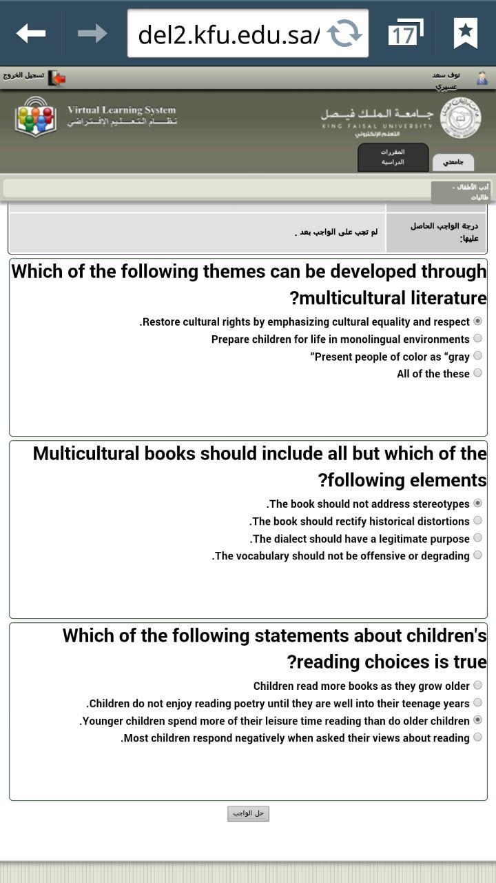

الواجب الثاني
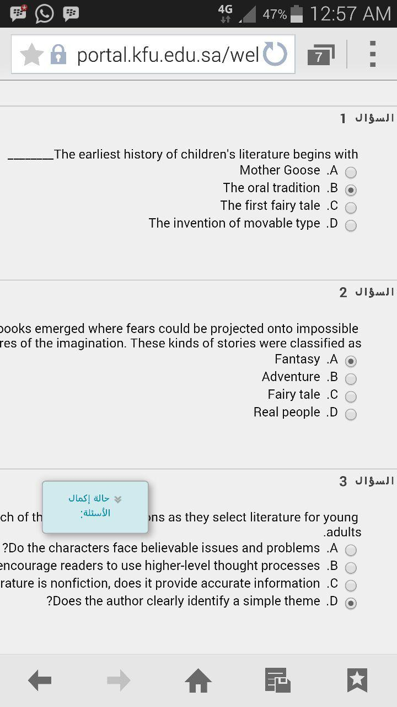

الواجب الثالث
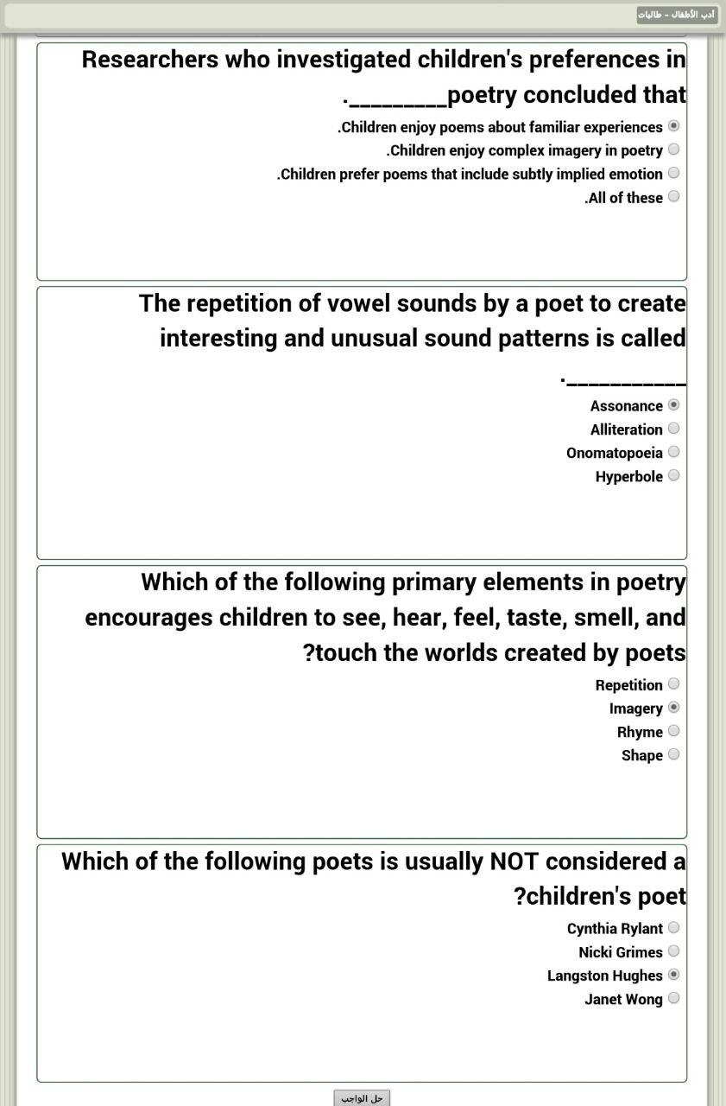

الواجب الاول علم اللغة الاجتماعي
1-refers to the ability of its holders to force obedience of other people to their will.
Banner
Language
Parole
Power
2-According to The Sapir-Whorf hypothesis, there is an causative link between ….….
all languages
culture and language
language and physics
fissures and nature
3-Artificial intelligence is the study of how to make computers ..………..
Misshaped
more sophisticated
more expensive
cheaper
الواجب الثاني
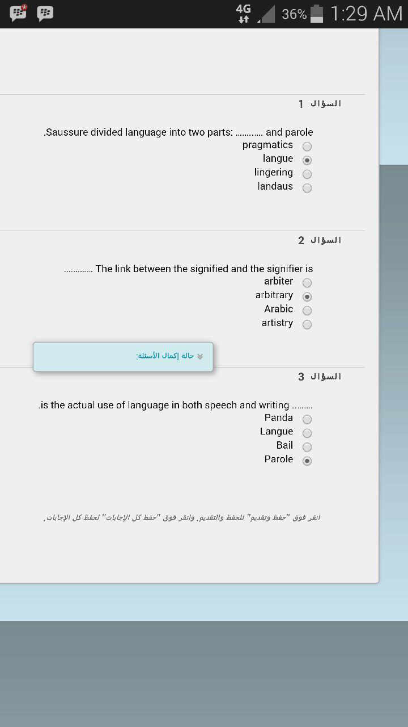

الواجب الثالث
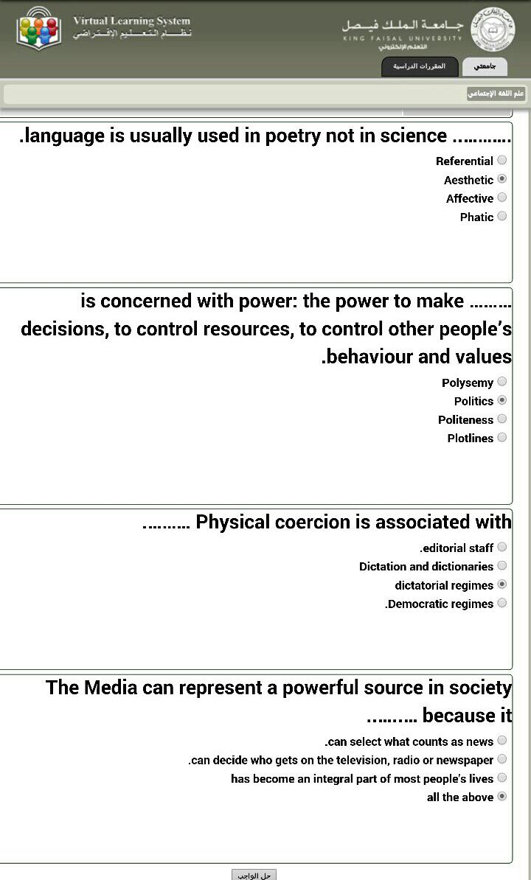

الواجب الاول ادب امريكي
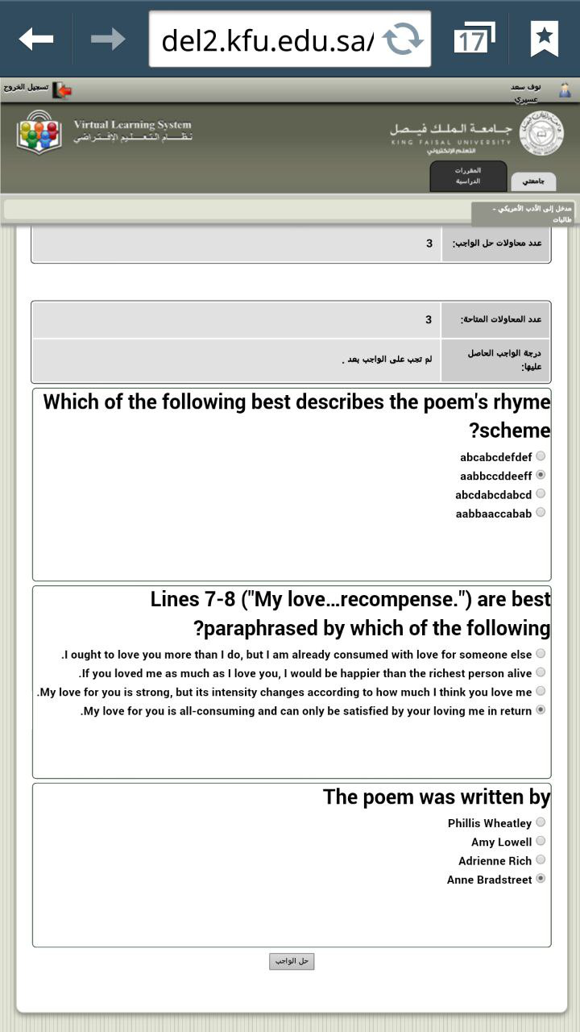

الواجب الثاني
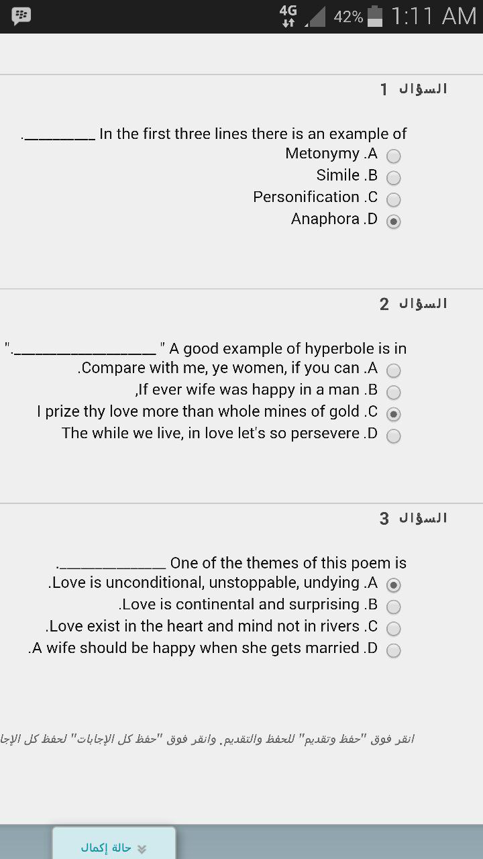

الواجب الثالث
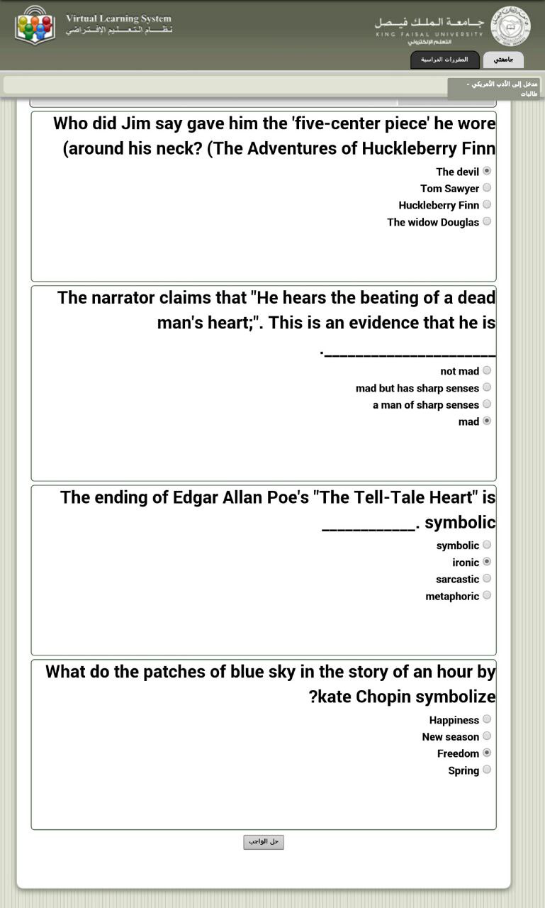

الترجمة التتابعية الواجب الاول
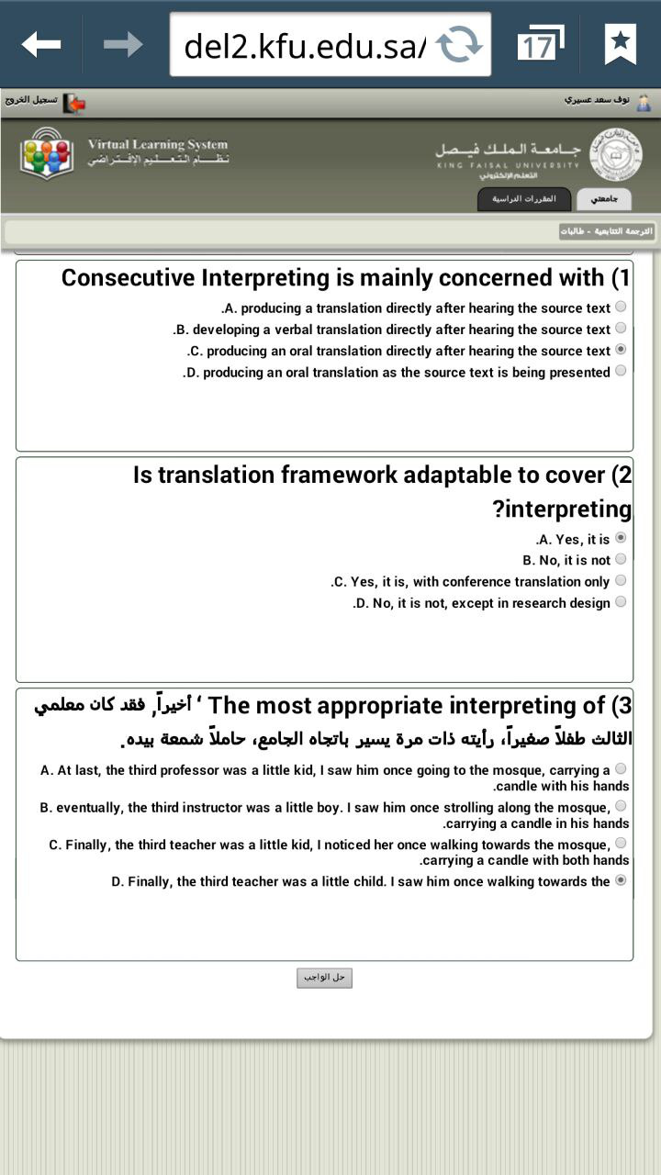

الواجب الثاني
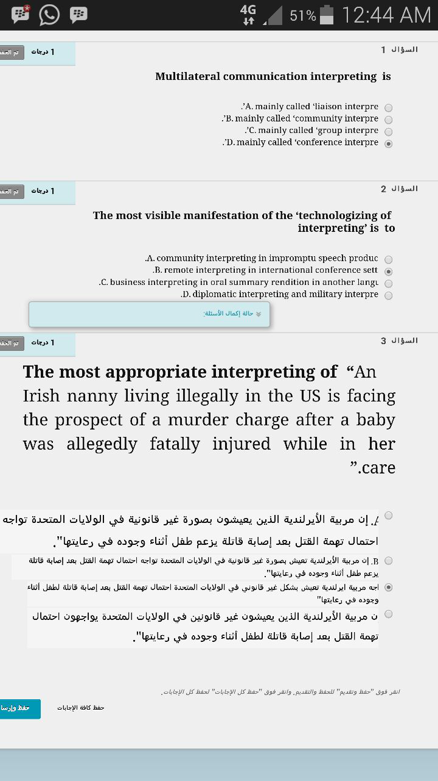
الواجب الثالث
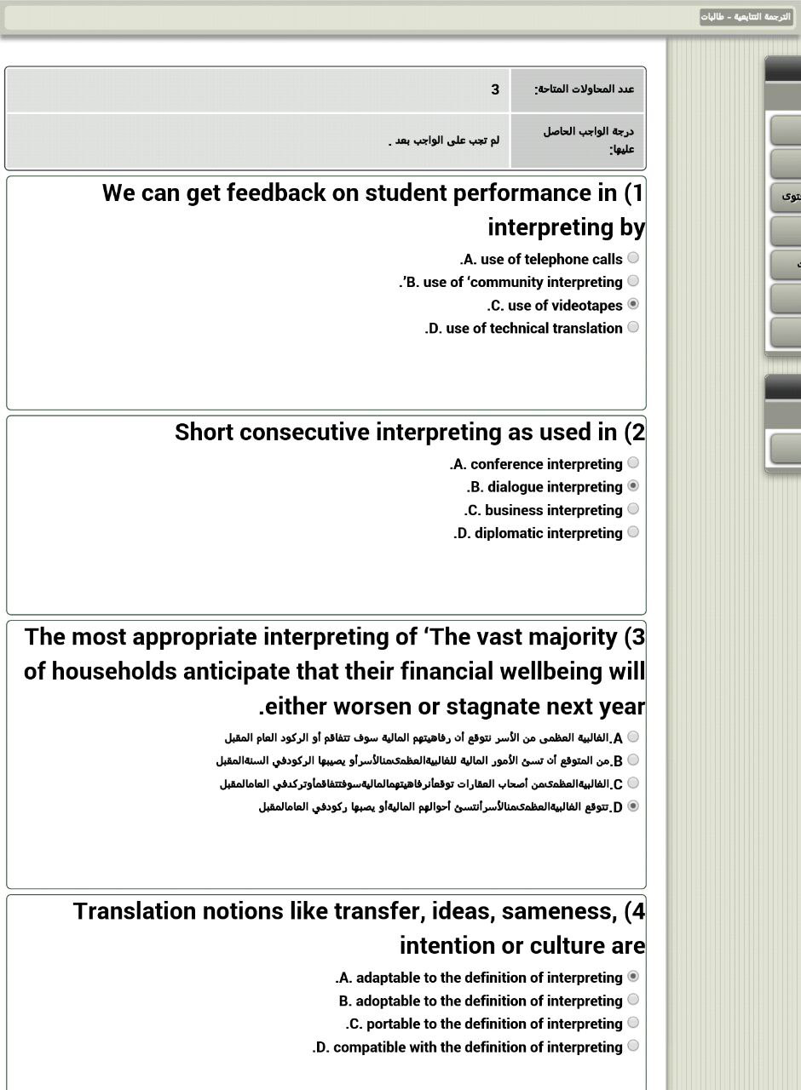

تحليل الخطاب الواجب الاول
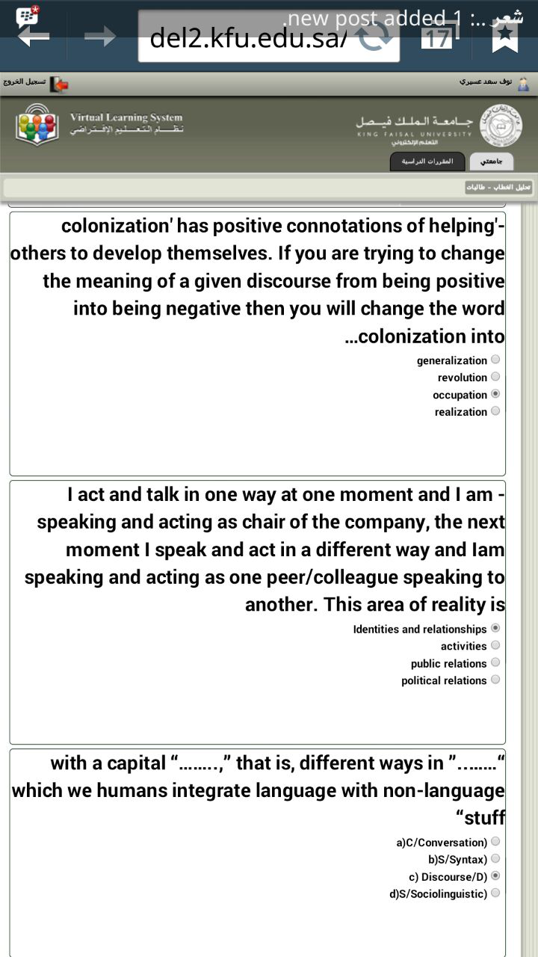

الواجب الثاني
- 1-Lots of interesting complications can set in when we think about identity enacted in and through ……... Whos can be multiple and they need not always be people
(a)language
(b)discourse
(c) linguistics
(d) identity
2-for “real Indians,” any conversation they do have with a stranger who may turn out to be a “real Indian” will, in the discovery of the other’s “Indianness,” establish substantial obligations between the conversational partners just through the mutual acknowledgment that they are “Indians”
(a)obligations
(b)conversations
(c)relations
(d) interrelations
3-The key to Discourses is “recognition.” If you put language, action, interaction, values, beliefs, symbols, objects, tools, and places together in such a way that others recognize you as a particular type of who (……) engaged in a particular type of what (…….) (a)identity/identity two
(b)activity/work
(c) identity/activity
(d) people/ranks

الواجب الثالث
