English Language Essay

^{7th} Class
Cause & Effect Essay

What is a Cause and Effect Essay?
*A Cause and Effect Essay provides reasons and explanations for events, conditions, or behaviors.
* It involves tracing probable or known effects of a certain cause or examining one or more effects and discussing the reasonable or known cause(s).

Intro : Cause and Effect
* Cause and Effect analyzes why something happens.
* Some effects are caused by multiple causes.
- Some causes, in turn, can result in multiple effects.
Every event has a cause and every cause has a result.

Hint: Cause and Effect
* In this unit, you will look at the situation (effect) and examine the reasons (causes) for it.
* Usually there are more than one reason for the situation.
* When there are many reasons, there is usually one that is most important.

Remember !!!
Remember the following points when you write about the causes of an effect:
- Look at the possible causes and discuss them.
- Support all the causes. Give good examples.
- State your most important cause list. This will make your essay m ore interesting.

Understanding the Assignment
* Cause and Effect Essay assignments typically use the following language:
"What are the causes of X?"
"What led to X?"
"Why did X occur?"
"Why does X happen?"
"What would be the effects of X?"
Example: Define recession and discuss the probable effects a recession would have on American society.

Transitions
* Transitions for showing cause: because and as

- Because and as introduce a reason clause. They both answer the question “why?” Both because and as can bу used at the beginning of the sentence or in the middle.
* Use a comma after the reason if you start the sentence with because and as.

Two Ways of Organization:
* There are two ways to organize a cause-and-effect essay: block organization and chain organization.
* Some topics work better when organized in block, while others work better when organized in a chain. If the causes and effects are closely related, it id s better to use a chain organization.

First Type: Block organization

You discuss all of the causes in one block (one, two or three paragraphs, depending on the n umber of causes). Then you discuss all the effects in another block.

Cause-and-Effect Structure Words
Cause structure words:
the first reason is, the next cause, because
Effect structure words:
the first effect, as a result, consequently
Note: use a semicolon before and a comma after consequently and therefore.
Transition Paragraph
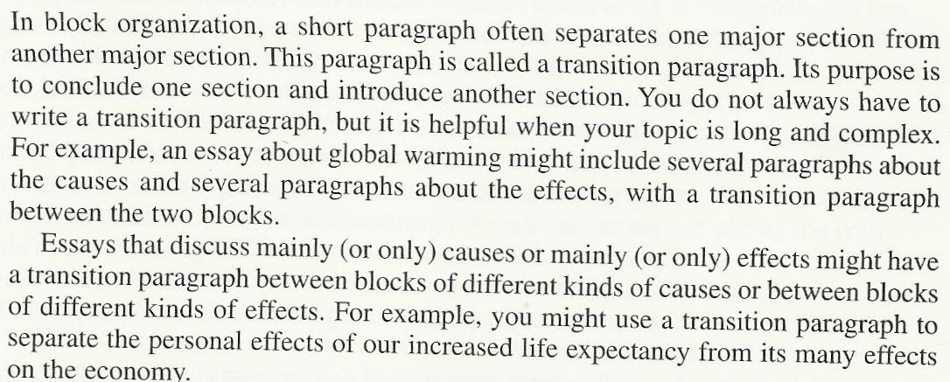

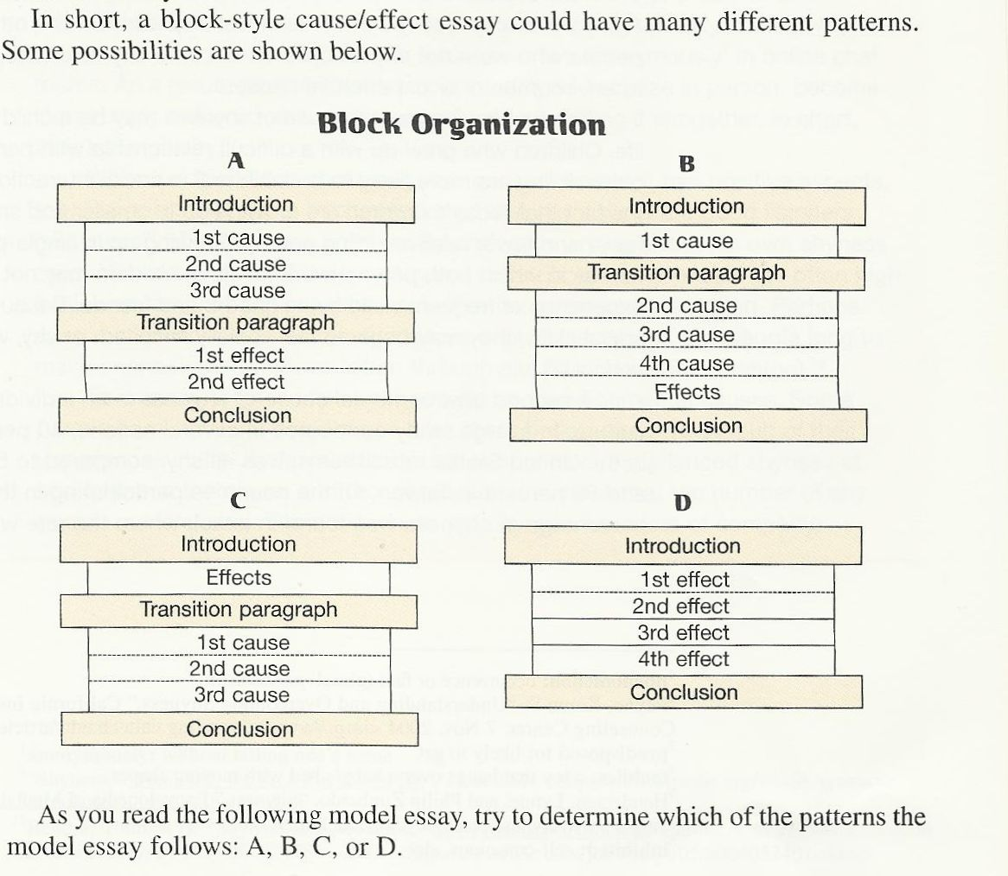

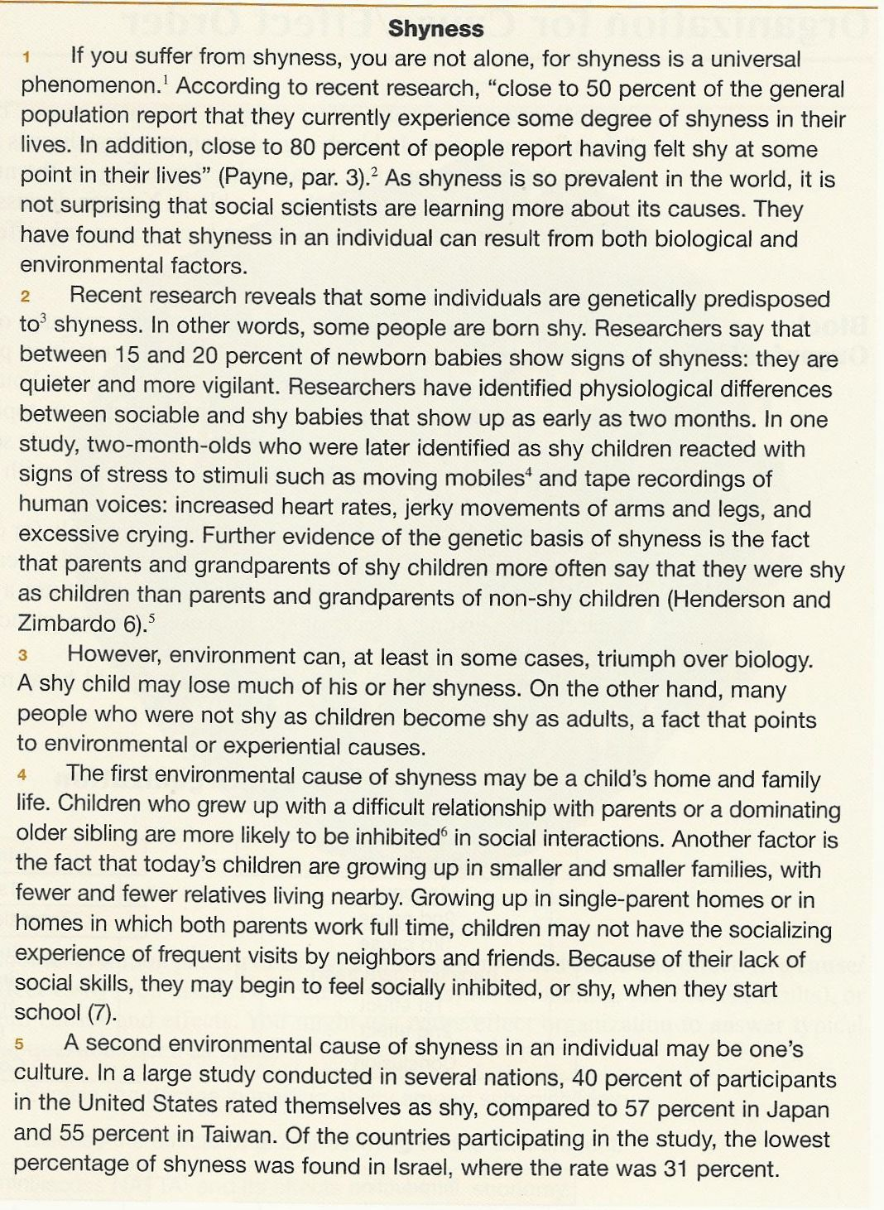

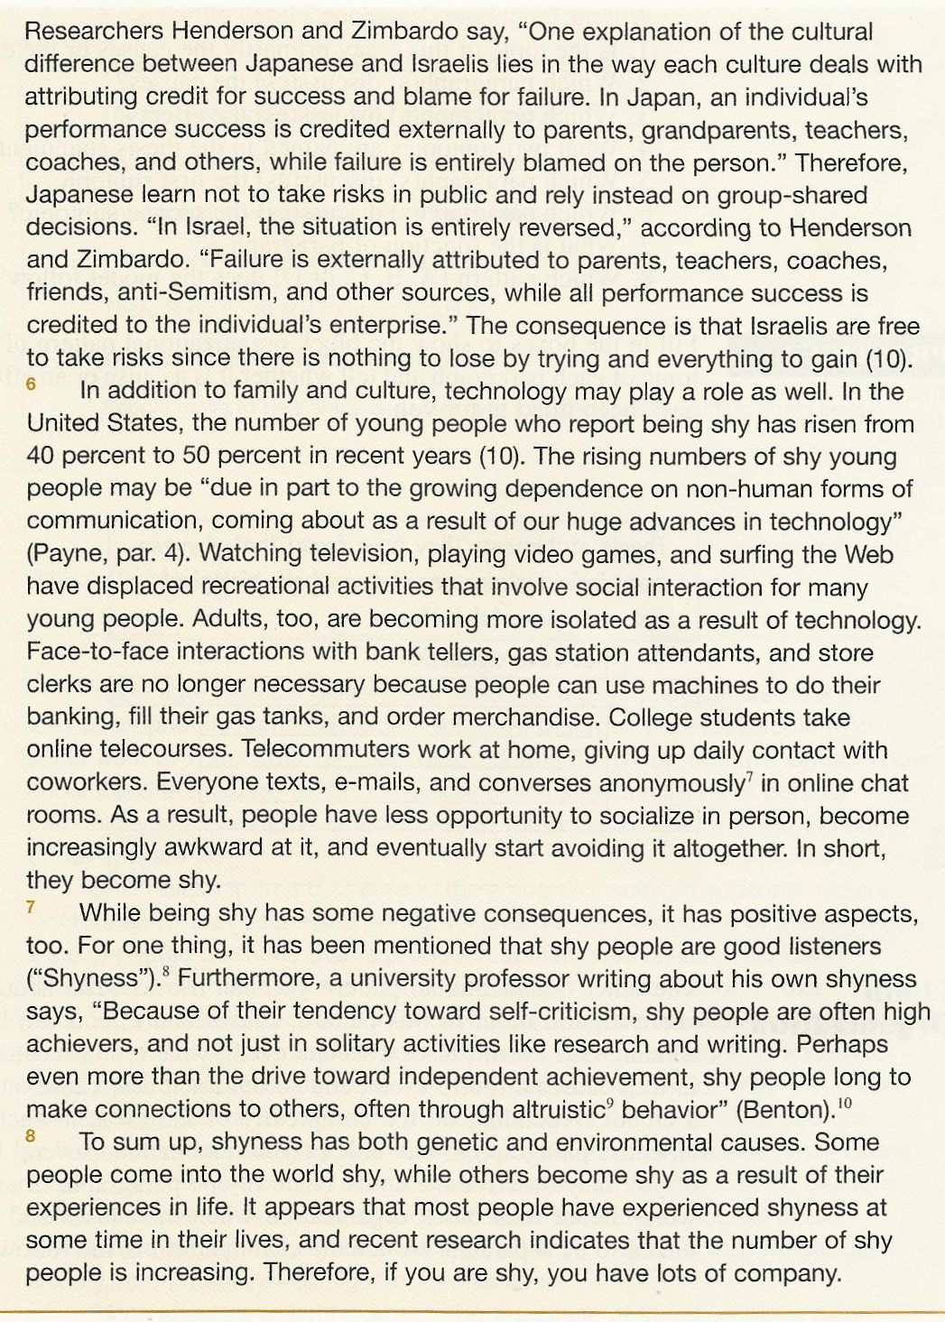

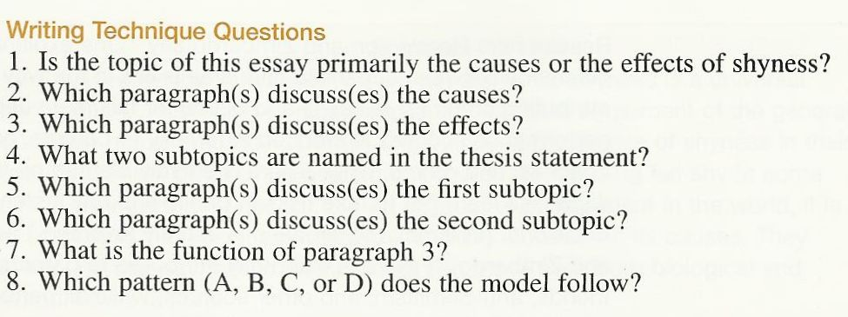
The Answers:
1. It discusses mainly the causes of shyness.
2. Paragraph 2, 4, 5, and 6
3. Paragraph 7
4. (1) biological and (2) environmental factors.
5. Paragraph 2
6. Paragraphs 4, 5, 6
7. Paragraph 3 is a transition paragraph. It divides the biological from the environmental causes
8. Pattern B
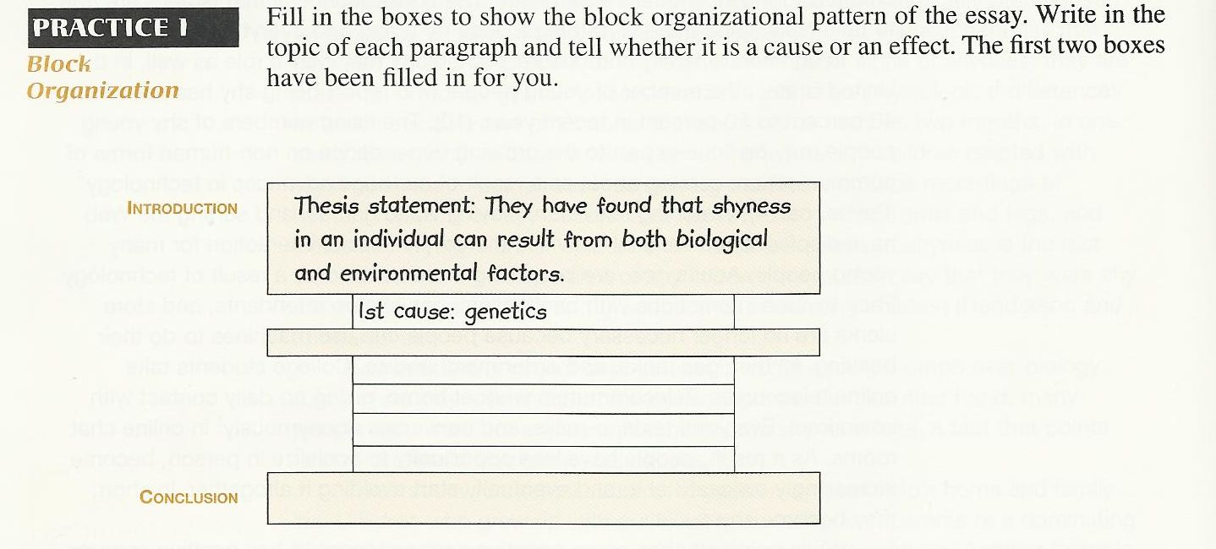

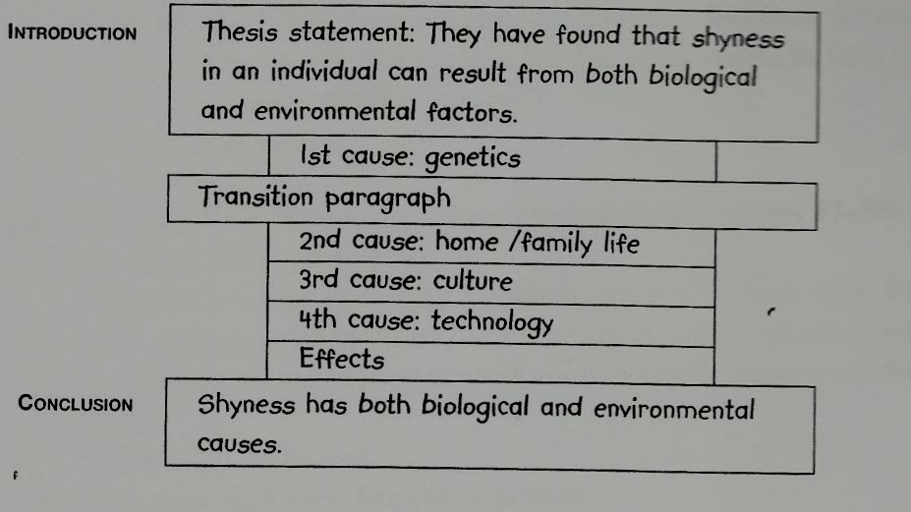
Second Type: Chain organization
You discuss a first cause and then the effect, a second cause and its effect, a third cause and its effect, and so on.
Notice the Chain Organization
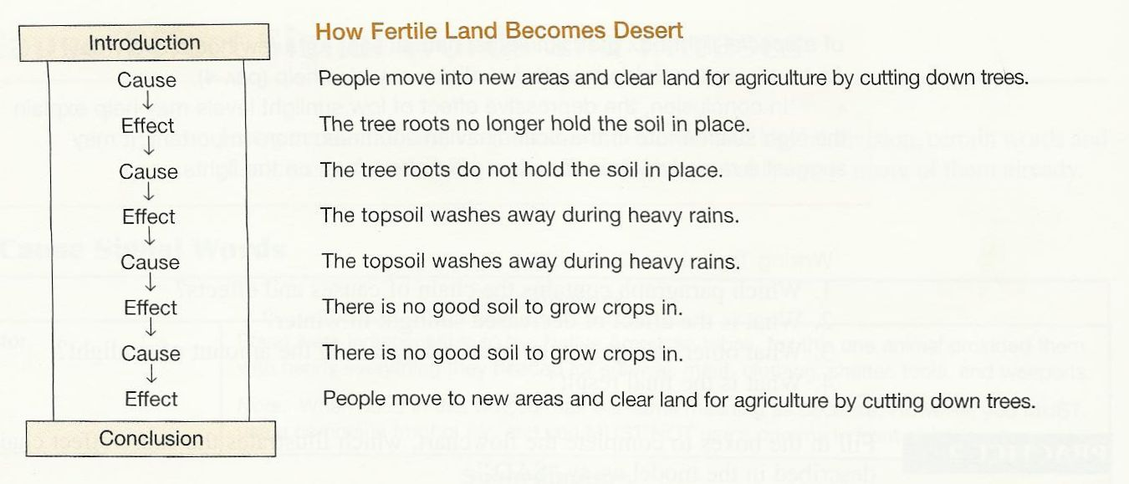

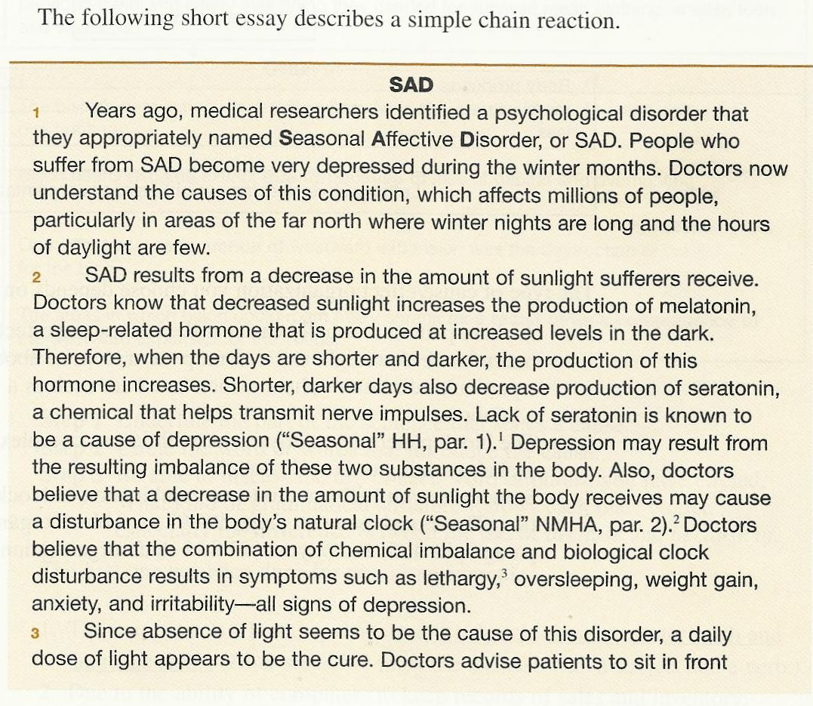
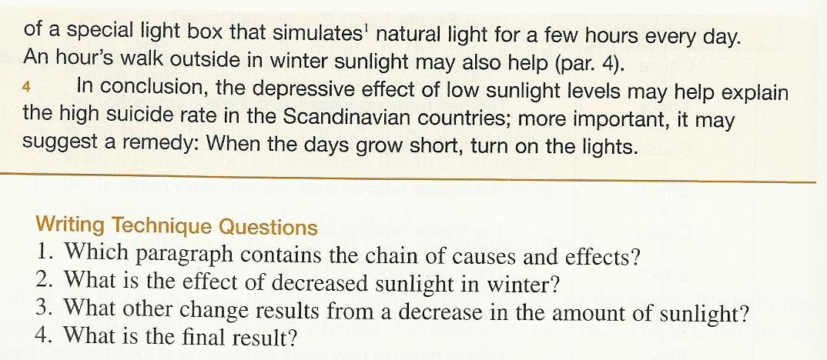

The Answers:
1. Paragraph 1
2. Chemical imbalance.
3. Disturbance in the body’s natural clock.
4. Lethargy, oversleeping, weight gain, anxiety, and irritability – all signs of depression

With my best regards
~Mrs.ENGLI$H~

`

