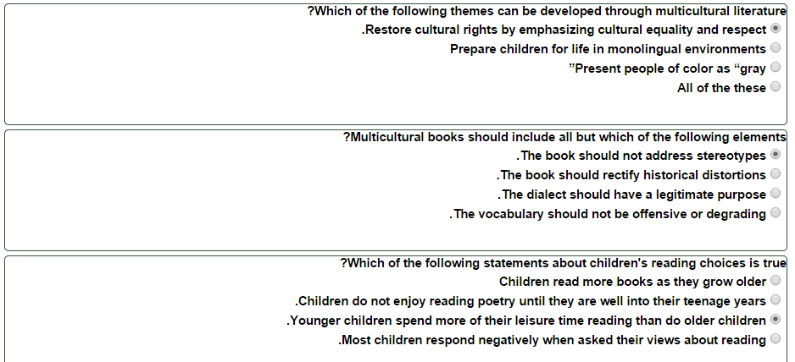

Researchers who investigated children's preferences in poetry concluded that_________.
Children enjoy poems about familiar experiences
The repetition of vowel sounds by a poet to create interesting and unusual sound patterns is called ___________.
Assonance
Which of the following primary elements in poetry encourages children to see, hear, feel, taste, smell, and touch the worlds created by poets?
Imagery
Which of the following poets is usually NOT considered a children's poet?
. Langston Hughes

