KING ABDULAZIZ UNIVERSITY
DEPARTMENT OF EUROPEAN LANGUAGES

LANE 215 FINAL EXAMI EXTERNAL STUDENTS
A

PART ONE : READING CONVERSATION
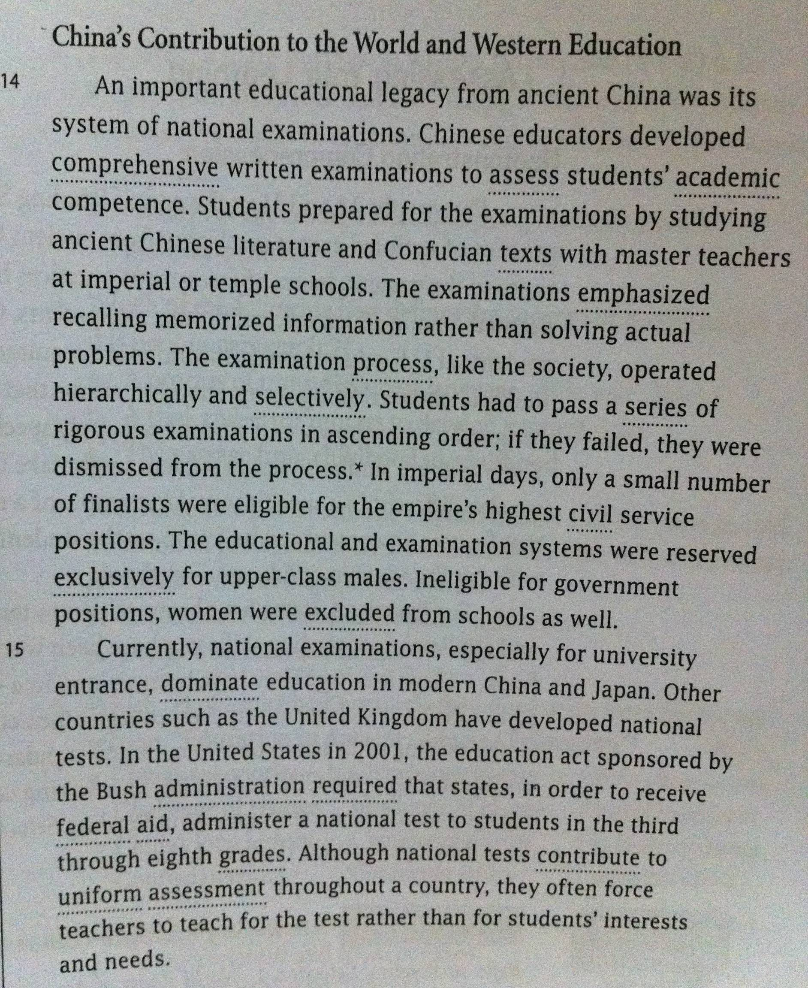
A. READ THE FOLLOWING SELECTION, THEN ANSWER THE QUESTIONS BY CIRCLING THE CORRECT CHOICE ON YOUR ANSWERING SHEET .

1. Paragraph 15 addresses the use of national exams. The last sentence of this paragraph reveals a bias. Witch of the following assumptions most influenced the writer in this selection ?
- Teachers should "teach for the test." .
- Teachers should base their teaching on student needs and interests .
- Teachers should support national tests .

2. paragraphs 14 and 15 discuss the practice of national exams as a legacy from ancient China .
- TRUE b. FALSE

3. In imperial days, women were allowed to work for the government.
- TRUE b. FALSE

4. The test focused on solving problems.
- TRUE b. FALSE

5. National tests in the U.S.A are mandatory for some grades.
- TRUE b. FALSE

6. In the imperial days, key position in the government were kept for those who scored the highest score in their test.
- TRUE b. FALSE

7. The educational and the examination systems were available for every male in the imperial China.
- TRUE b. FALSE

8. Students had to pass a list of tough tests from difficult to less difficult order.
- TRUE b. FALSE

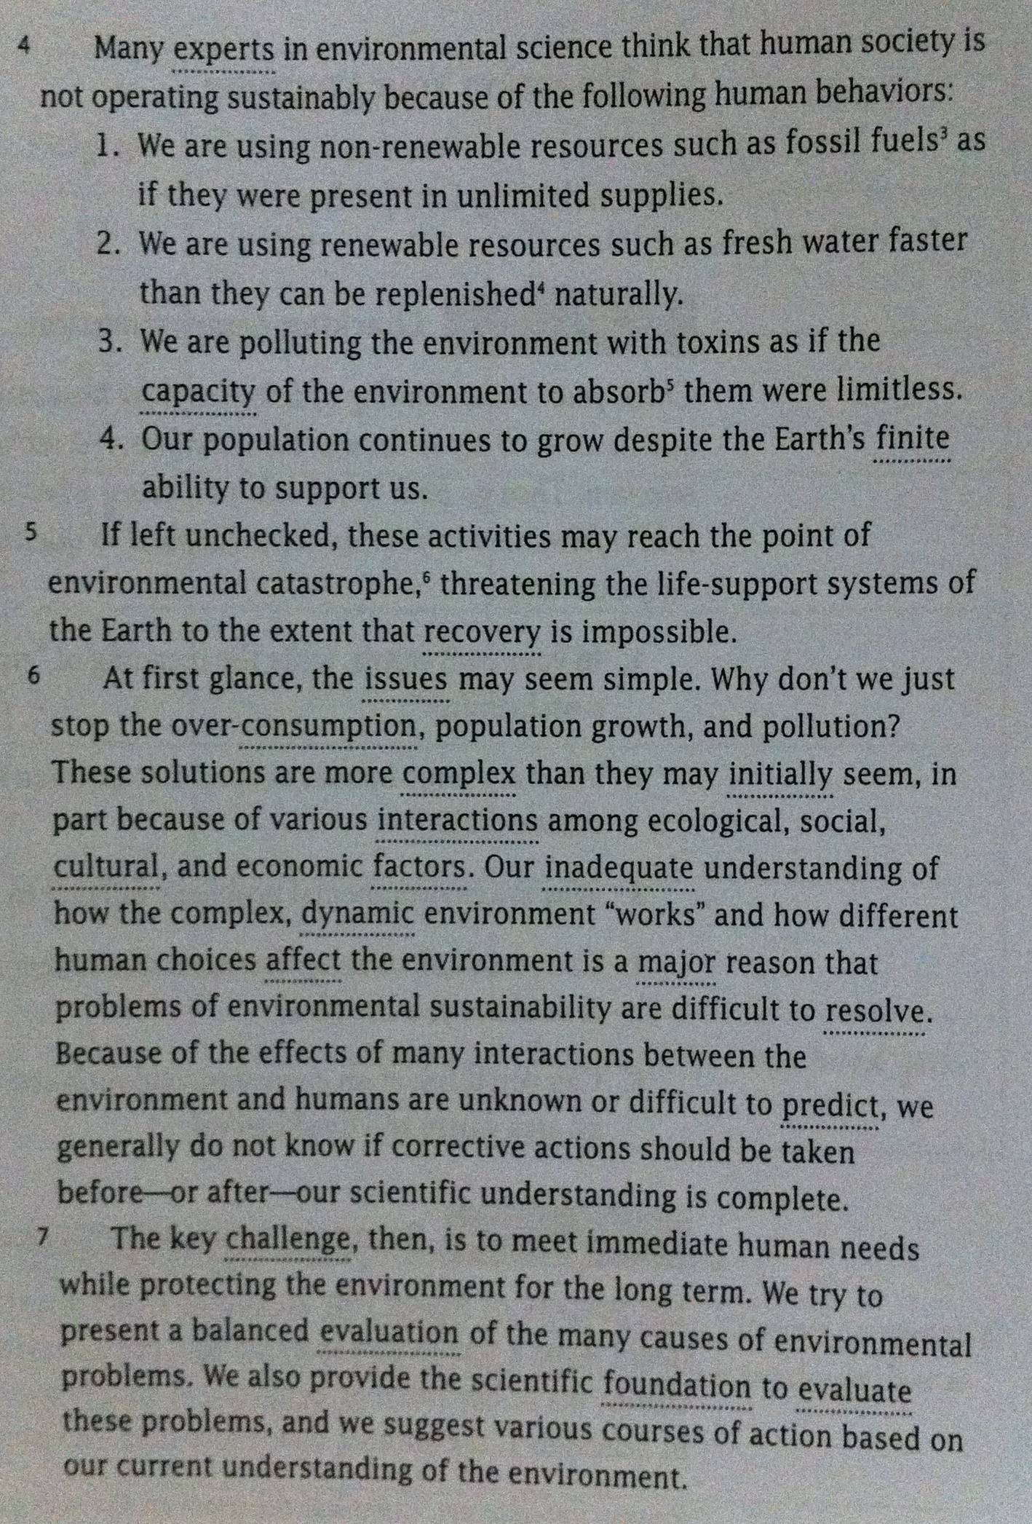
B. READ THE FOLLOWING SELECTION, THEN ANSWER THE QUESTIONS BY CIRCLING THE CORRECT CHOICE ON YOUR ANSWERING SHEET .

9. Many experts believe that sustainability is working well in human society.
- TRUE b. FALSE

10. Renewable resources such as fossil fuels are present in unlimited supplies.
- TRUE b. FALSE
11. The ability of the environment to absorb the toxins were limitless.
- TRUE b. FALSE
12. The earth population grows despite the earth limitless ability to support us.
- TRUE b. FALSE
13. It is easy to stop over-consumption.
- TRUE b. FALSE
14. Inadequate means :
- GOOD b. BAD c. ENOUGH d. NOT ENOUGH
15. It is hard to predict the interactions between the environment and human beings.
- TRUE b. FALSE
16. Catastrophe means :
a. A MAJOR DISASTER b. A MINOR DISASTER c. AN AVERAGE DISASTER

C. Match each cited source with the correct theory, study or ideas associated with the researchers. You will need to read the paragraph in the box below the table in order to do this.
 | Cited Sources | Associated Research Theme
17. | Tulving, 1993 | Implicit memory and _  A. problem solving .  B. ads.  C. amnesia.  D. self concept .
18. | Jacoby, Marriot, & Collins, 1990
19. | Nelson, 1993
20. | Duke & Carlson, 1993

Psychologists are now studying the role of implicit memory (and disassociations between explicit and implicit memory) in such important psychological phenomena as amnesia (Schacter, Church, & Treadwell, 1994; Tulving, 1993), depression (Elliot & Greene, 1992), problem solving (Jacoby, marriot, & Collins, 1990), prejudice and stereotyping (Fiske,1998), the development of self-concept in childhood ( Nelson, 1993), and even the power of ads to associate brand names with good feelings ( Duke & Carlson, 1993), The results of these studies shed new light on implicit memory and how it operates in the real world. (Source: Bernstein et at, 2000)

D. Match each step of the scientific method with the correct example.
 | Scientific Method Step | Associated Action
21. | Hypothesis | - The Lake Washington Project can serve as successful example for other communities.  - Lake decline could be reversed if pollution were stopped . (If additional phosphorus was not introduced into the lake from sewage effluent, the lake would slowly recover.)  - Observe what happens. The hypothesis proved true. The lake water returned to normal by 1975 and by 1980 was even cleaner.  - Build a ring of sewers around the lake to collect sewage discharge, and treat and transport it to the Puget Sound, away from Lake Washington.
22. | Experiment
23. | Analysis
24. | Share Knowledge

PART TWO : VOCABULARY
A. Each of the statements below supports a Muscle Reading step. Select the correct step.

25. "One study revealed that corporation presidents usually wear out the front of their chairs first."
a. outline b. read c. recite d. review

26. "One classic study suggests that you can profitably devote up to 80% of your study time to active reciting."
a. question b. answer c. recite d. review

27. "A review within 24 hours moves information from your short-term memory to your long-term memory."
a. question b. answer c. recite d. review

28." One of the characteristics of memory is that even when you cannot recall something immediately, you can relearn it more easily if you have already learned it once."
a. outline b. read c. recite d. review

B. Find the meaning of the bold words :
29. Shade each section of discovery wheel to the appropriate level.
a. approved b. similar c. highest d. accurate
30. I have adequate time each day to accomplish what I plan.
a. finish b. assemble c. further d. reach
31. I apply techniques that enhance my memory skills.
a. control b. strengthen c. change d. ensure
32. I can recall information when I am under pressure.
a. find b. review c. remember d. connect
33. I am aware of my cultural biases and open to understanding people with different backgrounds.
a. viewpoints b. conditions c. forms d. knowledge
43. I am candid with others about who I am, what I feel, and what I want.
a. insecure b. shy c. positive d. truthful
C. Circle the correct choice on your answering sheet :
35. As investigators tried to find out what prompted Weston's deadly attack, it ___________ that he had been diagnosed in 1996 as a paranoid schizophrenic.
a. concluded b. emerged c. estimated d. undertook
36. Do all mental patients _____________ a similar threat to the society?
a. acquired b. welfare c. pose d. variable
37. ____________ people retain a great deal of information, they also lose a great deal.
a. estimated b. released c. concluded d. whereas
38. Memory plays a critical ___________ in your life .
a. aware b. role c. pose d. style
39. The pharaoh was at the summit of the Egyptian social ____________ .
a. diversity b. debate c. furthermore d. hierarchy
40. Humanity must meet present needs without endangering the ___________________ of future generations.
a. resolve b. welfare c. stable d. intense

