Psycholinguistics

Dr. Mohammad Almoaily


Textbook
1
Fundamentals of Psycholinguistics Author:
Eva M. Fernandez and Helen Smith Cairns Publisher:
WILEY-BLACKWELL (2011)

Introduction
Content:
- What is psycholinguistics?
- Some disciplines related to psycholinguistics.
- Exemplary questions in the field of psycholinguistics.

Psycholinguistics
What is psycholinguistics?
“Psycholinguistics is an interdisciplinary field of study in which the goals are to understand how people acquire language, how people use language to speak and understand one another, and how language is represented and processed in the brain”
(Fernandez and Cairns, 2011, p.1)
Some disciplines related to psycholinguistics:
- Phonetics
- Discourse analysis
- Language pathology (e.g. speech therapy)
- Neuroscience
- Language teaching Exemplary Questions in psycholinguistics
- How are words and word meanings represented in someone’s mind?
- How are sentences composed in someone’s mind at the time of speech?
- How are words and sentences and their meanings analyzed at the time of listening or reading? For example, we may ask:
How language is processed by the brain?
- Language perception (listening and reading).
- Language production (speaking and writing).
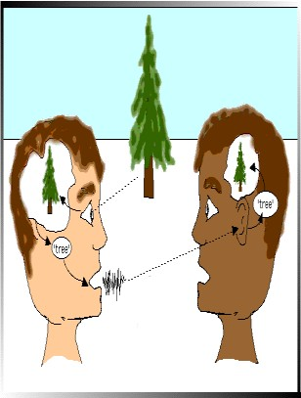

Picture references
- https://sites.google.com/site/wuhpnet/psycholinguistics

Content:
Lecture 1 Beginning Concepts

- Language vs. speech, thought and communication
- Signal and meaning
- Linguistic Creativity
- Prescriptive vs. descriptive grammar 2
- Linguistic competence vs. linguistic performance

Language, thought, and communication
Is the term language synonymous to the term speech?
No! Speech is one form of language. There are other forms such as writing and signals (i.e. sign language). What about thought, is it synonymous to the term language?
No! There are individuals (e.g. infants) who can think but cannot produce language.
Similarly, we can ask: are the terms language and communication synonymous?


“Language is the primary communication system for human beings, but it is not the only way to communicate” (Fernandez and Cairns, 2010, p.6)

Signal and meaning
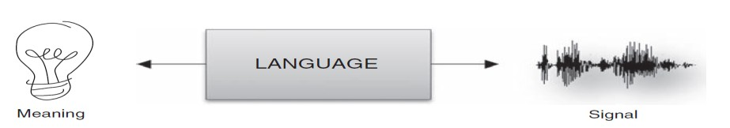
/hɔrs/ (horse)

Linguistic Creativity
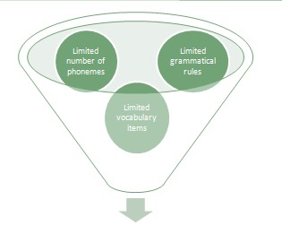
  - Unlimited number of linguistic utterances

Prescriptive vs. descriptive grammar
Prescriptive grammar provides a “prescription” (i.e. how language should be used) “People who teach language are interested
in teaching a standardized use of language, the form of a language that
is accepted in academic and business circles” (Fernandez and Cairns, 2010, p. 9)
Descriptive grammar describes how a certain language is actually used by its native speakers For example: Me and Nasser went to Dammam
is accepted by a descriptive grammarian, but not by a prescriptive one.

Linguistic competence vs. linguistic performance
- Linguistic competence is the linguistic knowledge that provides a system for pairing sound and meaning (i.e. the ability of linking words with their meanings).
- Linguistic Performance is the use of such knowledge (i.e. linguistic competence) in the actual processing of sentences.
- Error vs. mistake 3

References
  - Fernandez, E.M. & Smith Cairns, H. (2010) Fundamentals of Psycholinguistics. Wiley-Blackwell
Lecture 2

Methods of Psycholinguistic Research (I)

Contents

    - Important facts
- Language processing is subconscious. 4
- Often, language processing is not observed physically.
    - How to analyse language processing?
1. Slips of the tongue

Important Facts I

1. Language processing (i.e. language production and language perception) is subconscious:
When reading an English text, do your eyes move continuously or move with slight pauses?
While reading, your eyes do not move smoothly from left to right. If you were unaware of this fact, this is because language processing is subconscious!
Important Facts II

- Since language processing is a mind-internal process, it is mostly not physically observable.
For example, we cannot see how does the mind combine words to produce sentences?
To overcome this predicament (i.e. hidden language processing), psycholinguists GUESS the hidden mental process by analyzing the observable behavior.


How to observe hidden linguistic processes?

  - Slips of the tongue (morphemes & the mind)
  - Vocabulary experiments (e.g. lexical decision, the priming paradigm).
  - Timed-reading experiments
  - Event-related potentials.

Slips of the tongue & Spoonerisms

Examples
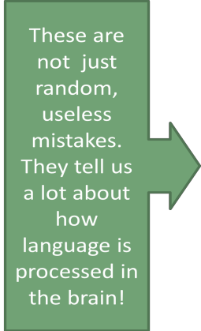
Slips of the tongue involve: exchanging morphemes within a sentence

Intended: Bad salad
Produced: Sad ballad Intended: I’d forgotten about that Produced: I’d forgot aboutten that Intended: easily enough
Produced: easy enoughly
So what do slips of the tongue tell us about the brain and language processing?


5

They tell us that
- We plan our speech before uttering it.

- Morphemes function independently from words during sentence planning. Intended: rules of word formation
Produced: words of rule formation

Reminder
Lecture 3
Psycholinguistic Research Methods II

Vocabulary Processing

Language processing is mind-internal and thus cannot be seen/observed. Therefore, psycholinguists
analyze linguistic behavior instead. 6

Contents

How are vocabulary items organized in the mind?
- The tip of the tongue phenomenon:
  - What does it mean?
  - What explanations does it offer?

How are entries (i.e. words) organized in the mind?

Lexical items are organized alphabetically in a dictionary, in the brain, however, vocabulary items are organized differently.

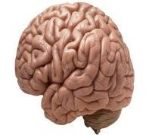

VS
It was on the tip of my tongue!
Have you been in a situation where you could remember the meaning of a word, its sound, its first letter, or other words it rhymes with, but could not remember the word you were looking for?

Tip of the tongue definition:
Remembering some details about a word, but not the word itself.

It was on the tip of my tongue!
Similarly, have you been in a situation where you could remember some details about a word you came across, but you were not sure what does the word mean?
(e.g. eagle: bird + predator)

Why does the tip of the tongue phenomenon often happen to us?
Lexical entries are grouped in the brain as a complex network, according to their sound and meaning.

How does the mind organize entries (i.e. lexical items)?
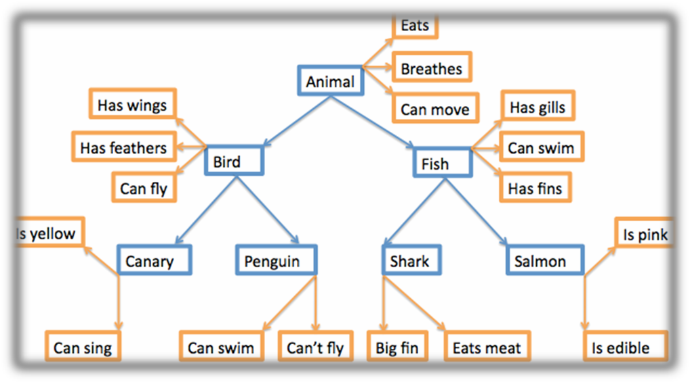

Vocabulary experiments
Lexical decision and priming are two experiments which help us understand:

How are entries (i.e. words) linked together?
How are entries accessed? 7
What information is contained in an entry?
These two experiments are going to be discussed in detail in the upcoming lecture…

Exercise
Choose the right item:
In psycholinguistics, one thing we can learn from the tip of the tongue phenomenon is that:
- Lexical entries are easy to forget
- Lexical entries are organised alphabetically in our mind
- Entries are grouped in the mind (e.g. according to their meaning and sound)
- Entries are stored independently in the mind
The answer is (c). You may need to view this lecture again if you did not choose the right answer!

Contents
Lexical Decision Experiment Priming Experiment
Lexical Decision Experiment
Lecture 4

Psycholinguistic Research Methods III Vocabulary experiments

8



Lexical Decision
A lexical decision experiment is conducted by asking a native speaker to sit in front of a computer screen where he/she is asked to judge as quickly as possible whether the word that appears on the screen is a real word or not.

If the word is real the participant clicks “yes”; if not, the participant clicks “no”.

What is the purpose of lexical decision experiments?
What we are looking for in this task is:
Response latency: and that is the time it takes for the a participant to respond “yes or no”.
Response accuracy: and that is whether or not the participant responded accurately.

Details
When designing this task, the participants are usually tested on one set of stimuli against another set of stimuli. For example:
“Nouns” vs. “Verbs”. “concrete words” vs. “abstract words”
This test measures the speed and accuracy in which the mental lexicon is accessed.

Interesting findings
It has been found that it usually takes participants about a half a second to press “yes” for word they
know or frequently used words. However, it takes three-quarters of a second to press “yes” for less common words. This is commonly known as the frequency effect.

What we can infer from this is that our mental lexicons are probably organized in a way that words we use often are more easy to access.

Priming
Priming can be considered as an extension of lexical decision task. However, in this task before the participant is asked to choose “yes” or “no” the target word is preceded by another stimulus (called the prime). What is measured is the extent the prime influences the participant’s lexical decision on
the target stimuli.
Prime (e.g. bird) → stimulus (e.g. pigeon) → Yes/no

When the target is preceded by a related word the response is usually quicker.

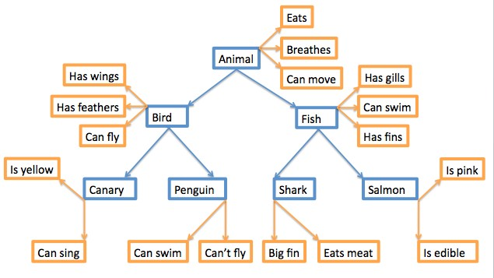 9
(Picture 2)

References
(picture 1): http://tcho.hanyang.ac.kr/images/HPPL_Perception_booth.gif

(picture 2):
http://upload.wikimedia.org/wikipedia/commons/c/cb/Hierarchical_Model_Mental_Lexicon.png

Exercise
Response latency is:

  - The time it takes the respondent to complete a lexical decision task
  - The Accuracy of the respondent’s answer
  - Deciding that the stimulus is an English word
  - Deciding that the stimulus is not an English word
The answer is (a)
Lecture 5

The Biological Basis of Language

Contents:
- Lenneberg’s criteria for determining whether a communication system is based in the biology of a species or not.
- How language is based in the biology of humans?

Lenneberg’s criteria for determining whether a communication system is based in the biology of a species or not

  - The communication system has to be species specific (e.g. lion roars are only understood by species of the same type).
  - The communication system has to be universal to all members of the species.
  - Certain aspects of behavior and cognitive function for the system emerge only during infancy
  - Adaptation of the behavior of the growing individual to the behavior of other individuals around him.

Now let us see if Lenneberg’s criteria apply for the human language How language is based in the biology of humans?
- Language is species specific:
  - Animals cannot talk and they cannot be taught a human communication system

Language is universal
  - infants are genetically prepared to acquire language
  - all human languages have universal properties (e.g. all languages have phonology, morphology, and syntax)

There is an age restriction for acquiring the first language
  - Critical period: linguistic competence of the first language can only be achieved if the language is learnt before puberty

How language is based in the biology of humans?

- Language development is triggered by the environment Children will not ACQUIRE language if:
  - It is not accessible in their environment
  - There is nobody to interact with them

Exercise

10

Language is based in the biology of humans, because:

    - Language is species specific
    - There are universal aspects of language
    - There is an age restriction for acquiring the first language
    - All of the previous items are correct
The answer is (D)

Lecture 6

Neurolinguistics

Contents:

- What is Neurolinguistics?
- How can aphasia tell us about the representation of language in the brain?
- Language lateralization

Neurolinguistics:

Neurolinguistics is the study of the representation of language in the brain.

How does the brain look like?
Which hemisphere controls language?

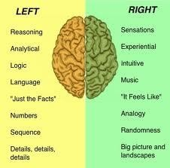

What happens to language if there is a damage in the left hemisphere of the brain?

It can lead to aphasia: language impairment caused by brain injury.

Aphasia:

There are two types of aphasia, depending on the damaged area of the brain:

11

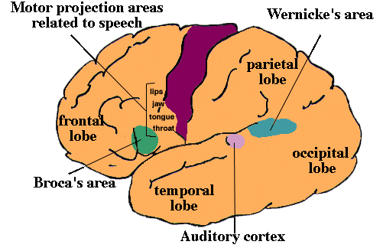

Broca's aphasia is also known as non-fluent aphasia.
Is characterized by halting, effortful speech; it is associated with damage involving Broca’s area in the frontal lobe of the left hemisphere.

Wernicke's aphasia is also known as fluent aphasia.
Is characterized by fluent meaningless strings; it is caused by damage involving Wernicke’s area in the temporal lobe of the left hemisphere.

12

Language lateralization:
Contra-lateral control:

The left hemisphere of the brain controls the right side of the body, and vice-versa

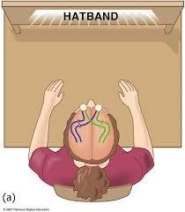

How can this affect language? Handedness:
For the majority of people, language is in the left hemisphere (this is why the majority of people are right- handers)
Some people, however, language is in the right side (left handers)

Lecture 7

The Acquisition of Language (1)

Contents:

Language Acquisition Device (LAD)

- Early Stages of Language Acquisition:
- Before birth to 12 months
- 12 months to 24 months
- The pre-school years

Language Acquisition Device (LAD):

LAD can be defined as: a property of the child’s brain that gives it a tendency for acquiring language

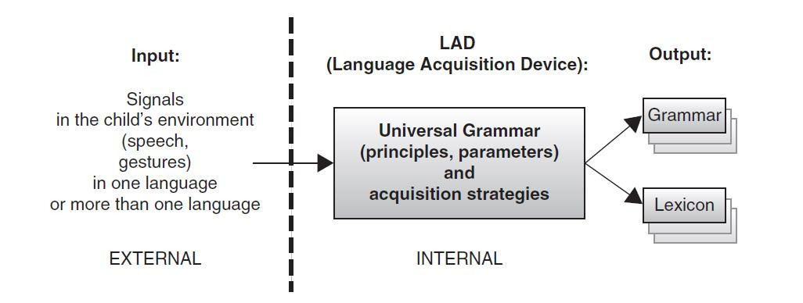

Early Stages of Language Acquisition:

- Before birth to 12 months: Before birth:
- Hearing begins to develop at around 18 weeks
  - Soon after the development of hearing, the fetus starts to respond to auditory stimulation.
  - Hence, it can be argued that humans’ sensitivity to language start even before birth

From birth to 12 months:
- Infants have had access to the general prosody (the rhythm and intonation) before they were born
  - Thus, they are able to recognize their mother’s voice
  - Most children start to discriminate many phonemic contrasts at this stage
  - - Newly-born infants have had access to the general prosody (the rhythm and intonation) before they were born
  - Thus, they are able to recognize their mother’s voice
  - Most children start to discriminate many phonemic contrasts in this period (before they are 12 months old)
  - Babbling: Infants start to babble (i.e. produce consonant-vowel strings) after the 6th month.

From 12 months to 24 months:
  - Children spend a few months in the holophrastic stage (one-word stage). One word, such as milk, can be used to convey the meaning of an entire phrase.

13

Pre-school years:
Vocabulary spurt: Soon after the child leaves the holophrastic stage, vocabulary acquisition speeds up rapidly.
In average, the child acquires from 4 to 8 new words everyday in his/her pre-school years.

Exercise

14

The holophrastic stage is:

      - Before birth
      - Between birth and 12 months
      - Between 12 months and 24 months
      - After 24 months The answer is C

Lecture 8

The Acquisition of Language (2)

Contents:

Later Stages of Language Acquisition
  - Discourse ability
  - Meta-linguistic awareness

Second Language Acquisition

Later Stages of Language Acquisition:

- Discourse ability
- Children can take turns in conversations and maintain a topic over a limited number of conversational turns
- People acquire a mature ability to converse for the exchange of information in late childhood
- Communication skills are mastered at different ages…
- Difference in communication skills can also be found across adult speakers of a language.

Meta-linguistic awareness
In a later stage of language acquisition, people become aware that language is not just a means of communication, but also an object (e.g. the ability to perceive speech as a string of phonological units).

Second Language Acquisition:

- There are similarities between first and second language acquisition (e.g. the stages of the acquisition of bound morphemes).
- Yet, there are limitations to SLA such as:
- Slower pace of acquisition, as compared to first language acquisition.
- Ultimate attainment

Exercise

15

People start to develop discourse ability in their late childhood, this includes:

- Taking turns in conversations
- Crying to express anger
- Laughing to express joy
- None of the previous is correct The answer is A

Contents:
Lecture 9

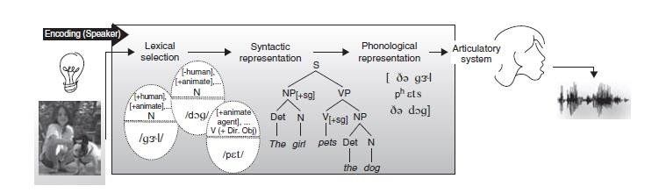
Speech Production

16

Bilingual Speakers’ Production
- Planning Speech
  - Accessing the lexicon
  - Building simple sentence structure
  - Creating agreement relations
  - Building complex structure
  - Preparing a phonological representation

Producing Speech
  - Actual production of speech

Bilingual Speakers’ Production:
Unilingual vs. bilingual modes:

unilingual mode (only one language):
consulting only one of the grammars leads to production in one of the two languages.

bilingual mode
When the bilingual’s two languages are being used in the same conversation, the speaker has access to both grammars and lexical items from both languages. This may lead to code-switching (switching between two languages in one conversation).

Stages of Speech Production:

Speech production has two main stages:

- Planning
- Actual production

Stages of Speech Production (Planning): 1- Accessing the lexicon (lexical retrieval)
A word can be retrieved using two kinds of information: meaning or sound. The speaker selects the appropriate word to the conversation.

Building simple sentence structure:
Grammatical encoding: Building a linguistic structure for the intended meaning.

Creating agreement relations:
E.g. Subject-verb agreement .

Building complex sentence structure:
Creating complex, multi-clausal sentences

Preparing a phonological representation
The mental representation of a sentence that serves as input to the systems responsible for articulation (speech, writing, or gestures) is phonological.

Stages of Speech Production (actual production):

After the speech is planned, the brain gives instructions to speech organs (tongue, lungs, vocal tract) to produce speech

Exercise

17

Lexical retrieval is:

  - A stage in language perception
  - A stage in language production
  - A vocabulary experiment
  - None of the previous is correct The answer is B

Contents: Perceiving Speech
Lecture 10

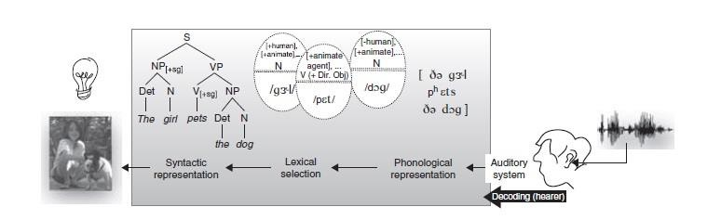
Speech Perception

- The phonemic inventory and speech perception
- Constructive speech perception
- Bottom-up and top-down information
- Suprasegmental information in the signal

18

The Role of Orthography Perceiving Speech
  - The phonemic inventory and speech perception:
Knowledge of the phonemic inventory of a language is necessary for perception. This explains why is it easier for beginning language learners to understand material with subtitles.

Constructive speech perception:
The perception system is constructive because it uses additional information to the signal, such as lip movement, in the perception of speech.

Bottom-up vs. top-down processing: Bottom-up processing:
Using the acoustic signal (i.e. phonemes) to understand speech.

Top-down information:
Using contextual information to understand speech. (e.g. sandstorm.. “…. …. … windows”).

Suprasegmental information in the signal:
Variations in duration, pitch, stress, and amplitude (loudness) can affect speech perception. Compare: Trustee with trusty

The Role of Orthography in perception (while reading):

Orthography is the writing system of a language.
Researchers have found that phonology and orthography play an important role in the perception of written texts.
For example: French learners of English have difficulties identifying the phoneme /p/ in words like absurd
than lapsus

Exercise

Knowledge of the phonemic inventory of a language is:
- Not necessary for perception
- Necessary for perception
- Necessary for production
- Both B and C The answer is D

19

Lecture 11

Speech Perception (Lexical Access)

Contents

Recap
Possible vs. impossible words Morphemes
Cohort model of Lexical Access

20

Recap from lecture 4

Lexical decision experiments (lexical decision tasks and priming) are used to test the brain’s access to lexical items.
Known words are easier (faster) to access than unknown words.

Impossible non-words vs. Possible non-words

Possible non-words are:
- not found in the lexicon of a language
- not violating the phonotactics (phonological rules) of the language.
- Examples: (ranp, floth, droy) Impossible non-words are:
- not found in the lexicon of a language
- violating the phonotactics (phonological rules) of the language.
- Examples: (trjaz, shlkal, tlat, zner)

Do our brains react differently to these two type of non-words?
- It takes longer to decide that possible non-words are not real, as if the retrieval system conducted an exhaustive, ultimately unsuccessful, search for their entries in the lexicon.
- Brain imaging experiments measuring blood flow in the brain show that the active areas when exposed to possible non-words are different to the areas activated when exposed to impossible non-words (Petersen et al 1990).

Morphemes:

What happens to derived words (i.e. words created by adding bound morphemes to them, e.g. teach vs. teacher) during speech perception?
If the derived form (e.g. teacher) is created by adding a morpheme (i.e. -er) to a stem (teach), the morpheme must be removed before the stem is accessed. This is called morpheme stripping. In other words, the bound morpheme is removed before the lexicon is accessed.

The cohort model of lexical access

A word’s cohort consists of all the lexical items that share an initial sequence of phonemes (e.g. click clip, cliff).
The cohort model of lexical access provides an explanation for the quick recognition of words during perception:
Acoustic information is rapidly transformed into phonological information, and lexical entries that match the stimulus phonologically are activated.
A factor that affects retrieval times for words is neighborhood density. A word's neighborhood consists of all the lexical items that are phonologically similar.

Exercise

21

Before lexical retrieval, bound morphemes are

  - Kept
  - Removed from the word they are bound to
  - Only kept if they are derivational morphemes
  - Only kept if they are inflectional morphemes The answer is (A).

Lecture 12

Structural Processing (1)

Contents

The Psychological Reality of Syntactic Structure
The clause as a processing unit Structural ambiguity

Building Structure
The parser and its properties Gap vs. fillers
Pronominal referents

22

The Psychological Reality of Syntactic Structure

Syntactic units (e.g. subject NPs and predicate VPs)
are NOT labeled as such in the signal. Yet psycholinguists think that hearers systematically compute syntactic structure while processing sentences, as illustrated below:

(The clause as a processing unit) Clause boundary: the location where a new clause begins.
Compare these two sentences:
- In her hope of marrying Anna was surely impractical.
- Your hope of marrying Anna was surely impractical.

During listening, your mind “cuts” the received auditory input into clauses (segments). This process helps you understand auditory signal.

(Structural ambiguity)

Structural ambiguity: one sentence with more than one meaning. For example:
The man saw the boy with the binoculars

(the boy is carrying binoculars) (the man saw the boy using binoculars)

Often, an ambiguous sentence can be disambiguated when put into context

Building Structure:

During the process of perception, the brain works like a parser (parsing is the mental process of building syntactic structure out of the linear set of words during listening to texts).
There are properties of the parser:
  - It prefers simple structures rather than complex structures
  - It computes relationships between words rapidly and efficiently
  - It breaks down complex sentences to simpler sentences
  - It responds differently to morpho-syntactic violations (e.g. syntactically wrong sentences)

(Gaps and fillers)

One function of the syntax is to move elements of a sentence
around. An element that has been moved is called a filler, and it has left a gap at its original position: Mike drove the red car
Which car did Mike drive [ ]?

[filler] [gap]
In order to create structures that represent sentence meaning, when it encounters a filler, the parser must identify the location for its gap.

(pronominal referents)

Pronouns refer to noun phrases, the job of the parser is to locate which NPs these pronouns refer to: The teacher saw the student and asked him to do an extra homework.

Exercise

23

The parser:

- Computes relations between words
- Prefers simple structures
- Responds to morpho-syntactic violations differently
- All of the previous items are correct

The answer is (D).

Lecture 13

Structural Processing (2)

Contents

Information used to build structure
- Lexical information
- Prosody
- Non-linguistic information

24

A general overview

There are the types of information available to the parser which help it form a mind-internal structure of the signal.
These types of information are lexical, prosodic, and non-linguistic.

Lexical information

The direct input to the parser is a set of words ordered linearly (one after the other); the parser’s job is to figure out how these words are related hierarchically.
Lexical material do not provide the parser with semantic information only. Lexical material can contain morphosyntactic information, too. Consider this ambiguous sentence:
Mary understood the problem had no solution.
The problem can be (object) or (subject)…

Prosody:

Prosody is: the intonation and phrasing of a sentence. Consider how changing the intonation can influence the meaning of this sentence (blue indicates rising intonation and black indicates falling intonation):
They invited Sue and Jim and Amanda got rejected. They invited Sue and Jim and Amanda got rejected.

Non-linguistic information

Non-linguistic information (such as real-world knowledge) helps the listener in processing (understanding) the signal.
Consider this sentence:
Put the apple on the towel in the box.
The sentence is ambiguous if you cannot see the apple, the towel, and the box. The apple can be already on the towel and you are asked to put it in the box. Or the towel can be in the box and you are asked to put the apple on the towel which is inside the box.

Exercise

Which of the following helps the listener in perceiving the signal:

  - Lexical information
  - Prosody
  - Non-linguistic information
  - All the previous items are correct

The answer is (D).

25

Lecture 14

Remembering Sentences and Discourse Processing

Contents

Definition of the term discourse

Working memory and sentence processing Discourse Processing

26

Definition of the term discourse:

Sets of sentences that have some sort of connection to each other.

The topic of a given discourse segment – as well as its participants, its context, and its function – will determine the amount of knowledge necessary for successful engagement with it.

Working memory and sentence processing:

There are two types of memory:
Working memory (short-term memory) and Long-term memory.
During discourse, working memory plays a key role in sentence processing. For instance, Just and Carpenter (1992) showed that people with low memory spans have more difficulty with subject–object relative clauses than do people with high memory spans.

(Long-term memory)

Three important things happen to sentences when they get stored in long-term memory:

First, information about structure and even individual lexical items is lost, while meaning is retained.
Second, meanings of many sentences are combined, so individual sentences no longer have independent representations.
Third, inferences are added to representations of meaning

Discourse processing

(Anaphoric reference)
An anaphor is a linguistic device that refers to someone or something that has been mentioned in the previous context. An anaphor can be either a pronoun or a definite noun phrase (a noun phrase introduced by a definite article).

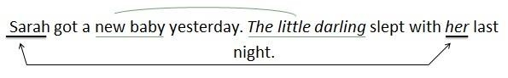

(Making inferences)

Memory for sentences is enhanced by inferences (personal conclusions), which are stored in memory alongside information extracted directly from sentences that were actually experienced. Inferences are used to create connections between sentences in a discourse. Consider this example:

We checked the picnic supplies. Soft drinks were warm.
The listener can infer from these two sentences that soft drinks are part of the picnic supplies.

Exercise

27

Working memory is:

    - Long-term memory
    - Short-term memory
    - Short-term and long-term memory
    - None of the previous is correct The answer is (B).

