- صفحة 8
- I arrived in Frankfurt
- I found out the departure area
- I was a woman and three children coming toward the seat
- I found a place to sit next to four empty seats with a red duffel bag on there of them
- A little girl sat on the floor near me and obened a bag
- She took out a crocheted heart and a pair of scissors
- I stopped her from running the heart
- We separated some lace from a stip of cloth
- The girl and her mother told me the story of the wedding and the cook,s actions
- The woman went to telephone india and learned that her mother was all right
- We got on the airplane to go to Cincinnati
========================================================

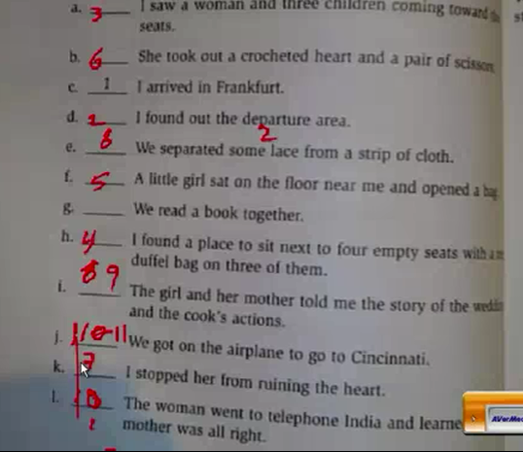

صفحه 9

1-where did the Indian woman fiy from to Frankfurt?
She flew from delhi
2-where did jean fly from?
Jean flew from turkey
3-who made the crocheted heart?
The grandmother of the children
4-why was the woman tired?(give more than one reason)
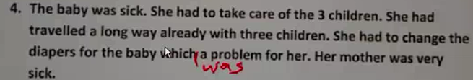
5-Why was sara angry?
Because (some one)tried to kill her grandma
6- Why was the angel?
Jean,the narr at or of the story
7-who was the groom?
The girls uncle
8-where was the groom tow days after the wedding?
They left on a trip
==========================================

صفحه 14

1-what are the names of the people in Chandra,s family
Sara,ama,and baby boy(without a name)
2-what tool is mentioned that can cut?
3-how many guests came to the wedding?
4- how do we know that the family is rich?
5-who put the poison in the food?
Wht is delhi?
How long was jean's layover?
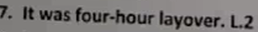
Why did Chandra leave her children with a stranger?
