اللغة الانجليزية
المحاضرة الثانية
Reading Skill (مهارة القراءة)
- Scanning المسح
- Skimming القشط
- Previewing Vocabulary استعراض المفردات
- Revising some structures مراجعة بعض التراكيب
- Writing : Jumbled sentences الكتابة: الجمل المخلوطة
- Read the following essay ,then answer the questions that follow
أقراء القطعة التالية ثم اجب عن الأسئلة التالية:
My name is Elena Sanchez. I am from Mexico, but now I live in California. I'm a student here in English language classes at a small college.
I live in an apartment building. It's on the corner of Olive Street and Sycamore Avenue. My address is 2201 Olive Street. There's a big olive tree in front of the building. There's a park across the street. There are a lot of oak trees in the park. The trees are beautiful in the summer.
A lot of my neighbors are from different countries. The people next to me are from Indonesia. The family across from the Indonesian family is from Colombia.
The stores in this neighborhood are always busy. There's a Korean drugstore and an Armenian flower shop.
There are three restaurants on Olive Street: One Mexican, one Japanese, and one Moroccan-Italian-American.
I like my neighborhood, but I ask myself one question. Where are the Americans?!!!

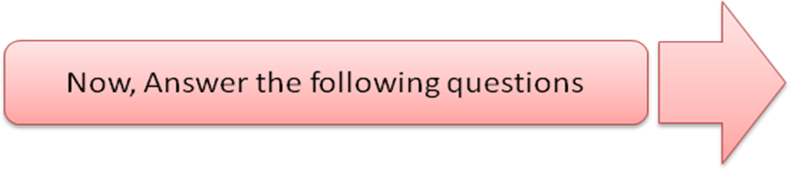

أسمي ألينا سانشيز أنا من المكسيك لأكن أنا ألان بشكل مباشر في كاليفورنيا أنا طالب هنا في اللغة الانجليزية في فصل صغيرة بالكلية أنا بشكل مباشر في عمارة سكنية هي على زاوية الشارع الزيتوني ودرب الجميز عنواني 2201 شارع زيتوني هناك شجرة زيتون كبيرة أمام البناية هناك متنزه عبر الشارع هناك الكثير من الأشجار البلوطية في المتنزه إن الأشجار جميله في الصيف.
الكثير من جيراني من البلدان المختلفة إن الناس بجانبي من اندونيسيا أن العائلة عبر من العائلة الاندونيسية من كولومبيا أن المخازن في هذا الحي مشغول دائماً هناك صيدلية كورية ودكان زهرة أرمني هناك ثلاث مطاعم على الشارع الزيتوني مكسيكي واحد يابانيون واحد وأمريكي مغربي إيطالي واحد أحب حيي لكني أسال نفسي سؤال واحد أين الأمريكان.
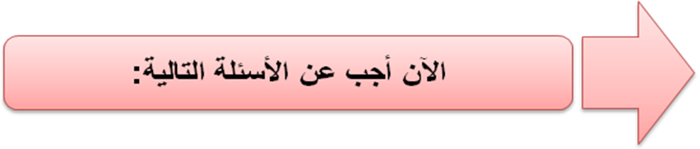
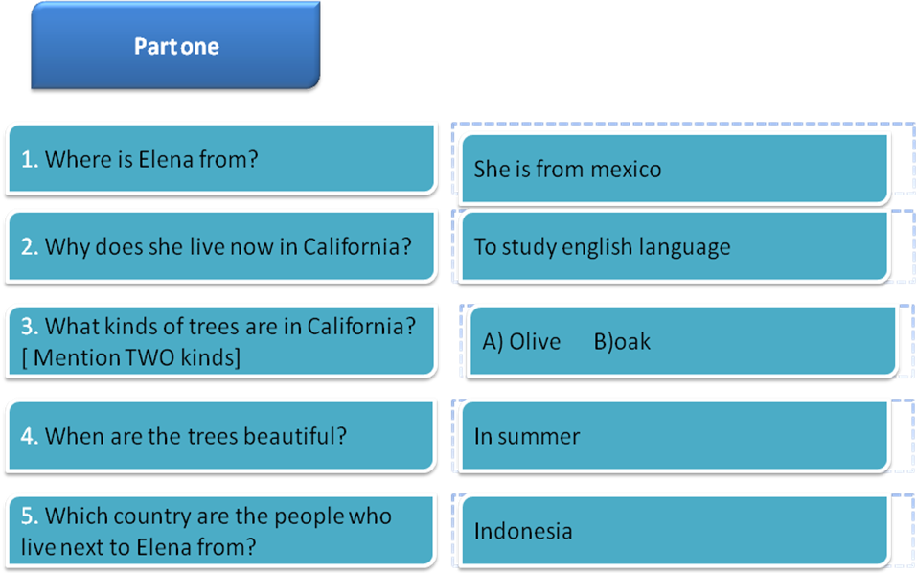

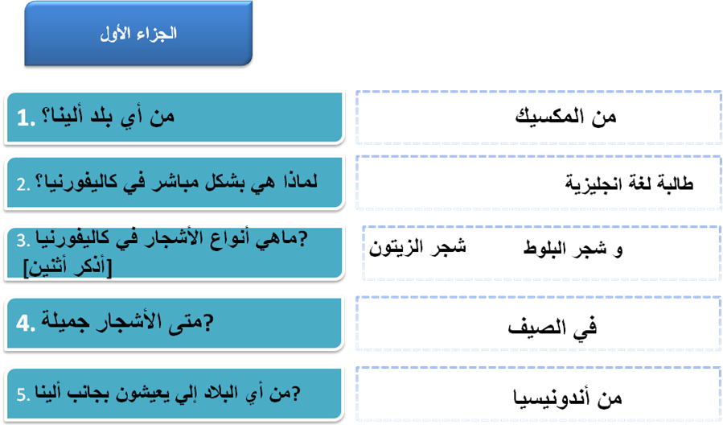
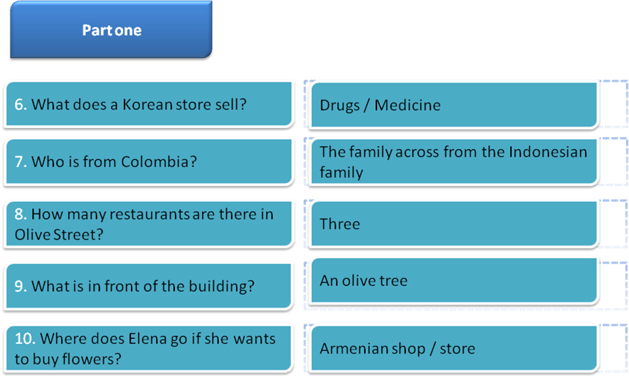

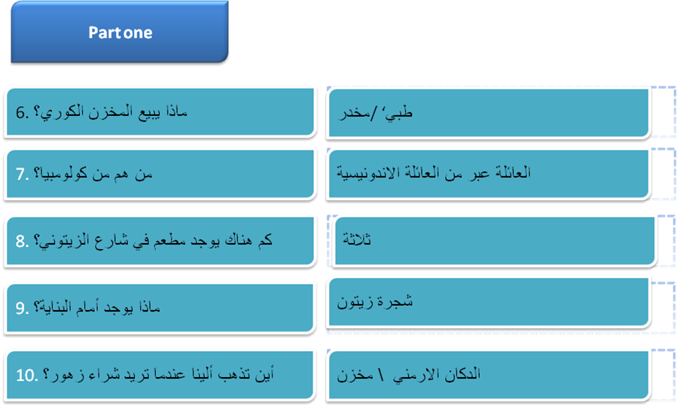

Complete each the following statements with correct information based on the passage content.
- The underlined word " here" LINE 2 refers to: California
- The underlined word " one" LINE 11 refers to: Restaurant
- The underlined pronoun “ me” refers to: Elena
- A word in the passage which has the same meaning as " shops" is Stores
- A word in the passage which has the same meaning as " flat" is Apartment
- A word in the passage which has the same meaning as " road" is Streat
- A word in the passage which has the opposite meaning of "behind" is In front of
- A word in the passage which has the opposite meaning of "ugly" is Beautiful
- A word in the passage which has the opposite meaning of " free" is Busy
- The simple past form of the verb "am" is Was
- The simple past form of the verb " are" is Were
Structure التركيب
Part One : Circle the correct response الجزاء الأول : اختار الإجابة الصحيحة
1.Salma and Fatima -----------------from Riyadh.
a. is
b. was
c. has
d. are
2. ___________ your car new?
a. Are
b. Is
c. Aren't
d. Has
3. London ------------------ a country. It is a city.
- is
- aren't
- isn't
- Are
4. ----------- ant is ---------------- insect.
- An / an
- An / a
- A / an
- A / a

5. Are you a doctor? No, ---------------------.
- I'mn't
- amn't
- Iamn't
- I'm not
6. Where is the water? ------------------- inside the refrigerator.
- They're
- It
- It's
- He's
7. A teacher usually starts a lesson by writing the date------------------the board.
- in
- under
- over
- On
8. My friend is from America.---------- lives in New York city.
- I
- We
- He
- It

9. ------------ in the house now.
- We're
- Wer'e
- Were
- We re
10. Are you ready? - -------------------------------.
- No, I'm not
- Yes, I'm
- No, Iamn't
- Yes, You're
- Vocabulary
A.Fill in each blank with a word from the box

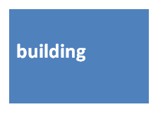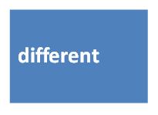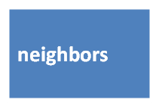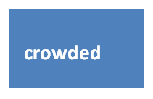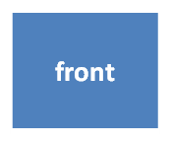

1.This store is always crowded .There are always lots and lots of people.
2. My neighbors are from Mexico. They're very nice people.
3. There are two big trees in front of my house.
4. There is a big apartment building on the corner of the street.
5. People in my neighborhood are from different countries.

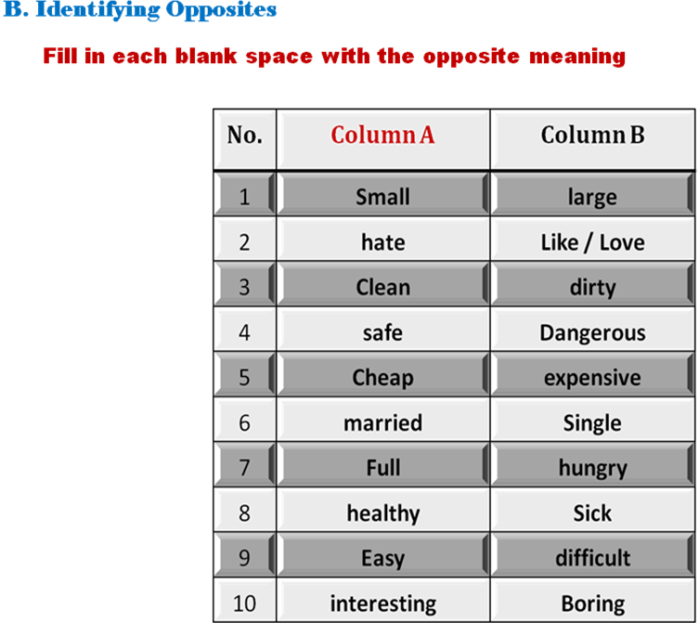
- Writing: Jumbled sentences
Rewrite the words in the correct order to make meaningful sentences
