English 101
Lecture (9)
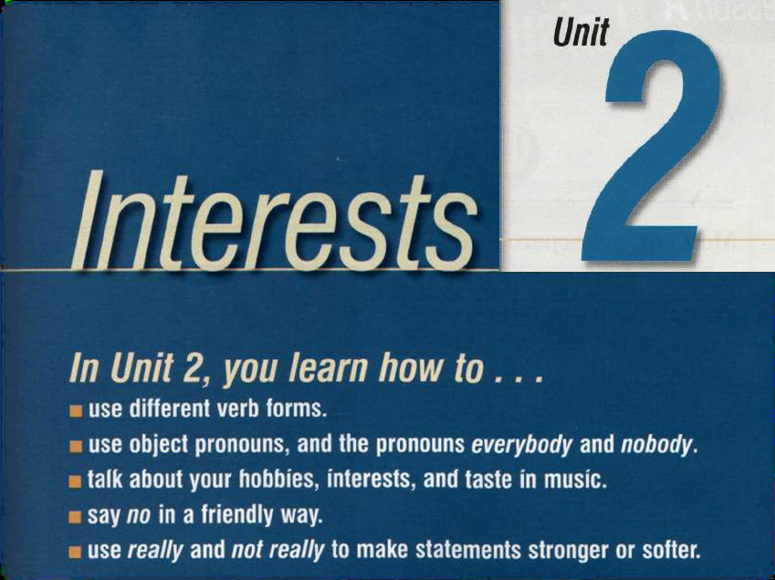
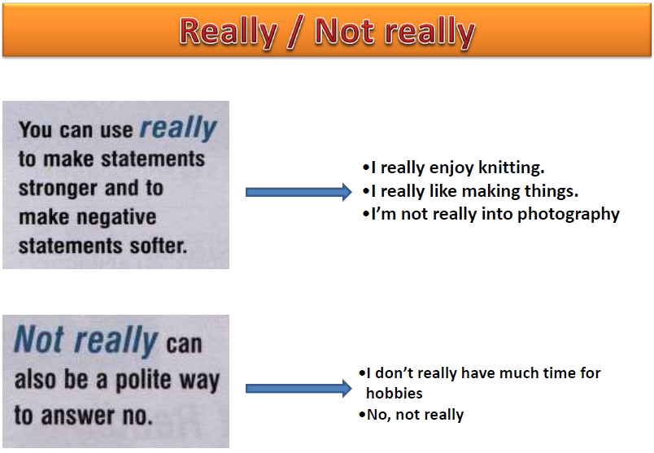
Answer the following questions. Give your own answers using REALLY OR NOT REALLY .:
1. Are you interested in sports?
Not really. I don’t really play any sports.

2. Are you into computers?
Well, I am really into computer games.

3. Do you enjoy doing jigsaw puzzles?
Not really. I think jigsaw puzzles are boring.

4. Are you good at fixing things?
No, not really. I’m not good with my hands.

5. Do you make your own clothes?
No, I’m not really into sewing. But I really like shopping.

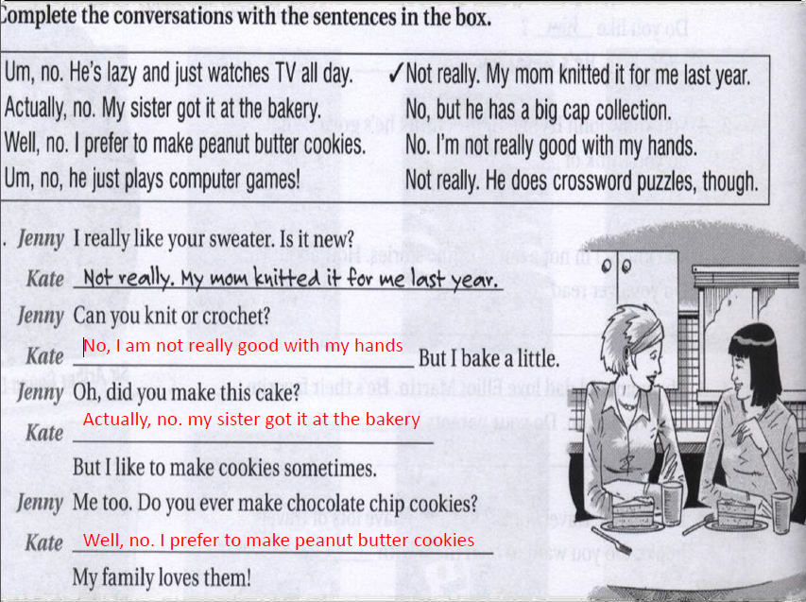
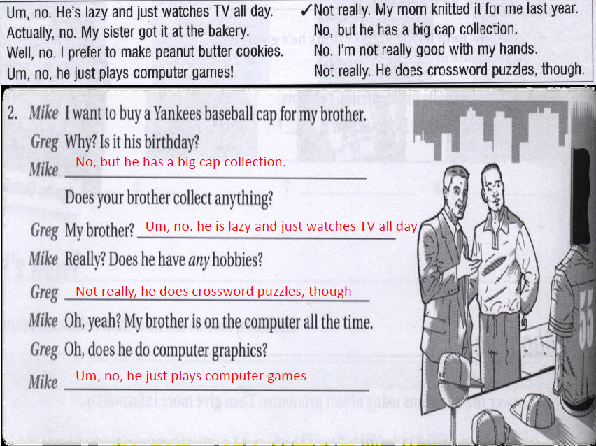
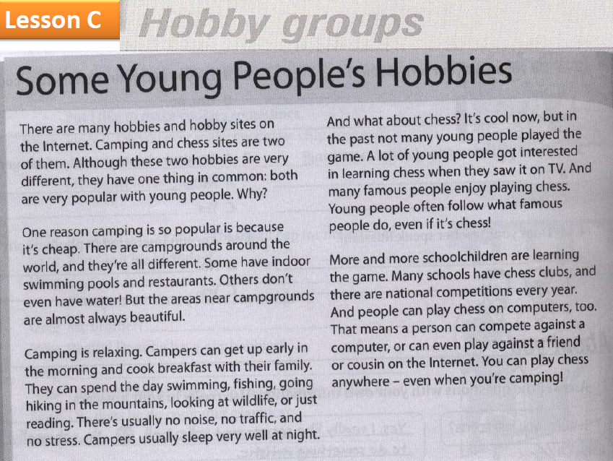

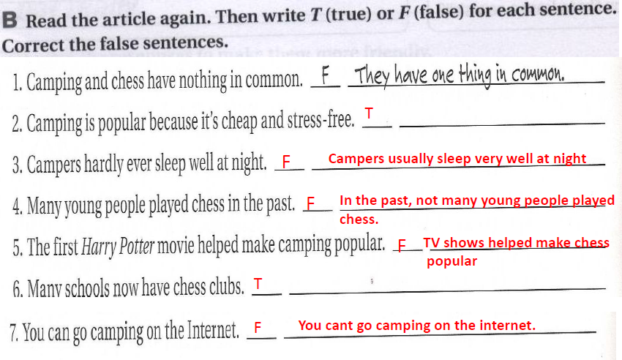

Conjunctions: and, but, or, also, and because.
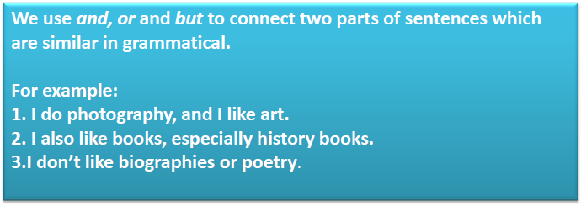
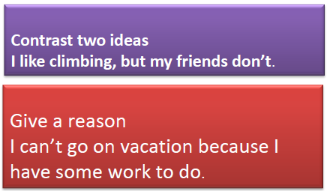
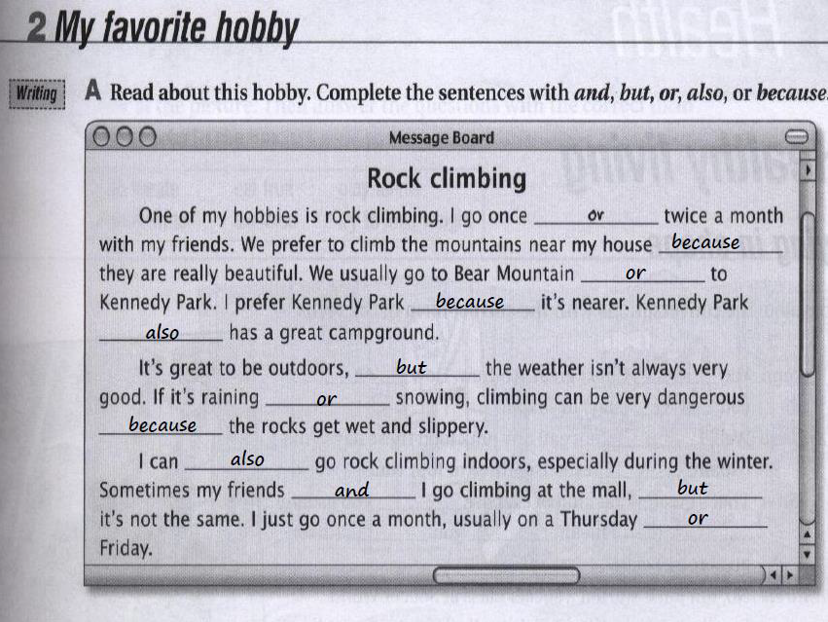

Good luck

