The name of the country and the term "English" derive from the Old English word for one of the three Germanic peoples that invaded the British Isles in the fifth century C . E ., the Angles. "Britain" and "British" derive from a Roman term for the inhabitants' language of the British Isles, called "Brythonic" or p-Celtic.
Englishness is highly regionalized. The most important regional divide is between the south and the north. The south, chiefly represented by the regions of the southeast, southwest, East Anglia, and the Midlands, now contains the economically most dynamic sectors of the country, including the City (the chief financial center of the United Kingdom) and the seat of the national government, both in London. The north, the cradle of industrialization and the site of traditional smokestack industries, includes Yorkshire, Lancashire, Northumberland, Cumbria, Durham, Merseyside, and Cheshire. Especially in the last decades of the twentieth century, the north has experienced industrialization, severe economic hardship, and cultural. England
is also a culture of many smaller regionalisms, still centered on the old governmental unit of the county and the local villages and towns. Local products, such as ale, and regional rituals and art forms, such as Morris dancing and folk music, many of which date back to the preindustrial era, allow people to shape their attachments to their communities and the nation. Merged with the north–south divide and regionalism are notions of working class, middle class, and upper class as well as rich versus poor.
England's role as a destination for migration also has influenced conceptions of Englishness. Historically, the most prominent immigrant group has been the Irish, who came in two major waves in the modern era: 1847 and 1848 after the potato famine, and during and after World War II. Scots were present in England by the 1700s and settled in England in large numbers during the nineteenth and twentieth centuries, often for economic reasons. Welsh in-migration came to prominence when deindustrialization began in Wales in the 1920s. This inmigration has brought the so-called Celtic fringe into English culture in a host of ways. There has also been the impact of Jewish, Flemish, Dutch, French Huguenot, German, Italian, Polish, Turkish, Cypriot, and Chinese cultures since the twelfth century. The loss of Britain's colonies has brought Afro-Caribbeans, Bangladeshis, Pakistanis, Indians, and migrants from northwestern and eastern Africa in significant numbers. Judgments of whether England's newcomers feel themselves to be "English" vary by group and even by individual.

Geography. England covers 50,357 square miles (130,423 square kilometers) of the main island of the British Isles and lies off the northwestern coast of Europe, separated from the mainland by the English Channel. The Gulf Stream makes the climate mild and rainy. The country is also divided into a highland zone and a lowland zone along a line from the mouth of the River Exe in the southwest to the mouth of the River Tees in the northeast. The highland zone's soil is poor and rocky, mainly
suitable for raising livestock, but in the lowlands the land is flatter, the soil is fertile, and there are many navigable rivers. As a result of its favorable topography, the lowland region has always had the majority of the population, supported most agriculture and trade, and had the largest cities including the capital, London. The highland zone did not develop rapidly until the nineteenth century, when its coal and iron deposits allowed it to surge to prominence in the industrial revolution;

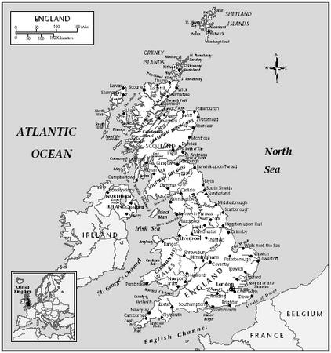

England
its communities struggle in England's postindustrial era.
Demography. The population was 49.5 million in 1998. The estimated nonwhite proportion of the population for that year was 7.3 percent, with the officially designated ethnic groups being black Caribbean, black African, black other, Indian, Pakistani, Bangladeshi, and Chinese.

