Instructor: Ammar Sultan Al-Maani

Elements of Class المحاضره ((11))
- Comparatives and Superlative
- =========================================================
Contents
.Introduction
-What is a noun?
-What is an adjective?
-What is a syllable?
.Syllable – further examples
.Adjectives
-Comparative form
.How to built comparative forms?
-Superlative form
.How to built superlative forms?
.Summary
-Comparison chart
----------------------------------------------------------------------------------------------------------
What is a noun?
Noun is a word which refers to a thing, person,activity, place etc.

car

reading

street
Teacher

------------------------------------------------------------------------------
What is an adjective?
Adjective is a word which describes a noun
adjectives
noun

big
car

fast
expensive

============================================================
Examples
Adjectives

large larger largest
The first apple is large.
The second apple is larger than the first.
The third apple is the largest of the three.
---------------------------------------------------------------------------------------------------

The jalopy is a fast car.
The racecar is the faster car.
The dragster is the fastest car.
----------------------------------------------------------------------------------------------------
What is a syllable?
Syllable is a part of a word containing vowel sound
read

ing

read ............

ing

1st syllable

2nd syllable

--------------------------------------------------------------------------------------------------------

Syllables – examples

- One-syllable adjectives

2. Two-syllable adjectives

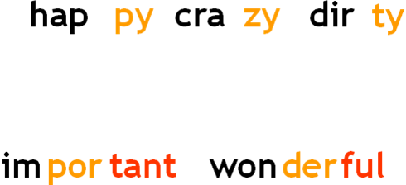
3. Three-syllable adjectives

-----------------------------------------------------------------------------------------------------------
LET’S START ☺
Adjectives and adverbs are words the modify other words. The comparative form of an adjective or adverb compares two things. The superlative form of an adjective or adverb compares three of more things.
---------------------------------------------------------------------------------------------------
What is a “comparative form”?
Comaprative form expresses the idea of ‘more’

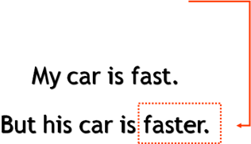
------------------------------------------------------------------------------------------------------

“Comparative form”?
How is a ‘comparative’ form built?
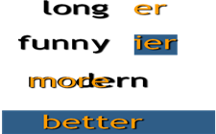
more
modern

funn y

irregular adjectives
for example ‘good’

for example ‘good’
one syllable adjectives

two syllable adjectivesending in -ly

ending in -ly
other two and three syllable adjectives

Change of ‘y’ into ‘i’
We want the comparative form
of the adjective ‘funny’

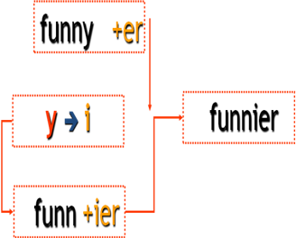

What is a “superlative form”?
Comaprative form expresses the idea of ‘most’
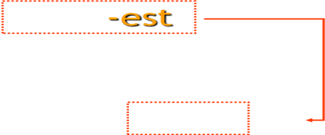
My car is fast.
Your car is fast.

But his car is the fastest.

fastest.
fast

-----------------------------------------------------------------------------------------------------------

“Superlative form”?
How is a ‘superlative’ form built?
one syllable adjectives

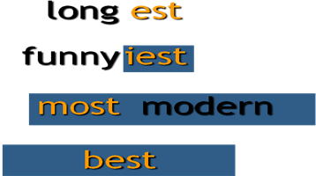
two syllable adjectives

ending in -ly

other two and three syllable
adjectives
irregular adjectives
for example ‘good

-----------------------------------------------------------------------------------------------------------
Summary comparison
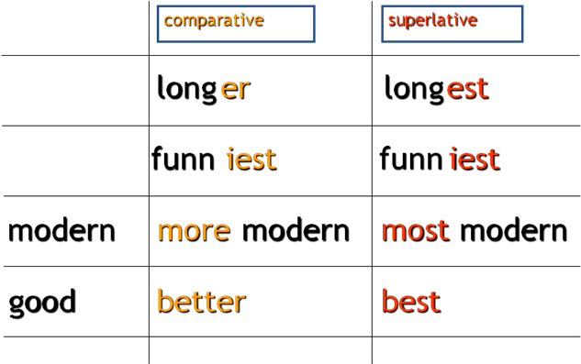
long

funny

To make comparative and superlative forms of adjectives some rules must be followed.
Rule 1
To form the comparative or superlative of one syllable words with
more than one vowel OR ending
with more than one consonant at the
add -er OR -est.
tall | taller | tallest
neat | neater | neatest
deep | deeper | deepest

Rule 2
To form the comparative or
superlative of a one syllable word ending
in e add -r OR –st
wide | wider | widest
fine | finer | finest
cute | cuter | cutest
Rule 3
To form the comparative or superlative of a one syllable word with one vowel and one consonant at the end double the consonant, and add -er OR -est.
sad | sadder | saddest
big | bigger | biggest
fat | fatter | fattest
Rule 4
To form the comparative or superlative of a two syllable word ending in y, change the y to i, then add -er OR -est.
happy | happier | happiest
jolly | jollier | jolliest
lazy | lazier | laziest
Rule 5
To form the comparative or superlative of a two syllable word ending a vowel-sound that is not stressed then add -er OR -est.
Adjectives ending in –le, -ow, er frequently take –er and –est.
yellow | yellower | yellowest
gentle | gentler | gentlest
simple | simpler | simplest

Rules at a Glance
Adjective form | Comparative | Superlative
Only one syllable, with more than one vowel or more than one consonant at the end. Examples:  light, neat, fast, tall, neat, deep | Add -er:  lighter, neater, faster, taller, neater, deeper | Add -est:  lightest, neatest, fastest, tallest. neatest, deepest
Only one syllable, ending in E. Examples:  wide, fine, cute | Add -r:  wider, finer, cuter | Add -st:  widest, finest, cutest
Only one syllable, with one vowel and one consonant at the end. Examples:  hot, big, fat, sad | Double the consonant, and add -er:  hotter, bigger, fatter, sadder | Double the consonant, and add -est:  hottest, biggest, fattest, saddest
Two syllables, ending in Y. Examples:  happy, silly, lonely, jolly | Change y to i, then add -er:  happier, sillier, lonelier, jollier | Change y to i, then add -est:  happiest, silliest, loneliest, jolliest
two syllable word ending a vowel-sound that is not stressed  yellow, simple | Add -er:  yellower, simpler | Add -est:  yellower, simpler
Two syllables or more, not ending in Y. Examples:  modern, interesting, beautiful, | Use more before the adjective:  more modern, more interesting, more beautiful | Use most before the adjective:  most modern, most interesting, most beautiful

NOTE: Like adjectives some adverbs can
take comparative and superlative forms, with -er and -est:

Sally works hard.
Steve works harder than Sally
Kathy and Sue work the hardest of all.

The bird sings loudly.
The moose sang louder than the bird.
Pete sang the loudest of them all.
------------------------------------------------------------------------------------------------------

List of Adverbs in Which -er and -est May Be Added
Adverb | Comparative | Superlative
fast | faster | fastest
slow | slower | slowest
quick | quicker | quickest
early | earlier | earliest
bright | brighter | brightest
high | higher | highest

----------------------------------------------------------------------------------------------
However, the majority of adverbs do not take these endings. Instead, they form the comparative using more and the superlative using most:
Adverb | Comparative | Superlative
recently | more recently | most recently
effectively | more effectively | most effectively
frequently | more frequently | most frequently

-----------------------------------------------------------------------------------------------------------------
Irregular Comparative and Superlative Adjectives and Adverbs
Some comparative and superlative forms are irregular and do not follow any rules or patterns. These must be memorized.
-----------------------------------------------------------------------------------------------------------------
Irregular Adverbs
Word | Comparative | Superlative
badly | worse | worst
much | more | most
little | less | least
much | more | most
well | better | best
------------------------------------------------------------------------------------------------------------------
Irregular Adjectives
Word | Comparative | Superlative
good | better | best
bad | worse | worst
much | more | most
little | less | least
far | farther | farthest
old | older  elder | oldest  eldest
-------------------------------------------------------------------------------------
Example:
Nathan made good stew.
Molly's stew was better than Nathan's.
Ezra made the best stew of all.

