اللغة وتقنية المعلومات – د. عبدالله الفريدان

الواجبات

الواجب الاول
1. What does CALL stand for?
a) Case application language learning
b) Computer assisted language learning
c) Communication aided language learning
2. Three important stages in the CALL process. These are
a) Development/ usage/ evaluation
b) Purchase/assessment/selling out
c) Trail/ evaluation/replacement
d) Trail/ evaluation/ usage
3. Thinking about Designing CALL materials is the same like thinking of
a) Designing a car
b) Designing a house
c) Designing textbooks
d) Designing clothes

الواجب الثاني

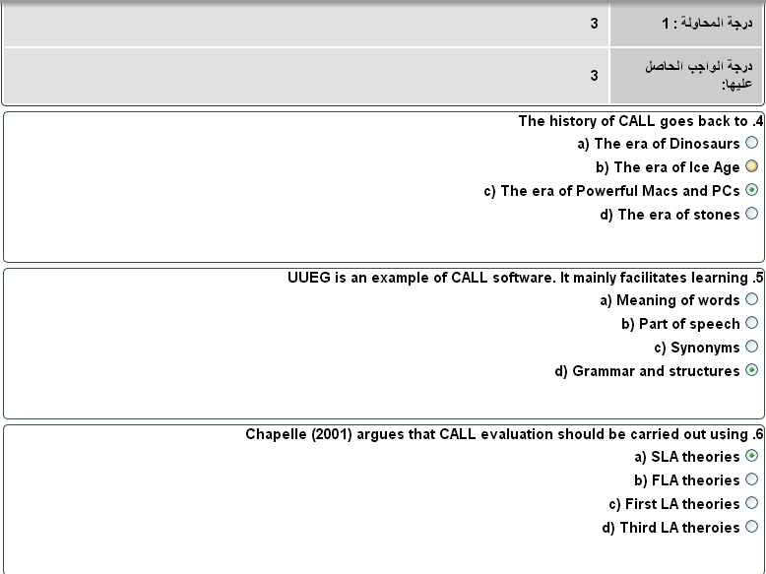

الواجب الثالث

1. There are two stages in Chapelle’s (2001) evaluation. These are
a. Usage and evaluation
b. Implementation and assessment
c. Judgmental and empirical
d. Subjective and objective
2. CALL software can be defined as
a) Any potential software usable by language learners in connection with learning
b) Any software available in the market accessible to all
c) Any anti-virus software that is free or shareware
d) Any multimedia software that is free or shareware
3. Evaluation can be defined as
a) Using an application for learning purposes
b) Judging the price of an application
c) Deciding on the fitness of something to certain purposes
d) Assigning the availability of an application
4. A corpus is
a) Stored information
b) Stored images and videos
c) Stored collection of language data
d) Stored

اسئلة اختبارات

منقول كما هو للاخ / غسان

اللغة وتقنیة المعلومات
Language & T. I.
رمز المقرر ٧٤٠٣٤٦٠
جامعة الملك فیصل
كلیة الآداب – لغة انجلیزیة – انتساب مطور
الدكتور عبدالله عبدالوھاب عبدالله الفریدان
alfridan@kfu.edu.sa البرید الالكتروني
جوال المقرر :
Office Hours:
ان اصبت فمن الله وان اخطأت فمن نفسي والشيطان
طبعا الاجوبة باللون الاحمر والأسئلة باللون المخالف وعدد اسئلة
الاختبار ٥٠ سؤال ولكن هنا ما اسعفتني به الذاكرة واعتذر عن
التقصير والخطأ
اتمنى ان تكون ذو فائدة للجميع

1. What does CALL stand for?
Computer assisted language learning

2. Three important stages in the CALL process. These are
Development / usage / evaluation

3. Thinking about Designing CALL materials is the same like thinking of
Designing textbooks

4. The history of CALL goes back to
The era of Powerful Macs and PCs

5. UUEG is an example of CALL software. It mainly facilitates learning
Grammar and structures

6. Chapelle (2001) argues that CALL evaluation should be carried out using
SLA theories

7. There are two stages in Chapelle's (2001) evaluation. These are Judgmental and empirical

8. CALL software can be defined as
Any potential software usable by language learners in connection with learning

9. Evaluation can be defined as
Deciding on the fitness of something to certain purposes

10. A corpus Is
Stored collection of language data

11. The criteria are:
language learning potential, learner fit, meaning focus, positive impact, authenticity, and practicality.

12. Evaluation is a matter of judging the fitness of something for a particular purpose

13. The important difference between book and CALL is a book is not typically dynamic or interactive.

14. The important difference between book and CALL is , a book is more limited in its media capability.

15. The important difference between book and CALL is use of written materials has few technological prerequisites

16. ‘Evaluation of CALL is a situation-specific argument’.

17. the nature of the T/L situation, the learners and their needs

18. Evaluation of materials prior to purchasing them or creating access to them for any learners. I.e. as a result of evaluating materials you decide whether to buy or adopt them or not, for some specific learners.

19. Evaluation after the program has been acquired and used with some learners for a bit. Here the question is whether it was a success and the action is to use/not use the program again with these or other learners.

20. curriculum designers who might evaluate to choose suitable coursebooks for a course are less likely to extend this activity to CALL, so the job is left to the teacher

21. Methods of evaluation: Introspective judgmental
evaluation.

22. Introspection means relying on one's own
judgment/experience, and maybe published consensus on what should be there

23. When trying out a CALL program it is especially useful often to make deliberate mistakes to see how the program responds.

24. 'expert judgment'
method of evaluation. The evaluator introspects and somehow accesses an unanalysed notion of some users of the software, an unanalysed impression of the software, and matches the two using often inexplicit criteria.

25. Checking the frequency level of the vocabulary against a standard reference list, grading the exercise types that are incorporated on a recognised scale of task difficulty etc. This might be called 'materials analysis'

26. Doing an analysis of learners' needs or interests, finding out what the school budget actually has available, etc. This is in effect 'analysis of the learning/teaching situation'.

27. checklist approach:
Be explicit about where the list comes from, which existing one is being used/adapted, and have as many detailed subsections as possible.

28. Don't forget (c) i.e. explanation of how each feature of the program (a) does or doesn't fit (b).

29. The beginnings of a CALL checklist follow, inspired mainly by Odell 1986

30. Aspects of software that are usually present and need to be looked at separately for evaluation:
What price, What hardware platform required ,What other software needed as prerequisite , Does it have restricted compatibility with operating systems

31. output features: Sound, Graphics, Video, Written fonts, Screen layout?

32. Chapelle (2001) describes this criterion as the degree of 'beneficial' focus on form that the software provides to its learners.

33. Furthermore, both the colourful, animated pictures and the quizzes contribute to 'input enhancement'

34. Chapelle argues that CALL software should have the ability to let students 'notice' their errors as this would help them to shift to 'a syntactic mode' that aids in internalizing the new form

35. error awareness helps students to 'monitor and self-correct their use of language'

36. When all of the answers are correct, the software displays a 'well done'

37. A further strength of the program is the feedback provided in the test sections

38. CALL materials must suit the target learners, and accordingly its tasks should be set at a level that is neither too simple nor too difficult

39. USERS OF CORPORA
Dictionary makers ,Descriptive grammarians ,Stylisticians ,Language learning researchers ,Writers of teaching course materials .Writers of teaching syllabuses .Computational linguists

40. What is NLP?
Natural Language Processing (NLP)

41. Computers use (analyze, understand, generate) natural language

42. Why Study NLP?
Human language interesting & challenging , NLP offers insights into language, Language is the medium of the web , Interdisciplinary: Ling, CS, psych, math

43. Scientific Goal : Identify the computational machinery needed for an agent to exhibit various forms of linguistic behavior .

44. Engineering Goal
Design, implement, and test systems that process natural languages for practical applications .

45. Applications
speech processing ,summarization ,machine translation , question answering ,information extraction

46. The sentence exhibit ambiguity
I can fish.

47. Grammar Induction
Start with a tree bank = collection of parsed sentences

كويز

كويز اللغة وتقنية المعلومات - د.عبدالله الفريدان
l الكويز بواسطة : رقشَاءُ !
l المصدر : منتديات التعليم عن بعد
http://www.e1500.com/vb/quiz.php l
l بتاريخ : 2014 / 05 / 02

السؤال رقم: 1
1-Scientific Goal of NLP Identifies the ……… needed for an agent to exhibit various forms of linguistic behavior
a) Living expenses.
b) Most appropriate time.
c) The best business company.
d) computational machinery.

السؤال رقم: 2
2- Speech processing , machine translation , question answering andsummarization are : ...
a) Some Applications of weapon industry
b) Recycling or reprocessing of used material
c) Psycholinguistic analysis.
d) Natural language processing

السؤال رقم: 3
3- The …….. of NLA designs, implements, and tests systems that process nature language for practical applications.
a) Scientific goal. . .
b) Financial goal.
c) Engineering goal
d) Indirect goal

السؤال رقم: 4
BNC Stand for the ……… . . .
a) British national companies.
b) The Brazilin national corpus
c) The Brazilin Network corpus
d) The British national corpus

السؤال رقم: 5
5- If you using the checklist approach, some key things that you should not forget are ……
a) To be explicit about where the list come from. . .
b) To be explicit about which exiting list is being uses/adapted.
c) To have as many detailed subsections as possible
d) All the above

السؤال رقم: 6
6- According to (Long & Robinson 1998), pervious research has proven that some techniques in highlighting grammatical forms and writing them in italicized, bold letters are ……
a) Useless
b) Not effective
c) Very effective
d) Partially useless

السؤال رقم: 7
7- Chapelle argues that CALL software should have the ability to let students ……….. as this would help them in internalizing the new forms.
a) See their image l
b) Notice their success l
. c) Notice their errors l
d) Notice their progress l

السؤال رقم: 8
8- According to Borg ( 1999), error awareness helps students to …...
a) Use monitors and repeat the same errors. l
b) Monitors and self-correct their use of language. . . l
c) Monitors their teachers use of language l
d) Monitors the errors that the software makes l

السؤال رقم: 9
9- When all of the answers are correct, the software displays …….. message in red at the top of the exercise.
a) "Incorrect answers l
b) A "well done". l
c) A "poorly done l
d) A :wrong answer l

السؤال رقم: 10
10- In grammar, a " tree bank" refers to
a) A bank where can deposit orange trees. .. l
b) A financial institution where you can deposit money. l
c) A collocation of grammatical sentences l
d) A collocation of parsed sentences l

السؤال رقم: 11
11- Natural language processing can best by applied in the field of ..
a) Human rights. . l
b) Computational linguistics. l
c) Photoshop. l
d) Painting l

السؤال رقم: 12
12- The colored …… in a CALL software is of significance because it helps students form and allows the computer to take on the role of the teacher.
a) Feedback. . l
b) Food bag. l
c) Full bag. l
d) Hardback l

السؤال رقم: 13
13- According to Shchan (cited in Chapelle 2001). CALL material must the target learners, and accordingly its takes should be set at a level that is …….
a) Neither too simple nor too difficult. . l
b) Too simple. Style l
c) Too difficult. l
d) Too simple and too difficult l

السؤال رقم: 14
14- Some users of corpora are ……
a) Dictionary makers, computational linguistic and descriptive grammarians.. l
b) Slyllsticians and teachers making class takes l
c) Sociolinguists, language learning researches and writers of teaching syllabuses. l
d) All the above. L

السؤال رقم: 15
15- The beginning of a CALL checklist was inspired mainly by …….
a) Odell ( 1986) l
b) Chapelle ( 2001). l
c) Al Fraidan ( 2013 l
d) Odel ( 2013 l

السؤال رقم: 16
16- Specification ( External per-requisites of a CALL software) usually needs to be ……. To any consideration of real pedagogical value.
a) Prior l
b) During. l
c) After. l
d) All the above l

السؤال رقم: 17
17- Some aspects of software that need to be looked as separately for evaluation are ………….
a) Place, ventilation and electricity, etc. . l
b) Place, platform and management required, prerequisite software, etc l
c) Screen protectors, dust protecting covers and chat software like Yahoo, Skype, letc..
d) Email account, connection to the internet and IP hiding software, etc l

السؤال رقم: 18
18- Some output of a CALL software are
a) Sound, graphics, video, written fonts, screen layout, etc. . . l
b) Syntax, linguistic, morphology, etc. l
c) Apples, oranges, vegetables, chasse and meat, etc l
d) Hard dies, mouse, wires, television, keyboard, etc l

السؤال رقم: 19
19- Instead of using global judgment, one can breakdown this into a
a) Checklist l
b) Recipe l
c) Judgment l

السؤال رقم: 20
20- Choose the sentence that exhibits ambiguity.
a) I go fishing every Monday. l
b) I like fishing in the river l
c) I can fish l
d) Fishing in the river is interesting l

السؤال رقم: 21
We study Natural Language Processing because …….
a) It helps in commutation with computer. . . l
b) It helps in commutation with people l
c) It offers insights into language l
. d) All the above l

السؤال رقم: 22
22-According to Chapelle (2001-p52). Evaluation of CALL is a argument.
a) Situation – Specific l
b) Animal – specific. l
c) Arabic – specific l
d) English – specific l

السؤال رقم: 23
23- You cannot really evaluate a CALL software without also thinking of how this software will be used in the ……….
a) Learning and teaching process. . . l
b) Eating and digestion process. l
c) Sleeping and thinking process l
d) None of the above l

السؤال رقم: 24
24- Evaluation a CALL software after the program had been acquired and used with learners, involves the question of
a) Whether this software was a success and the action is to use it or not with l current or other learners.
b) Whether to buy this software or not. . l
c) What learners it would suit. l
d) All the above l
السؤال رقم: 25
25- Evaluation of CALL material prior to purchasing them will …..
a) Help you decide whether to buy or not. l
b) Help you decide whether this software was a success and therefore can again. l
c) Help you decide what to eat for breakfast. . l
d) Help you give the software to your learners l

