
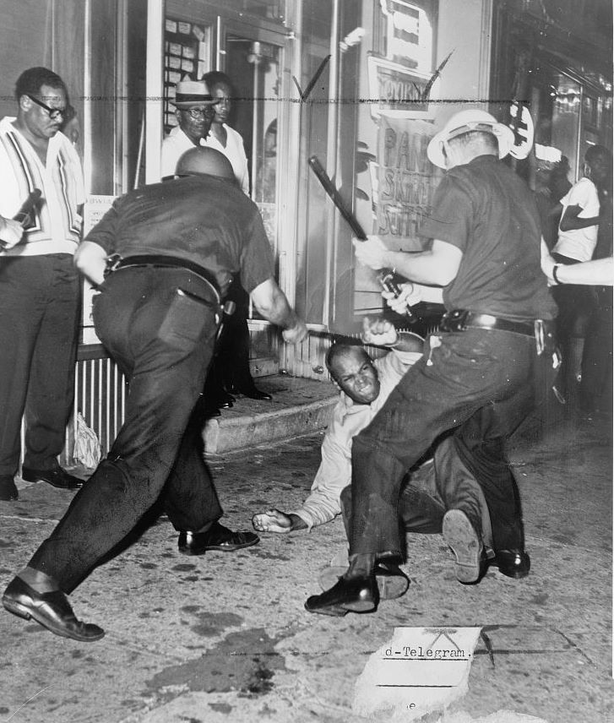
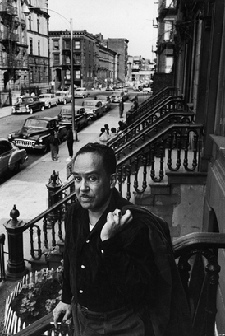
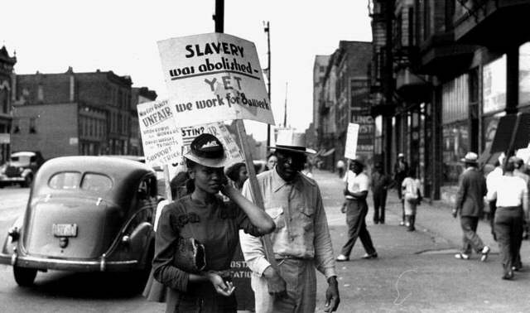
HARLEM
Brief Historical Background

English Language & Literature Department
American Literature
Prof. Maha Sallam

Harlem is known in it's strange spread of poverty and crimes, while in the other hand, it has one of the most prestigious universities in New York "University", as well as Columbia University in which Dr. Edward Said, the Palestinian origin, head the English Department in the eighties of the last century.
In Harlem, we can feel enormous civilian gaps between it and Manhattan district .. There African American are still suffering racism and discrimination, while in contrast whites are not.
So this short paper will deal with these following points to be more familiar about the historical background of Harlem:
- Harlem Origination and Location.
- Harlem's three neighborhoods.
- A Brief Historical Background of Harlem in General.
- African-Americans Migration to Harlem.
- The Great Migration.
- Impact Of The Great Migration.
- Harlem's Famous Venues.
- Cotton Club of Harlem.
- The Savoy Ballroom in Harlem.
- Apollo Theater.
- Economic Reality And The Harlem Race Riot Of 1935.
- World War II and it's relation to the African-Americans of Harlem .
- The Civil Rights Movement in Harlem.

Harlem Origination and Location
Harlem "Black mecca", is a large neighborhood within the northern section of the New York City borough of Manhattan. Since the 1920s, Harlem has been known as a major African-American residential, cultural and business center. Originally a Dutch village, formally organized in 1658, it is named after the city of Haarlem in the Netherlands. Harlem's history has been defined by a series of economic boom-and-bust cycles, | 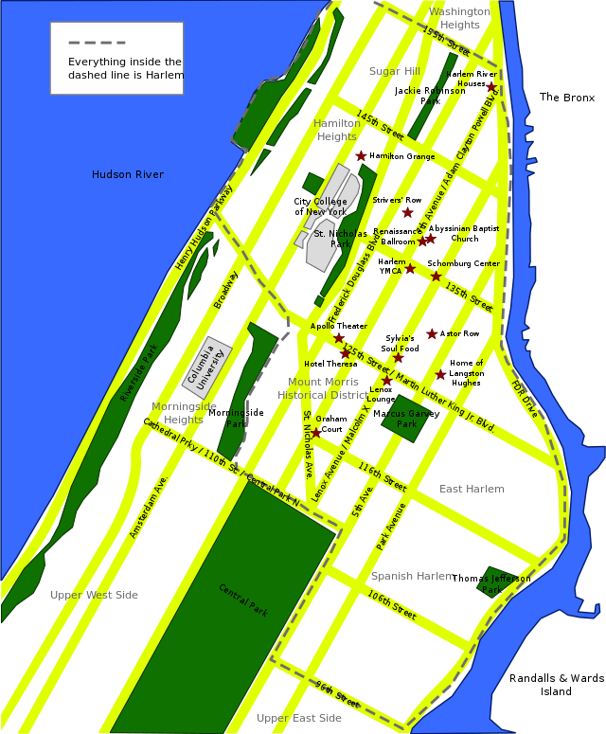  Harlem
with significant population shifts accompanying each cycle.
Before the arrival of European settlers, the area that would become Harlem (originally Haarlem) was inhabited by the Manhattans, a native tribe, who along with other Native Americans, most likely Lenape occupied the area on a semi-nomadic basis. As many as several hundred farmed the Harlem flatlands. Between 1637–39, a few settlements were established. During the American Revolution, the British burned Harlem to the ground. It took a long time to rebuild, as Harlem grew more slowly than the rest of Manhattan during the late 18th century. After the American Civil War, Harlem experienced an economic boom starting in 1868. The neighborhood continued to serve as a refuge for New Yorkers, but increasingly those coming north were poor and Jewish or Italian. The Metro-North Railroad as well as the Inter borough Rapid Transit and elevated railway lines, helped Harlem's economic growth, as they connected Harlem to lower and midtown Manhattan.
Harlem's three neighborhoods:
1. East Harlem, (more commonly referred to as Spanish Harlem): (east of Park Avenue, west to the East River, between East 96th Street and East 125th Street),
2. Central Harlem, (historic "Harlem" of the Black Renaissance) east of Morningside Avenue, and St. Nicolas Avenue and west of 5th Avenue, in between 110th Street and 155th Street),
3.West Harlem, (mainly used officially, generally not used).

A Brief Historical Background of Harlem in General
The Jewish and Italian demographic decreased, while the black and Puerto Rican population increased in this time. The early 20th-century Great Migration of blacks to northern industrial cities was fueled by their desire to leave behind the Jim Crow South, seek better jobs and education for their children, and escape a culture of lynching violence; during World War I, expanding industries recruited black laborers to fill new jobs, thinly staffed after the draft began to take young men.
In 1910, Central Harlem was about 10% black. By 1930, it had reached 70%. Starting around the time of the end of World War I, Harlem became associated with the New Negro movement, and then the artistic outpouring known as the Harlem Renaissance, which extended to poetry, novels, theater, and the visual arts. So many blacks came that it "threatened the very existence of some of the leading industries of Georgia, Florida, Tennessee and Alabama." Many settled in Harlem. By 1920, central Harlem was 32.43% black. The 1930 census revealed that 70.18% of Central Harlem's residents were black and lived as far south as Central Park, at 110th Street.
However, by the 1930s, the neighborhood was hit hard by job losses in the Great Depression. In the early 1930s, 25% of Harlemites were out of work, and employment prospects for Harlemites stayed bad for decades. Employment among black New Yorkers fell as some traditionally black businesses, including domestic service and some types of manual labor, were taken over by other ethnic groups. Major industries left New York City altogether, especially after 1950. Several riots happened in this period, including the 1935 and 1943 riots.
There were major changes following World War II. In the late 1950s and early 1960s, Harlem was the scene of a series of rent strikes by neighborhood tenants, led by local activist Jesse Gray, together with the Congress of Racial Equality, Harlem Youth Opportunities Unlimited (HARYOU), and other groups. These groups wanted the city to force landlords to improve the quality of housing by bringing them up to code, to take action against rats and roaches, to provide heat during the winter, and to keep prices in line with existing rent control regulations. The largest public works projects in Harlem in these years were public housing, with the largest concentration built in East Harlem.
Typically, existing structures were torn down and replaced with city-designed and managed properties that would, in theory, present a safer and more pleasant environment than those available from private landlords.
Ultimately, community objections halted the construction of new projects. From the mid-20th century, the terrible quality of education in Harlem has been a source of distress. In the 1960s, about 75% of Harlem students tested under grade levels in reading skills, and 80% tested under grade level in math. In 1964, residents of Harlem staged two school boycotts to call attention to the problem. In central Harlem, 92% of students stayed home. In the post-World War II era, Harlem ceased to be home to a majority of the city's blacks, but it remained the cultural and political capital of black New York, and possibly black America.
By the 1970s, many of those Harlemites who were able to escape from poverty left the neighborhood in search of safer streets, better schools and homes. Those who remained were the poorest and least skilled, with the fewest opportunities for success.

African-Americans Migration to Harlem
Dating back to Colonial America, the Upper Manhattan enclave of Harlem (extending from 110th to 168th Streets) has been, by turn, a Dutch, German and Jewish neighborhood. The influx of African-Americans for which Harlem is more widely known didn't occur until 1904 when black entrepreneur Philip A. Payton opened the Afro-American Realty Company and began leasing apartments to blacks at slightly higher rents than those charged to other ethnic groups.
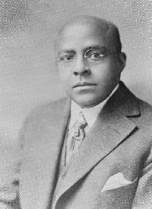 |  | 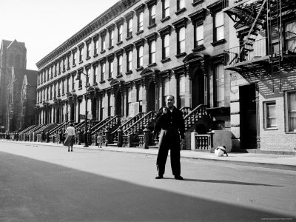
 | Philip A. Payton |  | Row house built for the African-American population of Harlem in the 1930s

Black Harlem emerged as landlords opened their doors to this new market sector. Considered a ghetto by some, a sanctuary by others, this neighborhood was home to the Harlem Renaissance, incubator of the Jazz and Swing Eras, and witness to two World Wars. Harlem's history is intricately woven into the experience of African-Americans, who migrated by the thousands to what Harlem Renaissance poet and writer Claude McKay called "the Negro Metropolis":
"[Harlem] is the Negro capital of the world. And as New York is the most glorious experiment on earth of different races and diverse groups of humanity struggling and scrambling to live together, so Harlem is the most interesting sample of black humanity marching along with white humanity."

The Great Migration
Beginning in the early 1900s, thousands of blacks sought relief in Harlem from the institutionalized racism and violence below the Mason-Dixon line. In the 1920s artists, intellectuals and reformers flocked to Harlem seeking an atmosphere that was both socially tolerant and conducive to the creative expression of the black community. Others made their pilgrimage after a series of natural and economic disasters (worst of all, the Great Depression in the 1930s) left them without any form of agricultural work. By the end of World War II, Harlem had become the terminus for hundreds of thousands of blacks that had begun their northern exodus four decades earlier.
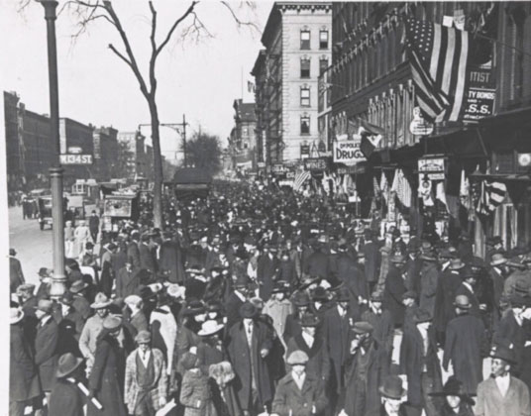 | 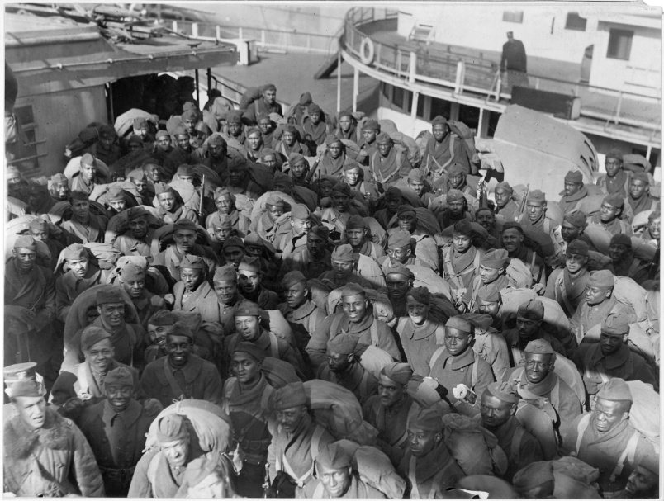

Impact Of The Great Migration
As a result of housing tensions, many blacks ended up creating their own cities within big cities, fostering the growth of a new urban African-American culture. The most prominent example was Harlem in New York City, a formerly all-white neighborhood that by the 1920s housed some 200,000 African Americans. The black experience during the Great Migration became an important theme in the artistic movement known first as the New Negro Movement and later as the Harlem Renaissance, which would have an enormous impact on the culture of the era. The Great Migration also began a new era of increasing political activism among African Americans, who after being disenfranchised in the South found a new place for themselves in public life in the cities of the North and West.

Harlem's Famous Venues
Throughout the 1920s, 30s and 40s, Harlem earned its reputation as the Mecca for Jazz and blues. Venues like the Cotton Club, The Savoy Ballroom and Apollo Theater made stars out of entertainers such as Duke Ellington, Cab Calloway, Ella Fitzgerald, James Brown, Michael Jackson, D'Angelo and Lauryn Hill. While the Cotton Club closed its doors years ago, The Apollo Theater still lights up with major headlining acts.
Cotton Club of Harlem (1923 )
Opened in 1923, New York was operated by white New York gangster Owney Madden. Madden used the Cotton Club as an outlet to sell his “#1 Beer” to the prohibition crowd. Although the club was briefly closed several times in the 1920s for selling alcohol, the owners’ political connections allowed them to always reopen quickly. The Club was decorated with the idea of creating a “stylish plantation environment” for its entirely white clientele. As with many New York City clubs of the time period, that meant the upper class of the city. The Cotton Club at first excluded all but white patrons although the entertainers and most of staff were African American. Exceptions to this restriction were made in the case of prominent white entertainment guest stars and the dancers. The oppressive segregation of the Cotton Club was reinforced by its depiction of the African American employees as exotic savages or plantation residents.
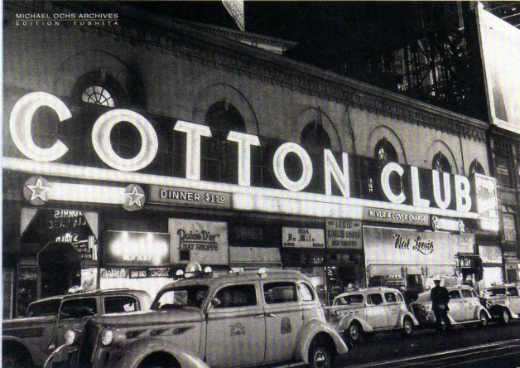 | 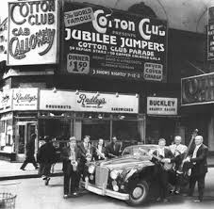

The music was often orchestrated to bring to mind a jungle atmosphere. By transforming the club into this plantation atmosphere and bringing in celebrities, Owney Madden created a demand for the Cotton Club and its exclusionary policies and also helped perpetuate widely held stereotypes about African Americans. The entertainers who played at the Cotton Club were some of the most widely known blues and jazz performers of their time including Ethel Waters, Cab Calloway, Ellington and many others. The race riots of Harlem in 1935 forced the Cotton Club to close until late 1936.
The Savoy Ballroom in Harlem
Lenox Avenue was the heart of Harlem and the site of the many of entertainment venues that made Harlem's nightlife famous. One of these clubs, the Savoy Ballroom, would emerge as a focal point, in part, because it allowed interracial dancing, unlike other famous Harlem nightspots such as the Cotton Club, which did not welcome African-American patrons. Opened in December of 1926, the "home of happy feet" spanned a full city block and boasted a 10,000-square-foot dance floor. Two bands, perched on each of the Savoy's bandstands, "battled" one another for audience approval.
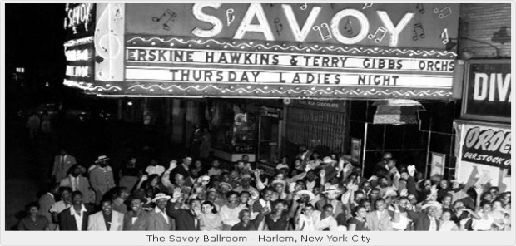 | 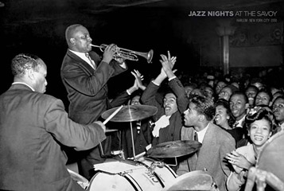
"Lindy Hoppers" and "Shim-Shammers" gathered on the wooden dance floor to elect one band as the evening's winner, or to compete in athletic dance contests. Raucous and festive, the Savoy hired black performers and kept admission reasonable so the less affluent could enjoy its festivities. Hot, progressive and always happening, the Savoy Ballroom thrived through the Harlem Renaissance, the Jazz Era and the Wartime Swing Era, finally closing its doors in 1958.
Apollo Theater
The neo-classical theater known today as the Apollo Theater was designed by George Keister and first owned by Sidney Cohen. In 1914, Benjamin Hurtig and Harry Seamon obtained a thirty-year lease on the newly constructed theater calling it Hurtig and Seamon’s New Burlesque Theater. Like many American theaters during this time, African-Americans were not allowed to attend as patrons or to perform.
In 1933 Fiorello La Guardia, who would later become New York City’s Mayor, began a campaign against burlesque. Hurtig & Seamon’s was one of many theaters that would close down.
Cohen reopened the building as the 125th Street Apollo Theatre in 1934 with his partner, Morris Sussman serving as manager. Cohen and Sussman changed the format of the shows from burlesque to variety revues and redirected their marketing attention to the growing African-American community in Harlem.

Frank Schiffman and Leo Brecher took over the Apollo in 1935. The Schiffman and Brecher families would operate the Theater until the late 1970s.
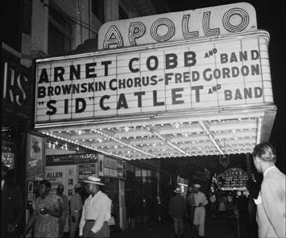 | 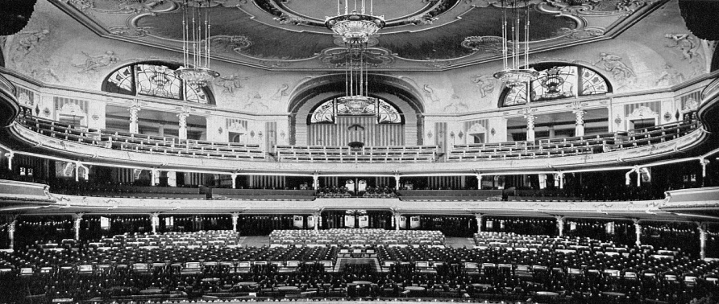
The Apollo reopened briefly in 1978 under new management then closed again in November 1979. In 1981, it was purchased by Percy Sutton a prominent lawyer, politician, media and technology executive, and a group of private investors. Under Sutton’s ownership, the Theater was equipped with a recording and television studio.
In 1983, the Apollo received state and city landmark status and in 1991, Apollo Theater Foundation, Inc., was established as a private, not-for-profit organization to manage, fund and oversee programming for the Apollo Theater. Today, the Apollo, which functions under the guidance of a Board of Directors, presents concerts, performing arts, education and community outreach programs.

Economic Reality And The Harlem Race Riot Of 1935
Even during the early '20s, when it seemed that Harlem blacks might be overcoming the insults of a racist society, they were still shut out of skilled jobs. Educated professionals were relegated to positions as elevator operators and housekeepers. That is, until the Crash of 1929 when the economic meltdown forced them from these menial positions. They joined 16 million other Americans who were also unemployed during The Great Depression, but the economic resources of the African-American community could not be contrasted favorably with even the poorest of whites. The Harlem Race Riot of 1935 was not only an eruption in response to the rumored murder of a young black shoplifter by white police "will be more explain in the upcoming pages" , but the culmination of years of humiliation and miserable poverty.
The riot would be a defining moment for Black Harlem. In the years that followed, the New Deal's public works projects initiated a halting economic recovery. During WWII, almost full employment for New York City accompanied unprecedented social and economic changes for Harlem.

World War II
Harlem swarmed with uniformed black soldiers on leave, many of whom frequented clubs like the Savoy Ballroom. Some 750,000 African-Americans served in WWII in segregated all-black units. But at home, the war proved to be a meaningful back-drop for civil-rights initiatives. Black labor organizer A. Philip Randolph assembled a March on Washington that compelled the federal government to respond to black interests. On June 25, 1941, President Roosevelt signed Executive Order 8802, forbidding racial discrimination "in the employment of workers in defense industries." New York, which became a center for the war industries, opened up jobs in shipbuilding and other trades that had previously been barred to blacks.
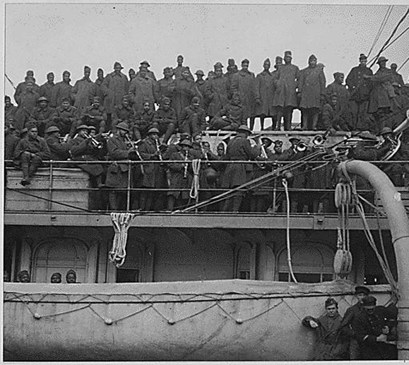 | 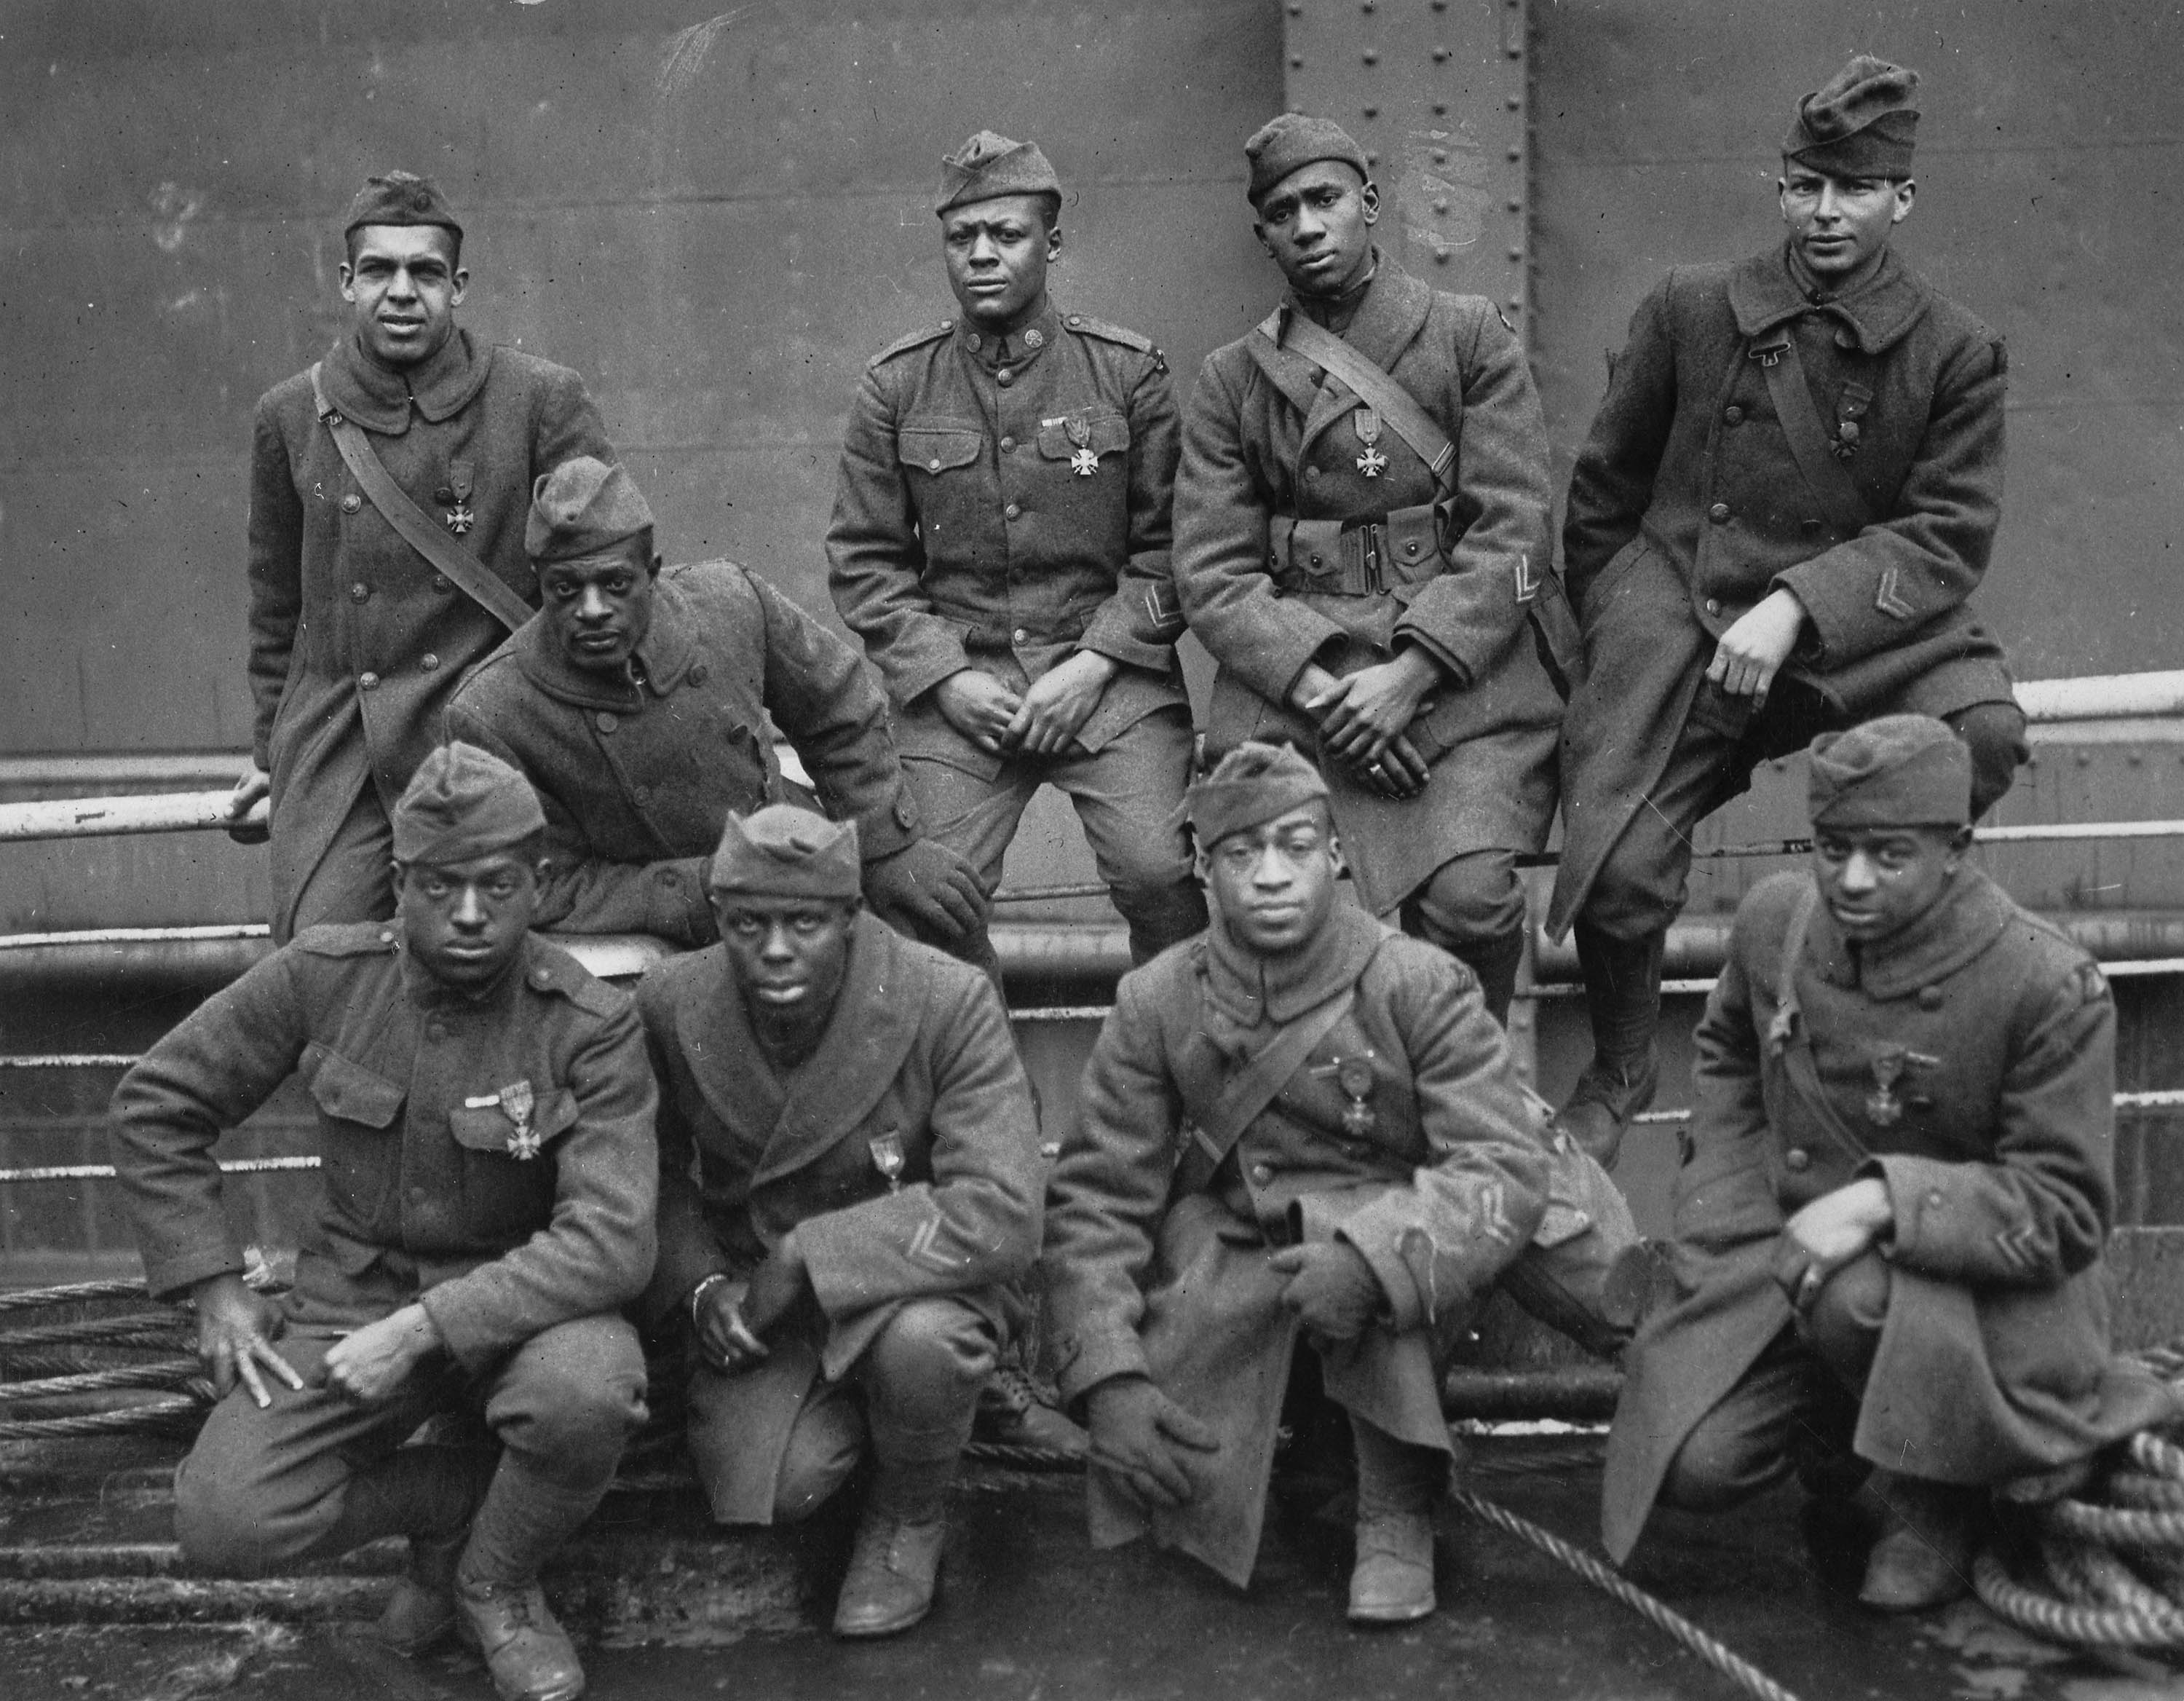 | 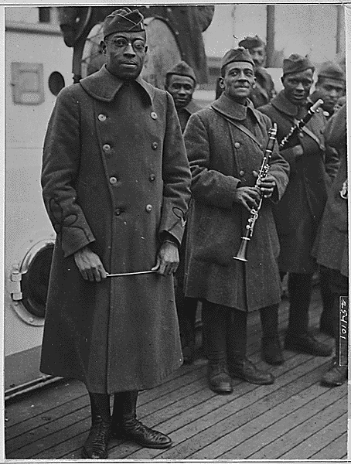
The twist to this story is that people began to have money but nowhere to spend it. Goods ranging from coffee to automobiles were rationed or unavailable for civilian purchase. The government urged cutting back and recycling to help in the war effort. There were 'dim outs' on Broadway and in Grand Central Station. Posters warned of 'idle talk' because gossip and speculation about the war or about one's job in a factory could be overheard by spies.
Billboards said, 'Is this trip really necessary?' to remind people to conserve gas. Even fashion was affected: people were encouraged to wear clothes that used less fabric short skirts for women and cuff less pants for men. The entire nation was subject to a kind of self-control that had previously been associated with poverty, but was now a great show of patriotism.
Although the daily reports of the dead, missing and wounded traumatized Americans, this war of wars managed to end the Depression and pull Harlem out of economic devastation. Also, the government propaganda that raised public consciousness about the value of freedom and human rights abroad created a vocabulary and awareness that would later be used to address racial oppression at home. In 3,000 Miles To A Hospital, Elizabeth M. Phillips, the first African-American female war correspondent, writes about American race relations that "a trip to the European Theatre of War could never be any worse. Over there I'll not be shot at because I'm colored, but because I am an enemy." Together the Depression and WWII became the great social levelers of the 20th century and paved the way for the civil rights movements of the '60s.

The Civil Rights Movement in Harlem
The civil rights movement was a political, legal, and social struggle to gain full citizenship rights for African Americans. It was first and foremost a challenge to segregation, the system of laws and customs separating African Americans and whites. During the movement, individuals and civil rights organizations challenged segregation and discrimination with a variety of activities, including protest marches, boycotts, and refusal to abide by segregation laws.
The New York Race Riots of 1964 were the first in a series of devastating race-related riots that ripped through American cities between 1964 and 1965. The riots began in Harlem, New York following the shooting of fifteen year-old James Powell by a white off-duty police officer on July 18, 1964. Charging that the incident was an act of police brutality, an estimated eight thousand Harlem residents took to streets and launched a large-scale riot, breaking widows, setting fires and looting local businesses. The eruption of violence soon spread to the nearby neighborhood of Bedford-Stuyvesant and continued for six days, resulting in the death of one resident, over one hundred injuries, and more than 450 arrests.
The New York Race Riots of 1964 highlighted the racial injustice and growing civil unrest existing in northern cities and served as a powerful indicator of the urgent need for social and economic reforms for African American communities outside of the South.
The Resources:
- http://www.history.com/topics/black-history/great-migration
- http://crdl.usg.edu/events/ny_race_riots/?Welcome
- https://www.apollotheater.org
- http://www.pbs.org/hollywoodpresents/theoldsettler/about/about_harlem.html
- http://www.blackpast.org/aah/cotton-club-harlem-1923
- http://en.wikipedia.org/wiki/Harlem

