Table of contents

Table of contents ---------------------------------------------------------------------2
Introduction ---------------------------------------------------------------------------3
The Stock Market Crash: The beginning of the Great Depression --------------4
The Main Areas of Depression --------------------------------------------------------------------5
Causes of the Depression -----------------------------------------------------------6
Effects of the Depression -----------------------------------------------------------7
Roosevelt and the New Deal --------------------------------------------------------8
The end of the Depression ----------------------------------------------------------9
Cited works --------------------------------------------------------------------------11

Introduction

The Great Depression, which lasted from 1929 to the early 1940s, was a severe economic downturn; an economic slump in North America, Europe, and other industrialized areas of the world. In the United States, the Great Depression began soon after the stock market crash of October 1929, which sent Wall Street into a panic and wiped out millions of investors. Over the next several years, consumer spending and investment dropped, causing steep declines in industrial output and rising levels of unemployment as failing companies laid off workers. By 1933, when the Great Depression reached its nadir, some 13 to 15 million Americans were unemployed and nearly half of the country’s banks had failed. Though the relief and reform measures put into place by President Franklin D. Roosevelt helped lessen the worst effects of the Great Depression in the 1930s, the economy would not fully turn around until after 1939, when World War II kicked American industry into high gear.
During the greatest economic depression in the history, the number of unemployed people reached upwards of 13 million. Many people lived in primitive conditions close to famine. One New York family moved into a cave in Central Park. In St Louis, more than 1,000 people lived in shacks made from scrap metal and boxes. There were many similar Hoovervilles; which are shantytowns built by the unemployed and destitute people at that time, all over America. Between one and two million people travelled the country desperately looking for work. Signs saying 'No Men Wanted' were displayed all over the country.

The Stock Market Crash: The beginning of the Great Depression

After nearly a decade of optimism and prosperity, the United States was thrown into despair on Black Tuesday, October 29, 1929, the day the stock market crashed and the official beginning of the Great Depression. As stock prices plummeted with no hope of recovery, panic struck. Masses and masses of people tried to sell their stock, but no one was buying. The stock market, which had appeared to be the surest way to become rich, quickly became the path to bankruptcy.
And yet, the Stock Market Crash was just the beginning. Since many banks had also invested large portions of their clients' savings in the stock market, these banks were forced to close when the stock market crashed. Seeing a few banks close caused another panic across the country. Afraid they would lose their own savings, people rushed to banks that were still open to withdraw their money. This massive withdrawal of cash caused additional banks to close. Since there was no way for a bank's clients to recover any of their savings once the bank had closed, those who didn't reach the bank in time also became bankrupt.

THE MAIN AREAS OF DEPRESSION

The US economy had experienced rapid economic growth and financial excess in the late 1920s, and initially the economic downturn was seen as simply part of the boom-bust-boom cycle. Unexpectedly, however, output continued to fall for three and a half years, by which time half of the population was in desperate circumstances (map1). It also became clear that there had been serious over-production in agriculture, leading to falling prices and a rising debt among farmers. At the same time there was a major banking crisis, including the "Wall Street Crash" in October 1929. The situation was aggravated by serious policy mistakes of the Federal Reserve Board, which led to a fall in money supply and further contraction of the economy.

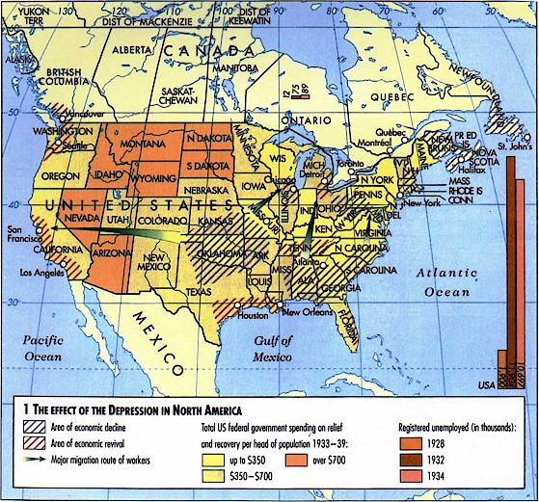
(Map 1)

Causes of the Depression

- As early as 1926, there were signs that the boom was under threat - this was seen in the collapse of land prices in Florida.
- Eventually, there were too many goods being made and not enough people to buy them.
- Farmers had produced too much food in the 1920s, so prices for their produce became steadily lower.
- There were too many small banks - these banks did not have enough funds to cope with the sudden rush to take out savings, which happened in the autumn of 1929.
- Too much speculation on the stock market - the middle class had a lot to lose and they had spent a lot on what amounted to pieces of paper.
- The Wall Street Crash of October 1929 was a massive psychological blow.
- America had lent huge sums of money to European countries. When the stock market collapsed, they suddenly recalled those loans. This had a devastating impact on the European economy.
- The collapse of European banks caused a general world financial crisis.

Effects of the Depression

- Unemployment - 13 million people were out of work.
- Industrial production dropped by 45 per cent between 1929 and 1932.
- House-building fell by 80 per cent between 1929 and 1932.
- The entire American banking system reached the brink of collapse.
- From 1929 to 1932, 5,000 banks went out of business.
- Although many people went hungry, the number of recorded deaths from starvation during the Depression was 110, although many other illnesses and deaths were probably related to a lack of nutrition.

Roosevelt and the New Deal

The U.S. economy broke down and entered the Great Depression during the presidency of Herbert Hoover. Although President Hoover repeatedly spoke of optimism, the people blamed him for the Great Depression. Just as the shantytowns were named Hoovervilles after him, newspapers became known as "Hoover blankets," pockets of pants turned inside out (to show they were empty) were called "Hoover flags," and broken-down cars pulled by horses were known as "Hoover wagons."
During the 1932 presidential election, Hoover did not stand a chance at reelection and Franklin D. Roosevelt won in a landslide. People of the United States had high hopes that President Roosevelt would be able to solve all their woes. As soon as Roosevelt took office, he closed all the banks and only let them reopen once they were stabilized. Next, Roosevelt began to establish programs that became known as the New Deal.
These New Deal programs were most commonly known by their initials, which reminded some people of alphabet soup. Some of these programs were aimed at helping farmers, like the AAA (Agricultural Adjustment Administration). While other programs, such as the CCC (Civilian Conservation Corps) and the WPA (Works Progress Administration), attempted to help curb unemployment by hiring people for various projects.

The End of the Great Depression
To many at the time, President Roosevelt was a hero. They believed that he cared deeply for the common man and that he was doing his best to end the Great Depression. Looking back, however, it is uncertain as to how much Roosevelt's New Deal programs helped to end the Great Depression. By all accounts, the New Deal programs eased the hardships of the Great Depression; however, the U.S. economy was still extremely bad by the end of the 1930s.
The major turn-around for the U.S. economy occurred after the bombing of Pearl Harbor and the entrance of the United States into World War II. Once the U.S. was involved in the war, both people and industry became essential to the war effort. Weapons, artillery, ships, and airplanes were needed quickly. Men were trained to become soldiers and the women were kept on the homefront to keep the factories going. Food needed to be grown for both the homefront and to send overseas.
The entrance of the U.S. into World War II was the reason why the Great Depression in the United States has ended.

Works Cited

History.com Staff. “The Great Depression”. History.com. A+E Networks, 2009. Web. 13 February 2015.

http://www.bbc.co.uk/schools/gcsebitesize/history/mwh/usa/walldepressionrev1.shtml

http://www.english.illinois.edu/maps/depression/about.htm

http://history1900s.about.com/od/1930s/p/greatdepression.htm

