The Middle Passage
The Trans-Atlantic Slave Trade

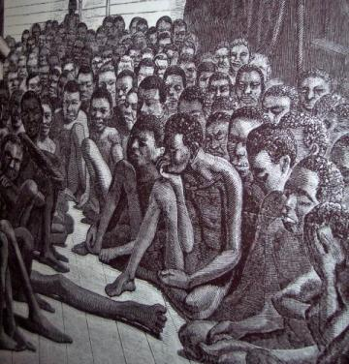

Back in middle ages, slavery and human trading used to be something as common as trading gold, clothes, fabric and even wood. It was a form of luxury, to own a slave or to buy a human being. Humanity was stripped naked, and was not familiar of the masks, which are very popular in our time and age.

European merchants used to travel overseas to African countries just in order to ship Africans who were either traded for food, raw materials, gold or any European object, that is considered foreign to Africans, and in some if not most cases, they were kidnapped. Welcome to the age of slavery, welcome to The Middle Passage.

The two Americas and the Caribbean received their share of slaves from European traders, who used to enslave Africans mostly from eight countries: Senegambia, Upper Guinea, Windward Coast, Gold Coast, Bight of Benin, Bight of Biafra, West Central Africa and Southeastern Africa.

The inhumane act had a huge toll on Africans and on both sides of the world. The Europeans and Americans suffered from silent venoms, which were the vile acts that were never condemned nor frowned upon. This caused scarcity of basic humane acts, such as smiling to people of color, or patting the head of an African child. Women were known to force their children to wash their hands if they ever played with a child of a slave, what would be the result of this? Naturally, the enslaved child will grow up resenting his masters, and it might cause them to want to kill them to show disapproval of humiliation. They used to be humiliated and tortured for the simplest things just to ensure their obedience, as for the rebellious slaves, they could be easily killed and no one will act against it, or say a word about it. It was a time where evil was a natural act, and surely was not an age of innocence.

During this horrific period, many slaves have tried to escape or stand up against the unjust and tyranny, but all of them were either tortured to death or killed in the spot. The pain and agony produced word heroes, artists and legends, and most importantly abolitionists.

Most people are familiar with the name Rosa Parks, an African American woman, who refused to sit in the back of the bus, where it was for the people of color. Rosa was named “The First Lady of Civil Rights” and “The Mother of The Freedom Movement”.
Rosa Parks was born years and years after Abraham Lincoln, the 16th president of the United States abolished slavery. But as we can see, regardless of the fact that slavery has ended, its ugly roots still exist and produced as a result, racism and prejudice. This is why in the 20th century, people had special places for those of color, special schools and special facilities, this way they will not be able to mingle with white the white man.

Slavery has ended constitutionally, but its dark shadows are still peeking in every corner. Up till now some Americans can’t accept a black president, won’t allow a doctor of color to treat them and can’t allow their children to marry a person of color. In the 90s, African Americans started singing the pain and agony away in rap and hip hop songs, they sang for freedom and equality. They made jokes about it, and dark comedy emerged, where they indirectly showed how ugly racism against people of color in America is.

All this pain, which people of color are still suffering from, was the result of The Middle Passage. The toll of that age is hiding under masks, under layers of skin. It’s unspoken but felt, unwritten but affective, undocumented but always decisive. The black people still celebrate the first ones in everything; the first black woman to win an Oscar, the richest and most powerful woman is black and most importantly the first black president. It’s now the new generation’s role to purify and clean and to start planting greenery over the molded ground, where the Middle Passage emerged, the faith is igniting, but it needs time.

Wafa M. Almasoud ID: 209045827

