Drama

What Is Drama?
A drama is a story enacted onstage for a live audience.

Notice
Drama is a literary composition involving conflict, action crisis and atmosphere designed to be acted by players on a stage before an audience. This definition may be applied to motion picture drama as well as to the traditional stage.

What Is Drama?
The word drama comes from the Greek verb dran, which means
“to do.”
*The earliest known plays . . .
*were written around the fifth century B.C.
*produced for festivals to honor Dionysus, the god of wine and fertility

Notice
The Etymology of the word drama is derived from the Greek verb dran meaning to do or to act. Basically, drama involves the presentation of a situation or the telling of a story in terms of some kind of physical action, such as savages dancing around a totem pole, or strolling players presenting their "interludes" in inn yards of sixteenth-century England, or that of a sophisticated group of actors performing a comedy in a theatre.
Usually this action is visible physical action on a stage. The basic means of presenting life on the stage is through the spoken words of the actors as well as through pantomime (farce, joke) and other forms of physical movement. We should say that a drama tells a story by means of dialogue and action.

What is a play?
A play is a representation of human beings
“in action.” But “action” does not mean mere
physical movement; it includes psychological
motivations that lie behind visible behaviour.
The dramatic action incorporates what is
actively done and the purpose for which it is
done

Notice
Play is a translation of (ludus /lauds) which means recreation or play

Origin of Drama
1- The Primitive Drama:
* Religious in nature
Struggle between life and Death
* actors
* audience: whole tribe
* open place, outside
* directors: people to guide them

Notice
Greek theatre took place in large hillside amphitheatres. The players included a chorus and their leader, and the "lines" were more chanted than spoken. The chorus performed in the "orchestra", not on a raised stage. The use of masks to represent characters and high-soled boots worn to add height to the players limited the movement of the actors. Greek drama was dominated by the works and innovations of five playwrights : Aeschylus (525-456 B.C.), Sophocles (496-406 B.C.) , Euripides (480-406 B.C.), Tragedians; Aristophanes (448-380 B.C.) and Menander (342-292 B.C.) Comedies. The drama had its roots in religious ritual and celebration, particularly in the worship of Dionysus, the god of festivity.

Tragedy
A tragedy is a play that ends unhappily.
Most classic Greek tragedies deal with serious, universal
themes such as
1right and wrong 2justice and injustice 3life and death
Tragedies deal with human limitations against the larger forces of destiny.
notice
Greek theatre grew out of a religious festival, and was often concerned with the deepest questions about morality and the relationship between mortals, the gods, and fate.
Tragedy
The protagonist of most classical tragedies is a tragic hero. This hero
  - is noble and in many ways admirable
  - has a tragic flaw, a personal failing that leads to a tragic end
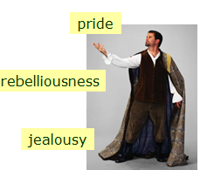
Comedy A comedy is a play that ends happily. The plot usually centers on a romantic conflict.

Comedy
The main characters in a comedy could be anyone:
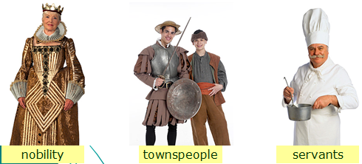
Comedy
*Comic complications always occur before the conflict is resolved.
In most cases, the play ends with a wedding . *

2-The Medieval Drama
Drama in England began in the church.
* Liturgical Plays( public worship); short playlets,4 lines with 4 priests as actors, inside the church, stories from Bible.
* Mystery plays (Miracle Plays)
Bible stories or events from lives of saints, miracles of Prophets.
Notice
The Church linked its own religious holidays with these seasonal festivals and began to use dramatic form to illustrate the stories underlying these holidays so as to reinforce their religious connotation and to better communicate the stories to an illiterate congregation. The dramas continued to grow, moving out of the sanctuary and into the open air in front of the Church. The members of town guilds began to contribute to these dramas. Each guild prepares a decorated cart called pageant like a stage to actors. The audience surrounds the cart& watch performance. E.g. fall of Lucifer, the creation of Heaven and hell etc..

2-The Medieval Drama
* Morality plays:religious in intention, but concerned with the lives of ordinary people
*Interludes: short plays presented between acts of long morality plays.
Notice
Morality plays Plots invented by authors; playwrights. Actors: not guildsmen, but members of local acting associations, acting companies. They dramatize virtues : honesty, chastity, friendship..best example Everyman talks about death, all friends of man refuse to join him to the journey with death except good deeds.
*Interlude Plays: minor characters, in banquets of rich people. They are funny

3-The Elizabethan Drama
The Golden Age
*Inn yards: traveling actors
*Fear of plague, Puritan objection
*The Globe, centre open to the sky, octagonal( eight angles& sides)
*1642 Puritans closed the theatres

Notice
*T he Golden Age of Elizabethan Drama
*Inn yards: traveling actors
*Fear of plague, Puritan objection
*Theatre outside city boundaries
*1576 The theatre
*The Globe, centre open to the sky, octagonal
*Theatre outside city boundaries*Theatre inside city boundaries
*Women are not allowed to act
*1642 Puritans closed the theatres
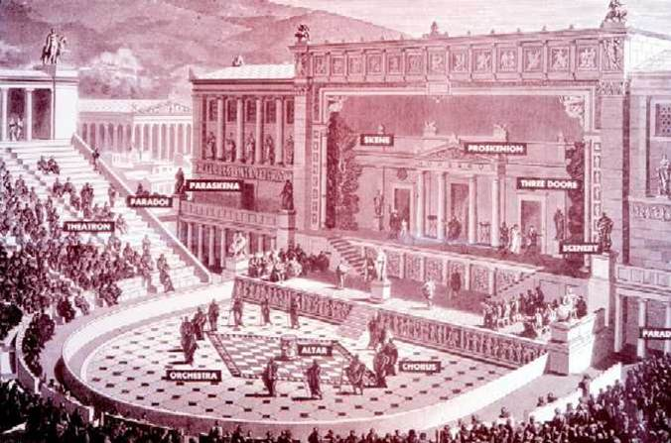
Notice
Performance of a Play: When you read a play, remember that it is meant to be performed for an audience. Stage Directions Playwright describes setting and characters’ actions and manner. Performance
Theater artists bring the playwright’s vision to life on the stage. The audience responds to the play and shares the experience.

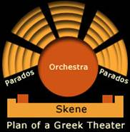
Performance of a Play Theatre artists include
Actors ,Directors, Lighting technicians, Stage crew
Parades=entrance 4 public
Orchestra: space where the choir performed
Skene: entrance for actors

Elizabethan Stage
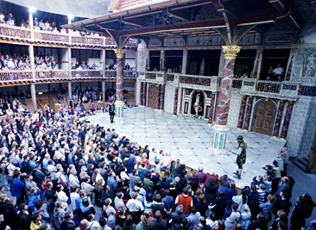
Notice
Setting the Stage : Stages can have many different sizes and layouts . “Thrust” stage, The stage extends into the viewing area, The audience surrounds the stage on three sides.
Setting the Stage
“In the round” stage is surrounded by an audience on all sides.
Proscenium stage
  - The playing area extends behind an opening called a “proscenium arch.”
  - The audience sits on one side looking into the action.
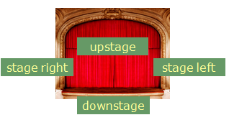

Stages in Shakespeare’s time were thrust stages.
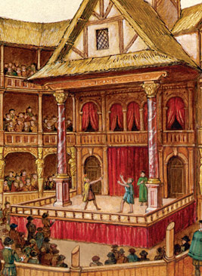
Notice
The Globe was built by Cuthbert Burbage, the brother of the most famous Shakespearean actor of the Elizabethan Age, Richard Burbage. It has total capacity of 2,000 and 3,000 spectators, all performances at the Globe were conducted, weather permitting, during the day . There was no proscenium arch, no curtains, and no stagehands to speak of other than the actors themselves. The original structure of the Globe Theatre stood until 29 June, 1613, when its thatched roof was set ablaze by a cannon fired in a performance of Henry VIII and the Globe burned to the ground.
Setting the Stage
Scene design transforms a bare stage into the world of the play. Scene design consists of
- sets
- lighting
- costumes
- props
A stage’s set might be
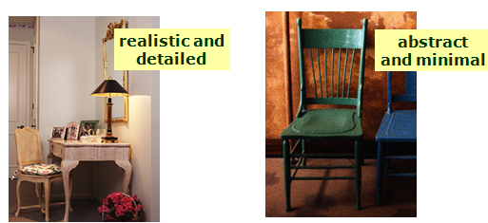

Setting the Stage
A lighting director skillfully uses light to change t The costume director works with the director to design the actors’ costumes.
he mood and appearance of the set.
Like sets, costumes can be
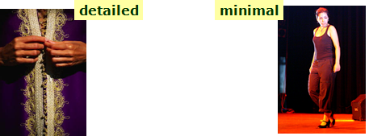

*Props (short for properties) are items that the characters carry or handle onstage.
*The person in charge of props must make sure that the right props are available to the actors at the right moments.
The Characters
The characters’ speech may take any of the following forms.
Dialogue: conversations of characters onstage
Monologue: long speech given by one character to others
Soliloquy: speech by a character alone onstage to himself or herself or to the audience
Asides: remarks made to the audience or to one character; the other characters onstage do not hear an aside

The Audience
Finally, a play needs an audience to
experience the performance
understand the story
respond to the characters

Tragedy
Comedy
2-The Medieval Drama
Drama in England began in the church.
* Liturgical Plays( public worship); short playlets,4 lines with 4 priests as actors, inside the church, stories from Bible.

* Mystery plays (Miracle Plays)
Bible stories or events from lives of saints, miracles of Prophets.
2-The Medieval Drama
* Morality plays:religious in intention, but concerned with the lives of ordinary people
*Interludes: short plays presented between acts of long morality plays.
3-The Elizabethan Drama
The Golden Age
*Inn yards: traveling actors
*Fear of plague, Puritan objection
*The Globe, centre open to the sky, octagonal( eight angles& sides)
*1642 Puritans closed the theatres
Theatres
Elizabethan Stage
Stages in Shakespeare’s time were thrust stages.

Setting the Stage
The Characters
The Audience

