Elements Of Drama
According to Aristotle there are six elements:
* Plot
* Character
* Thought
* Diction
* Music
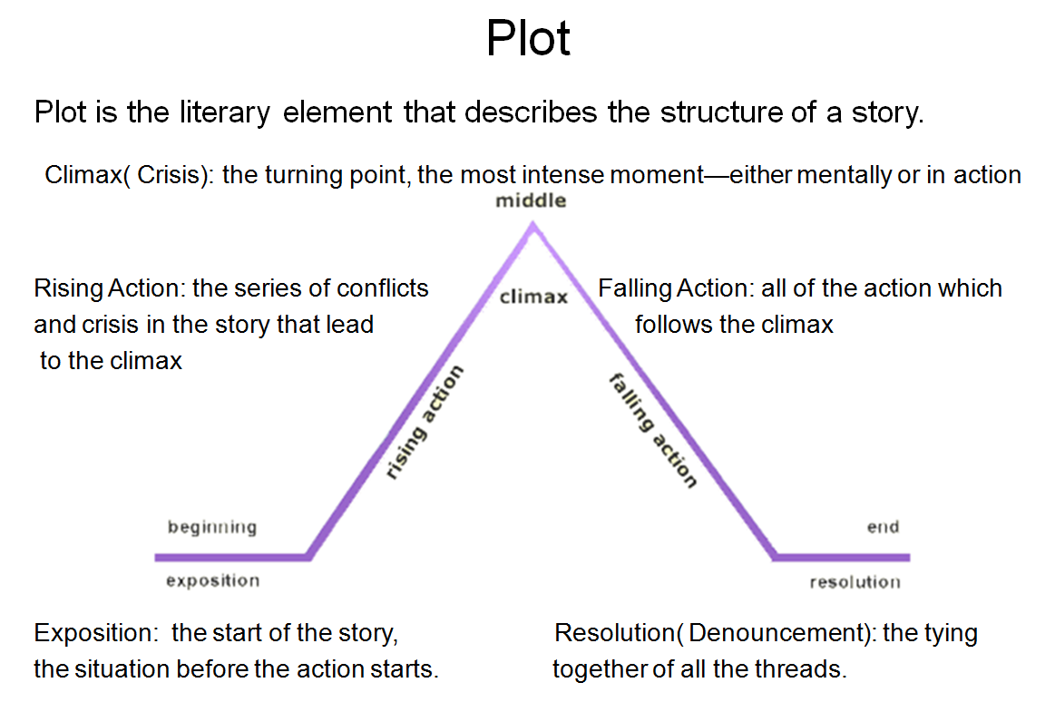
* Spectacle

The Beginning
It involves exposition, or the
setting forth of information –
about earlier events, the identity
and relationship of the characters,
and the present situation. While exposition is an
un-avoidable part of the opening scenes, it is not
confined to them, for in most plays information
about the past is only gradually revealed

The Middle
The middle of a play is normally
composed of a series of complications.
A complication is any new element that
changes the direction of the action –
the discovery of new information, for example, or the arrival of a character.
The substance of most complications is discovery. Discoveries may involve objects, persons , facts, values, or self. Means other than discoveries may be used to precipitate complications. Natural disasters are sometimes used.
The series of complications culminates in the crisis, or turning point of the action.

The End

The final portion of a play, often called the resolution, denouement, or catastrophe extends from the crisis to the final curtain.

Plot Conflict

Conflict is the dramatic struggle
between two forces in a story.
Without conflict,
there is no plot.
Character Vs character
Character Vs Nature
Character Vs Self
Character Vs Society

Character
Character is a person depicted in a narrative or drama.
Characters may be flat, minor characters; or round, and major. The main character in a story is generally known as the protagonist; the character who opposes him or her is the antagonist. Character is revealed by how he/ she responds to conflict, by his or her dialogue, and through descriptions
Characterization is the playwright’s means of differentiating one personage from another.
It may be divided into four levels:
* Physical
* Social
* Psychological
* Moral

Physical
. Basic facts as:
* Sex
* Age
* Size
* Colour/ appearance

Social
The factors that place a character in a particular environment.
* Economic status
* Profession
* Trade
* Religion
* Family relationships

Psychological

The inner workings of the mind:
* A character’s habitual responses
* Desires
* Motivations
* Likes
* Dislikes
Since drama most often arises from conflicting desires, the

psychological is the most essential level of characterization.

Moral
*It is most fully developed in serious plays.

* It reveals what characters are willing to do to
get what they want (as opposed to what they
have said, they or others should do in such
situations).

*Moral decisions differentiate characters more
fully than any other type.

A playwright can emphasize one or more of these levels and may assign many or few traits, depending on how the character functions in the play.
*Minor characters
*Principal characters
The principal characters need to be drawn in considerable depth.
A character is revealed in several ways:
* Through descriptions in stage directions and prefaces,
* What the character says
* What others in the play say and, most important,
* Through what the character does.

Thought
Sometimes the author’s intention is clearly stated in the script.
Dramatists in different periods have used various devices to project ideas:
* Direct statement:
chorus, soliloquies, asides
* Allegory
* Symbol.
Greek chorus 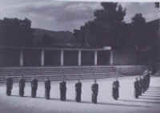

Diction

*Language ( diction) is the playwright’s primary means of expression.

*The basic criterion for judging diction is its appropriateness to the characters, the situation, the level of probability, and the type of play.

Music

Music, as we ordinarily understand the term, does not occur in every play. But if the term is extended to include all patterned sound, it is an important ingredient in every production.

*The performers- through the elements of pitch, stress, volume, tempo, duration, and quality- transform print into sound. It is through these elements that meaning is conveyed.

*In addition to the sound of the actors’ voices, a play may also use music in the form of incidental songs and background music
Spectacle

The visual elements of a production:
* the movement and spatial relations of characters
* lighting
* settings
* costumes
* properties

The reader of a script must try to envision the spectacle in order to grasp a play’s full power.
Many older plays contain almost no stage directions, and all clues must be sought in the dialogue to help the reader visualize the action

