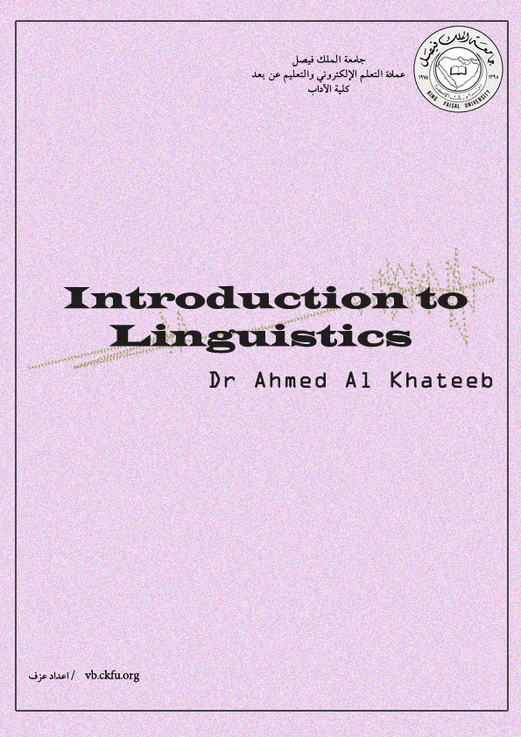Lecture 1
The Origins of language
Introduction to linguistics
- Linguistics includes the systematic and scientific study of language.
- Linguistics is concerned with understanding the structure and nature of language which is divided into: phonetics, phonology, morphology, syntax, semantics and pragmatics.
- Linguistics deals with other perspectives on language which are represented in specialized or interdisciplinary branches such as sociolinguistics, psycholinguistics, neurolinguistics and second language acquisition.
Before we start: we should be aware that:
- We do not know how language was originated. Yet, we know that spoken language developed thousand years before written language.
- It is estimated that some spoken languages have developed between 100,000 and 50,000 years ago.
- Written languages have developed nearly 5000 years ago.
- There is ability of producing sounds and vocal patterning which is shared among different creatures such as fish and birds; but that is not human language.
- No physical evidence relating to the speech of our distant ancestors that might tell us how language was existed in the early stages.
Speculations about the sources of the origins of language
- The divine source
- The natural sound source (bow-wow/pooh-pooh theories)
- The social interaction source
- The physical adaptation source (teeth and lips/mouth and tongue and larynx and pharynx)
- The tool-making source (the human brain)
- The genetic source (innateness hypothesis)
- The divine source
- Divine is related to God or Creator ‘الهي’.
- In most religions, it is believed that language appears to be a divine source that provides human with language.
- Some experiments confirm that if human infant get deprived of hearing language around them, they would spontaneously begin using God or Creator-given language in the Psamtik story.
- Yet, other experiments - of children who lived in isolation without contact with humans - did not confirm the results of divine-source experiments as in the Cases of Victor and Aveyron who were discovered in the 18th century; as they did not show a spontaneous language, as in the previous experiment.

- The natural sound source
- This view is based on the concept that natural sounds which are attained through the auditory system that develops before birth which later develop to identify sounds in the environment.
- This will help humans to connect between a sound and the thing (or organ) producing that sound.
- Imitation of natural sounds lead to the development of primitive words (which were heard by early men and women around them).
- Jespersen (1922) called this idea of acquiring natural sounds ‘Bow-wow’ and ‘Pooh-pooh’ theories.

- Bow-wow theory
- It focuses on imitation of sounds then using it to refer to objects (even when they are not present), e.g. Coo-Coo.
- In every language, there are words which seem to be naturally occurring sounds such as splash and boom; which may refer to sounds similar to the noises they describe.
- Yet, it is hard to see how soundless things (low branch) or abstract concepts (truth) have been referred to in a language that echoed natural sounds. Therefore, the view that language is only a set of words to describe names for things not always necessary.

- Pooh-pooh theory
- While this theory is based on that speech developed from the instinctive sounds people make in emotional circumstances.
- So, the original sound of language came from natural cries of emotion such as pain, anger or joy.
- Words such as Ah!, Wow!, Ooh! are all used with sudden intakes of breath; unlike when we want to talk which is the opposite.

- The social interaction source
- This view is based on the idea that the source of our language is the physical effort of several people and interaction which is to be coordinated.
- It happens when a group of early humans develop a set of hums, groans … etc. that were used when they were carrying things.
- It claims that the development of human language takes place in a social context through groups.
- Groups are important particularly in the past to main communication; which had different uses within their social interaction.

- The physical adaptation source
- This source is based on physical features human processes that are distinct from other creatures (particularly non-humans) which may have enabled speech production.
- Our (human) ancestors showed adaptation to up-right posture and revised role for the front limbs.
- Adaptation (or changed) happened to fossilized skeletal structures which later began to be similar to modern humans.
- This (partial) adaptation appeared to be more relevant to speech.
- Such features would not enable speech in some primates; yet they are clues that a creature with similar features might have the capacity for speech production.

- Teeth and lips
- Human teeth are different from other creatures. They are suitable to produce sounds such as F or V.
- Human teeth are upright and suitable for chewing.
- Human lips have intricate muscle interlacing more than other primates.
- Human lips are appropriate to produce sounds such as P or B and M.

- Mouth and tongue
- Human mouth are small compared to other creatures; as a part of an extended vocal tract with an L-shape not straight path from front to back.
- Human tongue are shorter, thicker and more muscular than other creatures; to produce a variety od sounds inside the oral cavity.
- The intricate muscles in mouth and tongue and lips and teeth help to articulate a wider range of shapes and a more powerful delivery of sounds produced through these shapes.
- Larynx and pharynx
- Human larynx is ‘voice box’ which comprises of vocal folds and vocal cords; which different other creatures larynx.
- Larynx helps human to choke on pieces of food.
- Human pharynx has a longer cavity than many other creatures; which works as a resonator for increased range and clarity of the sounds produced through the larynx and vocal tract.
- Therefore, there are advantages of getting this extra vocal power to outweigh the potential disadvantages from an increased risk of chocking which might lead to death.

- The tool-making source
- It is speculated that human hands and manual gestures may have been a precursor of language.
- Two million years ago, human managed to develop preferential right-handedness and had become able to make stone tools; tool-making is evidence of a brain at work.
- The human brain (1)
- The human brain is lateralized; where it has different functions for each hemisphere.
- Left hemisphere of the brain is responsible for complex vocalization and speaking
- Interestingly, motor cortex that controls the muscles of the arms and hands is next to articulatory muscles of face and jaw. It is believed that there is a connection between the language-using and tool-using abilities of humans.
- The human brain (2)
- Many speculative proposals argue that the origins of speech is based on human producing single noises to indicate objects in their environment. Yet, it lacks structural organization. All languages require the organizing and combining of sounds and signs in specific arrangement.

- The human brain (3)
- In terms of tool-making, it is not enough for human to grasp one rock (to make one sound) but need to bring two rocks to create proper contact with the first and to develop a tool
- In terms of language structure, the human may have developed the naming ability first for producing consistent noise; then to bring another specific noise to build a complex message.

- The genetic source (innateness hypothesis)
- The human baby are born with larynx that is higher in the throat that is to breathe and drink at the same time.
- After a few months, the larynx descends, the brain develops and start walking and talking.
- In fact, young child’s language is complex and seen as more than physical adaption of species. It seems that language is an innate feature; what is known as ‘innateness hypothesis’
- The ‘innateness hypothesis’ refers to something in human genetics as the source, possibly a crucial mutation.
- As we consider this hypothesis, there is a movement from fossil evidence or the physical source of adaptation towards analogies with how computer work (being pre-programmed or hard-wired)
- Yet, we are not sure when this rapidly genetic change might take place or how it might relate to the physical adaptation.

Lecture 2
Animals and Human Language

Two key questions to think about:
- Is it possible that a creature could learn to communicate with humans using language?
- Does human language have properties that make it so unique to be learned by other creatures?

Communication
During our communication, we need to distinguish between:
- Communicative signals:
It happens when someone intentionally use language to tell this person something.
e.g., I am one the applicants for the vacant position of senior brain surgeon at the hospital. This is considered as to be intentionally communicating something.
- Informative signals:
It happens when someone may become informed about you through signals that you have not intentionally sent. For example, someone might note that you have a cold because you sneezed.
Both of animal communication and human language are considered to be means of intentional communication.

Properties of human language
Humans are able to reflect on language and its uses. Without this abilities humans would not be able to reflect on properties of human language.
- Displacement
- Arbitrariness
- Productivity
- Cultural transmission
- Duality
- Displacement
- It allows language users to talk about things and events not present in the immediate environment.
- Indeed, displacement allows us to talk about things and places whose existence we cannot even be sure of.

2. Arbitrariness
- There is no natural connection between a linguistic form and its meaning. This connection is arbitrary.
- Some words in English seem to be less arbitrary such as crash and slurp.

- Productivity
- It is also called creativity and open-endedness.
- It means that the potential number of utterances in any human language is infinite; unlike the communication system of other creatures.
- Animal communication lacks productivity which can be described ‘fixed reference’.

- Cultural transmission
- Language is acquired through a culture with other speakers not from parental genes.
- Humans are born with some predisposition to acquire language in a general sense; but not born with the ability to produce utterances in specific language such as English but rather to acquire the first language as children in a culture.
- Non-humans are born with a set of specific signals that are produced instinctively.

Talking to animals
Some spoken languages are directed by humans to animals, as we see in circus animals.
Chimpanzees and language
- In an experiment regarding teaching a chimpanzee to use a human language, Luella and Winthrop Kellog reported that the chimpanzee (Gua) had the ability to understand nearly 100 words but did not manage to any of them.
- Another experiment was done by Catherine and Hayes to teach a chimpanzee (Viki) a human language. Catherine and Hayes spent five years attempting to get Viki to say some English Words. Viki managed to produce some basic words such as mama, papa and cup.
- From these experiments and others, it was concluded that non-human primates do not actually have the physical and structural ability (vocal tract) to articulate the sounds used in speech.
- Chimpanzees, apes and gorilla can all communicate with a wide range of vocal calls, but they just cannot make speech sounds like humans.
- From different experiments, it was concluded that the Chimpanzees’ behavior is viewed as a type of conditioned response to cues provided by human trainers.
- Herbert’s also concluded that Chimpanzees are clever creatures who produce certain type of behaviors to get rewards which can make sophisticated tricks.
Using language
- Some Chimpanzees were found capable of taking part in interaction with humans – using a symbol system by humans.
- Chimpanzees did not perform linguistically on a level comparable to a human child.
- The behavior of a two-year human child interacting with a caregiver is an example of using language.
- We observe very similar behavior from Chimpanzees when they interact with humans
- Accordingly, we can say that in both cases we observe participants ‘using language’.
- Yet, there is a still difference in term of ‘using language’ between humans and non-humans.
Such meaning of ‘using of language’ (by humans) is the capacity to develop a complex system of sounds and structures which allow users to use extended discourse containing infinite number of novel utterances. It is in this more comprehensive and productive sense that we say that language is uniquely human.

Lecture 3
The sounds of language (phonetics) علم الصوتيات
In this lecture we will be looking at the following questions:
1. How the symbols of the International Phonetic Alphabet (IPA) can be used to represent both consonant and vowel sounds of English words?
(IPA is an internationally recognized set of phonetic symbols developed in the 19th century to restrict one-to-one correspondence between sounds and symbols)
2. What physical aspects of human vocal tract are involved in the production of those sounds?
- Phonetics:
- It refers to the general study of the features of speech sounds.
- Phonetics is classified into:
- Articulatory phonetics which refers to how speech sounds are made or articulated.
- Acoustic phonetics which refers to the physical properties of sounds such as sound waves in the air.
- Auditory phonetics which refers the perception of speech sounds.
- Voiced and voiceless sounds
- When the vocal cords are spread apart, the air from the lungs passes between them unimpeded. Sounds produced in the way are described as voiceless.
- Such voiceless sounds are: S or F (by placing your fingertip on the top of your Adam’s apple, you can not feel any vibration).
- On the other hand, when the vocal cords are drawn together, the air from the lungs repeatedly pushes them apart as it passes through, creating a vibration effect. This is described as voiced.
- Such voiced sounds are: Z or V (by placing your fingertip on the top of your Adam’s apple, you can feel some vibration).

- The two classes of sounds:
  - 1. Consonants (الحروف الساكنة) nearly 24 sounds
- A consonant is a speech sound that is articulated with complete or partial closure of the vocal tract.
- Most consonant sounds are produced through tongue to shape the oral cavity through which the air is passing.
- Places of articulation of sounds describes the location inside the mouth at which the constriction takes place.
Consonant sounds (الحروف الساكنة)
- Places of articulation are:
bilabials,
labiodentals,
dentals,
alveolars,
palatals,
velars and
glottals
Places of articulation of consonant sounds:
- Bilabials = both lip
e.g.
([p],[b],[m])
2. Labiodentals = the upper teeth with the lower lip
e.g.
([f], [v])
3. Dentals = the tongue tip behind the upper teeth or between the teeth.
e.g., ([Ө][ð]) الاصوات هنا ذا , ثا
4. Alveolars = the front part of the tongue on the alveolar ridge (the rough area behind and above the upper teeth)
e.g.,
([t],[d],[n],[s],[z])
5. Palatals = the tongue and hard palate (on the roof of the mouth)
e.g.,
([j])
6. Velars = the back of the tongue on the velum (soft palate)
e.g.,
([k],[g],[ŋ])
7. Glottals = using the glottis, the open space between the vocal folds
([h])
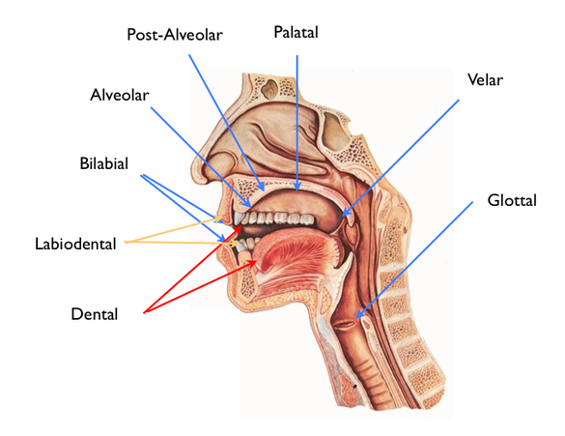
The two classes of sounds:
Within consonant sounds, we have:
- Familiar symbols which denote to most consonant sounds such as [p] in pop and [m] mom. (bilabial voiceless consonants - produced by both lips)

- Unfamiliar symbols which refer to less familiar sounds, as they two ways of representing them, such as [th] in words thus and loathe. (dental voiceless consonants - produced with the involvement of teeth)
- Manner of articulation (what kind of constriction is there)
- It is concerned with the degree of obstruction or the type of channel imposed upon the passage of air at a given place of articulation.
- It ranges from completely closed to completely open:
- Stops Air flow is COMPLETELY CLOSED
- Fricatives الاصوات الاحتكاكية
- Affricatives
- Nasals
- Liquids
- Glides
(Vowels) COMPLETELY OPEN
- Stops or plosives = produced by completely stopping the air.
- Fricatives = produced by forcing the air through a narrow channel made by placing two articulators together, such as /f/ and /th/
- Affricates = produced as stops at the beginning and released as fricatives at the end, such as /ch/ and /j/
- Nasals = produced by allowing the air to escape freely through nose, such as /n/ and /m/.
- Liquids = produced by partial closure in the mouth, such as /r/ and /i/.
- Glides/semi-vowels = produced with the tongue in motion or from the position of a vowel, such as /w/ and /y/ in yes and west.

- 2. Vowels ((الحروف المتحركة
- A vowel is produced with a relatively free flow of air. They are voiced.
- Vowels have four positions: front, back, high and low areas. For example, the pronunciation of heat and hit have a high front vowels because the sound is made with the front part of the tongue in a raised position. On the other, the vowel in hat is produced with the tongue in lower position and the sound in hot can be described as a low-back vowel.
Vowels ((الحروف المتحركة
- A vowel is a speech sound in which the mouth is open and the tongue is not touching the top of the mouth, the teeth. (Oxford Learner’s Dictionary).
- Vowel is a speech sound produced by humans when the breath flows out through the mouth without being blocked by the teeth, tongue, or lips. (Cambridge Learner’s Dictionary).
Vowels ((الحروف المتحركة
- The position of the highest point of the tongue is considered to be the point of articulation of the vowel.
- The vertical dimension of the vowel diagram is known as vowel high, which includes high, central (mid), or low vowels. The horizontal dimension of the vowel diagram includes tongue advancement and identifies how far forward the tongue is located in the oral cavity during production.
Vowels ((الحروف المتحركة
- e
mid, front, unrounded, example: lake
- i
high, front, unrounded, example: reep
- o
mid, back, rounded, example: oar
- u
High, back, rounded, example: poop
- 3. Diphthongs
- Diphthongs is a combination of two adjacent vowel sounds within the same syllable.
- There are eight diphthongs commonly used in English: /eɪ/, /aɪ/, /əʊ/, /aʊ/, /ɔɪ/, /ɪə/, /eə/, and /ʊə/.
- For example, the phrase no highway cowboys /ˌnoʊ ˈhaɪweɪ ˈkaʊbɔɪz/ has five distinct diphthongs, one in every syllable.
- Words such as Hi or Bye have two vowel sounds and the movement of these diphthongs is from low towards high front.
- Diphthongs double vowels
- aɪ
ride, chloride, tide
- ɔɪ
boy, toy, voice,
- aʊ
trout, couch
Standard English (RP = Received Pronunciation) has 44 phonemes (speech sounds):
- Consonants, 24;
- Vowels, 12;
- Diphthongs, 8.
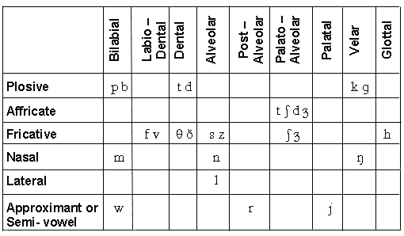
English consonant chart -24 (place + manner of articulation)
English vowels chart (12 vowels)
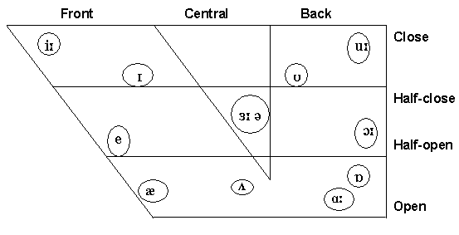
English diphthong chart (8 diphthongs)
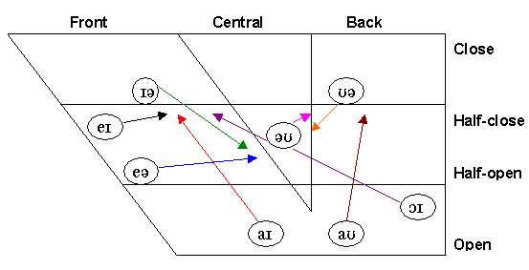

Vowel sounds:
- 5 long vowels:
e.g., bean, barn, born, boon, burn
- 7 short vowels:
e.g., pit, pet, pat, putt, pot, put, another
- 8 diphthongs:
e.g, bay, buy, boy, no, now, pair, poor

