Lecture 8
Chapter 3
Gender and Relationship
Vocabulary:
Today we will try to do the vocabulary exercise on page 51 together.
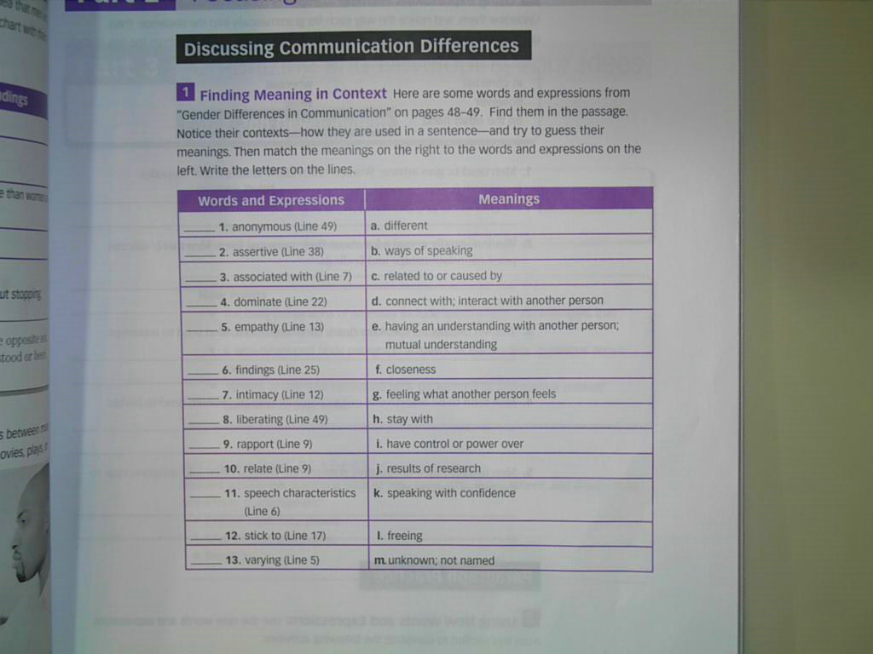
P: 51…
1- m 7- f 13- a
2- k 8- l
3- c 9- d
4- i 10- e
5- g 11- b
6- j 12- h

We will stop here.
Go to the next lecture
THANK YOU

مع تحياتي لكم :
☺ معتزهـ ☺

