Lecture 9
Chapter 3
Gender and Relationship
Exercise 2 on page 52.
Turn your textbook to page 52 and follow the lecture.
Studying a well-developed paragraph:
Consider exercise 1 on page 54.
Analyzing a Paragraph:
Consider exercise 2 on page 54.
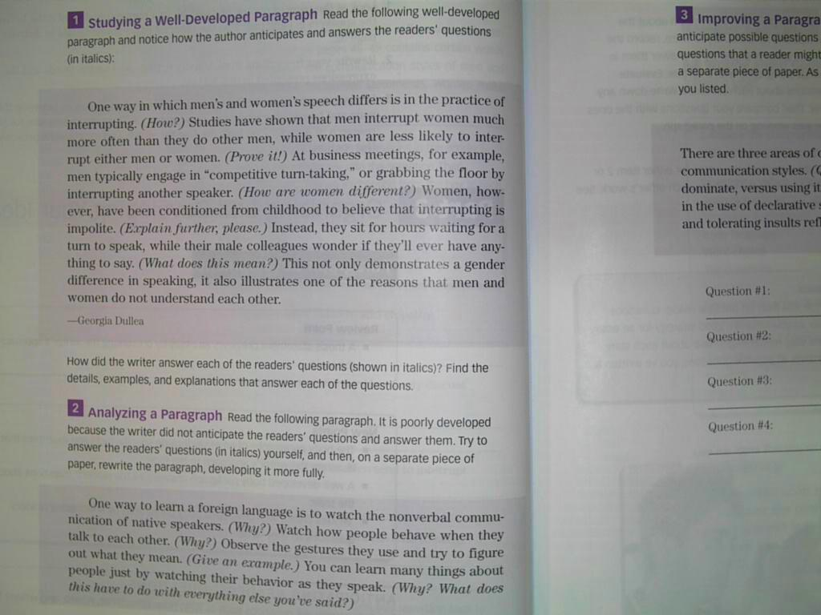
We will stop here.
Go to the next lecture مع تحياتي لكم:
THANK YOU ☺ معتزهـ ☺

