Lictuer 11

- Introduction
In the preceding chapters we have reviewed in some detail the various features of language that people use to produce and understand linguistic messages. Where is this ability to use language located? The obvious answer is ‘in the brain’. However, it can’t be just anywhere in the brain.

- Neurolinguistics
- The study of the relationship between language and the brain is called neurolinguistics. Although this is a relatively recent term, the field of study dates back to the nineteenth century. Establishing the location of language in the brain was an early challenge, but one event incidentally provided a clue.
- Because of an accident , a patient suffered from a damage in the front part of his brain, but his language abilities were unaffected. This leads to conclude that while language may be located in the brain, it clearly is not situated right at the front.

Parts of the brain 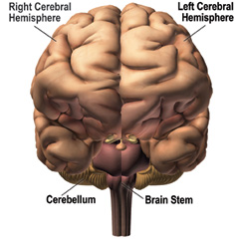
Parts of the brain
Since that time, a number of discoveries have been made about the specific parts in the brain that are related to language functions. We now know that the most important parts are in areas above the left ear.

- Broca’s area
Wernicke’s area
The motor cortex
The arcuate fasciculus

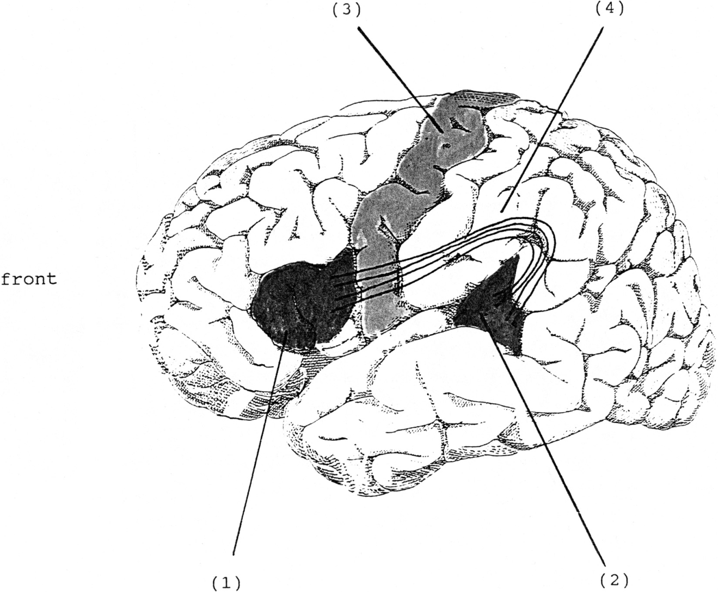

- Broca’s area

The part shown as (1) in the illustration is technically described as the ‘anterior speech cortex’ or, more usually, as Broca’s area. Named after Paul Broca, a French surgeon, who reported in the 1860s that damage to this specific part of the brain was related to extreme difficulty in producing speech. So Broca’s area is crucially involved in the production of speech.

- Wernicke’s area

The part shown as (2) in the illustration is the ‘posterior speech cortex’, or Wernicke’s area. Carl Wernicke was a German doctor who, in the 1870s, reported that damage to this part of the brain was found among patients who had speech comprehension difficulties. So Wernicke’s area is crucially involved in the understanding of speech.

- The motor cortex and the arcuate fasciculus
The part shown as (3) in the illustration is the motor cortex, an area that generally controls movement of the muscles (for moving hands, feet, arms, etc.). Close to Broca’s area is the part of the motor cortex that controls the articulatory muscles of the face, jaw, tongue and larynx. Evidence that this area is involved in the physical articulation of speech comes from work reported in the 1950s by two neurosurgeons, Penfield and Roberts (1959).

The motor cortex and the arcuate fasciculus

The part shown as (4) in the illustration is a bundle of nerve fibers called the arcuate fasciculus. This was also one of Wernicke’s discoveries and is now known to form a crucial connection between Wernicke’s and Broca’s areas.

- The localization view

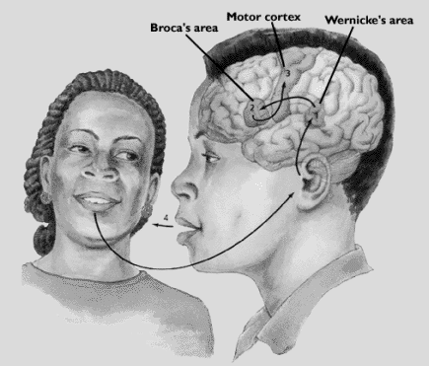

The localization view

Specific aspects of language ability can be accorded specific locations in the brain. This is called the localization view and it has been used to suggest that the brain activity involved in hearing a word, understanding it, then saying it, would follow a definite pattern. The word is heard and comprehended via Wernicke’s area. This signal is then transferred via the arcuate fasciculus to Broca’s area where preparations are made to produce it. A signal is then sent to part of the motor cortex to physically articulate the word.

The localization view
This is certainly an oversimplified version of what may actually take place, but it is consistent with much of what we understand about simple language processing in the brain. we are forced to use metaphors mainly because we cannot obtain direct physical evidence of linguistic processes in the brain. Because we have no direct access, we generally have to rely on what we can discover through indirect methods. Most of these methods involve attempts to work out how the system is working from clues picked up when the system has problems or malfunctions.
- The tip of the tongue phenomenon

Minor production difficulties of this sort may provide possible clues to how our linguistic knowledge is organized within the brain. In the tip of the tongue phenomenon, we feel that some word is just eluding us, that we know the word, but it just won’t come to the surface. When we make mistakes in this retrieval process, there are often strong phonological similarities between the target word we’re trying to say and the mistake we actually produce, e.g., (distinguisher/extinguisher) and (medication/meditation). Mistakes of this type are sometimes referred to as malapropisms.

- Slips of the tongue

Another type of speech error is commonly described as a slip of the tongue. This produces expressions such as ‘a long shory stort’ (story short), ‘use the door to open the key’ (the key to open the door) , and ‘a fifty-pound dog of bag food’ (bag of dog food ).
Slips of this type are sometimes called spoonerisms after William Spooner

- Slips of the ear
Slip of the ear is a processing error in which one word or phrase is heard as another, as in hearing ‘great ape’ when the utterance was “gray tape”. It may also be the case that some malapropisms (e.g. medication/meditation) originate as slips of the ear.
However, some problems with language production and comprehension are the result of much more serious disorders in brain function.
- Aphasia

Aphasia is defined as an impairment of language function due to localized brain damage that leads to difficulty in understanding and/or producing linguistic forms.
The most common cause of aphasia is a stroke (when a blood vessel in the brain is blocked or bursts), though traumatic head injuries from violence or an accident may have similar effects. Those effects can range from mild to severe reduction in the ability to use language.
- Broca’s aphasia

Broca’s aphasia (also called ‘motor aphasia’) is a language disorder in which speech production is typically reduced, distorted, slow and missing grammatical markers. The frequent omission of functional morphemes (e.g. articles, prepositions) and inflections (e.g. plural -s, past tense -ed) has led to the characterization of this type of aphasic speech as ‘agrammatic’. In agrammatic speech, the grammatical markers are missing. In Broca’s aphasia, comprehension is typically much better than production.
- Wernicke’s aphasia

The type of language disorder that results in difficulties in auditory comprehension is sometimes called ‘sensory aphasia’, but is more commonly known as Wernicke’s aphasia. Someone suffering from this disorder can actually produce very fluent speech which is, however, often difficult to make sense of.
Difficulty in finding the correct word, sometimes referred to as anomia, also happens in Wernicke’s aphasia.

- Conduction aphasia

Conduction aphasia is a language disorder associated with damage to the arcuate fasciculus in which repeating words or phrases is difficult. Individuals suffering from this disorder sometimes mispronounce words, but typically do not have articulation problems. They are fluent, but may have disrupted rhythm because of pauses and hesitations. Comprehension of spoken words is normally good. However, the task of repeating a word or phrase (spoken by someone else) creates major difficulty.

Conduction aphasia
Language disorders of the type we have described are almost always the result of injury to the left hemisphere. This left hemisphere dominance for language has also been demonstrated by another approach to the investigation of language and the brain.

Dichotic listening

An experimental technique that has demonstrated a left hemisphere dominance for syllable and word processing is called the dichotic listening test. This technique uses the generally established fact that anything experienced on the right-hand side of the body is processed in the left hemisphere, and anything on the left side is processed in the right hemisphere. So, a basic assumption would be that a signal coming in the right ear will go to the left hemisphere and a signal coming in the left ear will go to the right hemisphere.

Dichotic listening

In this process, the language signal received through the left ear is first sent to the right hemisphere and then has to be sent to the left hemisphere (language center) for processing. This non-direct route takes longer than a linguistic signal received through the right ear and going directly to the left hemisphere. First signal to get processed wins.

- The critical period

The apparent specialization of the left hemisphere for language is usually described in terms of lateral dominance or lateralization (one-sidedness). it is generally thought that the lateralization process begins in early childhood. It coincides with the period during which language acquisition takes place. During childhood, there is a period when the human brain is most ready to receive input and learn a particular language. This is known as the critical period.

The critical period
Though some think it may start earlier, the general view is that the critical period for first language acquisition lasts from birth until puberty. If a child does not acquire language during this period, for any one of a number of reasons, then he or she will find it almost impossible to learn language later on.

- Genie

A girl discovered in 1970 at age 13 who had not acquired her first language.
Spent her life in a state of physical, sensory, social, and emotional deprivation.
Unable to speak
Started to imitate sounds, but couldn’t produce grammatically complex speech.
She was using the right hemisphere: in dichotic listening, she showed ‘left ear advantage’

