Psycholinguistics is an interdisciplinary field of study in which the goals are to: 1- understand how people acquire language.
2- how people use language to speak and understand one another.
3- how language is represented and processed in the brain.
--------------------------------------------
Language is the primary communication system for the human species. In ordinary circumstances it is used to convey thoughts through speech. It is a special system, however, that functions independently of speech, thought, and communication.
-------------------------------------
Speech ought not to be confused with language, though speech is indeed the most frequent mode for transmitting linguistic information.
---------------------------------------
Why people confuse thought and language?
1- because we verbalize our thoughts using language.
2- many animals can think but cannot communicate using language.
---------------------------------------
How to language can be distinguished from communication in general?
Language is the primary communication system for human beings, but it is not the only way to communicate.
----------------------------------------
What evidence do we have that language is biological?
1- all human babies are born with a brain that is genetically prepared to organize linguistic information.
2- all human languages have universal properties.
3- language does not need to be taught, and acquisition cannot be suppressed. Language acquisition in the child is a naturally unfolding process, much like other biologically based behaviors such as walking.
4- critical period in the acquisition of their first language. Most researchers agree that the optimal period for first language acquisition is before the early teen years (13-14-15)
---------------------------------------
Language acquisition could not be possible without two crucial ingredients,
1- A biologically based predisposition to acquire language. الاستعداد لتعلم اللغة
(brain develops. This is called the nativist model of language acquisition)
(developing brain provides the infant with a predisposition to acquire language)
2- Experience with language in the environment.
---------------------------------------
Language is a formal system for pairing signals with meanings.
Language’s grammar is the set of rules that creates sentences in a language.
lexicon is the words of a language.
Prescriptive grammar is the form of a language that is accepted in academic and business circles and conform to the standard.
Descriptive grammar is when you describe how people use language every day. is, the language system that underlies ordinary use.
i.e . Me and Mary went to the movies.
Mary and me went to the movies.
Linguistic competence. knowledge of language that is in a person’s brain (or mind), knowledge that provides a system for pairing sound and meaning.
Linguistic performance. the use of such knowledge in the actual processing of sentences, by which we mean their production and comprehension.
species specific. it is unique to that species – the system is likely to be part of the genetic makeup of members of the species.
Aphasia is a language impairment linked to a brain lesion
Neurolinguistics is the study of the representation of language in the brain, and the discovery of aphasias led to the birth of this interdisciplinary field.
Broca’s aphasia, also known as non-fluent aphasia (they take long to give you one word).
Wernicke’s aphasia, also called fluent aphasia, is characterized by fluent meaningless.
Positive evidence. to provide information about the language the child is acquiring.
Negative evidence is ungrammatical language that the child hears.
-----------------------------------------
Knowledge of a grammar and a lexicon is tacit (or implicit) unconscious in our heads.
----------------------------------------
To say that language is lateralized means that the language function is located in one of the two hemispheres of the cerebral cortex. For the vast majority of people, language is lateralized in the left hemisphere.
----------------------------------------
control of the body is contra- lateral: the right side of the body is controlled by the left motor and sensory areas, while the left side of the body is controlled by the right motor and sensory areas.
--------------------------------------------
Further evidence of the dominance of the left hemisphere for language comes from studies of dichotic listening. In this kind of experiment, participants are presented auditory stimuli over headphones, with different inputs to each ear. For instance, the syllable ba might be played into the right ear, while at the same exact time da is played to the left ear. The participant’s task is to report what was heard. On average, stimuli presented to the right ear are reported with greater accuracy than the stimuli presented to the left ear. This is known as the right-ear advantage for language. It occurs because a linguistic signal presented to the right ear arrives in the left hemisphere for decoding by a more direct route than does a signal presented to the left ear. From the left ear, the signal must travel first to the right hemisphere, then across the corpus callosum to the left hemisphere (Kimura 1961, 1973). Thus, information presented to the right ear is decoded by the left hemisphere earlier than the information presented to the left ear.
-----------------------------------------
What do we have in Language Acquisition Device (LAD)?
Universal Grammar and acquisition strategies.
----------------------------------------
Another part of the child’s biological endowment is a set of acquisition strategies that enable the child to take the input from the environment and construct a grammar that conforms to the organizational principles of UG. These strategies, or operating principles (Slobin 1973, 1985), determine what will be the most salient and easily acquired aspects of language.
------------------------------------------
Who provide positive evidence to the children?
the main providers of input are the people who interact with the child: parents, caretakers, siblings, and any other children or adults engaging in routine linguistic interactions with the child.
----------------------------------------------
In the first half of the first year of life infants interact in a variety of ways with their caretakers, but their vocalizations are primarily soft coos and gurgles that are not at all like actual language. In the second half of the first year, true babbling begins.
-----------------------------------------------
one-word stage of language, also called the holophrastic period, because each word conveys as much meaning as an entire phrase.
-------------------------------------------------
Underextension is a case in which the child will acquire a word for a particular thing and fail to extend it to other objects in the same category. For example, if a child learned the word flower in connection with a rose and did not extend its meaning to other kinds of flowers.
Overextension is when the child will extend a word incorrectly to other similar things. For example, a child might call all four-legged animals dog, or everything that is bright light.
a preverbal message The production of a sentence begins with the speaker’s intention to communicate an idea or some item of information. This has been referred to by Levelt (1989)
speech errors are called slips of the tongue
------------------------------------------------
When the child’s vocabulary approaches about 50 words, two interesting things happen:
1- The child starts putting words together to form rudimentary sentences.
2- Words are learned more rapidly than before, so much so that most children are said to go through a vocabulary spurt, and the rate of acquisition of vocabulary increases dramatically.
-----------------------------------------------------
What age can produce these sentences?
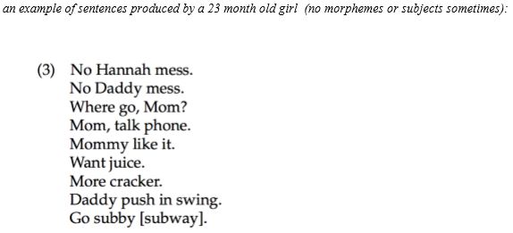
23 month or almost 2 years.
-------------------------------------------------------
mean length of utterance (MLU)
-------------------------------------------------------
Children sometimes overgeneralize the past tense -ed in situations like (he eated or he goed).
Around the age of 3 (with much individual variation), the child will begin to produce complex sentences
Children begin producing relative clauses spontaneously around the age of 3 or 4
-----------------------------------------------------
There is a considerable period between the time a child first uses a past tense marker and consistent use of past tense. (First, the child uses a morpheme, then will not use it sometimes then after time will always use it correctly).
-----------------------------------------------------
Derivational morphemes are expected from?
children of 7, 8, and 9 years of age
------------------------------------------------------
Which one come first in language production (syntactic representation or phonological representation)?
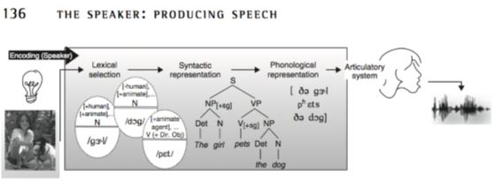
-----------------------------------------------------
unilingual mode (only one language), only one of the grammars is consulted to build structural representations, and the active language’s lexical entries are activated.
bilingual mode (when the bilingual’s two languages are being used in the same conversation), access to both grammars and lexical items from both languages must be possible).
One type of alternation between languages in bilingual speech is code-switching: is switching between two codes (two languages, or two distinct dialects of the same language) within the same discourse.
tag-switching, involves the insertion of frequently used discourse markers, like so, you know, I mean, etc.
--------------------------------------------------------
There are five stages: of steps of speech production.
1- Accessing the lexicon
2- Building simple sentence structure
3- Creating agreement relations
4- Building complex structure
5- Preparing a phonological representation
-----------------------------------------------------------
(lexicon is a dictionary of all the words a speaker knows)
A word can be retrieved using two different kinds of information:
meaning or sound
----------------------------------------------------------------
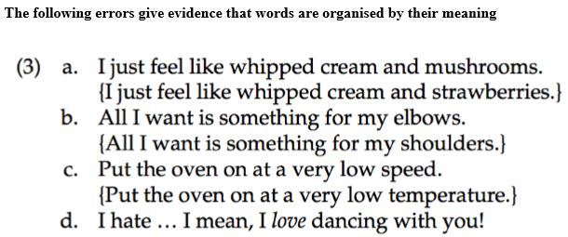

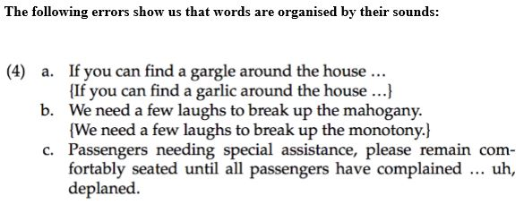
-----------------------------------------------------
A phenomenon in lexical retrieval that has fascinated psycholinguists for decades is the tip-of-the-tongue phenomenon (Brown and McNeill 1966; Aitchison 2003). A tip-of-the-tongue state occurs when the speaker knows the word needed but cannot quite retrieve it.
-----------------------------------------------------
We have three type of errors in phonology?
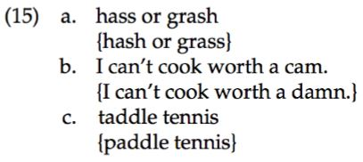
a. segment exchange error (the exchange is between two phonological elements: the final consonants in the two words)
b. perseveration error (a segment (in this case the /k/ of can’t) perseveres and intrudes in a later word (so the speaker utters cam rather than damn)
c. anticipation error (a speech sound that has not yet been produced (the /t/ of tennis) intrudes in an earlier word)
----------------------------------------------------------
There are three features of the speech signal that the speech perception system must deal with:
the signal is continuous
it transmits information in parallel
it is highly variable.
-------------------------------------------------------------
Speech constructive. This means that the speech perception system takes information anywhere it can find it to construct a linguistic percept of the acoustic signal.
-----------------------------------------------------------
McGurk effect (McGurk and MacDonald 1978) illustrates how visual and auditory information together affect the construction of a phonological percept. If you watch a video of a person mouthing [ɡa ɡa ɡa ...], together with the audio track of a person saying [ba ba ba ...], you will hear neither [ba] nor [ɡa] – but [da]
-------------------------------------------------------------
Another kind of illusion that illustrates the constructive nature of speech perception, phoneme restoration
----------------------------------------------------------
Slips of the ear are similar to phoneme restoration effects. Consider the person who “heard” She had on a French suit, from a signal produced by a speaker who intended to say She had on a trench suit. Slips of the ear are also called mondegreens,
*An important difference between slips of the ear and phoneme restoration effects is that the former are often the result of inattentiveness to the signal, while the latter can be truly illusory
----------------------------------------------------------
Bottom up: If you use the acoustic signal (i.e. speech of the speaker) to understand what the person said, then this is bottom up. For example, someone says ‘I will see you after the class’ and you think he just wants to see you after the class.

top-down: if you use context or prior knowledge in trying to understand what the other person said. For example, someone told you Ali heared what you said about him and he is very angry right now. you meet Ali and then he says ‘I will see you after the class’ but this time you understand something different (that he will start a fight for example). This is understanding aided by context so it is top-down processing.
----------------------------------------------------
The orthography of a language is its writing system, including the characters (graphemes).
--------------------------------------------------
What do we use lexical decision task for?
A technique widely used to investigate lexical access.
------------------------------------------------
impossible non-words violate English phonotactics.
possible non-words That is non-words that don’t violate English phonotactics (phonological rules).
----------------------------------------------
Types of priming
1- semantic priming (there is a meaning relationship between the prime and target word)
car-drive, nurse-doctor, student-teacher, mobile-phone
2- form priming (the prime and the target are not related semantically, but are related in their phonological form) cake-lake, map-gap, bell-sell, sling-bring, sin-win
masked priming can be used to study both semantic and form priming.
-------------------------------------------------

