اسئله مقرر القراءات والمطالعات للدكتور عمار المعاني ☺

المحاضره1:
Guess the Meaning
- In a number of countries, education is both compulsory-required-and universal, available to everyone, at least in primary school (elementary school.
Compulsory= ____Required______
Universal=__Available to everyone_____
Primary= _Elementary_____
2. Public schools are all both free and egalitarian; all students are considered equal and learn the same the same material.
Egalitarian = ______Equal________
-
¹Do you have a favorite season? ²Winter, fall, and spring have many advantages. ³However, summertime is my favorite season because it offers the tranquility of the beach as well as the exhilaration of outdoor sports. ⁴First, sitting on the other side of a sand dune, hidden by sea oats and sedge, I like looking at the Atlantic Ocean, scanning for dolphins and pelicans. ⁵Looking at something larger than I am gives me a sense of awe and gratitude and provides a backdrop for some deep musings.⁶Second, summertime provides me with the chance to go sailing, surfing, and hiking along the shore. ⁷The exercise enhances my sense of well being and creates a feeling of optimism.
The topic of the paragraph is
a. sailing and surfing.
b. summertime.
c. seasons at the beach.
d. ways to develop optimism.

The main idea of the paragraph is
a. sentence 1. b. sentence 2. c. sentence 3. d. sentence 4.
-
Choosing the Correct Pronoun
Circle the pronoun that agrees in number with its antecedent in each sentence.
- Each of the girls makes (her, their) own clothes.
- The jury finally made (its, their) decision.
- It often seems that television programmers are not concerned with (its, their) viewers.
- Both Tim and Tony write (his, their) mothers twice a week from camp.
-

المحاضره2:
Guess the Meaning
People spend hours in gridlock –that is, traffic so horrible that it simply doesn’t move – when thet commute.
Gridlock = __traffic so horrible_____
Under his leadership, city planners established priorities – in other words, a list of what was most important.
Priorities = _____a list of what was most important_______
-
Identifying the Main idea & Supporting Details
Why I Want to Learn English(1) There are three reasons why I want to learn English. (2) One reason is that English has become an international language.(3) It is now used by most international companies, including the company where I work, for business communication. (4) Another reason why I want to learn English is so that I can travel to English-speaking countries. (5) The United States, England, Australia and many other countries all use English as their primary language. (6) Finally, I want to learn English because I plan to move to the U.S. in the future. (7) I will become a manager for my company soon. (8) For all these reasons, I am very excited about learning English.
Identify the topic sentence: Why I want to learn English
Identify the conclusion: I'm very excited about learning English
Identify the first main point: Sentence 2: One reason is that English has become an international language
Identify the second main point: Sentence 4: Another reason why I want to learn English is so that I can travel to English-speaking countries.
Identify the third main point: Sentence 6: Finally, I want to learn English because I plan to move to the U.S. in the future.
Identify the support detail for the first main point: Sentence 3: It is now used by most international companies, including the company where I work, for business communication
Identify the support detail for the second main point: Sentence 5: The United States, England, Australia and many other countries all use English as their primary language.
Identify the support detail for the third main point: Sentence 7: I will become a manager for my company soon
-

Scanning this
Pulp Friction
Every second, 1 hectare of the world's rainforest is destroyed. That's equivalent to two football fields. An area the size of New York City is lost every day. In a year, that adds up to 31 million hectares -- more than the land area of Poland. This alarming rate of destruction has serious consequences for the environment; scientists estimate, for example, that 137 species of plant, insect or animal become extinct every day due to logging. In British Columbia, where, since 1990, thirteen rainforest valleys have been clearcut, 142 species of salmon have already become extinct, and the habitats of grizzly bears, wolves and many other creatures are threatened. Logging, however, provides jobs, profits, taxes for the government and cheap products of all kinds for consumers, so the government is reluctant to restrict or control it.
1.How many species of salmon have become extinct in BC?
a. 27
b. 31
c. 137
d. 142
Much of Canada's forestry production goes towards making pulp and paper. According to the Canadian Pulp and Paper Association, Canada supplies 34% of the world's wood pulp and 49% of its newsprint paper. If these paper products could be produced in some other way, Canadian forests could be preserved. Recently, a possible alternative way of producing paper has been suggested by agriculturalists and environmentalists: a plant called hemp.
2.How much of the world's newsprint paper is supplied by Canada?
a. 31 %
b. 49%
c. 34%
d. 19%
However, there is a problem: hemp is illegal in many countries of the world. This plant, so useful for fibre, rope, oil, fuel and textiles, is a species of cannabis, related to the plant from which marijuana is produced. In the late 1930s, a movement to ban the drug marijuana began to gather force, resulting in the eventual banning of the cultivation not only of the plant used to produce the drug, but also of the commercial fibre-producing hemp plant. Although both George Washington and Thomas Jefferson grew hemp in large quantities on their own land, any American growing the plant today would soon find himself in prison -- despite the fact that marijuana cannot be produced from the hemp plant, since it contains in the drug).
What drug can be obtained from a relative of hemp?
a. Cocaine b. heroin c. Amphetamine d. marijuana
-
المحاضره3:
A
For many years in the United States, most undergraduate students (in their first four years of college) were 18 to 22 years old. They attended college full-time, lived in a dormitory on campus, and expected many “extras” from their colleges, not just classes. But things began to change in the 1970’s, and are very different now. Today, these “traditional” students are less than one-quarter (1/4) of all college students. These days the nontraditional students are the majority; they are different from traditional undergraduates in several ways. They are older. Many attend college part-time because they have families and jobs. Most live off campus, not in dormitories. These traditional students don’t want the extras that colleges usually offer. They aren’t interested in the sports, entertainment, religious groups, and museums that are part of most U.S. colleges. They want mainly good-quality classes, day or night, at a low cost. They also hope for easy parking, access to information technology, and polite service. Both time and money are important to them.
1. What is the Topic? ___The difference between traditional and nontraditional students..________
2. What is the Main Idea? ________ The difference between traditional and nontraditional students.._____
3. According to the passage, how today students are different from traditional students?
Non-traditional students are the minority. -1 F
Non-traditional students are not working these days. -2 F
Non-traditional students live on campus.-3 F
Non-traditional students are majority and part-timers -4 T
As you read, it’s important to begin noticing words that often go together. Go back to A paragraph. Find words to complete the following phrases and write them in the blanks. Most are prepositions.
Paragraph A
Lived __________in____________ a dormitory _____on_________ campus.
Many ________attend______________ college part-time (verb)
Access _________to____________ information technology
Look back at the reading selection “Campus Life is Changing” to find the meanings of the following pronouns. What does each pronoun refer to?
They (Paragraph A, line 2) ____________students__________________________
They (paragraph A, line 6) ______________students______________________
Them (Paragraph A, line 12) nontraditional students
-
B
Psychological test reflect different learning styles in this new student population, too. Each person has a certain learning style, and about 60 percent of the new students these days prefer the sensing style. This means that they are very practical. They prefer a practice-to-theory method of learning, which is experience first and ideas after that. They often have difficulty with reading and writing and are unsure of themselves. Most of these students are attending college because they want to have a good job and make a lot of money.

What is the Topic? _________________________Learning styles in students' population _______
What is the Main Idea?________ Each person has a certain learning style, and about 60 percent of the new students these days prefer the sensing style ___________
According to the passage, what do 60 percent of the new students prefer these days?
a. They prefer a practice – to- theory method of learning.
b. They prefer a theory-to-practice theory method of learning.
-
C
In contrast other students (but not as many) prefer the intuitive learning style. These students love ideas. They prefer a theory-to-practice method of learning and enjoy independent, creative thinking. These “intuitive” are not very practical. They are attending college because they want to create unique works of art or study philosophy or someday help in the field of science.
Topic: _______________________Intuitive learning styles _____________________
Main Idea: _________________Students prefer a theory-to-practice method of learning and enjoy independent, creative thinking _______________________

-

There is a drawback for the students who prefer the sensing style of learning. A majority of college professors prefer the intuitive learning style. These teachers value independent thinking and creative ideas. Students in the sensing group are at a disadvantage because their way of thinking doesn’t match their teachers’.
Topic: _________________The sensing style of learning_____________________________
Main idea:________________ A majority of college professors prefer the intuitive learning style _____
Words in phrases : Paragraph D :
are ___at_____ a disadvantage.
Understanding Pronoun References: Their (Paragraph D, line 4)___________students____________
-
F
On all college campuses, student life is very different from what it used to be because of technology – specifically, the internet. At most colleges, all entering first-year students receive an email address. Dormitory rooms offer high-speed Internet access. Computer systems are available to everyone in computer labs, the library, and student centers. Application for classes and registration are usually now possible online. Most schools offer entire courses online. Many professors still have “office hours,” when students can come to talk with them about class work or ask for help. But increasingly, students can contact professors 24 hours a day, thanks to email. In many classes, students complete assignments and even take exams online. Perhaps most important for both students and professors, research is now easier and faster because of the new technology.
Topic :____________Technology in students' life_______________________
Main Idea: _____________The importance of technology in college campus__________________________
Understanding pronoun references: Them (paragraph F, line 6)
Words in phrases: As you read, it’s important to begin noticing words that often go together. Go back to F paragraph. Find words to complete the following phrases and write them in the blanks. Most are prepositions.
Life is different because __________of____________ technology
Are available _______________to_______________ everyone
Students ________________take_____________ exams (verb)
-
“There are several events that can change the Earth's surface very quickly. Volcanoes can erupt and spread lava, rock and ash for several miles. Earthquakes can leave large cracks in the Earth's surface.”
What is the main idea?
1. Several events can change the Earth's surface.
2. Earthquakes can cause large cracks.
3. Volcanoes can be dangerous.
4. Earthquakes
-
“Most of the world's volcanoes are part of the "The Ring of Fire." This is a ring of volcanoes that form a circle around the Pacific Ocean. Thousands of volcanoes make up "The Ring of Fire." These volcanoes formed the sea floor and many underwater mountains.’
What is the main idea?
1. There are thousands of volcanoes in the world.
2. Most volcanoes are part of the "Ring of Fire."
3. Some underwater mountains are volcanoes.
4. The Ring of Fire
-

Getting Meeting From Context
1. On the one hand, there are many advantages to this system. On the other hand, there are also several drawbacks.
On the other hand =_______________from one point of view
On the other hand = _______________From another point of view__________________

2. In a number of countries, education is both compulsory – required- and universal, available to everyone, at least in primary school (elementary school)
Compulsory=_______________Required__________________________
Universal= __________________Available to everyone_________________________
Primary school=_________________Elementary______________________
3. There are many more schools in cities than in rural areas.
Rural = ___________areas outside the cities [countryside]________________________
4. Public schools are all both free and egalitarian; all students are considered equal and learn the same material.
Egalitarian = ____________Equal____________________________
5. College students need great discipline; in order to make time for their studies, they need the self-control to give up hobbies, sports, and social life.
Discipline =_______________Self-control__________________________
6. Results on these exams affect the entire family because there is high status, or social position, for a whole family in which children have high test scores.
Entire= ____________________Whole_______________________
Status=____________________Social Position_______________________
7. Students themselves decide if they want college-preparatory or vocational classes in high school; no national exam determines this for them.
Determines = __________________Decides________________________
-
المحاضره4:
There's good news and bad news about life in modern cities—first, the bad.
People who study population growth predict a nightmare by the year 2025: the
global population will be more than 8 billion, and almost 4 billion of these
people will be living in cities in developing countries such as India and Nigeria.
Population growth is already causing unbelievable overcrowding. Due to overcrowding,
these cities have problems with air pollution, disease, and crime. People spend
hours in gridlock—that is, traffic so horrible that it simply doesn't move—when
they commute daily from their homes to their work and back. There isn't enough
water, transportation, or housing. Many people don't have access to health
services or jobs. Now the good news: in some cities, instead of worsening
urban life is actually getting much better.
What does developing countries mean? Poor countries
What does gridlock mean? Traffic so horrible
What does predict mean? To say in advance that something will happen
What does commute mean? moving from – to - ← تنقل
What does worsening mean? getting worse
-
It might not be a surprise to find that life in affluent cities is improving. But what about cities that aren't rich? The city of Curitiba, Brazil, proves that it's possible for even a city in a developing country to offer a good life to its residents. The mayor of Curitiba for twenty-five years, Jaime Lerner, was an architect and a very practical person. Under his leadership, the city planners established a list of priorities—in other words, a list of what was most important to work on. They decided to focus on the environment and on the quality of life. With an average income of only about $2000 per person per year, Curitiba has the same problems as many cities. However, it also has some creative solutions.
Identify The Main Idea :______________________ it's possible for even a city in a developing country to offer a good life to its residents._______________
What does affluent mean? Rich
What does priorities mean? a list of what's most important
-

[C] One creative solution is the method of garbage collection. In neighborhoods that garbage trucks can't reach, poor people bring bags of trash to special centers. At these centers, they exchange the trash for fresh produce—such as potatoes and oranges—or for bus tickets. At a recycling plant, workers separate bottles, plastic, and cans from other trash. Two-thirds of Curitiba's garbage is recycled, which is good for the environment. And the plant gives jobs to the poorest people, which improves their lives.
Trash à Garbage
Produceà vegetable and fruits
What does recycling plant mean? separating bottles, plastic, and cans from other trash.
-
D] Due to careful planning, Curitiba does not have the same traffic problems that most cities have. The statistics are surprising. The population has grown—now twice the size it was in 1974—but traffic has actually decreased 30 percent. Curitiba needed a mass-transit system but couldn't afford an expensive subway. City planners began, instead, with an unusual system of buses in the center lanes of five wide major streets..
-
To make the environment both cleaner and more beautiful, Curitiba has strict laws against polluters. But it also has low taxes for companies that have green areas, so several hundred major industries such as Pepsi and Volvo have offices in the city. Bringing natural beauty into the city is a priority. For this reason, Curitiba gave 1.5 million young trees to neighborhoods to plant and take care of. And the downtown shopping area is now a pedestrian zone—in other words, for walkers only, no cars—and is lined with gardens.
What does pedestrian zone means? Area for walkers only –no cars-
-
Clearly, overcrowding in big cities worldwide is the cause of serious problems. However, the example of Curitiba provides hope that careful planning and creative thinking can lead to solutions to many of them. Curitiba is truly, as Lewis Mumford once said of cities in general, a "symbol of the possible.
Find a sentence in the conclusion which seems to mean about the same main idea of the whole passage.
-
Elizabeth Steinberg was a healthy sixteen-year-old student on the tennis team at St. Charles High School, west of Chicago, Illinois. But in the fall of 1977, he started to have strange health problems. The same thing happened to dozens of teachers and students at the school. They went to doctors for treatment of a number of symptoms such as sore throats, tiredness, headaches, and respiratory (breathing) difficulties. Doctors treated respiratory infections with antibiotics, but the condition didn't seem to improve, except—mysteriously—on weekends and over vacations, when the symptoms disappeared. Experts came to investigate and find the cause. They discovered that St. Charles High, like thousands of other schools and office buildings nationwide, is a "sick building"—in other words, a building that creates its own indoor air pollution.
Topic: Health problems
Main Idea : All students in school have the same problem after years
Understanding Pronoun Reference: They (paragraph a, Line 4) Teachers and students

-
People have worried about smog for many years, and the government has
spent billions of dollars to try to clean up the air of big cities. But now we find that there is no escape from unhealthful air. Recent studies have shown that air inside many homes, office buildings, and schools is full of pollutants: chemicals, mold, bacteria, smoke, and gases. These pollutants are causing a group of unpleasant and dangerous symptoms that experts call "sick-building syndrome." First discovered in 1982, sick-building syndrome most often includes symptoms similar to the flu (watering eyes, headaches, and so on) and respiratory infections such as tonsillitis, bronchitis, and pneumonia.
Topic: Causes and symptoms of sick-building syndrome
Topic sentence: there is no escape from unhealthful air
What is the closest meaning to the word “Several” ? many
Understanding pronoun reference: these (par b, line 5). pollutants: chemicals, mold, bacteria, smoke, and gases
-
Although most common in office buildings and schools, the indoor pollution
that causes sick-building syndrome can also occur in houses. Imagine a typical home. The people who live there burn oil, wood, or gas for cooking and heating. They might smoke cigarettes, pipes, or cigars. They use chemicals for cleaning. They use hundreds of products made of plastic or particleboard—that is, an inexpensive kind of board made of very small pieces of wood held together with a chemical. These products give off chemicals that we can't see but that we do breathe in. In some homes, carbon monoxide from cars in the garage can enter the house. And in many areas, the ground under the building might send a dangerous gas called radon into the home. The people in the house are breathing in a "chemical soup."
Topic: Sick-building syndrome can also occur in houses
Topic Sentence or main idea: Sick-building syndrome can also occur in houses
Understanding Pronoun Reference:
1. they (paragraph c, line 3) People
2. them (paragraph c, line مو موجودة بالقطعة
-
There are several solutions to the problem of sick-building syndrome, among them cleansing the building. First, of course, experts must determine the specific cause in any one building. Then workers probably need to take out carpets, wallpaper, and ceiling tiles in order to remove mold and bacteria. Also, they need to clean out the air conditioning system and completely rebuild the system of ventilation. They should remove synthetic products and bring in natural products, instead, if they are available.
Topic: Several solutions to the problem of sick-building syndrome
Main idea: Several solutions to the problem of sick-building syndrome

Understanding Pronoun Reference: them (line 1) Solutions
Understanding pronoun reference : they ( line5) Workers
-
complete each sentence below with words from the preceding chart. Use the correct form of the base word and write the part of speech in the parentheses after each blank – (n) for noun, (v) for verb, (adj) for adjective, and (adv) for adverb.
- Solve
They are trying to find a ____solution ____ (n.) to the problem of overcrowding, but this is a difficult problem to ______ solve____ (v.).

2. Pollute
Most people know about air ___pollution____ ( n ) in big cities, but they’re just beginning to learn about the many ___pollutions____ ( n ) that we have inside buildings.
3. Crowd
There are __crowds___ ( n ) of people everywhere ; the mass-transit system is especially __crowded___ ( adj ).
4. Save
The city is not __safe___ ( adj ) because of crime. People can’t leave their homes __safely___ ( adv ) at night, and the police can’t provide for their __safety___ ( n ).
5. Beautify
Many people bring plants into their homes because the plants are __beautiful___ ( adj ). However, it's possible that these plants not only __beautify____ ( v ) the environment but also clean the air.
6. Differ
The causes of indoor air pollution __differ__ ( v ) from area to area. One reason for the __difference___ ( n ) is that people hear their homes __differently___ ( adv ). People in some areas burn wood for hear; in other areas, they use something ___different___ ( adj ).
-
المحاضره5:
Use signal words as your clues to find the meaning of the underlined words. Circle signal words and write their meaning in the space provided.
1. The encyclopedia defines astrology as “the ancient art or science of divining the fate and future of human beings from indications given by the positions of stars and other heavenly bodies.”
astrology means _______________An ancient art or science_______________________
2. Sales literature means printed matters that contain information on the goods.
Sales literature means ___________printed matters that contain information on the goods ______________________
3. The part at the back of the car used for holding luggage is called the car boot in United Kingdom, whereas Americans would refer to this as the car’s trunk.
car boot means ________ The part at the back of the car used for holding luggage _______________
-
Use signal words as your clues to find the meaning of the underlined words. Circle signal words and write the meaning in the space provided.
1. According to Indian custom, a great dowry of money and objects is given to the bridegroom, in other words, it is a dot.
dot = __________ a great dowry of money and objects that is given to the bridegroom __________
2. There are several types of aerosol cans. Simple ones contain a liquefied gas, called the propellant, in which material is dissolved, i.e., melt.
dissolved =___________melt_______________________
3. Our youth nowadays should not engage in intoxicating things such as alcohol, cigarettes, and tranquilizers, that is to say, they should not ingest them.
engage =________________ingest___________________
-
Use signal words as your clues to find the meaning of the underlined words. Circle signal words and write the meaning in the space provided.
1. Both facsimile (known as fax) and electronic mail (email) are ways of sending documents.
Facsimile =_________fax_____________________________
Electronic mail =_______e-mail___________________________
2. An FM radio DJ (disk jockey) broadcasts over the airwaves.
DJ =________________dick jockey___________________________
3. Infection ? becoming ill through contact with bacteria ? of the respiratory system such as the nose, the throat, and the chest is among the most common of all diseases.
Infection =______________ becoming ill through contact with bacteria ________________________
-
Use signal words as your clues to find the meaning of the underlined words by choosing the best answer for each
question. Circle signal words.

1. Some people in the North of Thailand do wickerwork, for example, they make elephants,
turtles, plates, beds, and chairs, from teak trees for earning money.
a) silver handicraft
b) bronze handicraft
c) niello handicraft
d) wood handicraft
2. The Savanna grasslands are the home of grazing animals such as elephants, giraffes,
antelopes and zebras. Lions, leopards and hyenas also live there.
a) non-backbone animals
b) meat-eating animals
c) invertebrate animals
d) grass-eating animals
3. A tourist guide advised them to see the elephant round up. There was racing,
colorful war procession, marching, kicking a ball and tug-of-war between men and elephants.
a) show | b) breed
c) sleep | d) born

Use signal words as your clues to find the meaning of the underlined words by choosing the best answer for each question. Circle signal words.
1. Ladda was promoted to be the chief secretary of the manager of the company, whereas her colleague, Somechai, was penalized.
a) promoted
b) punished
c) exiled
d) Rewarded
2. Although small pox has almost been eradicated. Malaria is prevalent in Kanchanaburee, Thailand. A policeman just died from the PF (Plasmodium Falsiparum) malaria last month.
a) destroyed completely
b) common found
c) fear of disease
d) Furbish
3. The plane is scheduled to leave for Phuket at 7:00 am but the plane departure has been postponed for two hours. That is to say, it will leave at 9:00 am instead.
a) retard
b) stop
c) extend
d) went back
-
Use signal words as your clue to find the meaning of the underlined words. Circle signal words and write the meaning in the space provided.
- Learning should not be limited to the classroom or with teachers. We can learn by ourselves about things that are not taught by teachers. Similarly, “self-learning” is encouraged for our education system.
What does the words “self-learning” mean? ---------- learn by ourselves ---------------
2. Thailand and South Korea have made a break-through in developing a new technology that enables high-speed Internet connections, just as phone service links are made efficiently through electric power lines. Both countries have joined hands to do business.
What do the words “high-speed Internet connections” mean? ما عرفت وش أحلها
← شبكات انترنت عالية السرعة..~
-
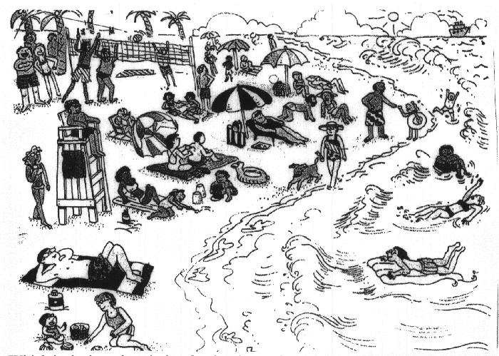
Which is the best description for the above picture?
a) Holiday on beach
b) Beautiful beach
c) Activity of people
-
المحاضره7:
Choose the most appropriate answer:
1. Something that is very popular and lasts for a short period of time is a ________________
a. hobby b. fad c. story d. meal
2. In my travels, I saw many different _____________ of furniture, clothing and food.
a. styles b. tests c. sheets d. cups
3. which of the following is closet in meaning to differentiate ? ______________
a. prepare b. enjoy c. apologize d. distinguish
4. Survive means: _______________:
a. die b. stay alive c. become tired d. laugh

5. The phrase To put on clothes has the same meaning as____________ clothes
a. wear b. buy c. wash d. keep
6. King Faisal University was established in 1975. The underlined word “ established” means:
a. invested b. painted c. founded d. closed
-
Choose the most appropriate answer:
7. The rich man has _________________ all his money in the new project.
a. invested b. invented c. invited d. interested
8. The phrase “ join officially a school or university” means: _____________.
a. pay b. live c. enroll d. drop
9. which of the following is closet in meaning to very clear and easy to understand?
a. plane b. blame c. brain d. plain
10. Parents should ___________ their children from watching violent movies.
a. help b. prevent c. join d. train
11. The phrase walk behind has the same meaning as ___________
a. run away b. avoid c. follow d. live
-
use common affixes
- I have a different idea; I _dis_agree.
- That can’t be; it’s just _im_possible.
- Say that again; please _re_peat it.
- Aliens look bad; they are _un_friendly.
- Tina took the car since she want_ed__ it.
- Now the car is run_ing_ down the road.
- Tina is in a hurry; she’s driving quick_ly_.
- Do you think that she has any ticket_s_?
-

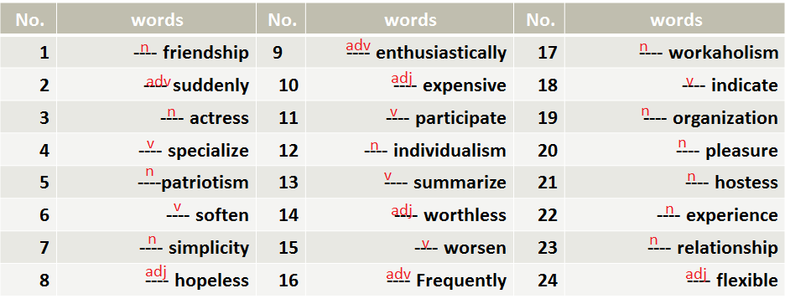

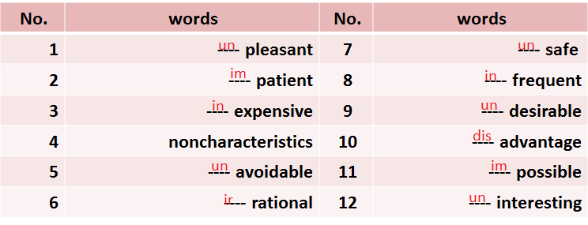

Circle the symbol of the correct answer a, b, c or:-
1. One of the following words begins with a prefix:_____________
a. understand b. university
c. unique d. unimportant

2. We change the meaning of the word “ possible” into its opposite by adding the prefix:__:
a. Dis- b. in
c. im d. un
3. To change the word “ hope” into adjective form, we add the suffix__________ :
a. F ul b. ly
c. ation d. al
4. We add the suffix “_________” to the word” apology” to to change it into verb .
a. ation b. ese
c. ize d. cal
-
Circle the symbol of the correct answer a, b, c or:-
1. The part of speech of the word” enthusiastically” is :_____________
a. Adv b. N
c. V d. Adj
2. We change the meaning of the word “ patient” into its opposite by adding the prefix:__:
a. Dis- b. in
c. im d. un
3. The word “ soften” is __________ :
a. A verb b. a noun
c. an adjective d. an adverb
4. We add the prefix “____” to the word” rational” to change it into its positive meaning .
a. ation b. ir
c. ize d. cal
-
المحاضره8:
Sample Questions Cause & Effect
- 1. He put on heavy clothes____________ the weather was very cold.
- a. because b. as a result c. therefore c. so
- 2. __________ the questions were easy, all students succeeded.
- a. As a result b. Since c. Consequently c. so

- 3. My friend is very rich. ____________ he has a new car and a villa.
- a. Therefore b. Since c. As c. because
- 4. The doctor didn’t come today. ____________ the lecture was cancelled .
- a. Because b. As c. So c. Since
- 5. _______ the film was boring, no one enjoyed it.
- a. As b. So c. Therefore c. As a result
- 6. The food was very delicious. _____________, we ate too much.
- a. Consequently b. Because c. Since d. As
-
Information Questions
- Circle the most suitable answer a, b, c or d for each of the following
- 1. __________ was the reason of the car accident? – It was the very high speed.
- A. Why B. Where C. What D. How
- 2. Could you please tell me __________ will be the final test ? - Next Monday.
- A. Where B. When C. How D. Who
- 3. _____________ do you eat a day? - Only twice.
- A. How far B. How long C. How often D. How
- 4. How long did it take you to finish doing the homework? - __________________
- A. Three kilometers B. Two hours C. Four children D. Yesterday
- 5. ____________ is knocking at the door? __ It is Rami
- A. How B. When C. Why D. Who
- 6. I really don’t know_________ the football match begins.
- A. when b. who C. what D. whose

- 7. How _________ is the hospital from the police station? _ Three kms.
- A. long B. often C. much D. far
- 8. ____________ did she say? – Nothing
- A. Who B. Why C. What D. When
- 9. I need your help please. I don’t know__________ to start this machine.
- A. who B. how C. what D. whose

- 10. _______________ house is that beautiful one? – Its mine
- A. Who B. What C. Whose D. Where
- 11. _________ colour do you prefer Aysha ? – The red one
- A. Which B. Who C. When D. how
- 12. How ____________ are you Abdullah? _ 178 cm
- A. long B. tall C. far D. old
-
- Choose the most appropriate answer:
- 1. Wash has the same meaning as ________________
- a. dig b. clean c. carry d. take
- 2. The word ‘_____________’ means a way.
- a. corners b. key c. climate d. path
- 3. which of the following is closet in meaning to average weather condition over a long time?
- a. mountain b. raining c. climate d. root
- 4. root means: _______________:
- a. cause b. solution c. feeling d. effect
- 5. The phrase make less has the same meaning as____________
- a. produce b. introduce c. reduce d. keep
- 6. The phrase lose power has the same meaning as:
- a. fall b. open c. go high d. close

-
Scanning & Skimming Reading Texts
-1-
- For the first time in history, almost the entire world is now sharing the same economic system. Communism began to fall in the late 1980s,and since then ,capitalism has spread to most corners of the world. The basis of a" pure” capitalist economy is free trade, also called “ open trade”. There are benefits of open trade for both rich and poor countries. For developed countries such as Japan and England, free trade brings with it more competition, which in turn brings advantages such as lower prices and more choices of products for consumers.
- For developing countries, open trade means that people have access to essential goods such as food, clothing, and fuel( for transportation and heat). An open economic system can be a key to improving the lives of people in both poor and rich countries because it can reduce poverty and improve living conditions.

- Choose the most appropriate answer:
- 1. What is the entire world now sharing?__________________________________
- a. The history b. the same economic system
- c. Communism d. leaking boats
- 2. The underlined word ‘benefits’ means ___________________.
- a. corners b. advantages c. goods d. conditions
- 3. Which of the following is closet in meaning to the underlined word “ reduce”
- a. make less b. increase c. import d. consume
- 4. The underlined pronoun “ it ” Line 5 refers to: _______________:
- a. Japan b. developed country c. open trade d. economy
- 5. When did Communism begin to fall?____________
- a. Last year b. in the late 1980s c. last week d. in 1980
- 6. What can reduce the poverty? ______________________
- a. Developed countries b. An open economy c. war d. Communism

-

-2-
- A hundred years ago, in most of the world , people didn’t have much choice about the work that they would do , where they would do it , or how they would do it. If their parents were farmers, they became farmers . The society _ and tradition _ determined their profession .twenty years ago in many countries , people could choose their livelihood . They also had the certainty of a job for life , but they usually couldn’t choose to change from one employer to another or from one profession to another . Today , this is not always the case. Career councilors tell us that the world of work is already changing fast and will change dramatically in the next 25 years.
- The situation varies from country to country, but in today’s economy, there is generally less job security worldwide . Even in Japan , where people traditionally had a very secure job for life ,there is now no promise of a lifetime job with the same company. One reason for the lack of job security is the worldwide decrease in manufacturing jobs. Another reason is employer’s need to hold down costs . This has resulted in two enormous changes for the workforce.
- 1. The most appropriate TOPIC for the reading passage is: ________________________
- A. Career councilors B. The society and tradition
- C. Parents and farmers D. Changing career trends
- 2. The part speech of the underlined word “ choice” is: A/ An _____________________
- A. Verb B. Noun C. Adjective D. Adverb
- 3. The underlined word “ varies” has the same meaning as the word: _______________
- A. carries B. constructs C. differs D. watches
- 4. What determined the profession in the past was______________________________
- A. the farmers B. the society and tradition C. the people D. the country
- 5. The MAIN IDEA of paragraph 1 is that ______________________________________________
- A. parents were farmers B. people in the past didn’t work
- C. the world of work has changed D. parents were farmers
- 6. A country that had a very secure job is _________________________
- A. Brazil B. Japan C. U.S. A D. China
- 7. The lack of job security is due to _____________________________________
- A. holding down costs B. Worldwide increase in manufacturing
- B. the traditions D. the same company
- 1. People who give advice about professions and careers are: ________________________
- A. Career councilors B. manufacturing jobs C. drawbacks D. career trends

- 2. The feeling that the worker will never lose his or her job is _____________________
- A. workaholism B. Job security C. job hopping D. work force
- 3. The movement of jobs to places with lower salaries is_______________
- A. self-confidence B. outsourcing C. job hopping D. work force
- 4. Changing from one job to another is______________________________
- A. job hopping B. Job security C. workaholism D. work force
- 5. The feeling of being happy and satisfied is “ _____________________________
- A. distract B. workaholism C. pleasure D. stress
- 6. He looked through the _____________________ ads and hoped to find his dream job.
- A. sports B. classified C. self D. drawback

- 7. The _________________ rate is very high and it is difficult to find jobs.
- A. salaries B. employment C. workaholism D. unemployment
- 8. When I began job hunting, I put in my application At the _________________office of many companies.
- A. personnel B. self C. dream D. traffic
-
المحاضره9:
1.The word “_____________” is closest in meaning to the word “ surprise “.
a. terrify b. challenge
c. laugh d. astonish
2. If you go to the______________ you will many boats and ships.
a. harbor b. office
c. hospital d. restaurant

3. The word “need” is closest in meaning to the word____________________
a. question b. visit
c. require d. invest
4. The phrase “ a space/ distance between two things or persons” is a__________
a. building b. street
c. wall d. gap
5.The word “_____________” is closest in meaning to the phrase “ make less “.
a. reduce b. widen
c. require d. worsen
6. most people prefer to ______________ by the sea coast.
a. relax b. test
c. work d. type
7. The word “hindrances” is closest in meaning to the word_______________
a. questions b. obstacles
c. facilities d. stories

8. The phrase “ an inspector who looks for criminals” is called a/n __________
a. detective b. astronaut
c. teacher d. servant
-
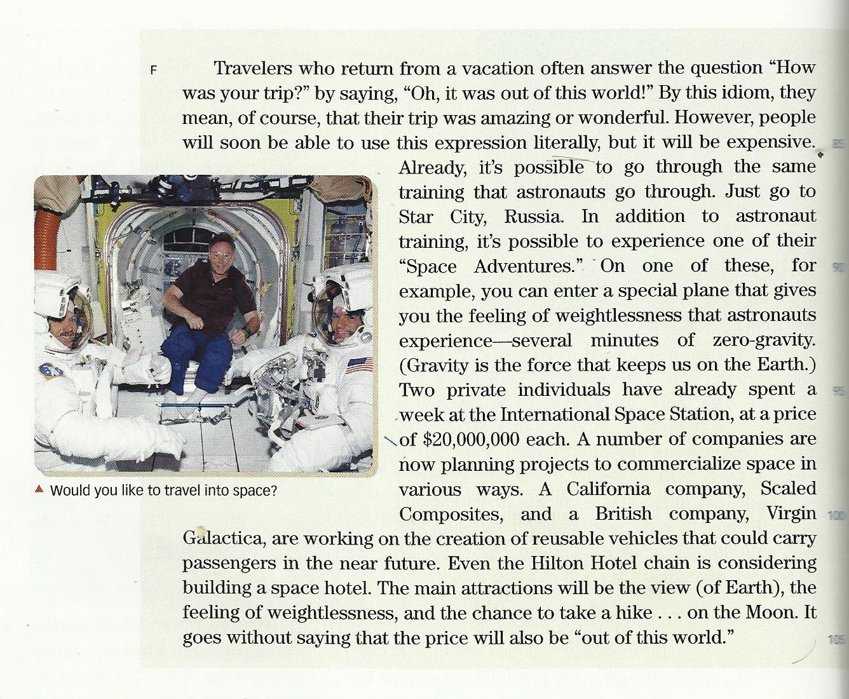
Choose the most appropriate answer:
1. What do the travelers who come from a vacation say about their trip?
a. We were sick? b. It was a long trip
c. Oh, it was out of the world d. Oh, Nice trip
2. The underlined pronoun “ it” line 2 refers to___________________ .
a. the answer b. the question
c. the trip d. this world
3. which of the following is closest in meaning to special ? ______________
a. strong b. enjoyable
c. public d. private
4. literally means: _______________:
a. word by word b. stay alive
c. unreal d. wonderful
5. How long does it take to give you the feeling of weightlessness?
a. Two weeks b. Three minutes
c. One hour d. Several minutes

6. The underlined pronoun “ their” line 3 refers to___________________ .
a. amazing trips b. people
c. travelers d. the vacations
7. It is clear that a trip to space is ______________
a. expensive b. tiring
c. public d. dangerous
8. How much did the two individuals who stayed a week at I S S pay?
a. $20,000,000 b. $40,000,000
c. it was free d. $10,000,000
9. The most appropriate TOPIC of the reading passage is____________________
a. California Company b. Travelling Into Space
c. Amazing Expression D. Galactica
10. The MAIN IDEA of the passage is_____________________________________
a. A trip to the sea is wonderful b. It is very cheap to go to space
c. Space travelling is now possible d. No one like to travel into space -
المحاضره 10:
1.The word “_____________” is closest in meaning to the word “ hints “.
a. creatures b. lectures
c. gestures d. features
2. Our Doctor always _________on the meanings of new words in English.
a. relaxes b. sheds light
c. types d. types
” 3. The phrasal verb “___________” is closest in meaning to the word “return
a. pick up b. look forward to
c. give back d. interest in
4. I called him by phone so many times but he didn’t ______________________
a. respond b. ask
c. sleep d. eat

5.The word “_____________” is closest in meaning to the verb “ get or obtain “.
a. reduce b. widen
c. require d. acquire
6. All students should ______________ that English language is very important.
a. realize b. test
c. work d. go
7. The word “honest or responsible ” is closest in meaning to the word_________
a. criminal b. upright
c. lazy d. clever
8. The phrase “ a metal piece of money ” is closest in meaning to the word______
a. coin b. banknote
c. paper d. invoice
-
Circle the most suitable answer a, b, c or d for each of the following
- The final test will be similar to the questions in the lectures exercises.
1. The part speech of “ final” is __________________________________
A. a verb B. an adverb
C. a noun D. an adjective
2. The part speech of “ questions ” is _____________________________
A. a verb B. an adverb
C. a noun D. an adjective
3. The part speech of “ will” is __________________________________
A. a main verb B. a verb to be
C. a modal D. a preposition
4. The part speech of “ in” is ___________________________________
A. a verb B. a preposition
C. a noun D. an adjective

Circle the most suitable answer a, b, c or d for each of the following
The doctor gave us the first homework last week.

5. The part speech of “ us” is _________________________pronoun
A. a possessive B. an object
C. a subject D. a reflexive
6. The part speech of “ gave ” is ______________________________
A. a present verb B. an auxiliary
C. a future verb D. a past verb
7. The part speech of “ last” is ________________________________
A. an adjective B. a verb to be
C. an article D. a preposition
8. The part speech of “ doctor” is _________________________________
A. a verb B. a subject noun
C. an object noun D. an adjective
-
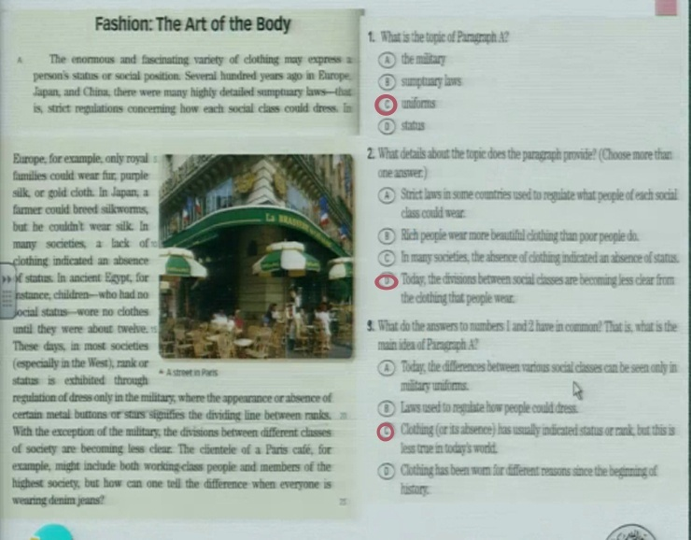
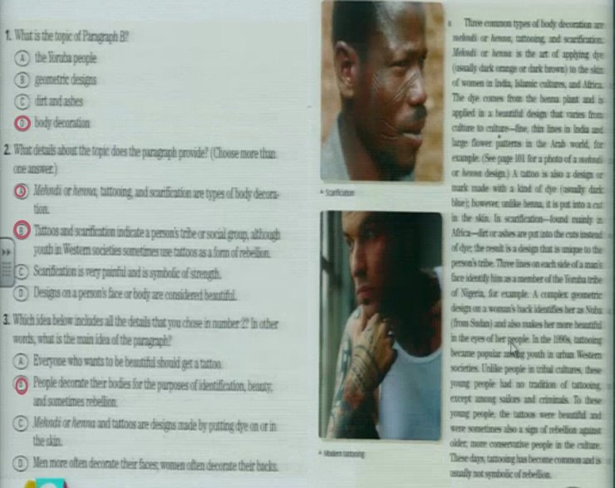
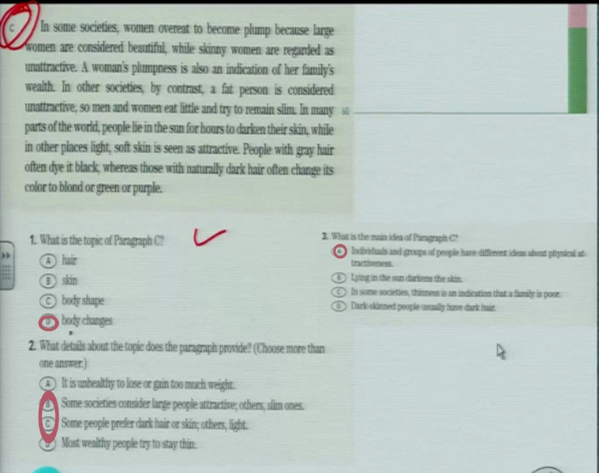
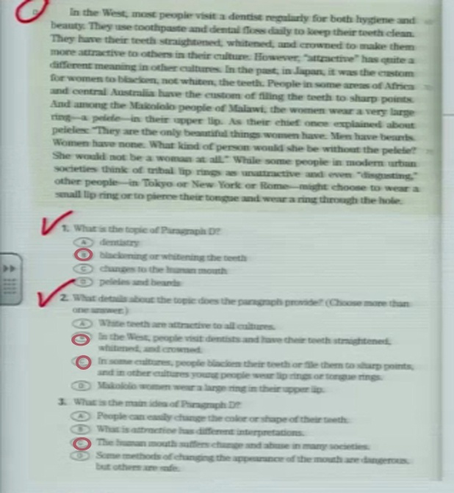
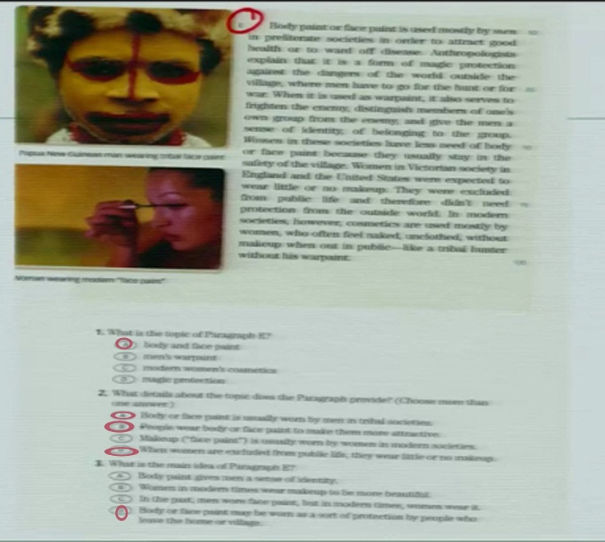
In some societies, women overeat to become plump because large women are considered beautiful, while skinny women are regarded as unattractive. A women's plumpness is also an indication of her family's wealth. In other societies, by contrast, a fat person is considered unattractive, so men and women eat little and try to remain slim. In many parts of the world, people lie in the sun for hours to darkens their skin, while in other places light, soft skin is seen as attractive. People with gray hair often dye it black, whereas those with naturally dark hair often change its color to blond or purple.
Now answer the questions that follow.
Choose the most appropriate answer:
1. The most appropriate topic for the paragraph is_________________________
A. Skin Change B. Hair Color
C. Different views about body shape D. Family's Wealth
2. The best Main Idea of the paragraph is that_____________________________
A. people with gray hair often dye It with black B. people lie in the sun to darken their skin
C. women's plumpness is also an indication of wealth D. people have different attitudes about their bodies

3.Why do men and women eat little in some in some societies?______________
A. To remain slim B. To become plump
C. Because they are poor D. To save much money
Choose the most appropriate answer:
4. The underlined pronoun " their " Line 5 refers_______________________________
A. people B. women
C. men D. fat persons
5. The word in the paragraph that is closest in meaning to the word " thin" is_______
A. plump B. skinny
C. blond D. attractive
6. The underlined pronouns " it " line 6 refers to______________________________
A. skin B. body
C. gray hair D. color
-
المحاضره11
We all know the expression to change your mind. But is it possible literally to change your mind-or, to be more precise, to change your brain? Reports from 2005 says yes. First, the bad news, at least for smokers: a study from the University of Edinburgh, in Scotland. It concludes that smoking makes people less intelligent. On cognitive tests ( tests that involve judgment), smokers did significantly worse than nonsmokers. The theory that toxins- poisons- in the smoke enter the blood and damage blood vessels providing the brain with oxygen. And there is more bad news, for most of us: a study from the University of London says that “ informania”- the constant flood of information from cell phones, emails, and text messaging- can reduce intelligence

- Where are the universities of Aberdeen and Edinburg located?

A. in London B. in Scotland
C. in the USA D. in Liverpool

- The underlined word “ precise “ line 2 means____clear____

A. clear B. different
C. normal D. ambiguous

- ___Smoking____is the cause of being less intelligent.

A. Sleeping B. Nonsmoking
C. Smoking D. Studying

- The test that involves judgment is called a/an ___Cognitive___ test.

A. Ability B. Toxins
C. Cognitive D. Vessel

5. The underlined pronoun “ it” Line 4 refers to ____a study______
A. the university B. Scotland
C. a study D. Edinburg

6. The underlined word “ intelligent “ line 2 means ___clever______
A. interesting B. different
C. famous D. clever

7. What is the function of blood vessels? _providing brain with oxygen__.
A. providing brain with blood B. thinking
C. providing brain with oxygen D. moving

8. The word in the paragraph which is closest in meaning to the word “
poisons” is ____toxins______
A. tests B. toxins
C. reports D. smokers

9. The constant flood of information from cell phones and emails is
called__informania____
A. informania B. toxin
C. intelligence D. blood vessels

10. The most appropriate TOPIC of the paragraph is __Changing your mind___.
A. providing brain with blood B. Smoking
C. providing brain with oxygen D. Changing your mind

1. Our doctor always ___points out___ the importance of the contents of
lectures in the final test.
A. fixes B. points out
C. looks D. takes

2. king Faisal University was __founded___ in 1975.
A. found B. founded
C. bought D. pointed out

3. The word “__merchant___” is closest in meaning to the word tradesman.
A. merchant B. policeman
C. district D. mature

4. The phrase “ fully grown” is closest in meaning to the word “ __mature__’
A. beautiful B. ugly
C. mature D. important

-
Practice
Complete the sentences with a, an, some or any.
1.- Would you like …a… cup of coffee?
2.- There is …some……. Butter in the fridge.
3.- Can I make …a…. telephone call?
4.- There weren’t ……any……… in the house.

Write a few, a little , much or many to complete these sentences . Don’t use some, any or a lot of.
1.- There’s some food but not …much… drink.
2.- .a few.. people arrived before the party started , but not many.
3.- There’s not …much….coffee in the cup.
4.- She hasn’t got …many… friends.
5.- I’m sorry, I haven’t got …much.. Time.
6.- The receptionist didn’t give me …much.. Information.

A lot of – some / any – Much / Many – A few / A little
Underline the correct item.
1.- Are you hungry? There is a little / a few roast beef left.
2.- I can’t make a cake. We haven’t got much / any eggs.
3.- There is a few / a lot of sugar in the cupboard.we don’t need to buy any.
4.- Can I have some / much milk for my coffee?
5.- We need a few / much more peppers to make the dish.
6.- We’ve got a lot of / a little bananas so you don’t have to buy any.
7.- There isn’t many / much food left . We’ll have to go shopping.
8.- This restaurant offers a few / a little vegetarian dishes.

Using [How much] or [How many]
____How many___ books are there on the desk?
___How much___ water is there in the glass?
___How many___ computers are there in the laboratory?
___How many___ mistakes are there in your exam?
___How much___ sugar is there on the floor?
___How many___ triangles did you bring?
___How many___ bones do we have?
___How many__ students are there in the classroom?
___How many___ credit cards do you have?
___How much___ money did you ask?

1. UNDERLINE THE CORRECT WORD IN EACH SENTENCE
Are there a/any people at the bus station?
Look at this shirt!. Can I borrow an/some iron?
Did you buy a/some magazine?
Could you buy a/some bread at the market?
There aren′t any/some payphones near here
She brings some/any balls to play

PLACE ANY OR SOME IN THE FOLLOWING SENTENCES
There isn´t _any_ money
There aren´t __any_ new clothes.
There are ___some__ pencils.
There aren´t _any_ more apples.
Threre is _some_ milk on the table.
There aren´t _any_ curtains.
There are _some_ other options.

Sample Questions
( many/much/ a few/ a little, some, several…etc )
1. I was very hungry. I ate __much__ .
a. many b. little c. much d. a few
2. __Many__ students will pass the test. It is very easy.
a. Few b. Some c. A few d. Many
3. Fortunately, __a few___ people died in the terrible accident.
a. Many b. Some c. Few d. A few
4. He was very happy . He won ___much_____ money in the project.
a. many b. much c. little d. a few
5. __Every_ student should have the textbooks.
a. many b Some c. Every d. All
6. I didn’t like the food. I ate ____little____
a. much b. many c. little d. few
-
المحاضره12
1. The weather in winter is ___colder___ than it is in summer.
A. colder B. cold
C. coldest D. the coldest
2. I have ___more___ money than you do.
A. much B. more
C. most D. least
3. Abdullah is ___the fastest___ of all boys.
A. the fastest B. the most fastest
C. fast D. faster

Do More Exercises
- What is the comparative of "sad"?
  - sader
  - sadder
  - sadier
  - saddier
- What is the comparative of "destructive"?
  - destructiver
  - more destructive
  - destructivier
  - more destructiver

- What is the superlative of "soft"?
  - softest
  - softiest
  - softtest
  - most soft
- What is the comparative of "hot"?
  - hoter
  - hotter
  - hotest
  - hottest
- What is the comparative of "heat"?
  - heater
  - heatter
  - heatier
  - hetter
  - none of these
- What is the superlative of "ugly"?
  - uglier
  - uggliest
  - uglyest
  - ugliest
- What is the superlative of "unpleasant"?
  - unpleasant
  - most unpleasant
  - more unpleasant
  - unpleasantest

10. To fall from a motorcycle is __more painful than___ to fall from a bicycle.
- more painful b) more painful than c) painfuller than d) the painfullest
11. If you suffer asthma, don’t go to Mexico City. It is one of the __most polluted___ cities in the world
a) pollutest b) more polluted c) polluter than d) most polluted
12. The ___farthest__ place from Chile is Australia. It’s on the other side of the world.
- farther b) farthest c) farther than d) farthest than
13. I don’t think your bike is __faster than___ mine.
- fastest than b) faster c) fastest d) faster than
14. Michael was __the tallest___ basketball player in the world
a) taller b) tallest c) the taller d) the tallest
15. Speaking Japanese is __easier than___ writing it.
a) the easiest b) easy c) easier than d) easyer than

Write the following sentences using the correct form of the adjective (comparative or superlative)
- Clare is _____________older than___________ Mike. (old)
- Jane is __the healthiest__ of the four. She eats very well and does a lot of sports, (healthy)
- The coach thinks that Peter is the __fastest__ player of the team, (fast)
- The Sahara desert is one of the ______hottest____ deserts in the world. (hot)
- The climate in the North of Chile is ___drier than it is____ in the South, (dry)
- Asia is _______bigger than________ Europe. (big)
- A Rolls-Royce is one of _____the most expensive___ cars in the world. (expensive)
- _____The most violent_____ hurricanes are developed over México, (violent)
- Diamonds are ___the most precious_____ jewels in the world. (precious)
- History classes are ____more interesting_____ chemistry classes. (interesting)
-
المحاضره 13:
A hundred years ago, in most of the world , people didn’t have much choice about the work that they would do , where they would do it , or how they would do it. If their parents were farmers, they became farmers . The society _ and tradition _ determined their profession .twenty years ago in many countries , people could choose their livelihood . They also had the certainty of a job for life , but they usually couldn’t choose to change from one employer to another or from one profession to another . Today , this is not always the case. Career councilors tell us that the world of work is already changing fast and will change dramatically in the next 25 years.
The situation varies from country to country, but in today’s economy, there is generally less job security worldwide . Even in Japan , where people traditionally had a very secure job for life ,there is now no promise of a lifetime job with the same company. One reason for the lack of job security is the worldwide decrease in manufacturing jobs. Another reason is employer’s need to hold down costs . This has resulted in two enormous changes for the workforce.
1. The most appropriate TOPIC for the reading passage is: ____________________
A. Career counselors B. The society and tradition
C. Parents and farmers D. Changing career trends
2. The part speech of the underlined word “ choice” is: A/ An ________________
A. Verb B. Noun
C. Adjective D. Adverb
3. The underlined word “ varies” has the same meaning as the word: ____________ A. carries B. constructs
C. differs D. watches
-
What kind of phrase is each of the following words:-
1. Important announcement
a. Noun Phrase b. Prepositional Phrase
c. Infinitive Phrase d. Verb Phrase

2. To speak frankly:
a. Noun Phrase b. Prepositional Phrase
c. Infinitive Phrase d. Verb Phrase
3. Travel to a foreign country:
a. Noun Phrase b. Prepositional Phrase
c. Infinitive Phrase d. Verb Phrase
4. Over the tree:
a. Noun Phrase b. Prepositional Phrase
c. Infinitive Phrase d. Verb Phrase
-
المحاضره14:

