- =================
Q1 - ...... apple a day keeps the doctor away
إجابة
 | A. | An
 | B. | The
 | C. | A
 | D. | 0
اجابه السؤال الأول هي a. An
ليه لان apple اسم مفرد وهي طبعا التفاحه بالعربي وابتدأت بحرف عله

السؤال 2

Q2 - I saw her ___ Xmas day.
إجابة
 | A. | in
 | B. | on
 | C. | at
 | D. | about

السؤال 3

- Q3- I was born ___ July.
- in
- b. on
- c.
- at
- about
اجابه السؤال الثالث هي a. in لانه يقول انا ولدت يعني لازم نحطها لانها بمعنى في
انا ولدت في شهر يوليو

- Rania is very lazy. She _________ comes late to her English classes.
always
never
sometimes
often
2 - Rami hates playing basketball because he is too short. He ______ plays football.
always
sometimes
never
often
3 - ______________ the physical exercises at home?
Do you do usually
Do you never do
Do usually you do
Do you usually do
------------------------------------------------------------------------------------
- 1. People in Saudi Arabia are as ______________ as people in Jordan .
more generous
generous
most generous
the most generous
2 - The weather in winter is _____________ than it is in summer.
colder
cold
coldest
the coldest
3 - I have ___________ money than you do.
much
more
most
least
4 - They always _______ English.
Study
studying
studies
studied
=================

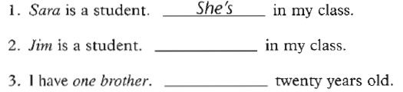
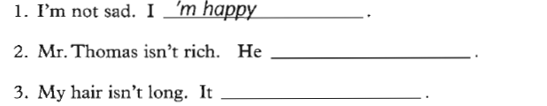
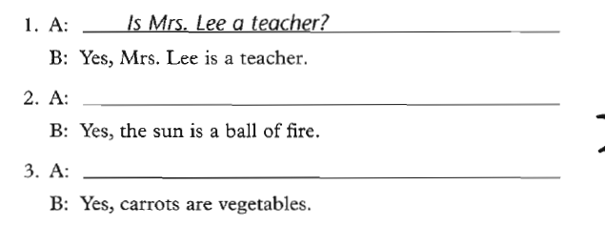

- Each of the girls makes (her, their) own clothes.
- The jury finally made (its, their) decision.
- It often seems that television programmers are not concerned with (its, their) viewers.
Both Tim and Tony write (his, their) mothers twice a week from camp.
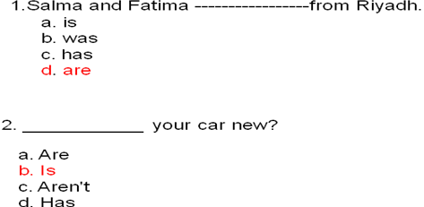
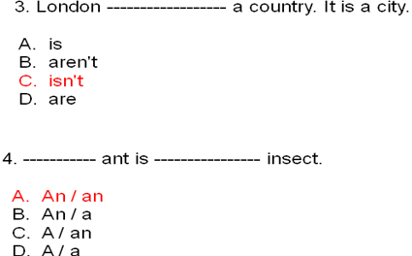
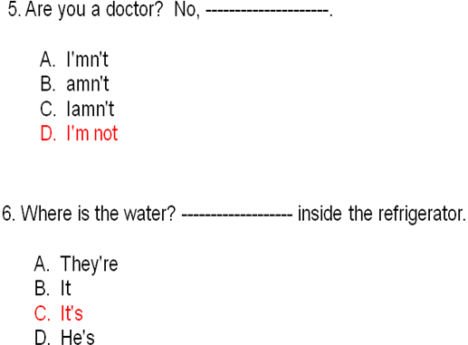
7. A teacher usually starts a lesson by writing the date------------------the board.
- in
- under
- over
D. on
8. My friend is from America.---------- lives in New York city.
- I
- We
- He
- It
9. ------------ in the house now.
- We're
- Wer'e
- Were
- We re
- 10. Are you ready? - -------------------------------.
- No, I'm not
- Yes, Im
- No, Iamn't
- Yes, You're

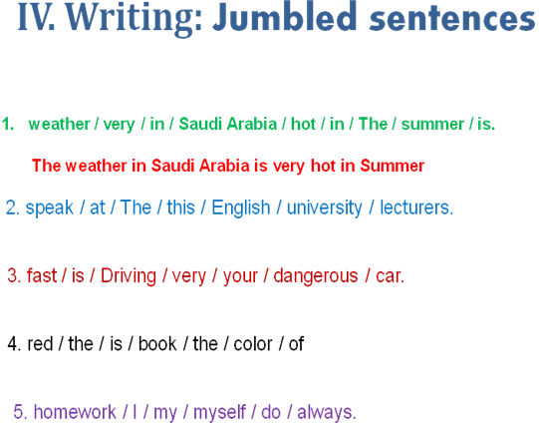
)3(Examples. ))A,AN))
_a_book an_orange _a_ car _a_story _an_ egg _a_lecture
_a_ man _an_umbrella _an_apple _a_ pencil _a_table _an_ email
1. Could you please give me _____ piece of cake?
a. an b. two c. a d. many
2. ___ dog is ____ animal.
a. An/a b. An/an c. A/an d. A/a
3. I visited ____Ahmed last week.
a. an b. the c. a d. Nothing
4. The capital of Saudi Arabia is ____ Riyadh.
a. Nothing b. an c. a d. the
5. I finished ____ unit in English language course.
a. an b. a c. three d. few
6. I take___ umbrella when it rains.
a. a b. an c. two d. several
))2((II. Exercise
1. The doctor gave__________ a lecture about pronouns.
a. we
b. us
c. our
d. ours
2. ______ friend sent an email to the doctor regarding the homework.
a. I
b. Me
c. Mine
d. My
II. Exercise
3. Hani visits _______ every week.
a. them
b. they
c. theirs
d. their
4. _______ are the books you told me about.
a. That
b. These
c. You
d. Their
5. The building you need is ___________.
a. these
b. those
c. there
d. her
6. That car over there is __________.
a. mine
b. me
c. my
d. I
مضارع توبي مع (هي للمؤنث )=
she
is
1. She______ at home now.
a. be b. was c. is d. been
2. My friends will_____________ here after 15 minutes.
نستخدم بعد الكلمات مثل
BE
will
a. are b. were c. been d. be
3. I ____in Riyadh two weeks ago.
a. was b. am c. be d. were
4. We _________ ready to start now.2
a. were b. aren’t c. weren’t d. isn’t

5. ____ Hiba at university yesterday?
a. Is b. Are c. Were d. Was
6. Will Rashed___ at university tomorrow?
a. be b. is c. was d. been
Exercise:
1. We _______ a lecture in English yesterday. ( has, have , had, having )
2. My friend________ a new car nowadays. ( has, having, had, have)
3. The students _____ studied English for a month.( has, have, had, having)
4. He has a car. He doesn’t have a car. Does he have a car?
5. He has got a car. He hasn’t got a car. Has he got a car?
1. She______ a new car nowadays.
a. had b. have c. has d. hasn’t
2. My friends ___________been here for 15 minutes.
a. has b. have c. hasn’t d. aren’t
3. I ____an English lecture yesterday .
a. had b. have c. has d. haven’t
4. Hind _________ a dictionary now.
a. hasn’t b. doesn’t have c. haven’t d. didn’t have
5. Ahmed and Abdullah _________a mathematics test now?
a. has b. have c. doesn’t have d. had
6. _______ she been here before ?
a. Have b. Has c. Is d. Was
1. You can go to the new ___________ and buy whatever you need.
A. hospital B. school
C. mall D. cinema

2. Doctors always advice smokers to give up smoking. The underlined word give up
has the same meaning as:
A. quit B. Start
C. help D. study
3. The children were afraid when they saw the ________________in the Luna park.
A. food C. monster
C. games D. juice
4. The phrase “ write the same thing’ means ________________ .
A. cut B. paste
C. copy D. delete
5. The trip to the sea was very, very good. “ very, very good” means:-
A. wonderful B. dangerous
C. terrible D. easy
3. The men, women and children in Saudi Arabia are kind and generous. The
underlined phrase can be replaced by:
A. visitors C. people
C. soldiers D. vehicles
a little / a few
aبدون اضافة
لان المبلغ غير متوفر او غير كافي

1. Have you got any money? Yes, I have got __ a little ______.
2. Have you got many envelopes? No, I’ve got just _____ few ___.
3. Does your friend speak English? Yes, he speaks _ a little _______.
4. Do you want sugar in your coffee? Yes, I would like _some_______.
5. We are going away for __ a few ______ days.
very little / very few
1. Your English is very good. You make ____ very little __________.
2. I drink _______ very little _______. I don’t like it.
3. Hurry up. We’ve got _______ very few ________.
4. I am sad and lonely. I’ve got ____ very few ___________.
5. I’m afraid I won’t be able to buy that, I’ve got very little
much / many
1. Do you drink _______ coffee?
2. I stay at home most of the time. I don’t go out ________.
3. I’ve seen _______ films with Brad Pitt.
4. How _________ photos did you take?
5. Do you eat ________ chocolate?

Fill in the following blank space with the most appropriate answer a, b, c or d:-
1. To ask oneself and think means:____________________
_- يسال نفسه و يفكر يعني : --- يتعجب ---

a. prefer b. wonder c. repair d. enjoy
2. “________” has the same meaning as “ proof”.\
--- ادله --- " له نفس معنى " دليل
a. essence b. similarity c. evidence d. reference
3. The word that has the same meaning as “ a chemical that helps us to grow” is______ .
الكلمة التي لها نفس المعنى مثل " المواد الكيميائيه تساعدنا على النمو " هي --- هرمون ---
a. germs b. sugar c. bacteria d. hormone
4. “ __________________” the same meaning as “ nevertheless”.
"--- بأية طريقة ---" نفس المعنى مثل "ومع ذلك " .
a. however b. because c. since d. as
5. something we use to refer to another thing is a _____________________
شي نستخدمه لنشير لشيء اخر هو الـ --- رمز --- .
a. book b. pen c. symbol d. sheet
6. __________ is the opposite of sleeping.
يقظ --- هي عكس نائم .
a. Dreaming b. Awake c. Running d. Active
----------------------------------------------------------------------------------------
Vocabulary Exercise
7. Wishes means:_____________________
الامنيات تعني --- الرغبات ---
a. wonders b. desires c. dreams d. studies
8. “________” has the same meaning as “ repair”
. "--- يصلح ---" له نفس المعنى مثل " يصلح "
a. fix b. damage c. prepare d. concern
9. The word that has the same meaning as “ reason” is___________ .
الكلمة التي لها نفس المعنى مثل " سبب " هي --- غرض ---
a. question b. purpose c. basic d. season
10. The word that means “period of time” is___________ .
الكلمة التي تعني "فتره من الزمن" هي --- مرحله ---
a. areas b. project c. stage d. sense
11. “ __________________” the same meaning as “ happens”.
"--- يحدث ---" نفس المعنى مثل " يحدث
a. occurs b. finishes c. starts d. enjoys
12. The word that means “go places” is _____________________
الكلمة التي تعني "الذهاب من الاماكن " هي --- يسافر ---
a. swim b. leave c. travel d. look
13. “__________” is the opposite of easy.
"--- معقد ---" ضد سهل
a. make sense b. complicated c. normal d. expensive
-------------------------------
( many/much/ a few/ a little, some, several…etc )
page 195
- انا كنت جائعا جدا . انا اكلت --- الكثير --- من الطعام
1. I was very hungry. I ate ______________ food .
a. many b. little c. much d. a few
2. _________ students will pass the test. It is vey easy.
الكثير --- من الطلاب سوف يجتازون الاختبار . انه كان سهلا جدا
a. Few b. Some c. A few d. Many
3. Fortunately, _______________ people died in the terrible accident
. لحسن الحظ , --- قليل --- من الناس يموتون في حوادث فضيعه
a. Many b. Some c. Few d. A few
4. He was very happy . He won ____________ money in the project
. هو كان سعيد جدا . هو امتلك --- الكثير --- من المال في المشروع
a. many b. much c. little d. a few
5. _______ student should have the textbooks.
--- كل واحد --- من الطلاب يجب ان يمتلك دفاتر .
a. many b Some c. Every d. All
6. I didn’t like the food. I ate ______________\
انا لا احب الطعام . انا آكل --- قليل ---
a. much b. many c. little d. few
7. I read ______________books about English literature.
انا اقرأ --- العديد ---- من الكتب عن الأدب الانجليزي
a. a little b. several c. much d. every
8. I haven’t seen ________students at university on Friday.
انا لم نرا --- أي --- من الطلاب في الجامعه يوم الجمعه
a, many b. some c. any d. a few
--------------------------------------------------
Sample Questions
1. The men ____________ in the building now.
a. worked b. works c. are working d. working

2. ___________________ waiting me at the moment? – near the pharmacy.
a. Where he is b. Where does he
c. Where did he d. Where is he
3. The boys __________________________ football now .
a. are play b. play
c. is playing d. aren’t playing
4. Listen! The baby ________________ in the next room.
a. will cry b. crying
b. are crying d. is crying
5. I can’t go with you. I ______________ my homework now.
a. did b. have don c. am doing d. do

Sample Questions
6. She ____________ meat with rice now.
a. isn’t liking b. doesn’t like c. is liking d. like

7. She___________________ meat with rice at the moment.
a. eats b. doesn’t eats c. is eating d. eat
8. The boys __________________________ football now .
a. are play b. play
c. is playing d. aren’t playing
9. look! The car________________ coming toward us.
a. will come b. coming
b. are coming d. is coming
10. My mother is in the kitchen. She ______________ now.
a. cooked b. have cooked c. is cooking d. cook

9)Exercise
I. The word “ __________” means work for free.
الكلمة --- تبرع --- تعني العمل مجانا .
A. employ B. volunteer
C. prepare D. watch
2. The phrase “ a big or strong difference” means ______________.
العبارة " اختلاف كبير او قوي " تعني --- تباين ---
A. contract B. difficulty
B. contrast D. similarity

3. You are________________ because every body knows about you.
انت – مشهور --- لان كل شخص يعرفك
A. sick B. a driver
C. a player D. famous
4. A person between 13 and 19 years old is a _____________________
الشخص الذي بين 13 و 19 من العمر هو --- مراهق -
A. teenager B. worker
C. volunteer D. pilot
5. In our society, a mother usually____________ her children and prepares food.
- في مجتمعنا , الام عادةً --- تعتني بــ --- اطفالها و تحضر الطعام
A. kills B. goes for
C. Takes care of D. sets out
6. The word “ ________________” is closest in meaning to the word “ a picture”.
الكلمة --- رؤية --- قريبة في المعنى من كلمة " صورة "
A. mission B. vision
B. revision D. television
7. The box is ________________ . It is not easy to break it.
الصندوق --- قاسي --- . ليس من السهل كسره
A. heavy B. rough
C. tough D. red
8. Some examples of ____________ are love, feelings and joy.
بعض امثلة --- المشاعر --- هي حب , احاسيس و فرح
A. invitation B. emotions
C. tourism D. sickness

Location or position of Frequency Adverbs in sentences.
1. If there is only a main verb in a sentence we put the frequency
adverb immediately before it
- اذا كان هناك فعل اساسي فقط في الجمله نضع حال التكرار مباشرة قبله adverb immediately before it .
e.g.,- Sami______________ his friends. مثل : سامي --- دائما يحترم --- اصدقائة
A. respects always B. respects never
C. always respects D. respects sometimes
2. If there is only one of the verbs to Be ( is, am, are, was, were ),we put the frequency adverb immediately after 2- اذا كان هناك احد افعال الكينونة فقط ( ( is , am , are , was , wereنضع حال التكرار مباشرة بعده . that verb to Be.
e.g.,- The students __ afraid of the final tests. مثال : الطلاب -- عادة ما يكونوا -- خائفين في الاختبارات النهائية .
A. usually are B. are usually
C. is usually D. usually is
3. If there is a helping verb and a main verb in a sentence we put the frequency adverb between the helping verb
3- اذا كان هناك فعل مساعد و فعل اساسي في الجملة نضع حال التكرار بينهما . and the main verb
e.g.- Our doctor ______________ his mobiley. مثال : دكتورنا --- قلما يغلق --- جوالة . A. has switched off rarely B. has rarely switched off
C. rarely has switched off D. never has switched off
4. In case of a question , we just replace the subject with the helping verb
4- في حالة السؤال , فقط تبدل مكان الفاعل مع الفعل المساعد .
مثال: الدكتور لم يخيب امل أي طالب ابدا . e.g. – The doctor has never disappointed any student.
في السؤال وضعنا الفعل المساعد has مكان الفاعل the doctor ثم نكمل باقي الجمله مثل ماهي .
هل الدكتور ابدا يخيب امل أي طالب ؟ Has the doctor ever disappointed any student?
Note: Be careful! In questioning, we change never to ever
ملاحظه: كن حذرا ! في السؤال , تتغير never ابدا الى everابدا

I. Exercise
1- صديقي ذكي جدا. هو --- دئما --- يجتاز الاختبارات . 1. My friend is very clever. He _________ passes the tests.
A. sometimes B. always
C. never D. seldom
2- صديقي ذكي جدا . هو --- ابدا --- لا يفشل بالاختبارات . 2. My friend is very clever. He _________ fails the tests.
A. always B. sometimes
C. never D. seldom
3- --- هل رايت بدا --- ثعبانا ؟ لا لم أرى . 3. ______________ a snake? – No, I haven’t.
A. Have you seen ever B. Have you ever seen
C. Have you seen never D. Have you never seen
4- هند دقيقة جدا . هي --- ابدا --- لا تاتي متأخره لعملها . 4. Hind is very punctual. She ______ comes late to her work.
A. always B. never
C. sometimes D. often
5. Rami plays football three times a week. He ______ plays football.
5- رامي يلعب كرة القدم ثلاث مرات باليوم . هو --- بعض الاوقات --- يلعب كرة القدم .
A. always B. sometimes
C. never D. seldom
6- --- هل عادة انت تفعل --- الواجب بمفردك ؟ 6. ______________ the homework alone?
A. Do you do usually B. Do you never do
C. Do usually you do D. Do you usually do
Exercise : Past Progressive
I. We saw an accident while we ____________ to university.
1- نحن راينا حادث بينما نحن --- كنا ذاهبين --- للجامعة
A. go B. have gone
C. were going D. was going
2. When he ________, it was raining heavily.
2- عندما --- وصلت --- , كانت تمطر بشد
A. was arriving B. arrived
B. arrives D. is arriving
3-As the children ________________ in the park, someone fell down.
3- لما الاطفال --- كانوا يلعبون --- في المنتزه , احدهم سقط .
A. were playing B. played
C. play D. are playing
Exercise
1- الكلمة --- تبرع --- تعني العمل مجانا . I. The word “ __________” means work for free.
A. employ B. volunteer
C. prepare D. watch
2- العبارة " اختلاف كبير او قوي " تعني --- تباين --- 2. The phrase “ a big or strong difference” means _______.
A. contract B. difficulty
B. contrast D. similarity
3- انت – مشهور --- لان كل شخص يعرفك . 3. You are________________ because every body knows about you.
A. sick B. a driver
C. a player D. famous
4- الشخص الذي بين 13 و 19 من العمر هو --- مراهق --- 4. A person between 13 and 19 years old is a _________
A. teenager B. worker
C. volunteer D. pilot
5. In our society, a mother usually____________ her children and prepares food.
5- في مجتمعنا , الام عادةً --- تعتني بــ --- اطفالها و تحضر الطعام .
A. kills B. goes for
C. Takes care of D. sets out
6. The word “ _____” is closest in meaning to the word “ a picture”.
6- الكلمة --- رؤية --- قريبة في المعنى من كلمة " صورة " .
A. mission B. vision
B. revision D. television

7- الصندوق --- قاسي --- . ليس من السهل كسره . 7. The box is _________ . It is not easy to break it.
A. heavy B. rough
C. tough D. red
8- بعض امثلة --- المشاعر --- هي حب , احاسيس و فرح . 8. Some examples of _______ are love, feelings and joy.
A. invitation B. emotions
C. tourism D. sickness =========================================================
Exercise : Adverbs of Frequency
1. Hind is very punctual. She _________ comes late to her work.
A. always B. never
C. sometimes D. often
2. Rami plays football three times a week. He ______ plays football.
A. always B. sometimes
C. never D. seldom
3. ______________ the homework alone?
A. Do you do usually B. Do you never do
C. Do usually you do D. Do you usually do
))10))Previewing Vocabulary1- الكلمة " --- خام --- " اقرب في المعنى للعبارة " غير مطبوخ " .
1. The word” _____________” is closest in meaning to the phrase “ not cooked”.
A. boiled B. raw
C. fried D. ugly
2. Some people lose weight fast, but they usually _____________ it back again
. 2- بعض الناس يخسرون الوزن بسرعة , لكنهم عادة --- يكسب --- ونه من جديد .

A. gain B. eat
C. help D. give
3. The word “ ___________” is closest in meaning to the phrase “ very beautiful”.
3- الكلمة " --- جذاب --- اقرب في المعنى للعبارة " جميل جدا " .
A. interesting B. attractive
C. difficult D. thin
4. She looks very ______________ because of the diet she follows.
4- هي اصبحت --- نحيله --- جدا بسبب الحمية التي تتبعها
A. slim B. ugly
C. dangerous tall

5. I remembered the meanings of all words ____________the word” except”.
- انا اتذكر معاني كل الكلمات --- باستثناء --- كلمة " لو لا "
A. expect B. accept
C. except D. receipt
6. My friend suffers from being _____________. He is now too fat.
صديقي يعاني من بداية --- سمنة --- . انه الآن بدين جدا
A. thin B. overweight
C. light D. happy
7. “ _________” is closest in meaning to the phrase “ old, smelly and very bad”
. "--- مقرف ---" اقرب في المعنى للعبارة " قديم , كره الرائحه و سيء جدا " .
A. interesting B. attractive
C. disgusting D. delicious
8. Dieting often doesn’t work. People usually gain back the weight.
The word “Work” means:___________________
الحمية غالبا ليست نافعة . الناس عادة يعودون لكسب الوزن . الكلمة " نافعة " تعني --- ناجحة -
A. have a job B. succeed
C. fail D. be active and try
-------------------------------------------------------------------------------------------------------------------
Exercise
Circle the most suitable answer a, b, c or d for each of the following
- The final test will be similar to the questions in the lectures exercises
. - الاختبار النهائي سوف يكون مشابه للأسئلة في تمارين المحاضرات .
1. The part speech of “ final” is __________________________________
- جزء الكلام " النهائي " هو --- صفة ---
A. a verb B. an adverb
C. a noun D. an adjective
2. The part speech of “ questions ” is _____________________________
جزء الكلام " اسئلة " هو --- اسم ---
A. a verb B. an adverb
C. a noun D. an adjective
3. The part speech of “ will” is __________________________________
- جزء الكلام " سوف " هو --- فعل شرطي ---
A. a main verb B. a verb to be
C. a modal D. a preposition
4. The part speech of “ in” is ___________________________________
جزء الكلام " في " هو --- حرف جر ---
A. a verb B. a preposition
C. a noun D. an adjective
Exercise
Circle the most suitable answer a, b, c or d for each of the following
The doctor gave us the first homework last week.
الدكتور اعطانا الواجب الاول اخر اسبوع
5. The part speech of “ us” is _________________________pronoun
- جزء الكلام " نا " هو ضمير --- الملكية
A. a possessive B. an object
C. a subject D. a reflexive
6. The part speech of “ gave ” is ______________________________
جزء الكلام " اعطى " هو --- فعل ماضي ---
A. a present verb B. an auxiliary
C. a future verb D. a past verb

7. The part speech of “ last” is ________________________________
جزء الكلام "اخر " هو --- صفة ---
A. an adjective B. a verb to be
C. an article D. a preposition
8. The part speech of “ doctor” is _________________________________
جزء الكلام "دكتور " هو --- اسم فاعل ---
A. a verb B. a subject noun
C. an object noun D. an adjective

=========================================================================
))12((Previewing Vocabulary
1. The word” __________” is closest in meaning to the phrase “ a way of acting”.
A. difficulty B. behavior
C. entertainment D. character
2. Most of the students feel _____________ because of the final tests.
A. worried B. thirsty
C. sleepy D. hungry
3. The word “ ___________” is closest in meaning to the phrase “ very clever”.
A. interesting B. intelligent
C. easy D. enjoyable
4. Every one felt ______________ because of the bad movie.
A. bored B. happy
C. dangerous D. tall
5. “____________” is closest in meaning to the phrase“ kinds of living things”.
A. islands B. beaches
C. species D. insects
6. All children _____________ watching cartoon movies.
A. dislike B. enjoy
C. are afraid of D. avoid
7. “ _________” is closest in meaning to the word “ like”.
A. hate B. attract
C. prefer D. avoid
8. When the sun rises, the fog ___________________ quickly .
A. disappears B. succeeds
C. returns D. fails
- Let’s Start Exercising
1. People in Saudi Arabia are as ______________ as people in Jordan .
A. more generous B. generous
C. most generous D. the most generous
2. The weather in winter is _____________ than it is in summer.
A. colder B. cold
C. coldest D. the coldest
3. I have ___________ money than you do.
A. much B. more
C. most D. least
4. Abdullah is ______________ of all boys.
A. the fastest B. the most fastest
in
C. fast D. faster
-------------------------------------------------------------------------------------------------------
Do More Exercises
- What is the comparative of "sad"?
  - sader
  - sadder
  - sadier
  - saddier
- What is the comparative of "destructive"?
  - destructiver
  - more destructive
  - destructivier
  - more destructiver
- What is the superlative of "soft"?
  - softest
  - softiest
  - softtest
  - most soft
- What is the comparative of "hot"?
  - hoter
  - hotter
  - hotest
  - hottest
- What is the comparative of "heat"?
  - heater
  - heatter
  - heatier
  - hetter
  - none of these
- What is the superlative of "ugly"?
  - uglier
  - uggliest
  - uglyest
  - ugliest
- What is the superlative of "unpleasant"?
  - unpleasant
  - most unpleasant
  - more unpleasant
  - unpleasantest
- What is the superlative of "small"?
  - smallier
  - smaller
  - smalliest
  - smallest
- What is the comparative of "lively"?
  - livelyer
  - more livelyer
  - livelier
  - more livelier
- What is the superlative of "deep"?
  - deeper
  - deepper
  - deepest
  - deeppest

shorter
1. Joe is……. than Ed. (short)
2. Al is the …… (short)----------shortest
3. Ed is the…. . (thin)-------------thinnest
4. Joe is…… than Al. (thin)------------thinner
5. Al has the…… clothes. (colorful)---------most colorful
6. Al is…… than Joe. (heavy)------------heavier
7. Ed is…… the . (light)----------------lightest
8. Joe is……. than Ed. (happy)------------happier
9. Ed is the ……. . (mysterious)-------------most mysterious
10. Joe is……… than Ed. (energetic)----------more energetic
---------------------------------------------------------------------------------------------------------
Choose the correct alternative for each sentence. (Comparatives or Superlatives)
1. I think that’s _____ film I’ve ever seen
- the funnier than b) the funny
- c) the funniest d) the funnier
2. Is football the _____ sport in Chile?
- popular b) more popular
- c) popularest d) most popular
3. Vegetables are _____ last week
- expensiver than b)more expensiver tham
- c) more expensive than d) most expensive
4. I think Vladimir is _____ intelligent person in the class
- more than b) the most
c) most d) the more
5. Don’t you think there are _____ things to do on hokidays than watching tv all day?
a) best b) bestest c) better d) better than
6. Summer is _____ season in our country
a) the hottest b) hotter than c) the hot d) hot
7. Groenland has the _____ weather of the world. It’s always raining and snowing
a) bad b) worse than c) worst d) worsest
8. The Everest is _____ the Aconcagua
a) the highest b) highest than c) the higher than d) higher than
9. Last week we had _____ day in Santiago, the temperature was –18ºC
a) the colder b) the coldest c) the cold d) colder than
10. To fall from a motorcycle is _____ to fall from a bicycle.
- more painful b) more painful than c) painfuller than d) the painfullest
11. If you suffer asthma, don’t go to Mexico City. It is one of the _____ cities in the world
- pollutest b) more polluted c) polluter than d) most polluted
12. The _____ place from Chile is Australia. It’s on the other side of the world.
- farther b) farthest c) farther than d) farthest than
13. I don’t think your bike is _____ mine.
- fastest than b) faster c) fastest d) faster than
14. Michael was _____ basketball player in the world
- taller b) tallest c) the taller d) the tallest
15. Speaking Japanese is _____writing it.
a) the easiest b) easy c) easier than d) easyer than

Write the following sentences using the correct form of the adjective (comparative or superlative)
- Clare is _______older than_____________________ Mike. (old)
- Jane is _the healthiet_______ of the four. She eats very well and does a lot of sports, (healthy)
- The coach thinks that Peter is the ______fastest____ player of the team, (fast)
- The Sahara desert is one of the ____hotest_____deserts in the world. (hot)
- The climate in the North of Chile is __________drver______ in the South, (dry)
- Asia is ______________bigger__________ Europe. (big)
- A Rolls-Royce is one of _most expensive_________ cars in the world. (expensive)
- _The most violent___ hurricanes are developed over México, (violent)
- Diamonds are __the most precious___ jewels in the world. (precious)
- History classes are __more interesting than___ chemistry classes. (interesting)
- ))13((In each of the sentences below, you will see a blank. Please choose one of the following articles for each sentence – a, an, the or leave it blank.
1. My father’s car is considered to be __a____ piece of art.
- 2. _______ (B/b)eauty is fleeting.
- 3. ___the____ (A/a)ir in the room was stifling.
- 4. The doctor told me that I needed ___the___ operation tomorrow.
- 5. __the____ (I/i)nformation I received was extremely important.
- 6. _the_____ (A/a)ir is made up of millions of atoms.
- 7. My parents could not believe that their dog had peed on __the____ carpet.
- 8. _an_____ (A/a)pple a day keeps the doctor away.
- 9. In some cultures ______ dogs are considered man’s best friend.
- 10. My sister decided to cut her hair with ___a___ scissors.
- 11. I was bitten by __a_____ mosquito in the Caribbean.
- 12. When the horn honked, it scared me and I dropped ______ glass on the floor.
- 13. In ancient Egypt _______ cat was considered sacred.
- 14. Is ___the____ water in Lake Erie safe to drink?
A, An, The, Zero Article

1. Could you please give me _____ piece of cake?
a. an b. two c. a d. many

2._____ dog is ______ animal.
a. An/a b. An/an c. A/an d. A/a
3. I visited ________ Ahmed last week.
a. an b. the c. a d. Zero Article
4. The capital of Saudi Arabia is_______ Riyadh.
a. Zero Article b. an c. a d. the
5. I finished _______ unit in English language course.
a. an b. a c. three d. few
6. I take ______ umbrella when it rains.
a. a b. an c. two d. several
=

