Lecture # 11
Types of Sentences: More about the Compound Sentence

Lecture Components
The compound sentence: Revision
Run-ons
Comma Splices
Conjunctive Adverbs

The Compound Sentence
A compound sentence is two simple sentences connected by a comma and a coordinating conjunction.
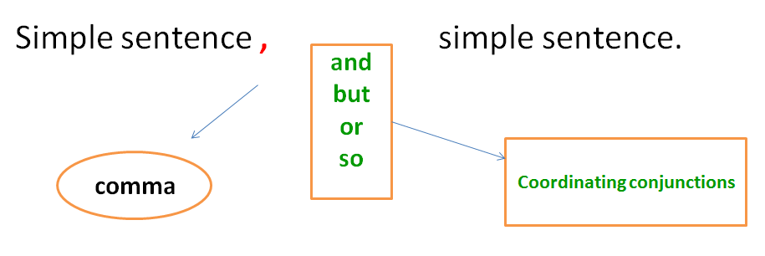

The Compound Sentence: Coordinating Conjunctions
- And connects two sentences with similar ideas. The sentences can be positive or negative:
My friend is a teacher, and his sister is a doctor.
He doesn’t like music, and she doesn’t like art.

- But connects two sentences with opposite ideas:
She likes art, but she doesn’t like music.

- Or connects two sentences that express alternatives or choices:
Every Friday, they go to a mall, or they visit some friends.

- So connects a reason and a result:
My friend and his sister work a lot, so they don’t go out very often.

Run-ons
أخطاء العطف: جملتان متصلتان دون علامة ترقيم أو حرف عطف
A run-on is two simple sentences incorrectly joined with no coordinating conjunction and no comma.
Subject + verb + subject + verb
Example:
Francisco worked out Maria cleaned her room. X
The first test was difficult the second one was easy. X

Correcting run-ons
كيفية تصحيح الخطأ السابق
There are two ways to fix run-ons:
- With a period (.).
Francisco worked out. Maria cleaned her room.
The first test was difficult. The second one was easy.
- With a comma and a coordinating conjunction.
Francisco worked out, and Maria cleaned her room.
The first test was difficult, but the second one was easy.

Practice
Which of the following is a run-on?
- Some people like cats others prefer dogs. ✓
- Some people like cats, others prefer dogs.
- Some people like cats, and others prefer dogs.
- Some people like cats. Others prefer dogs.

Comma Splice
أخطاء العطف: استخدام فاصلة بين جملتين كاملتين
The comma splice is two simple sentences incorrectly joined with a comma alone.
Subject + verb + , + subject + verb
Examples:
Some people like cats. Others prefer dogs. X
Francisco worked out. Maria cleaned her room. X
The first test was difficult. The second one was easy. X

Correcting Comma Splices
كيفية تصحيح الخطأ السابق
There are two ways to fix comma splices:
- With a period (.).
Some people like cats. Others prefer dogs.
Francisco worked out. Maria cleaned her room.
The first test was difficult. The second one was easy.
- With a comma and a coordinating conjunction.
Some people like cats, and others prefer dogs.
Francisco worked out, and Maria cleaned her room.
The first test was difficult, but the second one was easy.

Comma splices Online
Run-ons online

Practice
- Which of the following is a comma splice?
- Some people like cats others prefer dogs.
- Some people like cats, others prefer dogs. ✓
- Some people like cats, and others prefer dogs.
- Some people like cats. Others prefer dogs.

- Which of the following is a comma splice?
- I don’t watch TV, but my children do.
- I don’t like garlic. I don’t like onions.
- I don’t like garlic, I don’t like onions. ✓
- I don’t watch TV. My children do.

Identify the following sentence as either a comma splice, a run-on, or correct.
- We are going to have spaghetti for dinner, and we are going to have ice cream for dessert.
- Comma splice
- Run-on
- Correct ✓

Identify the following sentence as either a comma splice, a run-on, or correct.
- Would you like to play tennis, would you like to go to the golf course?
- Comma splice ✓
- Run-on
- Correct

Compound sentences with Conjunctive Adverbs
العطف باستخدام ظروف العطف
Study the following table:

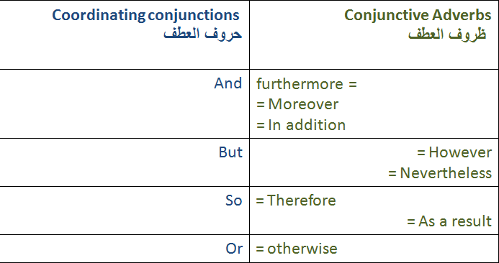

Compound sentences with Coordinating Conjunctions & Conjunctive Adverbs
- It is raining, so she is wearing a raincoat.
- It is raining; as a result, she is wearing a raincoat.
- I’m hungry, but I don’t have time to eat.
- I’m hungry; however, I don’t have time to eat.

- We are going to have spaghetti for dinner, and we are going to have ice cream for dessert.
- We are going to have spaghetti for dinner; in addition, we are going to have ice cream for dessert.
- You need to work harder, or you will get fired.
- You need to work harder; otherwise, you will get fired.

Conjunctive Adverbs online

Practice
- Which of the following sentences is punctuated correctly?
- Ali is tired, so, he would like to go to bed.
- Ali is tired so, he would like to go to bed.
- Ali is tired so he would like to go to bed.
- Ali is tired, so he would like to go to bed. ✓

- Which of the following sentences is punctuated correctly?
- My computer frustrates me however I couldn’t live without it.
- My computer frustrates me; however I couldn’t live without it.
- My computer frustrates me; however, I couldn’t live without it. ✓
- My computer frustrates me however, I couldn’t live without it.

-----------------------------------------
Lecture # 12
Types of Sentences:
The Complex Sentence

Lecture Components
The Complex Sentenceالجملة المعقدة

What is a clause?
A clause is a group of words that contains a subject and a verb. (= simple sentence)
There are two kinds of clauses in English:
- Independent clauses: جملة مستقلة
It rained.
- Dependent clauses:(also called a fragment) جملة تابعة
...because it rained.

An independent clause has one subject –verb pair and expresses a complete thought. (It is just another name for a simple sentence)
Examples:
It rained.
I wasn’t hungry.
Ahmad played football with his friends.
Leila watched a movie on TV.

A dependent clause is an independent clause with a subordinating conjunctionأدوات تكوين الجمل المعقدة ,
such as because, after, and when
…because it rained.
I wasn’t hungry because…
Ahmad played football with his friends after …
Before Leila watched a movie on TV….

A dependent clause does NOT express a complete thought, so it is NOT a sentence by itself.
It is only a fragment. It MUST be joined to an independent clause. The result is a complex sentence.
We didn’t go the park because it rained
I wasn’t hungry because I had a big breakfast
Ahmad played football with his friends after he did his homework.
Before Leila watched a movie on TV, she helped her mother in the kitchen.
These four sentences are called complex sentences

The Complex Sentence

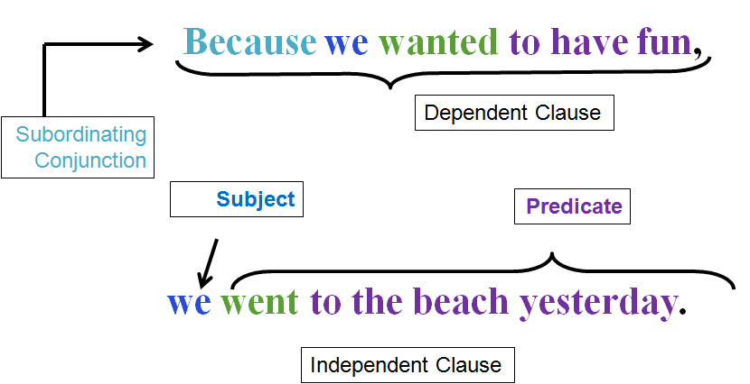

A complex sentence has one independent clause and one (or more) dependent clauses.
- We didn’t go the park because it rained
- I wasn’t hungry because I had a big breakfast
- Ahmad played football with his friends after he did his homework.
- Leila helped her mother in the kitchen before she watched a movie on TV.
We can change the order of clauses in a complex sentence.
- Because it rained, we didn’t go the park.
- Because I had a big breakfast, I wasn’t hungry.
- After Ahmad did his homework, he played football with his friends.
- Before Leila watched a movie on TV, she helped her mother in the kitchen.
If the dependent clause comes first, use comma (,) .

The Complex Sentence: Subordinating Conjunctions
The following are subordinating conjunctions that we use to make complex sentences;
After I will go to bed after I finish my homework.
Before I will finish my homework before I go to bed.
As soon as I will go to bed as soon as I finish my homework.
Since I have been doing my homework since I came from school.
Until I can’t go to bed until I finish my homework.
When I will go to bed when I finish my homework.
While I had a sandwich while I was doing my homework.
Although = Although he finished his homework, he couldn’t go to bed.
if = If you finish your homework, you can go to bed.
Unless = You cannot go to bed unless you finish your homework.
Because = You can go to bed because you finished your homework.

Coordination = Subordination
Study the following examples:
1.Francisco gets a shopping cart. Then Mrs. Garcia reads the shopping list. (Two simple sentences)
2. Francisco gets a shopping cart, and then Mrs. Garcia reads the shopping list. (Compound sentence)
3. Francisco gets a shopping cart before Mrs. Garcia reads the shopping list. (Complex sentence)

Sentences 1 and 2 and 3 have the same meaning. 1 = 2 = 3

Another example;
It started to rain. Ahmad put on his raincoat. 2 simple sentences
It started to rain, so Ahmad put on his raincoat. Compound sentence
Because it started to rain, Ahmad put on his raincoat. Complex sentence

Sentences 1 and 2 and 3 have the same meaning. 1 = 2 = 3

The Complex Sentence: Subordinating Conjunctions
Which is the best way to rewrite the following sentence?
“Cut the tomato and the onion. After that, put them in the bowl”?
- Cut the tomato and onion before you put them in the bowl. ✓
- Cut the tomato and onion after you put them in the bowl.
- Put the tomato and the onion in the bowl before you cut them.

Which is the best way to rewrite the following sentence?
They don’t buy junk food because they like healthy food.
- They don’t buy junk food, so they like healthy food.
- They don’t buy junk food, but they like healthy food.
- They like healthy food, so they don’t buy junk food. ✓
- They like healthy food, but they don’t buy junk food.

Choose the best subordinating conjunction.
Jamal hated school ______ he always got good grades.
- until
- because
- Although ✓
- if

Leila cleaned her room ______ her mother got home from work.
- if
- Before ✓
- until

Indicate whether each sentence is simple, compound, or complex.
- Sara began planning her summer vacation in December. simple
- Because I left the play early, I missed the surprise ending. complex
- Tanya was invited to a party, so she wants to buy a new outfit. compound
- After Alison finished playing the video game, she shut down the computer. complex
- The meaning of this poem is difficult to understand. simple
- Joe and his brother went fishing last weekend, and they caught lots of fish. compound

--------------------------------------------

Lecture # 13
Building Sentences: Prepositional Phrases

Lecture Components
Building a sentence
Prepositional Phrases

Building a Sentence بناء الجملة
Building a sentence
A sentence is a group of words which starts with a capital letter and ends with a full stop (.), question mark (?) or exclamation mark (!). A sentence contains or implies a predicate and a subject.

Building a Sentence
- Sentences can contain subjects فاعلand objects مفعول به .
The subject in a sentence is generally the person or thing carrying out an action. The object in a sentence is involved in an action but does not carry it out, the object comes after the verbالفعل .
- For example: The boy climbed a tree.

- If you want to say more about the subject (the boy) or the object (the tree), you can add an adjective نعت، صفة .
- For example: The young boy climbed a tall tree.
- If you want to say more about how he climbed the tree you can use an adverb ظرف .
- For example: The young boy quickly climbed a tall tree.

- The sentence becomes more interesting as it gives the reader or listener more information.
You can add a prepositional phraseجار ومجرور
- For example: The young boy quickly climbed a tall tree in the garden.

Prepositions
A preposition is a part of speech that shows a relationship between two things.
  - Location (on, under, in) للمكان
  - Timing (before, after, during) للزمان
  - Direction (from, toward, to) للاتجاهات
- The mouse is on the table.
Two things: mouse + table
Relationship: one is on the other
On is a preposition!

- The mouse is under the table.
Two things: mouse + table
Relationship: one is under the other
Under is a preposition!

Here is a list of the most common prepositions:
aboard | along | behind | but (except) | from | off | past | until
about | amid | below | by | in | on | since | up
above | among | beneath | down | inside | onto | through | upon
across | around | beside | during | into | out | to | with
after | at | between | except | near | outside | toward | within
against | before | beyond | for | of | over | under | without

Which word is a preposition?
The pizza in the oven is mine.

Which word is a preposition?
The girl by the door is my sister.

Which word is a preposition?
The runners raced around the track.

Prepositional Phrases
Let’s look again at the sentences you practiced with.
The pizza in the oven is mine.
The girl by the door is my sister.
The runners raced around the track.

Prepositional Phrases
in the oven
by the door
around the track

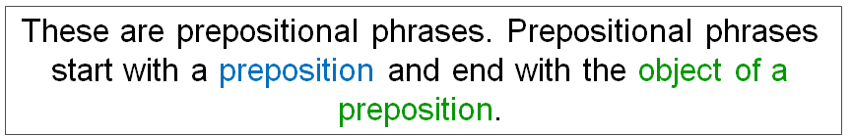

Identify the prepositional phrase.
I chose a book from the library.
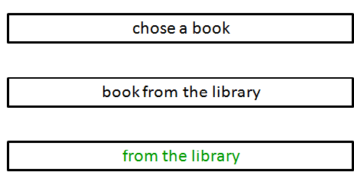

Identify the prepositional phrase.
I sat with my mom.
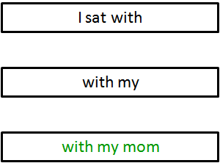

Prepositional phrases
We use prepositional phrases to write longer sentences.
- The students bought a book.
- The students in my class bought a book.
- The students in my class bought a book about flowers.

Another example:
- The questions were difficult.
- The questions in the English exam were difficult.
- The questions about prepositions in the English exam were difficult.

Prepositional phrases of place
الجار والمجرور للدلالة على المكان
Prepositional phrases of place
- The book on the desk is mine.
- The room across from the bathroom is Mary’s bedroom.
- I like to sit on the chair next to the window.
- My clothes are in the bag under the bed.

Prepositional phrases of time
الجار والمجرور للدلالة على الزمان
Prepositional phrases of time
- I saw my friends before the test.
- We will play tennis after class.
- I usually have a big breakfast in the morning.
- My father came back from Mecca at midnight.

Prepositional Phrases
Powerpoint presentation

---------------------------------------------------------

Lecture # 14
Final Exam - Model Questions

نماذج الأسئلة في هذه المحاضرة لا تغطي جميع المادة المطلوبة، وهي فقط لمعرفة أنماط الأسئلة التي سيشتمل عليها الاختبار النهائي. ))
علما بأن المادة المطلوبة هي الوحدات التي تم شرحها في المحاضرات بالإضافة إلى المواد المساندة
التي تم شرحها في المحاضرات من 10 إلى13 ))

نماذج أسئلة
النموذج الأول
Choose the best substitute for the underlined words. If the sentence is correct, choose “Make no change.”
- I would like to go to the moon.
- an
- a
- X
- Make no change ✓
- Othman is work in a restaurant.
- Othman works ✓
- Othman work
- Othman don’t work
- Make no change
- Othman and Ahmad is work in a restaurant.
- Othman and Ahmad works
- Othman and Ahmad work ✓
- Othman and Ahmad don’t work
- Make no change
- Cut the tomato and onion before you put them in the bowl.
- before put them in the bowl
- before you putting them in the bowl
- before you put it in the bowl
- Make no change ✓
- Their apartment has three bedrooms, and a living room, and a kitchen, and a bathroom.
- Their apartment has three bedrooms, a living room, and kitchen, and a bathroom.
- B. Their apartment has three bedrooms, a living room, a kitchen, and a bathroom. ✓
- Their apartment has three bedrooms, and a living room, a kitchen, and a bathroom.
- Make no change
- The scary film movie was cloudy.
- bright
- careful
- Frightening ✓
- Make no change
- We worked all day. It was amazing.
- It was good.
- It was very nice.
- It was exhausting. ✓
- Make no change.

- I’m hungry; moreover, I don’t have time to eat.
- However ✓
- as a result
- in addition
- Make no change

النموذج الثاني
Choose the word/words that best fit in the blank space:
Get ______ lettuce at the store.
- many
- B. five
- a
- some ✓
The man is talking to Mary. The man is talking to ___
- him
- Her ✓
- it
- them
We wanted to go to the beach; ________________, it started to rain and we stayed at home.
- otherwise
- However ✓
- in addition
I usually wake up _____ six o’clock ___ the morning.
- at in ✓
- in at
- In on
- on at
Every Friday, they play football_______ they watch television.
- , or ✓
- , or,
- , so
- , so,
Francisco was busy after lunch. Francisco wasn’t _____ after lunch.
- Bored ✓
- crowded
- colorful
- bright
Francisco was full at noon. Francisco wasn’t ________at noon.
- sick
- tired
- Hungry ✓
- happy

Identify the following sentence as either a comma splice, a run-on, a fragment, or correct.
“We are going to have spaghetti for dinner, and we are going to have ice cream for dessert.”
- Comma splice
- Run-on
- Fragment
- Correct ✓
What is the correct sequential order of the following sentences?
1. Next, Mrs. Garcia reads the shopping list.
2. First, the Garcia go to the supermarket.
3. After that, Maria and Mr. Garcia go get the groceries.
4. Second, Francisco gets a shopping cart.
- 2, 1, 3, 4
- 3, 2, 1, 4
- 4, 3, 2, 1
- 2, 4, 1, 3 ✓
Which is the best way to rewrite the following sentence?
“Faisal went to school. Sa’ad went to school.”
- Faisal went to school Sa’ad went to school.
- Faisal and Sa’ad went to school. ✓
- Faisal, Sa’ad went to school.
- Faisal went to school and Sa’ad went to school.
Which is the best way to rewrite the following sentence?
“It is raining, so she is wearing a raincoat.”
- It is raining; otherwise, she is wearing a raincoat.
- It is raining; however, she is wearing a raincoat.
- It is raining; in addition, she is wearing a raincoat.
- It is raining; as a result, she is wearing a raincoat. ✓
Which is the best way to rewrite the following sentence?
“I live in a place called Disneyland. I work in a place called Disneyland.”
- I live in a place and work in Disneyland.
- I live in a place called Disneyland and work in a place called Disneyland.
- I live and work in a place called Disneyland. ✓
- I live in a place called Disneyland I work in a place called Disneyland.
What is the best order of the following words in a sentence?
are / questions / we / answering / the / now
- We are answering the questions now. ✓
- Now we are the questions answering.
- We now are answering the questions.
- We are answering now the questions.
What is the subject in the following sentence?
"Ahmad and Khalid played tennis and football at school yesterday.”
- Ahmad
- Ahmad and Khalid ✓
- tennis and football
- tennis

What is the verb in the following sentence?
“He laughed and cried at the same time.”
- laughed and cried ✓
- laughed
- cried
- He
Which of the following sentences is punctuated correctly?
- I will go; therefore, you can stay home. ✓
- I will go therefore you can stay home.
- I will go; therefore you can stay home.
- I will go; therefore; you can stay home.
Which of the following sentences is a complex sentence?
- Ahmad did his homework before he had dinner. ✓
- Ahmad did his homework and had dinner.
- Ahmad had dinner and did his homework.

النموذج الثالث: قطعة وأسئلة
Questions : Study the following paragraph and then answer questions that follow
____________________________________ My father, mother, brother, and I went to a new zoo downtown. My father drove us to the zoo. It was very close to our home. We walked around the zoo after we arrived. We saw many animals. Some animals were beautiful. Some animals were funny. I really liked the snakes. I thought they were fascinating. My brother didn’t like them. He thought they were scary. Later on, we watched an animal show. ___1___ the show, the zookeeper gave me a snake! I held it for five minutes. It was really heavy, but it was beautiful. Later on, my brother held the snake, too. Now, he doesn’t think they are ___2___. They are his new favourite animal. __3__,

- Choose the best topic sentence for this paragraph .
  - My father drove us to the zoo.
  - we all had a good time at the zoo.
  - Some animals were funny.
  - I had an interesting trip last July. ✓

I had an interesting trip last July. My father, mother, brother, and I went to a new zoo downtown. My father drove us to the zoo. It was very close to our home. We walked around the zoo after we arrived. We saw many animals. Some animals were beautiful. Some animals were funny. I really liked the snakes. I thought they were fascinating. My brother didn’t like them. He thought they were scary. Later on, we watched an animal show. ___1___ the show, the zookeeper gave me a snake! I held it for five minutes. It was really heavy, but it was beautiful. Later on, my brother held the snake, too. Now, he doesn’t think they are ___2___. They are his new favourite animal. __3__,

- Choose the best concluding sentence for this paragraph.
  - My father drove us to the zoo.
  - we all had a good time at the zoo. ✓
  - Some animals were funny.
  - I had an interesting trip last July.

I had an interesting trip last July. My father, mother, brother, and I went to a new zoo downtown. My father drove us to the zoo. It was very close to our home. We walked around the zoo after we arrived. We saw many animals. Some animals were beautiful. Some animals were funny. I really liked the snakes. I thought they were fascinating. My brother didn’t like them. He thought they were scary. Later on, we watched an animal show. ___1___ the show, the zookeeper gave me a snake! I held it for five minutes. It was really heavy, but it was beautiful. Later on, my brother held the snake, too. Now, he doesn’t think they are ___2___. They are his new favourite animal. __3__, we all had a good time at the zoo.

- The best word for blank space (1) in the paragraph is: ____
- Later on
- During ✓
- When
- First

I had an interesting trip last July. My father, mother, brother, and I went to a new zoo downtown. My father drove us to the zoo. It was very close to our home. We walked around the zoo after we arrived. We saw many animals. Some animals were beautiful. Some animals were funny. I really liked the snakes. I thought they were fascinating. My brother didn’t like them. He thought they were scary. Later on, we watched an animal show. ___1___ the show, the zookeeper gave me a snake! I held it for five minutes. It was really heavy, but it was beautiful. Later on, my brother held the snake, too. Now, he doesn’t think they are ___2___. They are his new favourite animal. __3__, we all had a good time at the zoo.

- The best word for blank space (2) in the paragraph is: ____
- funny
- scary ✓
- good
- heavy

I had an interesting trip last July. My father, mother, brother, and I went to a new zoo downtown. My father drove us to the zoo. It was very close to our home. We walked around the zoo after we arrived. We saw many animals. Some animals were beautiful. Some animals were funny. I really liked the snakes. I thought they were fascinating. My brother didn’t like them. He thought they were scary. Later on, we watched an animal show. ___1___ the show, the zookeeper gave me a snake! I held it for five minutes. It was really heavy, but it was beautiful. Later on, my brother held the snake, too. Now, he doesn’t think they are ___2___. They are his new favourite animal. __3__, we all had a good time at the zoo.

- The best word for blank space (3) in the paragraph is: ____
- After that
- Later on
- In the end ✓
- First

-------------------------------------------------
☺THE END ☺
.. A7la Malak ..

