Lecture # 6
Write a Message
to a Friend
Lecture Components
Vocabulary
Days of the week
Free – time activities
Time expressions
Feelings and moods
Grammar
Simple past tense with regular verbs
Simple past tense with be and have
Writing:
Write a letter about last weekend

Days of the Week
Saturday
Sunday
Monday
Tuesday
Wednesday
Thursday
Friday

Francisco’s Schedule
Exercise B – page 82
What is Francisco doing at these times?
- It’s 3:15 on Monday.
He’s studying with his math group.
- It’s 7:00 on Thursday evening.
He’s practicing the guitar with Maria.
- It’s 6:30 on Friday morning.
He’s working out.
- It’s 8:45 on Saturday morning.
He’s playing basketball.
- It’s 10:45 on Sunday morning.
He’s cleaning his room.
- It’s 7:00 on Wednesday evening.
He’s calling grandma in San Diego.

Time Expressions
Time expressions tell WHEN something happens or HOW LONG something lasts:
WHEN:
in the morning, in the afternoon, in the evening
on Saturday, on January 3rd
at 12:oo p.m.
at noon, at night, at midnight
HOW LONG:
for two hours , for five days, for ten minutes
from 3:00 to 5:00
Time Expressions: Exercise C – page 82
- How long does Francisco play basketball on Saturday? (for)
He plays basketball for two hours.
- What time does Francisco call Grandma? (at)
He calls her at 7:00 p.m. on Wednesday evening.
- What day does Francisco clean his room? (on)
He cleans his room on Sunday.
- When does Francisco work out? (in)
He works out in the morning.
- How long does Francisco practice the guitar on Tuesday and Thursday? (from …to)
He practices the guitar from 6:30 p.m. to 8:00 p.m.

Adjectives: exercise D – page 83
These sentences are NOT true. Rewrite them using the correct adjective.
- Francisco is sad in Los Angeles.
Francisco is happy in Los Angeles.
- Francisco was wide awake on Saturday morning.
Francisco was very sleepy on Saturday morning.
- Maria didn’t play basketball because she was healthy.
Maria didn’t play basketball because she was sick.
- Francisco was full at noon.
Francisco was really hungry at noon.
- Francisco was busy after lunch.
Francisco was bored after lunch.
- Francisco was full of energy on Sunday evening.
Francisco was tired on Sunday evening.

Simple Past Tense with regular verbs: affirmative
- Francisco plays basketball every Saturday.
Francisco played basketball last Saturday.
- Maria and Francisco study every Sunday afternoon.
Maria and Francisco studied last Sunday afternoon.
- The Garcia family shop once a week.
The Garcia family shopped last week.
- I visit my grandfather every month.
I visited my grandfather a month ago.

Simple Past Tense with regular verbs:
Negative
Affirmative Negative Contractions
Did not work worked didn’t work
shopped did not shop didn’t shop

Simple Past Tense with regular verbs:
Negative
Affirmative | Negative
Francisco helped Maria | Maria did not help her mother.
I lived in Jeddah last year. | I did not live in Riyadh last year.
They studied on Sunday afternoon. | They did not study on Saturday afternoon.
The Garcia family shopped for food. | The Garcia family did not shop for clothes.

Simple Past Tense: Exercise A – page 83
- Maria __didn't play__ basketball on Saturday morning. (play)
- Francisco’s friend Rick __didn't call__ him on Saturday afternoon. (call)
- Francisco and Rick _didn't walk__ to the mall in the morning. (walk)
- Maria and Francisco _didn't watch TV_ on Saturday night. (watch TV)
- 5. On Sunday, Maria and Francisco __didn't stay home__all day. (stay home)
- 6. On Sunday morning, Francisco __didn't clean _clean his rooms for three hours. (clean)
- 7. On Sunday, Francisco __didn't work out ___ and Maria __didn't practice___ the guitar. (work out/ practice)
- 8. On Sunday evening, Francisco __didn't relax__. (relax)

Simple Past Tense with be (was/were): affirmative & negative:
Affirmative | Negative
I was at the game. | I was not (wasn’t) at the game.
You were hungry before lunch. | You were not (weren’t) hungry after lunch.
Francisco was tired on Sunday night. | Francisco was not (wasn’t) tired on Saturday night.
We were on a bus yesterday. | We were not (weren’t) on a plane yesterday.
You were my classmates last year. | You were not (weren’t) my neighbors last year.
They were busy on Saturday morning. | They were not (weren’t) busy on Saturday night.

Simple Past Tense with have(had): affirmative & negative:
Affirmative | Negative
Francisco had a basketball game on Saturday morning. | Francisco didn’t have a basketball game on Sunday morning.
Francisco and his family had plans on Saturday. | Francisco and his family didn’t have plans on Sunday.
I had breakfast at 7:00 a.m. this morning. | I didn’t have breakfast at 8:00 a.m. this morning.

Parts of a Letter:
There are usually five parts of a letter:
- The heading
- The greeting
- The body of the letter
- The closing
- The signature
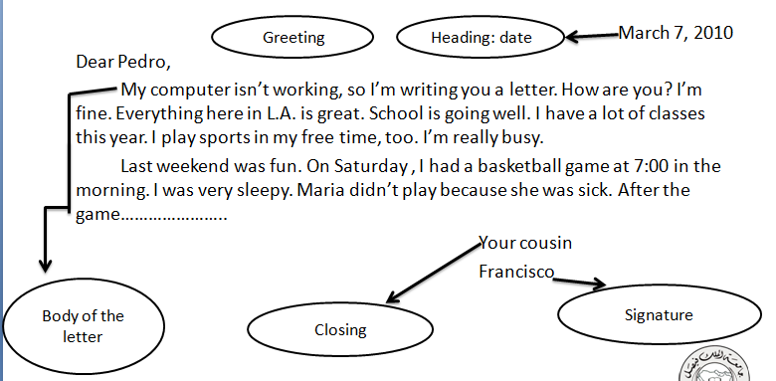

Label the parts of the following letter.
_4_Your friend,
_3_ How are you? I’m great. I’m sitting in the park right now. I’m relaxing with my friends. Last weekend was really exciting. I went to Jeddah with my family […] Did you do anything interesting? Write soon!
_1_ March 23, 2010
_5_ MAHER Al-HAMAD
_2_ Dear Abdullah,

Write a Letter to a Friend
First, tell the person how you are.
Then write about what you did last weekend.
Use time expressions to sequence events.
Finally, ask questions or make requests.
Example:
Message Outline
Greeting | Dear Salman,
Body | How I am? I’m busy. School is good. I have classes from …  What did I do last weekend? On Thursday, I played ….  What questions do I have? How are you? How is school? Are you busy?
Closing | Your friend,

Practice
What’s the best way to combine the following two sentences?
- Then in the afternoon, I played football.
- My friend Ahmad played football too.
- Then in the afternoon, my friend and Ahmad played football.
- Then in the afternoon, my friend Ahmad played football.
- Then in the afternoon, my friend Ahmad and I played football. ✓

What is the best order of the following sentences in a paragraph?
- I have classes Saturday to Friday from 7:00 a.m. to 2:00 p.m.
- My classes are interesting.
- Things here in Dammam are fine.
- I like my teachers, too.
- 1, 2, 3, 4
- 2, 3, 4, 1
- 4, 3, 2, 1
- 3, 1, 2, 4 ✓

Which sentence does not fit in the following paragraph?
- How are you? (2) How was your weekend? (3)Did you have fun? (4) I’m fine. (5) Please write soon.

- Sentence 1
- Sentence 2
- Sentence 3
- Sentence 4 ✓

What is a better word for “sleepy” in the following?
Then I had a big breakfast. I was sleepy.
- fine
- bored
- tired
- Hungry ✓

Choose the best substitute for the underlined words.
- I did my homework to three hours on Sunday.
- From
- At
- For ✓
- Make no change

- My sister practices the guitar in Monday afternoons.
- On ✓
- At
- To
- Make no change
- We watches movies last weekend.
- Are watching
- Watched ✓
- Watch
- Make no change

----------------------------------------------

