GRAMMAR
PHRASES AND SENTENCES
GRAMMAR: It is the description of the structure of phrases and sentences which will account of the grammatical sequences and rule out all the ungrammatical sequences.
- TYPES OF GRAMMAR: There are three types of grammar which are:
- (1) MENTAL GRAMMAR
- It is a form of internal linguistic knowledge which operates in the production and recognition of appropriately structured expressions in that language . This “ grammar” is subconscious and is not the result of any teaching.
- This is the interest of the psycholinguist.
- (2) “Linguistic etiquette”
- The identification of the “proper” or “best” structures to be used in a language .
- This is the interest of the sociolinguist.
- (3) Grammar
- It involves the study and analysis of the structures found in a language, usually with the aim of establishing a description of a particular language.
- The interest of the linguist . His concern is with the nature of language, independently of the users of that language.
- PARTS OF SPEECH
- There are many terms used in a grammatical description, particularly the terms of the parts of speech.
- 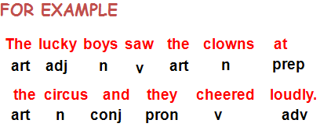
Traditional Grammar
These terms came from traditional grammar, which has its origins in the description of languages like Classical Latin and Greek. Since these were well-established grammatical descriptions of these older languages, it seemed appropriate to adopt the existing categories from these descriptions and apply them in the analysis of languages like English.
Traditional categories
Traditional grammatical analysis also uses a number of other categories, including “number”, “person”, “tense”, “ voice” and “gender”.
It is better to consider them in terms of concord or agreement. Ex. The boy likes the dog
Number : singular and plural
Person : 1st person ,2nd person, 3rd person.
Tense : present tense , past tense.
Voice : active voice , passive voice.
Gender : feminine , masculine gender.
Traditional grammar:
-“appropriateness” has not been into consideration.
In traditional grammar books, tables such as the following were presented for English, constructed by analogy with similar tables of forms in Latin grammar.
The Prescriptive Approach:
It claimed that the structure of English sentences should be like the structure of sentences in Latin. It was an approach taken by some grammarians in the 18th century.
Ex. Present tense, Active voice:
I love
You love
He loves
We love
You love
- There are two approaches to the study of language:
- 1. The prescriptive approach
- 2. The descriptive approach
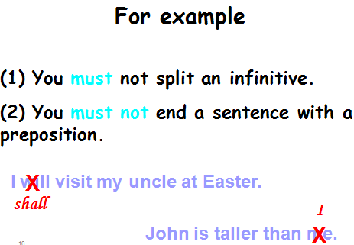

The Descriptive Approach
The descriptive approach and its beginning.
The inappropriateness of the old approach:
- English VS Latin languages.
- European languages VS non-European languages (Indian languages).
As a consequence, a rather different approach has been taken throughout the present century.
Descriptive Analysis:
The analyst collects samples of the language he or she is interested in and attempts to describe the regular structures of language as it is used , not according to some view of how it should be used .It is the basis of most modern attempts to characterize the structure of different languages.
The Descriptive Approach:
- In the study of grammar,there are different kinds of analysis:
- 1. Structural analysis
- 2. Immediate constituent analysis
- 3. Labeling and Bracketing
Structural Analysis:
Its main concern is to investigate the distribution of forms (e.g. morphemes) in a language. The method employed involves the use of “test-frames" which can be sentences with empty slots in them.
Ex. The ……………… makes a lot of noises.
I heard a ……………… yesterday.
As a result, one can produce a description of aspects of the sentence structures of a language.
Immediate Constituent Analysis:
The technique employed in this approach is designated to show how small constituents (or components) in sentences go together to form larger constituents.
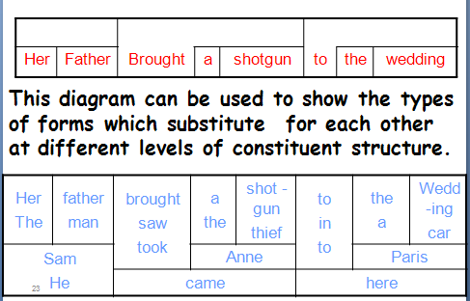

Labeling and Bracketing
An alternative type of diagram is designated to show how the constituent in sentence structure can be marked off via labeled brackets. The first step is to put brackets around each constituent, and then more brackets around each combination of constituents.
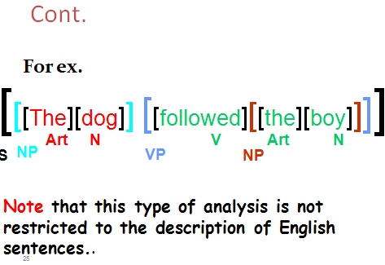

Exercise
Draw a single diagram showing the different levels of constituents by using the immediate constituent analysis for the following sentences:
1) A friend borrowed my car in June.
2) She went to town yesterday.
