SYNTAX
What is syntax?
The study of the structure and ordering of components within a sentence.
The word syntax came from Greek and literally meant “ a setting out together” or “arrangement”. Structural analysis, immediate constituent analysis and labeled or bracketed sentences are attempts to produce an accurate analysis of the sequence or the ordering “arrangement” of the elements in the linear structure of the sentence.
Generative grammar
Noam chomosky criticized grammar that concentrate upon the linear structure of the sentence. He concentrated upon a kind of grammar that has a set of rules that generates an infinite number of sentences in the language. That is why it is called generative grammar.
Some properties of the grammar:
A grammar of this kind must have a number of properties:
- The grammar will generate all the well-formed syntactic structures (sentences) of the language and fail to generate any ill-formed structures. /To account for all grammatical sentences / Property no.1: Enormous crickets in pink socks danced at the prom+ Milk the crumbled verb a+ Colorless green ideas sleep furiously
- This grammar will have a finite number of rules, but will be capable of generating an infinite number of well-formed structures. In this way, the productivity of language would be captured within the grammar. 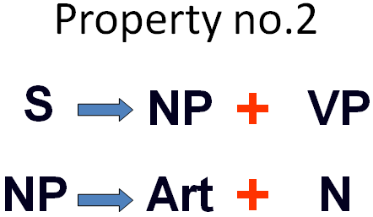
3- This grammar must be recursive.
Recursiveness is the capacity to be applied more than once in generating a structure.
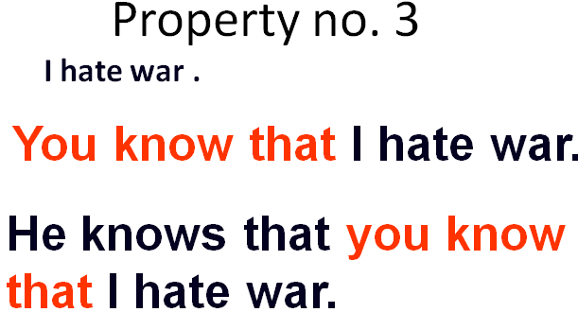

4- This grammar should be also capable of revealing the basis of two phenomena :
first, how some superficially distinct sentences are closely related, Property no.4 The student solved the problem.
The problem was solved by the student.
And
second, how some superficially similar sentences are in fact distinct.
Annie whacked a man with an umbrella.
Visiting relatives can be boring.
The hatred of the killers

Deep and surface structure:
In traditional grammar, we have passive and active sentences. But the distinction between them, is a difference in their surface structure, that is, the syntactic form. However, the two sentences are very closely related, even identical at some less “superficial” level. The other “underlying” level has been called their deep structure.

Deep structure (Def.):
A central theoretical term; opposed to surface structure.“ Deep structure” is the abstract SYNTACTIC REPRESENTATION of a SENTENCE- an UNDERLYING LEVEL of structural organization which specifies all the factors governing the sentence should be interpreted.
This level provides information which enables us to distinguish between the alternative interpretations of sentences which have the same surface form (i.e. they are AMBIGUOUS). It is also a way of relating sentences which have different surface forms but the same underlying meaning( active and passive sentences).

Active vs. passive
The student solved the problem
The problem was solved by the student.
Structural ambiguity (def.)
The general sense of this term, referring to a word or a sentence which expresses more than one meaning, is found in Linguistics , but several types of ambiguity are recognized. The most widely discussed in recent years is structural ambiguity. In transformational ambiguity, the alternative semantic representations can be shown only by relating the ambiguous sentence to different structures.
Annie whacked the man with an umbrella.
Annie had an umbrella and she whacked the man with it.
Annie whacked a man and the man happened to be carrying an umbrella.
Thus, the sentence is ambiguous. It has two different underlying interpretations which would be represented differently in the deep structure.
Also, Phrases can be also ambiguous:
The hatred of the killers
1) The killers hated someone
2) Someone hated the killers
So, the grammar must be capable of showing how a single underling, abstract representation can become different surface structures.
Different approaches:
There are different approaches to producing a complete syntactic description of a language. For some, the only relevant issues are syntactic ones, that is, how to describe structure, independently of “meaning” considerations. For others, the “meaning component” is primary.

Cont.
( )
= something optional
For example
The green book
NP
Art
( Adj )
N
NP Art N
NP pronoun
NP proper noun
{
}
Art N
pronoun
proper noun
Cont.
S SENTENCE
PN proper noun
Art article
NP noun phrase
* = ungrammatical sequence
consists of
Pro pronoun
Adj adjective
Prep preposition
PP
Prep. phrase
Labeled tree diagram
[ [The] [monkey]]
Art
NP
N
This is a linear sequence of constituents.
Labeled and bracketed sentence
Labeled tree diagram
NP
ART
N
The
monkey
This is a hierarchically organized analysis.
This is a tree diagram.
S
NP
VP
Art
N
The
monkey
V
NP
ate
Art
N
a
banana
Phrase structure rules
Phrase structure rules are the rules used in applying the tree diagram.
S
NP
VP
S
NP
VP
Lexical Rules
We can also have lexical rules which indicate the words to be used for constituents such as,
N { boy, girl, dog }
Transformational Rules:
1) John helped Mary yesterday.
2) Yesterday John helped Mary.
Cont.
S
NP
VP
V
NP
Adv
s
VP
NP
V
NP
Adv

