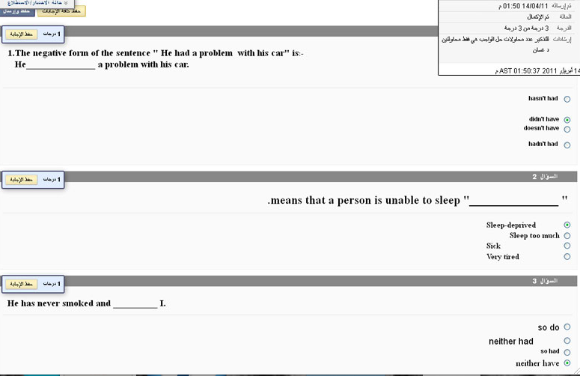
×..وآجب الآنجليزي..×
"
1.didn‘t have
2. Sleep-deprived
3. neither has
&
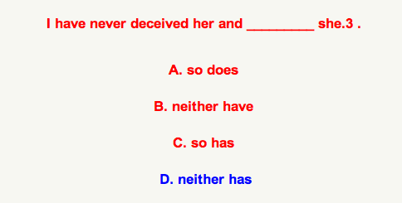
×..وآجب الآنجليزي الثآني ..×
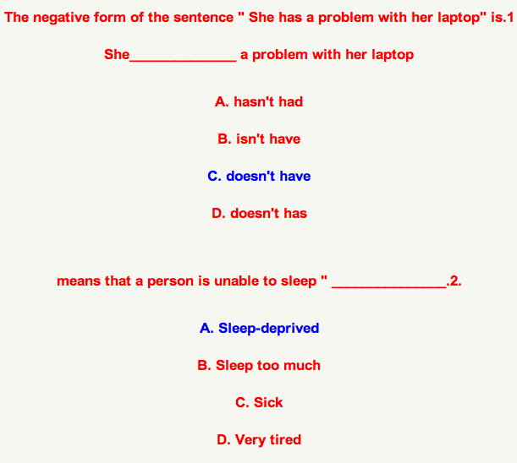

1.The negative form of the sentence " She has a problem with her laptop" is
She______________ a problem with her laptop
A. hasn't had
B. isn't have
C. doesn't have
D. doesn't has

.means that a person is unable to sleep " _______________.2
A. Sleep-deprived
B. Sleep too much
C. Sick
D. Very tired

. I have never deceived her and _________ she.3
A. so does
B. neither have
C. so has
D. neither has

