Lecture 6
Chapter 2
Danger and Daring
Thesis Statement and Supporting Ideas:
Turn your books to page 34 - 37
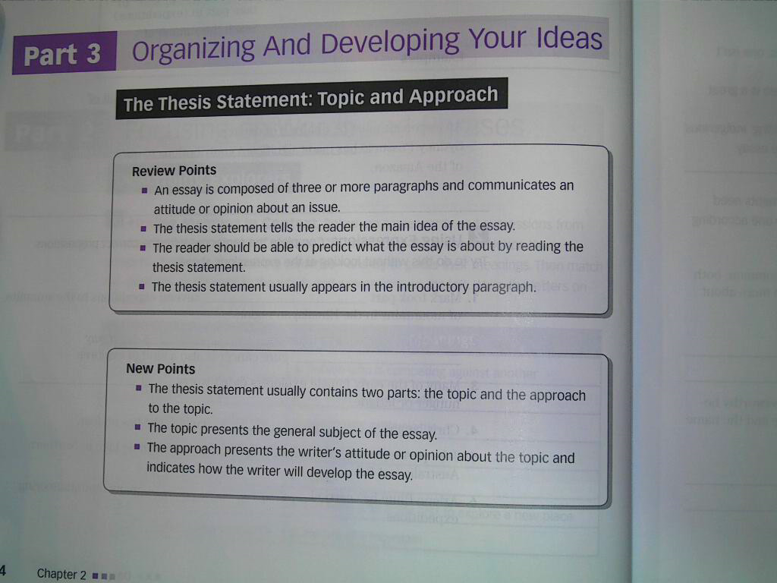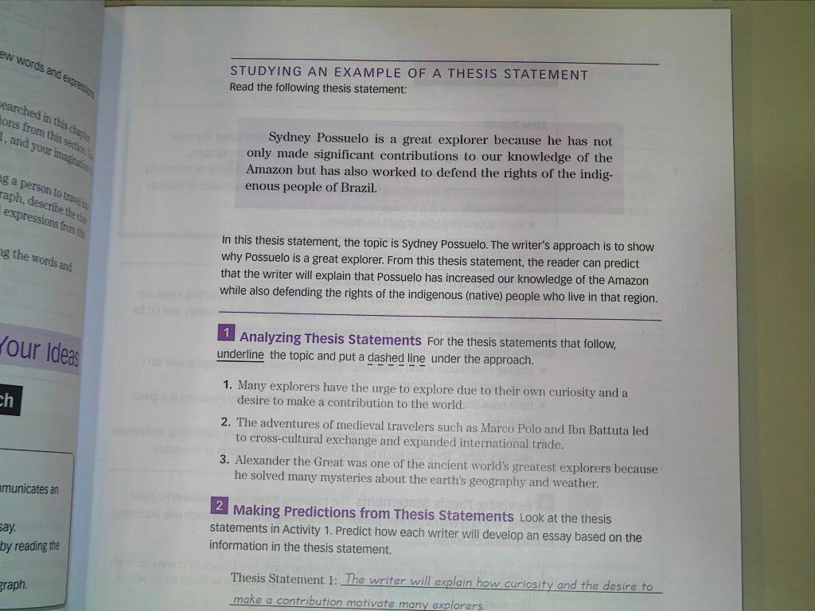
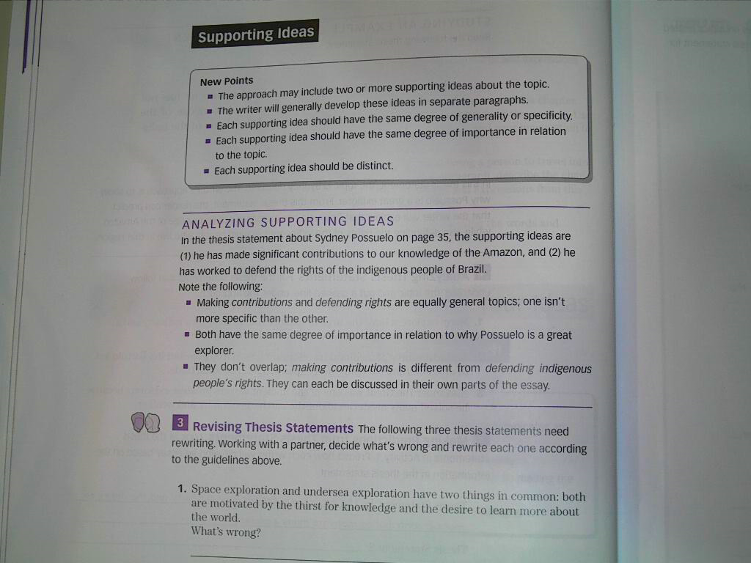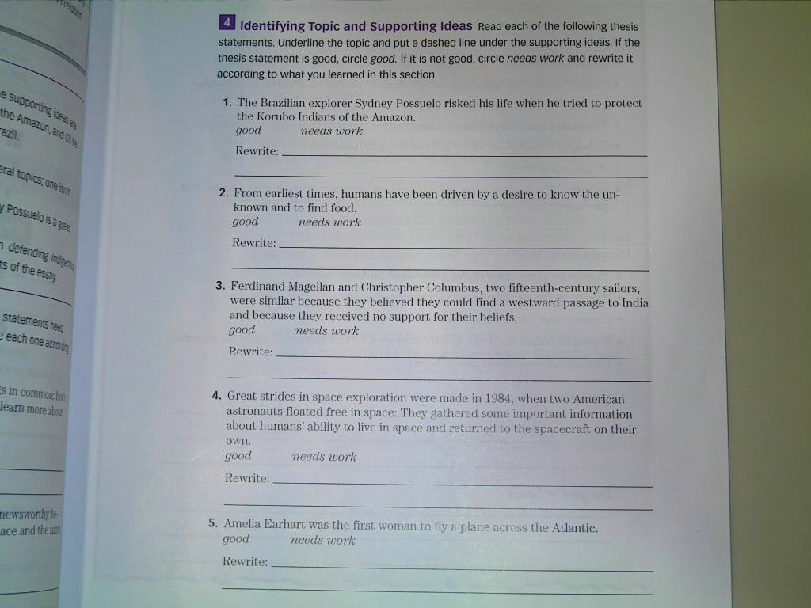
We will stop here.
Go to the next lecture
THANK YOU
مع تحياتي لكم :
☺معتزهـ ☺

