~(( Entire course content ))~
Introduction
Contents:
- Course description
- Course objectives
- Course material
Course Description:
Composition 2 is the second writing course. It focuses on a range of methods of advanced composition development: special, chronological, hypothetical and expository. The last includes development by analysis, definition, and comparison and contrast. In addition, it reinforces the skills of outlining and summary.
Course Objectives:
- Demonstrate knowledge of writing advanced composition
- Use various techniques of developing a composition: special, chronological, hypothetical, and expository.
- Develop compositions by definition, analysis, comparison and contrast.
- Writing detailed outlines for advanced composition.
Textbook:
Tanka J. and Baker, L (2004). Mosaic 2: Writing
Mcgraw-Hill
الكتاب متوفر لدى:
- مكتبة جرير (في الغالب)
- مكتبة العبيكان (في الغالب)
Course evaluation:
الدرجة | النشاط
10 درجات | المشاركة في منتديات الحوار على البلاك بورد
10 درجات | حضور المحاضرات المسجلة والمحاضرات المباشرة
10 درجات | الواجبات المنزلية
70 درجة | الاختبار النهائي
100 درجة | المجموع النهائي

الساعات المكتبية الجواله:
الساعات المكتبية:
الوقت | اليوم
10-12صباحاً | السبت
10-12صباحاً | الأحد
10-12صباحاً | الإثنين
رقم جوال المقرر:
0506682219
سيكون الجوال مفتوح في الأوقات المحددة بعالية وسيتم إغلاقة خارج هذه الأوقات، لذا على الجميع التقيد بهذه المواعيد
البريد الإلكتروني: ialmahboob@kfu.edu.sa


Lecture 1
Chapter 1
Languages and Learning
Focus:
By the end of the next lecture you will be expected to write a descriptive composition about “Learning a Language”.
Preparing to Write, page 4:
Look at the photos on page 4 and think about how the people in these photos would benefit from learning a foreign language.
Airline representative
Businessman
A student
Health care worker
1. Why might these people need to speak more than one language?
They should learn another language because they are most likely to meet people who speak a language other than their own.
2. What are some reasons to learn a second language?
A couple of reasons I think are important are to communicate with more people, and get to know and understand another culture.
3. What are some ways to learn a second language?
One could learn a language on his or her own or he or she could ask someone to teach him or her. A proper way to learn a language though, is to take classes in a school or institute.
Reading Passage:
Want to Learn a Language?
Don’t Make It a Mount Everest
Let’s read it together...

Vocabulary:
foreign language | conjugate | criterion
Creole | technique | advantages
cabdriver | immersion | dialogue
bargain | emphasize | likely
Experts | individual | opportunity
telephone booth | expensive | participate
proficiency | private tutoring | conversation
Task 1:
Respond to the following:
Give four reasons why you want to learn English.
Begin your answer like this
I want to learn English because ……
(Post your answer on the course forum)
We will stop here.
Go to the next lecture
THANK YOU


Lecture 2
Chapter 1
Languages and Learning
Exercise 1, page 12:
The meaning of some words and expressions in the reading passage.
Exercise 2, page 13:
Using some prepositions.
We will stop here.
Go to the next lecture
THANK YOU

Lecture 3
Chapter 1
Languages and Learning
Introducing the Essay:
In an essay you can:
- expresses an idea or opinion
- analyze, explain, or describe someone or some thing
- show the relationship between two or more things
- solve a problem
- or all of the above
The Academic Essay:
An academic essay usually contains four parts:
- An introductory paragraph
- A thesis or main idea statements
- Body paragraph
- A concluding paragraph
See exercise 2 and 3, page 15:
Have your books ready.
Task 2:
Do exercise 4 on page 18 as homework.
Remember to post your response on the course forum. Please do not send it as email.

We will stop here.
Go to the next lecture
THANK YOU


Lecture 4
Chapter 2
Danger and Daring
Focus:
In this chapter will try to learn how to write about an explorer.
Preparation:
Take a look at the photos on page 24. All of these people are explorers. Notice the information about their names, their achievements, and the date of their achievements are written below each photo.
Annapurna: A Woman’s Place:
We will read this passage together. See page 27-28.
Task 3:
Do exercise 4 on page 29 as homework. Do this exercise as best as you can.
Remember to post your response on the course forum. Please do not send it as email.

We will stop here.
Go to the next lecture
THANK YOU


Lecture 5
Chapter 2
Danger and Daring
Words and Phrases … page 32-33:
1. | ardent | passionate; enthusiastic
2. | ascent | climb
3. | endeavor | effort; an attempt
4. | felt the urge | had a vary strong desire
5. | summit | the top of a mountain
6. | legendary | famous
7. | notably absent | obviously not present
8. | pioneer | someone who is the first to explore a new place
9. | remote | far away from civilization
10. | rival | person who is competing against another
Describing personalities and achievements:
Personalities:
be unafraid of not worry about (her next meal)
laugh at (fatigue) figure out a way to
Achievements:
travel at high elevations participate in expeditions
carry out take part in expeditions
make significant contributions to reach the summit of
Task 4:
Do exercise 2 on page 33 as homework. Do this exercise as best as you can.
Remember to post your response on the course forum. Please do not send it as email.
We will stop here.
Go to the next lecture
THANK YOU


Lecture 6
Chapter 2
Danger and Daring
Thesis Statement and Supporting Ideas:
Turn your books to page 34 - 37
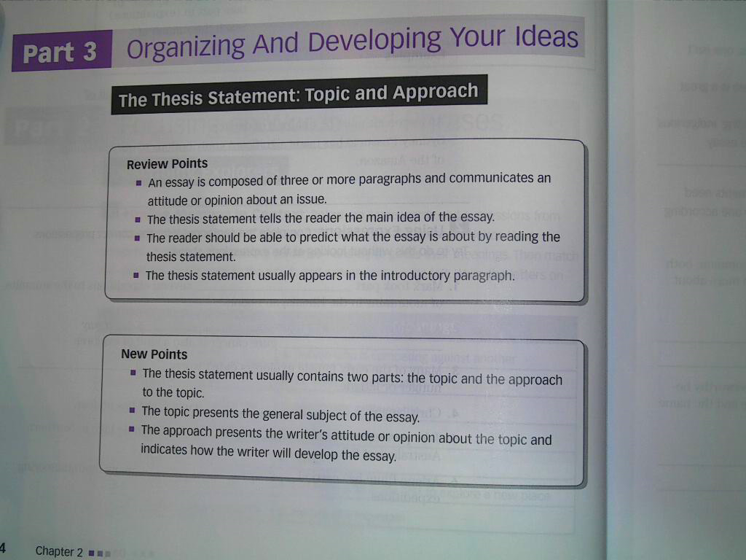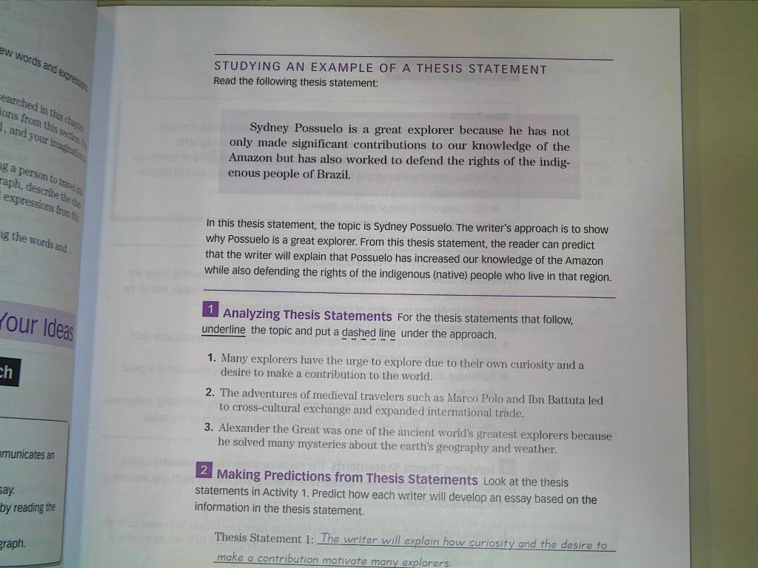
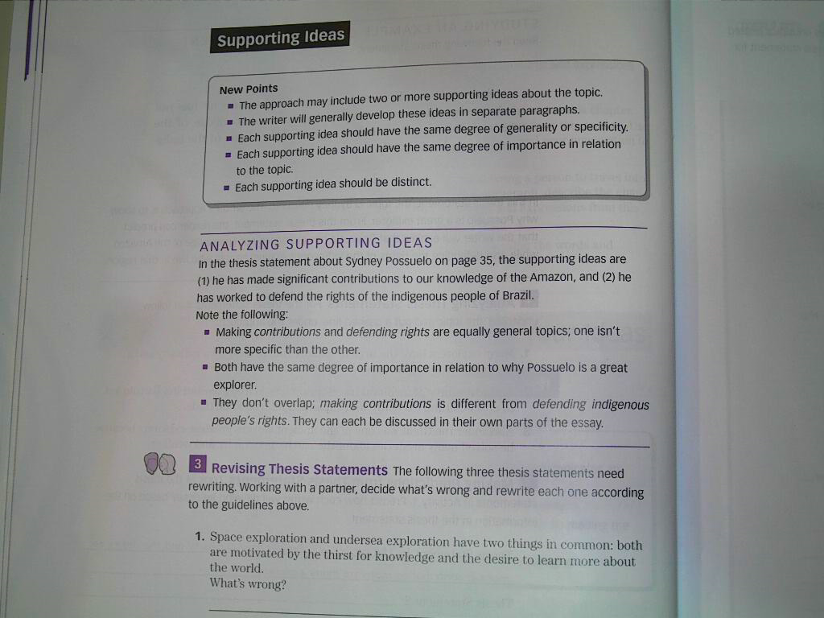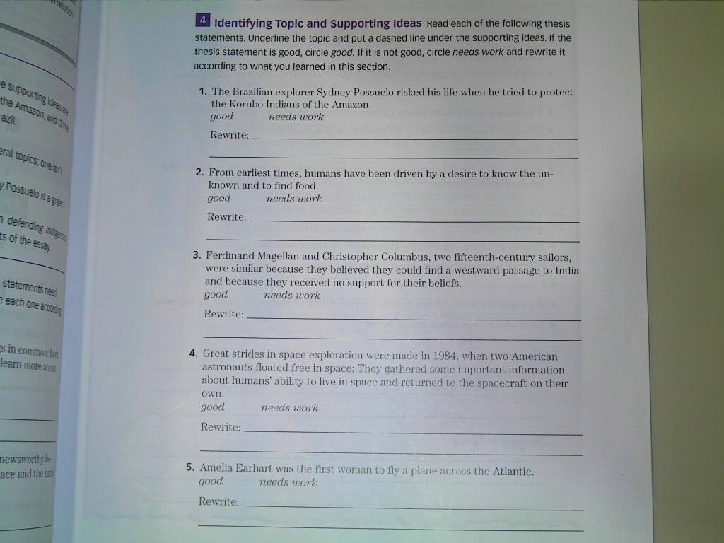
We will stop here.
Go to the next lecture
THANK YOU


Lecture 7
Chapter 3
Gender and Relationship
Focus:
In this chapter, you will learn to write about communication style differences between men and women.
The Photos on Page 46:
1. Man: Will you please go to the store for some eggs.
2. Woman: I really need a few things from the store, but I’m so tired.
3. Man: It’s a nice day.
4. Woman: It’s a nice day, isn’t it.
The reading passage on page 48-49:
Read the reading passage on page 48-49 before you continue with this lecture.
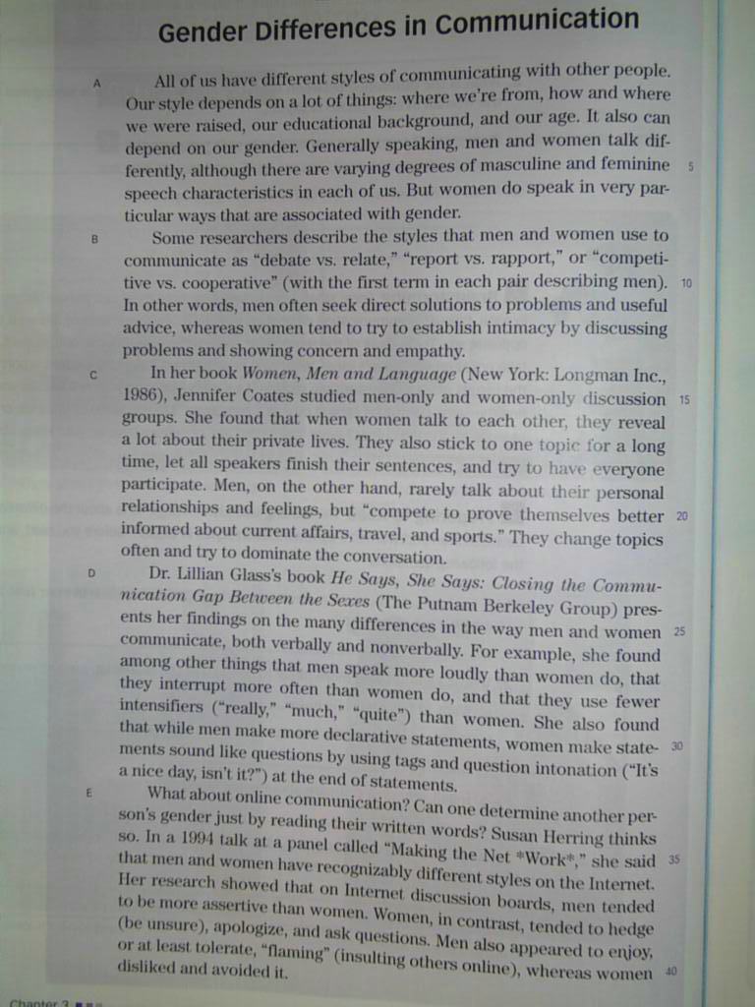
Questions on page 49:
1. According to the reading passage, what are some differences in face-to-face communication styles between men and women?
2. According to the reading passage, what are some differences in the online communication styles of men and women?
3. Give an example from your own experience of each of these communication style differences:
(a) “debate vs. relate,” (b) “report vs. rapport,” and (c) “competitive vs. cooperative.”
4. What does Gladys We mean when she says that online communication “is potentially liberating”? Do you agree?
Task 5:
Try to answer the previous questions on your own. Try to write correct grammatical sentences as best as you can.
Remember to post your response on the course forum. Please do not send it as email.

We will stop here.
Go to the next lecture
THANK YOU


Lecture 8
Chapter 3
Gender and Relationship
Vocabulary:
Today we will try to do the vocabulary exercise on page 51 together.
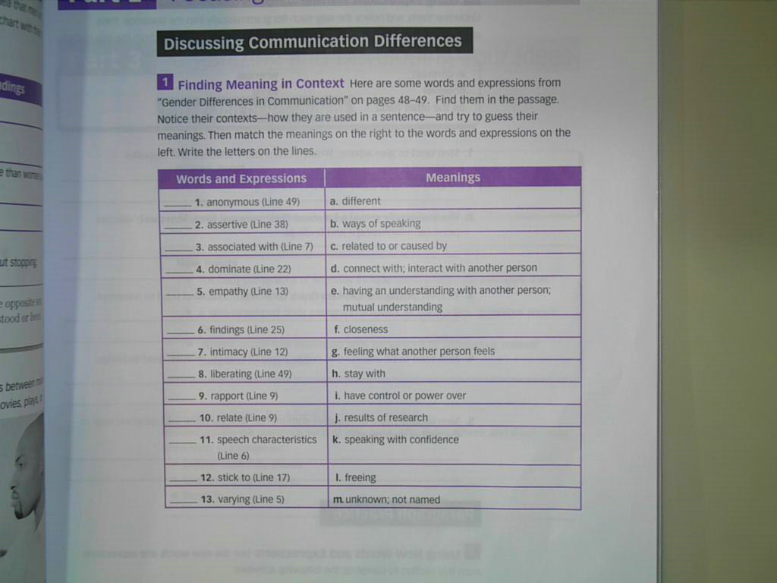
P: 51…
1- m 7- f 13- a
2- k 8- l
3- c 9- d
4- i 10- e
5- g 11- b
6- j 12- h

We will stop here.
Go to the next lecture
THANK YOU


Lecture 9
Chapter 3
Gender and Relationship
Exercise 2 on page 52.
Turn your textbook to page 52 and follow the lecture.
Studying a well-developed paragraph:
Consider exercise 1 on page 54.
Analyzing a Paragraph:
Consider exercise 2 on page 54.
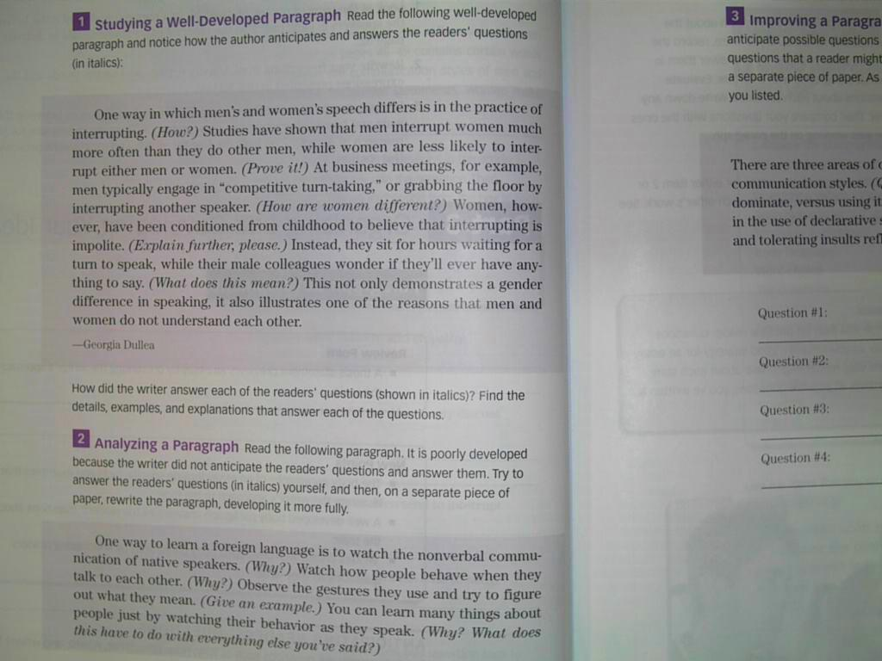
We will stop here.
Go to the next lecture
THANK YOU

Lecture 10
Chapter 4
Beauty and Aesthetics
Focus:
This chapter will focus on cause and effect. You will learn to write about personal aesthetics such as clothing, body paint, body piercing, tattoos …etc.
The photos on page 62:
Take a look at the photos on page 62 for examples of personal aesthetics.
Think about more examples.
Why do people change their natural appearance?
- To enhance beauty
- To hide flaws
- To indicate one’s place in a group or in society
- To indicate certain age (child or adult)
- To indicate wealth
- To disguise oneself or to become someone else
- To protect oneself from the environment
The Reading Passage page 64-66:
We will read the passage on page 64-66 together, and try to explain some of the ideas presented in it.
Try to follow, and then try to read it on your own.

We will stop here.
Go to the next lecture
THANK YOU


Lecture 11
Chapter 4
Beauty and Aesthetics
Understanding the reading:
- How old is the practice of tattooing?
- Where did the word tattoo come from?
- Why did the Britons wear tattoos?
- How did the Romans change their minds about tattoos?
- What is the purpose of moko?
Using a time line page 69:
Consider the chart on page 69. We will try to do this exercise together.

We will stop here.
Go to the next lecture
THANK YOU


Lecture 12
Chapter 4
Beauty and Aesthetics
Vocabulary:
We will consider two exercises in this lecture.
Exercise 1: page 70.
and
Exercise 2: page 71.

We will stop here.
Go to the next lecture
THANK YOU

Lecture 13
Chapter 4
Beauty and Aesthetics
Supporting Material:
We will consider the example on page 73 as an example of supporting ideas in a paragraph.

We will stop here.
Go to the next lecture
THANK YOU


مع تحياتي لكم :
☺ معتزهـ ☺

