In The Name Of Allah Most Gracious Most Mercifvl

King Faisal University
Deanship of E-Learning and Distance Education



English thought and culture
Instructor : Dr: Jamal Muhammad
Content of the article
By
Heart story



Lecture 1

Language and Culture
- Culture : the customary beliefs, social forms, and material traits of a racial, religious, or social group; also: the characteristic features of everyday existence shared by people in a place or time.
Language is a part of culture.-
Language in many ways is an expression of culture.-
- Culture affects language and vise versa.
- That field of study which deals with the effect of society on language use is called Sociolinguistics.

The Cultural History of English
Many social and political and events led to the development of English from its Germanic roots.
English originated as a common language of West Germanic tribes (Angles, Saxons
and Jutes) who populated the British Isles during the fifth century. This language is now known as Old English and differs greatly from English as we know it today.
The Norman conquest of The British Isles led to the mixing of old French words with Old English which resulted in the formation of Middle English, which more closely resembles modern English.

Timeline of the History of the English Language
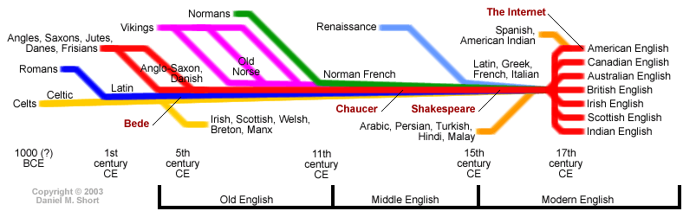
Modern English
The European Renaissance gave birth to the form of English we know today.
William Shakespeare coined over 2,000 words and many phrases and clichés.
The great vowel shift radically changed pronunciations in a relatively short period of time.
The printing press brought about standardization and codification culminating in the first dictionaries of the English language.
The Influence of the British Empire
Nearly a quarter of the world was dominated by the British Empire at one point.
British colonization and sea trade brought English to the four corners of the world.
The interaction with other cultures introduced many new words into the English lexicon.

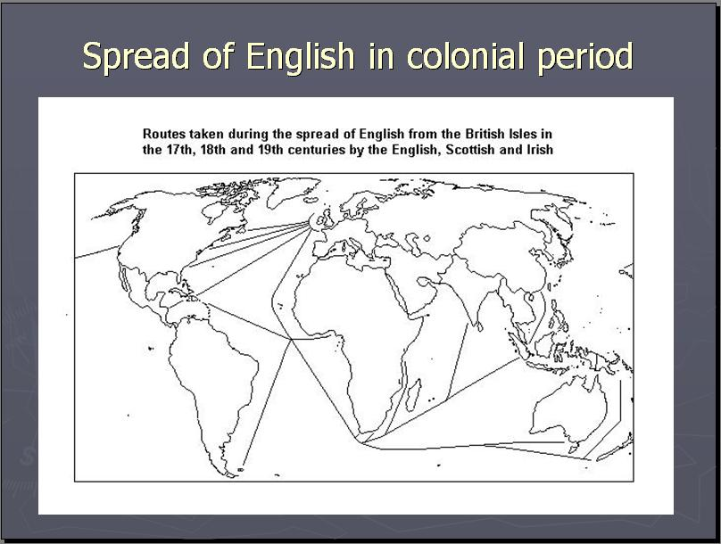

The Industrial Revolution and The Fall of the British Empire
The Industrial Revolution led to new inventions and discoveries which created a need for new terminology. Latin and Greek played a major role.
The decline of the British Empire resulted in London losing ownership of the English Language.
American English
Colonization of the American territories led to the development of a distinct variety of English.
After the second world war, America became the new superpower, supplanting Great Britain as the bearer of the English Language to the world.
Interaction with Native American tribal groups and Spanish speaking settlements caused an influx of new words to the American English lexicon.
Technology
The invention of the phonograph made it possible to store and distribute speech for the first time.
Talking films and video soon came after and allowed for the storage and distribution of visual language elements, such as body language and gestures.
Most people who are not native speakers of English have their first contact with the English language from a stored or broadcasted form as opposed to face-to-face contact.

