Lecture 2

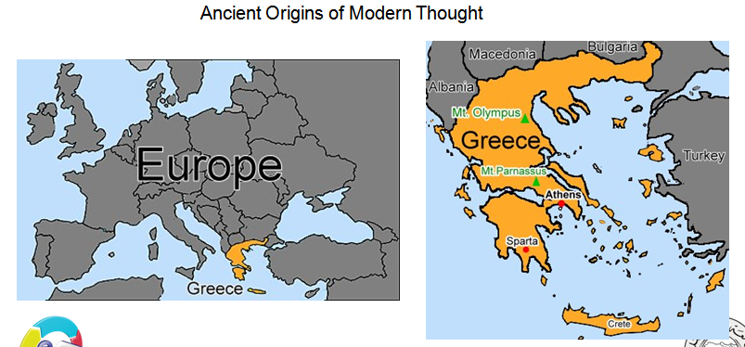

Socrates, Plato, and Aristotle
Socrates
-Born in Athens around 469 BCE, great thinker and debater
-Accepted no payment for his teaching
Was charged with corrupting the youth of Athens and with impiety and executed-
Plato
-The most famous student of Socrates
-Most of our knowledge of Socrates comes from the writings of Plato
-Argued against Athenian democracy in favor of republic government
Aristotle (384-322 BC)
-The greatest of Plato’s students and teacher of Alexander the Great
He was a polymath; he knew a great deal about almost every subject-
Plato vs Aristotle
Ethics: the discipline dealing with what is good and bad and with moral duty
and obligation.
Virtue: conformity to a standard of right, a commendable quality or trait
Aristotle differed with his teacher Plato on the issue of Ethics
For both Plato and Aristotle, virtue was essential for happiness (eudaimonia)-
Plato held the opinion (from his teacher, Socrates) that knowledge itself is virtue-
For Aristotle, virtues had to be practiced to be virtuous-

Nicomachean Ethics, Book 1: The Highest Good - Happiness
One central concept of the Ethics is eudaimonia, which is generally translated as
“happiness.”
While happiness is probably the best English word to translate eudaimonia, the term also
carries connotations of success, fulfillment, and flourishing.
A person who is eudaimon is not simply enjoying life, but is enjoying life by living successfully.
Aristotle treats happiness as an activity, not as a state. He uses the word energeia, which is
the root of our word energy, to characterize happiness. The point is that happiness consists
of a certain way of life, not of certain dispositions.

“Our discussion will be adequate if its degree of clarity reflects the subject-matter;
for we should not seek the same degree of in all sorts of arguments alike, any
more than in the products of different crafts.”
Aristotle warns us not to expect any precise rules or codes of conduct.
Ethics must remain flexible enough to account for the great deal of variety and possibility.
Aristotle tells us that virtue cannot be taught in a classroom but can be learned only through
constant practice until it becomes habitual

Book 2: Virtue is a State Between Two Extremes
Virtue is a disposition or state, not a feeling or a capacity.
Feelings are not the subject of praise or blame, as virtues and vices are, and while feelings
move us to act in a certain way, virtues dispose us to act in a certain way.
Our faculties determine our capacity for feelings, and virtue is no more a capacity for feeling
than it is a feeling itself. Rather, it is a disposition to behave in the right way.
The Doctrine of the Mean
Virtue is the intermediate or mean between two extremes, which are excesses
And deficiencies.
The mean will vary for different people.

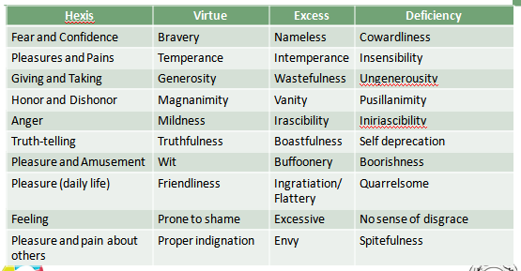

Summary
Socrates, Plato, and Aristotle were the forefathers of modern philosophy.-
-According to Plato and Aristotle, happiness (eudaimonia) is dependent upon virtue.
Aristotle taught that virtue cannot be taught in a classroom, but must be practiced.-
Virtue lies between two extremes of vice-

