Lecture 3
The Life of Aristotle
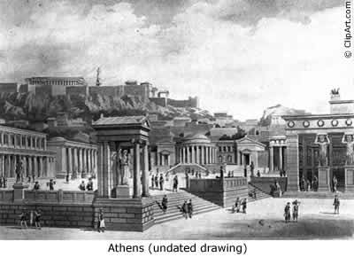

Aristotle’s early life
Parents
- Son of Nicomachus, a physician
- His father was a member of the guild of Asclepius, but believed in natural
Causes of illness as opposed to divine.
- He was a contemporary of Hippocrates
- He treated King Amyntas of Macedon, who was the father of Phillip and
grandfather of Alexander the Great
- His mother was a member of the aristocracy of Chalcis
Childhood
- Aristotle was said to have been a childhood playmate of Alexander.
- It is thought that he learned the basics of anatomy from his father.
- His parents died suddenly when he was ten or eleven years old.
- He was cared for after the death of his parents by his paternal Uncle Proxenus and his wife.
- Proxenus prepared him for advanced studies and sent him to Athens to study under Plat.

Plato vs Aristotle
Plato (Spirituality)
- Delighted in mathematics and arts.
- Considered abstractions the real reality.
- Believed in an innate sense of perfection and justice.
Aristotle (Materialism)
- Inspired by nature and life sciences.
- Reality was composed of substances; what is perceived by the senses is real.
- Held that ideas cannot exist without the input of the senses.

After the Academy
By the time of Plato’s death, Aristotle was considered one of Greece’s most Brilliant philosophers.
Speusippus was chosen over Aristotle to take Plato’s place as master of the Academy, probably because he was Plato’s nephew.
Held the opinion that the only sure knowledge was knowledge of mathematicalrelationships.
Aristotle, along with Xenocrates, left Athens to teach in Atarneus in Asia Minor.
Aristotle and Alexander the Great
Philip of Macedon began his campaign to conquer all of Greece in the same year that Plato died.
Aristotle joined the court of Philip and reunited with his childhood friend.
War broke out between Persia and the Hellenes and Aristotle’s friend Hermias was tortured to death. Aristotle wrote a elegy to Hermias in which he compared him to a God. This would cause him trouble later in life.
After the death of Philip, Alexander became king, and Aristotle returned to Athens to establish his own school, the Lyceum.
Alexander began his campaign to conquer Asia and took Aristotle’s nephew with him.

Life in Athens
After the death of his wife Pythias, Aristotle met Herpyllis, who would bear him his son Nicomachus.
He established the curriculum for the Lyceum which was more scientifically oriented than the Academy.
During this time he compiled most of his famous works.
The subject matter of philosophy at that time covered physics, mathematics, biology,Physiology, meteorology, astronomy, politics, psychology, rhetoric, literature, religion,Metaphysics, epistemology, logic, ethics and more.
From his base at the Lyceum, he dominated the world of philosophy for 13 years.
Fall from Grace and Death
King Alexander began behaving irrationally during his campaign to subdue India Insisting that his men marry Persian women and that they acknowledge him as a God. Some rebelled, including Aristotle’s cousin, Callisthenes, and were executed.
Resentment fostered in Athens to the rule of Macedon.
When Alexander died, there was a massive rebellion in Athens and the new regime Was preparing to indict him for his blasphemous elegy 20 years earlier.
He fled Athens to Chalcis, the land of his mother, where he died of illness.

Transmission of the Works of Aristotle
Aristotle left all his writings to Theophrastus, who succeeded him at the Lyceum
He bequeathed them to his nephew Neleus, who hid them in a cellar, where they Remained for 200 years.
It is believed they were found and given to Andronicus of Rhodes in Rome.
They were ignored by Byzantine Christians but apparently preserved by Muslims and Translated to Arabic and preserved in the great universities in Baghdad, Cairo, Toledo and Cordoba.

