
المملكة العربية السعودية
وزارة التعليم العالي
جامعة الدمام
كلية التربية بالجبيل

Data structure
Group.1
لطيفة موسى الجوير
روان القحطاني
عبير الهاجري
سمية حامد الغامدي
مريم الماص

Date:28\3\1433

D.Eman Ahmed Abdel Ghaffar

Task 1:
array is the development of imaginary to facilitate access to the content
of memory but in fact data stored in memory in the form of Bettat Mrts one after the other Three-dimensional array is a array within a array within a array.
The following program uses a multi-dimensional arrays (three dimensional)
Program prints the numbers from zero to a specific number in the matrix on the pages of every page that contains a number of columns and rows.
In this example we have identified two pages ,three columns and three rows.
Program:
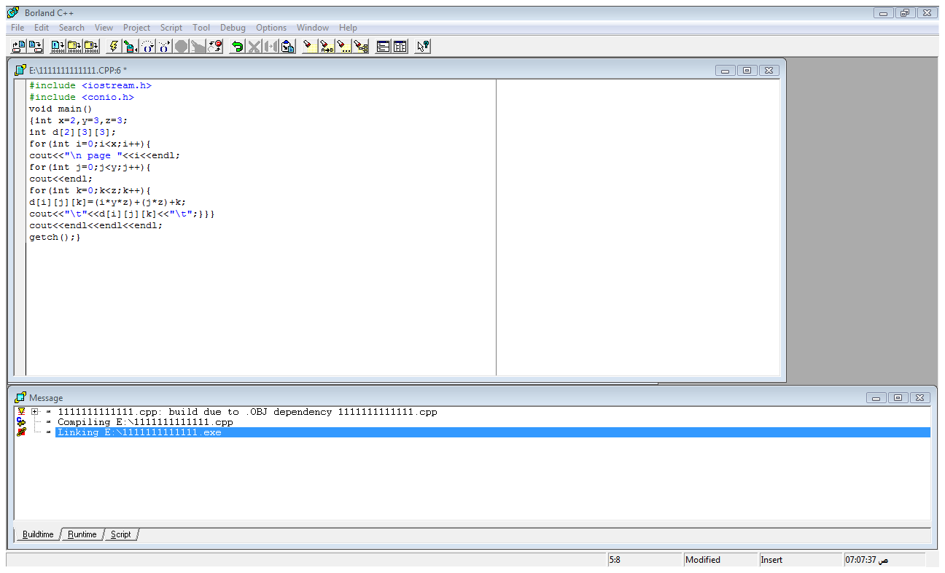
Out put:
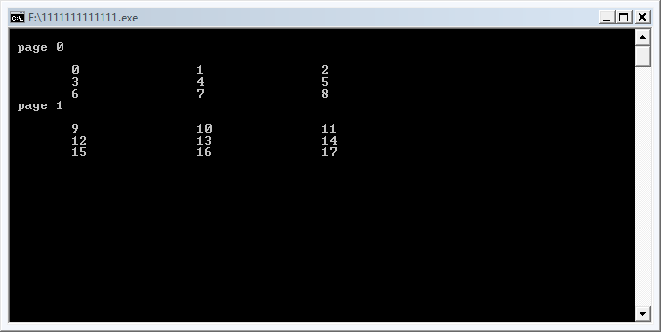
Reference: http://mycodelog.com/2010/05/21/array3d/
+فكرة فريق العمل
