Lecture 5
The History of Empiricism

Epistemology i/ɨˌpɪstɨˈmɒlədʒi/ (from Greek ἐπιστήμη (epistēmē), meaning "knowledge, science", and λόγος (logos), meaning "study of") is the branch of philosophy concerned with the nature and scope (limitations) of knowledge.
It addresses the questions:
What is knowledge?
How is knowledge acquired?
To what extent is it possible for a given subject or entity to be known?
How do we know what we know?

Origins of Empiricism
Aristotle laid the foundations of Empiricism with the concept of the Tabula Rasa:
What the mind (nous) thinks must be in it in the same sense as
letters are on a tablet (grammateion) which bears no actual writing
(grammenon); this is just what happens in the case of the mind.

Aristotle believed that the mind is similar to an empty tablet that is “written” on by Life experiences.

This contrasted with the Platonic view of innate knowledge.

Islamic Contributions to the Empirical Argument
Aristotle's theory of tabula rasa was further developed by Islamic philosophers

Ibn Sina - the tabula rasa is a pure potentiality that is actualized through education, and knowledge is attained through "empirical familiarity with objects in this world from which one abstracts universal concepts" developed through a "syllogistic method of
Reasoning”
Ibn Tufail included the theory of tabula rasa as a thought experiment in his Arabic philosophical novel, Hayy ibn Yaqdhan in which he depicted the development of the mind of a feral child "from a tabula rasa to that of an adult, in complete isolation from society" on a desert island, through experience alone.

Ibn al-Nafis in the 13th century also dealt with the theme of empiricism through the story of a feral child on a desert island, but depicted the development of the protagonist's mind through contact with society rather than in isolation from it.

Empiricism in the Renaissance
Thomas Aquinas challenged Platonic philosophy during the Italian renaissance. He adopted the Aristotelian position that the senses are essential to mind into scholasticism, making it a dogma
of Roman Catholic belief.

Machiavelli in particular was scornful of writers on politics who judged everything in comparison to mental ideals and demanded that people should study the "effectual truth" instead.

Leonardo da Vinci (1452–1519) said, “If you find from your own experience that something is a fact and it contradicts what some authority has written down, then you must abandon the
authority and base your reasoning on your own findings.”

Galileo's father used the method to solve music problems.

British Empiricism
The term became useful in order to describe differences perceived between two of its founders Francis Bacon, described as empiricist, and Rene Descartes, who is described as a rationalist.

Thomas Hobbes and Baruch Spinoza, in the next generation, are often also described as an empiricist and a rationalist respectively.

John Locke, the person who is normally known as the founder of British empiricism, stated in his An Essay Concerning Human Understanding “the only knowledge humans can have is a
posteriori, i.e., based upon experience.”

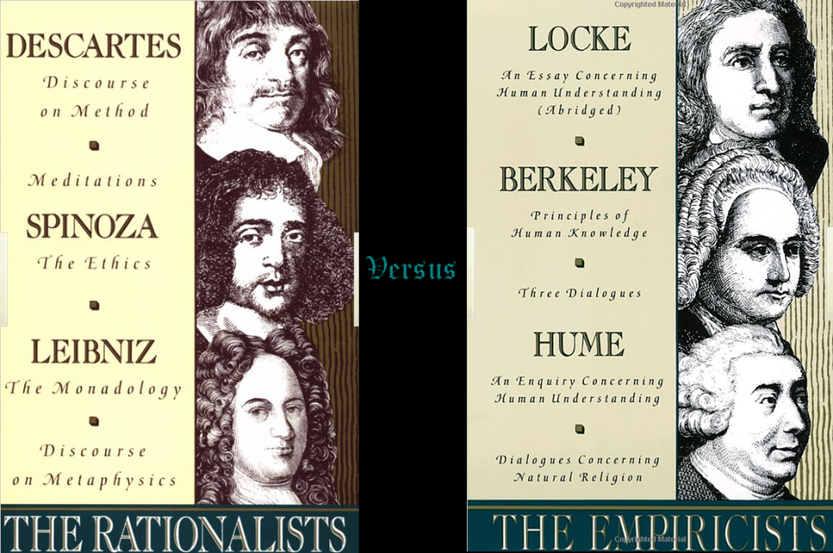

Logical Positivism
Attempted to synthesize the essential ideas of British empiricism (e.g. a strong emphasis on sensory experience as the basis for knowledge) with certain insights from mathematical logic.

Subscribed to a notion of philosophy as the conceptual clarification of the methods, insights and discoveries of the sciences.

They saw in the logical symbolism elaborated by Frege (d. 1925) and Bertrand Russell (1872–1970) a powerful instrument that could rationally reconstruct all scientific discourse into an ideal, logically perfect, language that would be free of the ambiguities and
deformations of natural language.

Pragmatism
Combined the ideas of empiricism and rationalism It developed mainly from discussions that took place while Charles Sanders Peirce and William James were both at Harvard in the 1870s..

Among Peirce's major contributions was to place inductive reasoning and deductive reasoning in a complementary rather than competitive mode.

John Dewey (1859–1952) modified pragmatism to form a theory known as instrumentalism

Dewey's basic thought, in accordance with empiricism was that reality is determined by past experience.

