Installation Sage Line50
To install Sage Line50 Program follow this steps:
1-Installation
Go to the link F :\ sageline50\line50 \disk1\setup .exe
Note: Drive letter F:\ - refers to removable disk (flash disk) on other computers display maybe drive letter E: or D: or H
Press setup

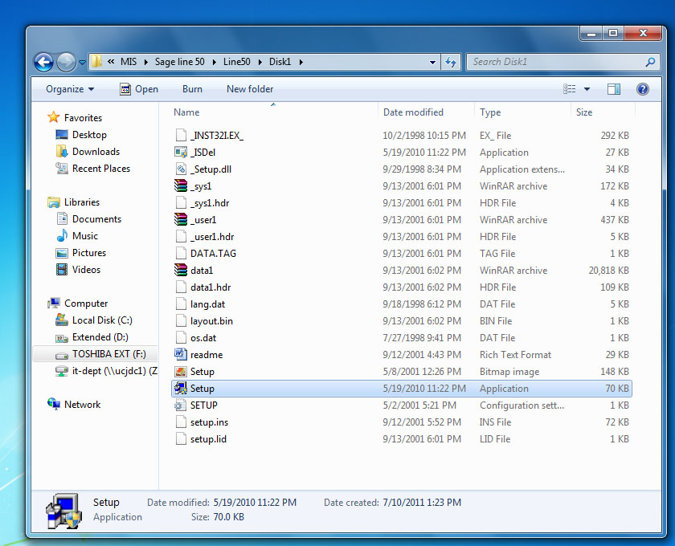

Press Yes “wait for few minutes ”
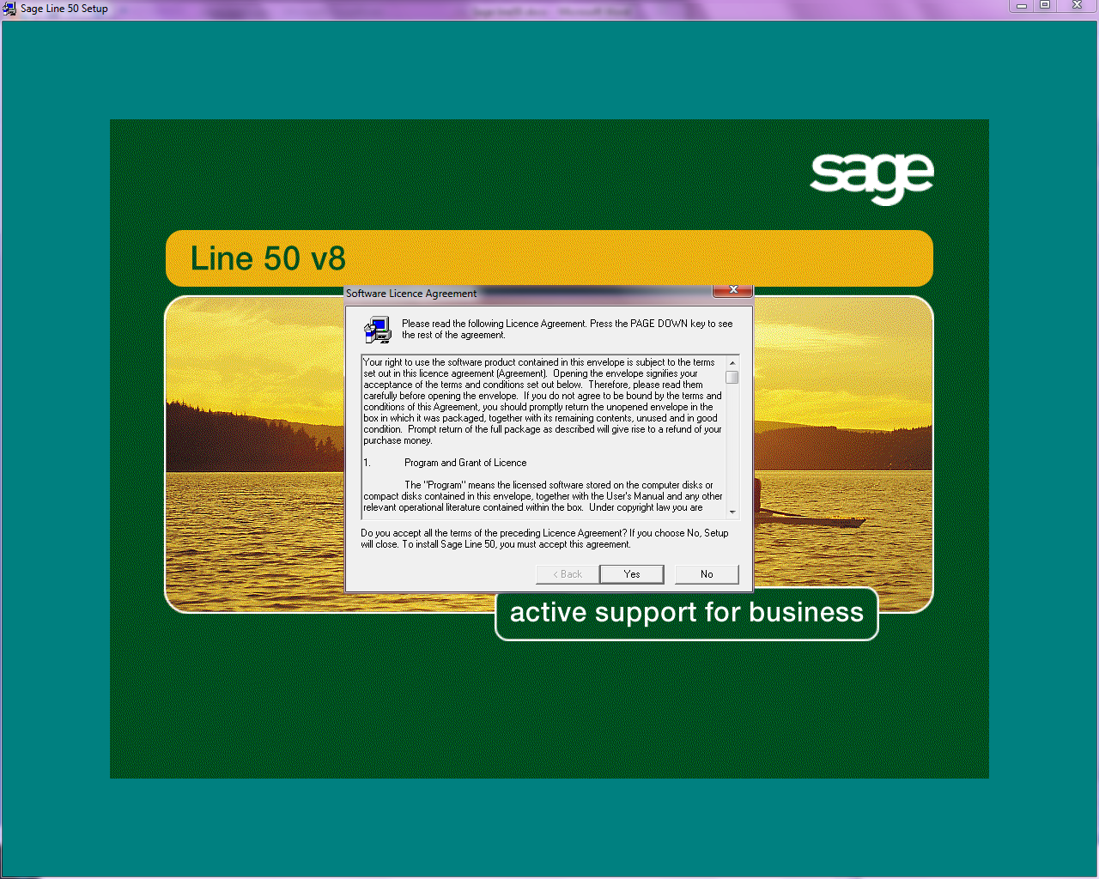

Choose Custom install
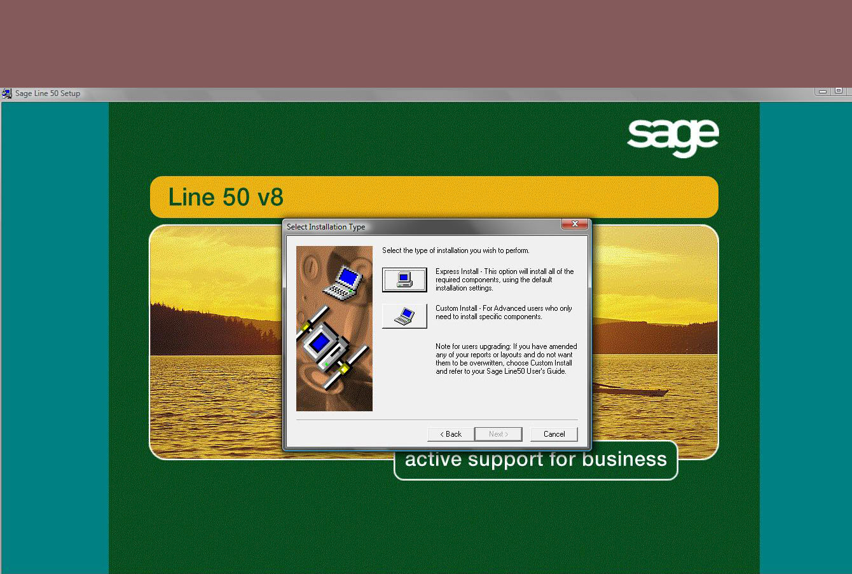

Check the destination folder is C:\program files\line50
Press Next
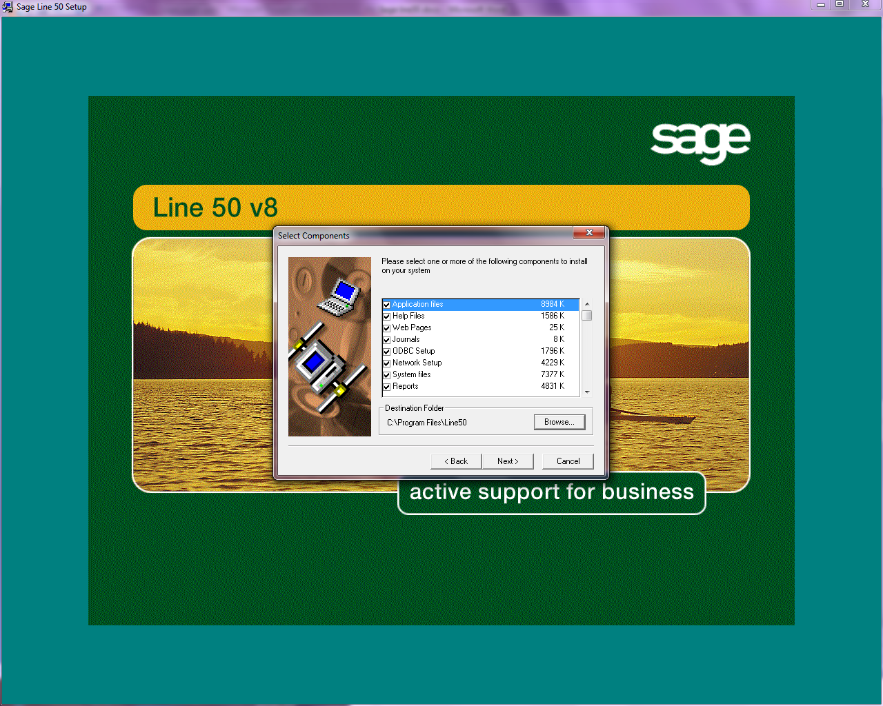

Press Next
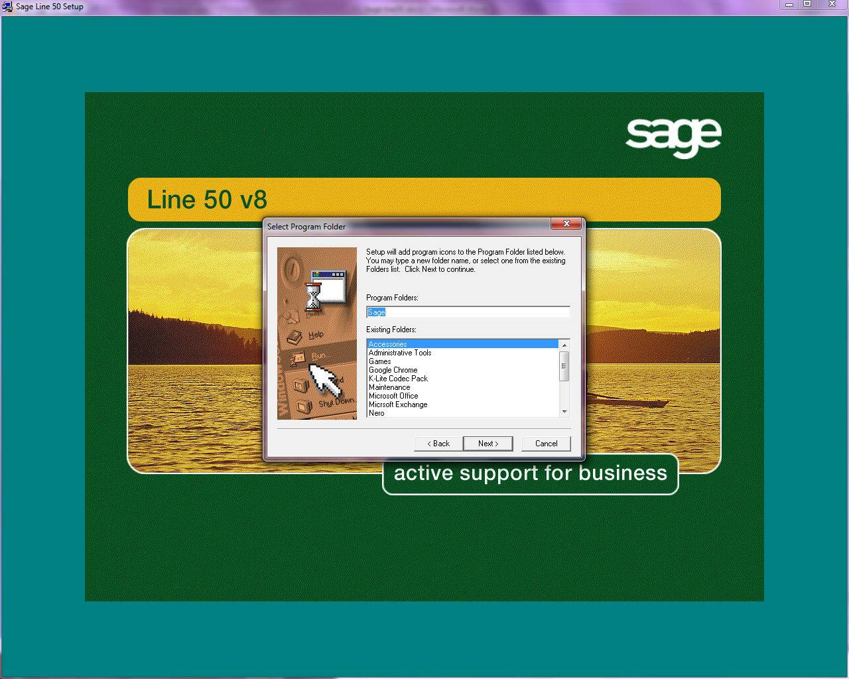

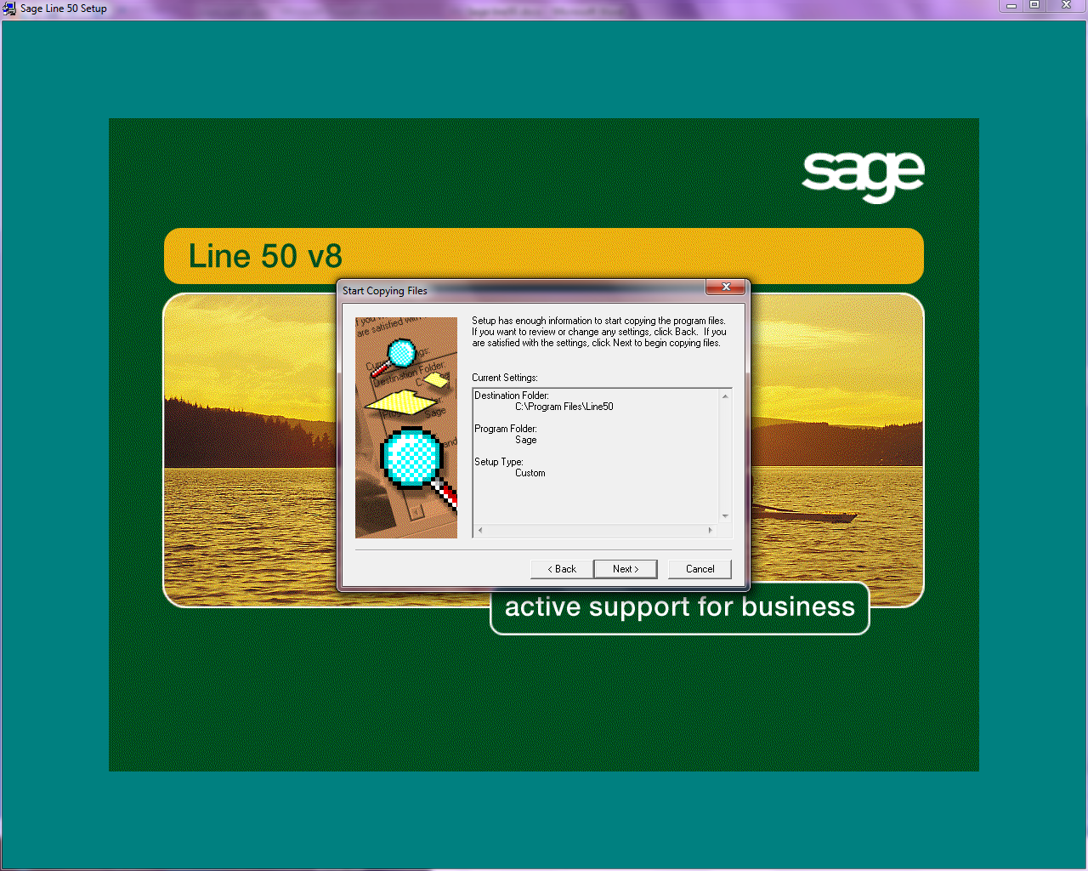
Press Next

Wait
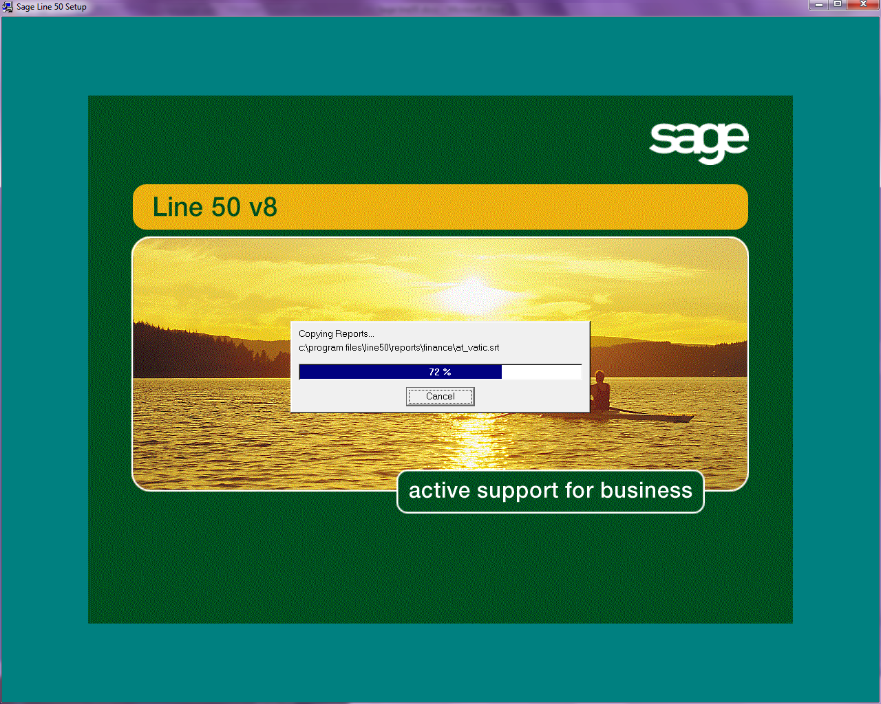

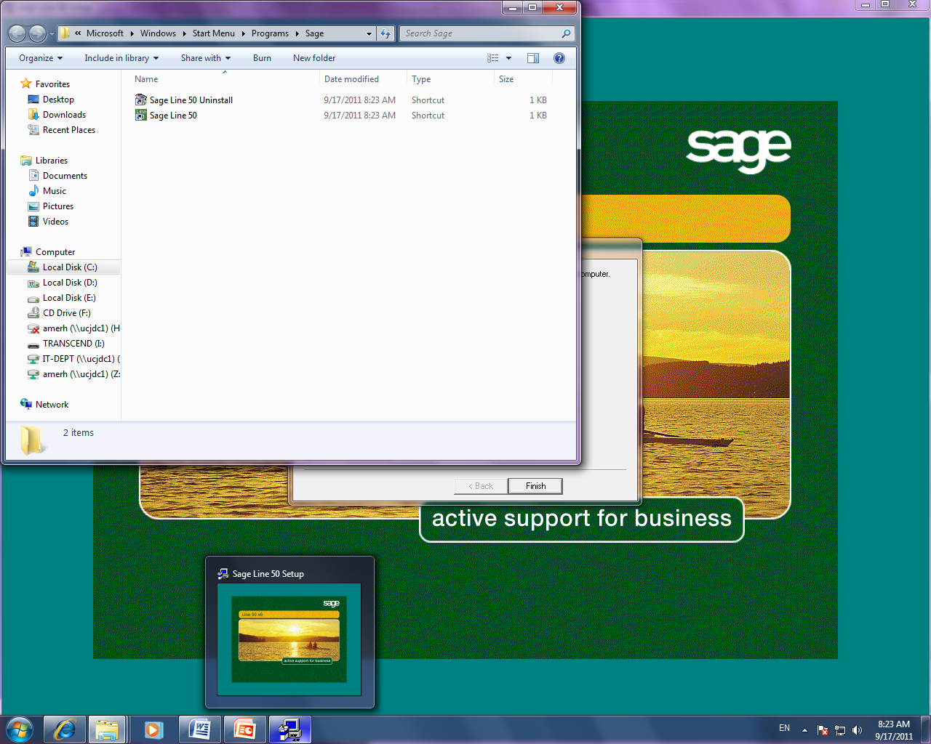

Press finish
