Describing a Sentence

- We humans are not the only species that engages in oral communication.
- Our language has an enormous range because it consists of parts that can be arranged in unlimited ways.
- Humans ability to arrange words in different ways allow us to produce a potentially infinite number of grammatical sentences, but because not all are grammatical, our grammar must consist of principles or rules for arranging them. Violations of the rules result in ungrammatical sentences.
Examples:
No Monkeys have words.
Monkeys have no words
Have Monkeys no words?
Have no Monkeys words?
No Words have Monkeys.
Have no words, Monkeys!
* Words monkeys have no.

Discovering the Parts of Sentences

- Example : The monkey saw a leopard.
- If you were asked to divide the sentence into its parts, you would of course identify the five words that comprise it. But what if you are asked about larger units? Are there any groupings of words in the sentence that seem to “go together”?
- Your intuitions would probably lead you to identify the monkey and a leopard as groupings in this sense. They seem to belong together in a way that monkey saw or saw a clearly do not. Furthermore, the monkey and a leopard seem very similar, as if they are groupings of the same type. In fact we can substitute one for the other and still have a grammatical ( although different) sentence: ( A leopard saw the monkey). In contrast. If we switch the monkey with a different grouping as saw a, the result would be ungrammatical: ( * Saw a the monkey leopard).

- If we determine that sentences are constructed out of such groupings, we will have gained an important insight into the structure of the English language. From now on, we will call such groupings PHRASES. That is, we will consider a phrase to be one or more words that occur together in a sentence and that we recognize as somehow working together as a unit. Phrases can be said to function as CONSTITUENTS--- that is, as parts that make up or constitute sentences. All subparts of sentences can be called CONSTITUENTS, from individual words like monkey to phrases like the monkey to the entire sentence itself. Another test of the reality of a phrase like the

monkey is whether other such phrases can be found that can substitute for it in a grammatical sentence.
Examples:
The crocodile saw a leopard.
A leopard saw a leopard.
The wise, old, alert monkey saw a leopard.
Anita saw a leopard.
The man who had a scar above his right eye saw a leopard.
We saw a leopard.
>>>>>> Let’s give this type of phrase a name…..we call it a noun phrase (NP).

- Not every grouping of words is a noun phrase (NP).
Examples:
* Ate saw a leopard.
* Ate a banana saw a leopard.
* Very happy saw a leopard.
* Fearfully saw a leopard.
* Over the river and through the woods saw a leopard.
- According to our test procedure, none of the above examples seems to be a noun phrase (NP).
- In addition to the two noun phrases in our example (The monkey saw a leopard), also contains the word saw, which, according to our test, is not a noun phrase. By performing the same substitution test that we conducted on noun phrases, we can find many other words that could take the place of saw in the sentence: angers, tickled, resembles, hypnotized, to name a few. So saw belongs to another category of CONSTITUENTS; we will call it a verb (V).

- Our analysis of our example ( The monkey saw a leopard) has shown us that it consists of a noun phrase (the monkey) followed by a verb (saw) and then another noun phrase (a leopard). So we can infer that:
S ---> NP + V + NP
- We can analyze our example further. Two of the constituents appear to have constituents of their own, because the noun phrases each consist of two words. The words the and a can be interchanged ( A monkey saw the leopard), and we will call them ARTICLES (Art). Likewise monkey and leopard belong to the category NOUN (N). We can infer:
NP---> Art + N
- This tells us that the noun phrase (the monkey) consists of the article the followed by the noun monkey.

- Finally, many people have the intuitive feeling that, just as a leopard is a constituent of the sentence ( The monkey saw a leopard), so too is the longer phrase saw a leopard. That is, they sense that the sentence consists of two major parts, the monkey and saw a leopard. Or to put it in terms of the sentence’s meaning, the sentence consists of (who-did-it?) part (the monkey) and a (did-what?) part ( saw a leopard). Let us give the latter constituent the name VERB PHRASE (VP). We observe that it consists of a verb ( saw) followed by a noun phrase ( a leopard). Therefore, we can infer:
VP---> V + NP
- Now, We can revise the rules:
S---> NP + VP
NP---> Art + N
VP---> V + NP

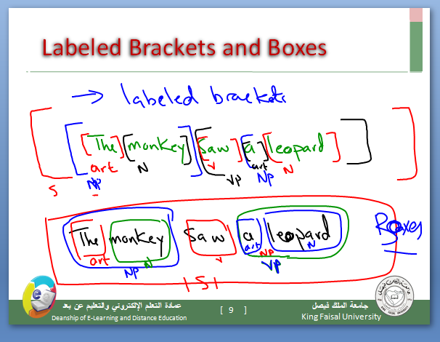

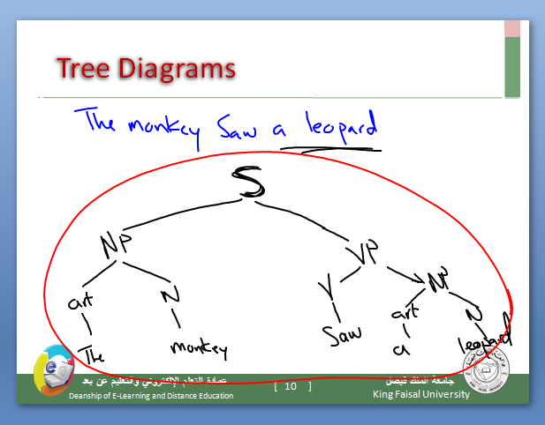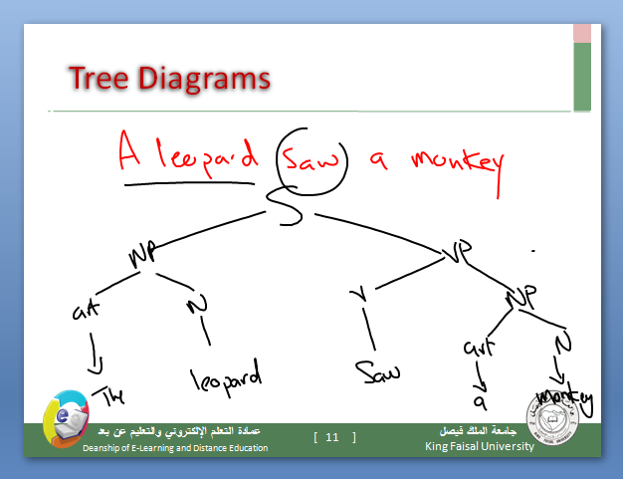

Exercises

1. Place labeled brackets around each of the constituents in the following sentence:
The soldier spied an enemy
2. Draw labeled boxes around the constituents in the following sentence:
An amateur won the championship
3. Draw a tree diagram of the following sentence:
A couple danced the tango

