Lecture 6
Linked list

Objects such as lists,sets, and graphs, along with their operations can be viewed as abstract data types just as integers, reals, and booleans are data types.
Integers, reals, and booleans have operations associated with them and so do data types such union, intersection, find, size, and complement.

Why Linked lists?
Let us consider an example of implementation of a STACK or a QUEUE using a linear array then it is necessary to declare the SIZE of the STACK or QUEUE array (at Compile time, allocate the memory "statically") this may leads to either memory wastage or insufficient memory. This is the main disadvantage of a linear array. So if we use a linked list, we can allocate the memory "Dynamically" (i.e. during Run time). So there will not be any problem of memory wastage or insufficient memory.
Whenever we want to insert or delete an element from a linear array either we must overwrite the value or we should shift the elements to new location. Where as in a linked list we can directly insert or delete the elements without effecting the other elements.
In the conventional linear array storage the memory allocation is contiguous. for ex: When we declare an integer array in 'C /C++ language'
inta[100]; //array declaration int is the data type size is 100
then '&a[0]' or &a is called as the base address .If we want to access the element through direct addressing then a[1] will be located at a location (&a[0]+ size(int)). Here size of int data type is 2 bytes. The addresses of the element located in an array at a position ' k' can be calculated using the formula given below
LOC (Array [k])= Base Address (Array) + k * size( data type declared)
'k' is the index of element . If the base address(&a[0]) is 1000, and data type is integer then nextelement will be located at the location 1002 (i.e.&a[1]= 1000+ 1*(2)), similarly the address of the element a[4] is 1008. So whenever we access the data, the computer calculates the address location as mentioned above . This process is much slower when compared to directly fetching data form memory using a pointer.
In A linked list each NODES don't need to be located in adjacent location. The storage may not be contiguous in a linked list. In a linked list , the access of data is done using a pointer. Thus the data access is much faster in linked list.
A linked list have an extra field to store the link address .

The disadvantages of arrays are...

1) The size of the array is fixed — 100 elements in this case. Most often this size is specified at compile time with a simple declaration such as in the example above . With a little extra effort, the size of the array can be deferred until the array is created at runtime, but after that it remains fixed.
(extra for experts) You can go to the trouble of dynamically allocating an array in the heap and then dynamically resizing it with realloc(), but that requires some real programmer effort.

2) Because of (1), the most convenient thing for programmers to do is to allocate arrays which seem "large enough" (e.g. the 100 in the scores example). Although convenient, this strategy has two disadvantages: (a) most of the time there are just 20 or 30 elements in the array and 70% of the space in the array really is wasted. (b) If the program ever needs to process more than 100 scores, the code breaks. A surprising amount of commercial code has this sort of naive array allocation which wastes space most of the time and crashes for special occasions. (Extra for experts) For relatively large arrays (larger than 8k bytes), the virtual memory system may partially compensate for this problem, since the "wasted" elements are never touched.

3) (minor) Inserting new elements at the front is potentially expensive because existing elements need to be shifted over to make room. Linked lists have their own strengths and weaknesses, but they happen to be strong where arrays are weak. The array's features all follow from its strategy of allocating the memory for all its elements in one block of memory. Linked lists use an entirely different strategy. As we will see, linked lists allocate memory for each element separately and only when necessary.
You might wonder how this compares with storing an ordered list of names in an array. The key difference is that an arraygives "random access" in that you can directly access any data item by its index number. This allows one to usebinary search instead of the slower sequential search, for example. A linked list gives only sequential access to the data, so that only sequential search is available.

A linked list is one example of a dynamic data structure. This means that it can easily grow, contract, and change as needed. An array is a static data structure.

What is a linked list?
- A linked list is a linear data structure used to organize the data in the memory,and can be used to implement other data structures, which are not necessarily adjacent in memory. In a linked list there are different numbers of nodes As its name indicates linked list is a list of items called the 'NODE' linked using pointers. A 'NODE' is a structure of List containing two or more fields called the 'data /Info' field and 'Link/address' field. The first field holds the value or data and the second field holds the reference to the next node or null if the linked list is empty .The last cell's Next pointer points to NULL.A linked list can be of any of the following type.

The following figure represents A Linked List:

A1
A2
A3
A4
A5

A Linked List with actual pointer values:

A1
800
A2
712
A3
900
A4
692
A5
0
1000
800
712
900
692

Deletion from a linked list

A1
A2
A3
A4
A5
Insertion to a linked list
A1
A2
A3
A4
A5
X

The Next pointer in the first structure has the value 800, which provides the indication of where the second structure is.

In order to access this list, we need to know where the first cell can be found. A pointer variable can be used for this purpose.

Each node is allocated in the heap with a call to malloc(), so the node memory continues to exist until it is explicitly deallocated with a call to free().

Node Example:
struct Node {
introllno;
char name[20];
......................
......................
};
struct Node *link; //stores the address of next node

List Type's
Singly-Linked Lists
Doubly-Linked Lists or Two way Linked List
Circularly-Linked Lists
Circularly-Doubly Linked Lists

Now let us see what is a Singly Linked List :
The following figure shows a singly linked list. It has single link field extended as list
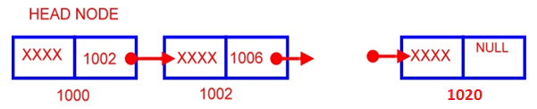
The above picture shows a singly linked list the first node is called the header node . This is the entry point to the list and the list is terminated when the link field of any of the node is NULL.
Now let us see what is a Doubly-Linked List :
The following figure shows a doubly linked list . The link is two way. Here the NODE contains two pointers LPTR left pointer and the RPTR right pointer. LPTR points to the previous node and RPTR points to the next node. Please note that whenever there is no node to point then the link is poited to NULL.
The advantage of Two way linked list is that the traversal becomes easy.
Now let us see what is a Circularly-Linked List :
A Circularly linked list is similar to singly linked list except that the 'Link' field of Last NODE points to the first node"
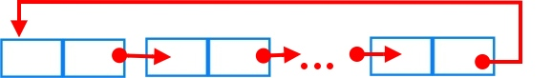

Linked List with a header

A1
A2
A3
A4
A5
header
L

The Front pointer will point to what is called a dummy node. This is a node containing no data. It is easier to code the insertion and deletion operations if the first node on the list contains no data. Otherwise, the code to insert a new first node or to delete the current first node must be different from the code to handle the normal cases.

Linked list operations:

1) Insert from front

2) Traverse

3) Insert from back

4) Insert after specified number of nodes

5) Delete from front

6) Delete from back

7) Delete specified number of node

8) Sort nodes

The items of the list

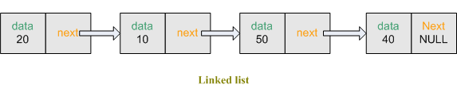

Defining the data structure for a linked list:

Struct node
{
Int data;
node *next;
};

typedefstructnode *PtrToNode;
typedefPtrToNodehead;

Insert from front:

At first initialize node type.
node *head = NULL;//empty linkedlist
Then we take the data input from the user and store in thenodedatavariable. Create a temporary node,node *tempand allocate space for it.

node *temp;//create a temporary node
temp = (node*)malloc(sizeof(node));//allocate space for node

Then placeinfo to temp->data. So the first field of thenode *tempis filled. Nowtemp->nextmust become a part of the remaininglinkedlist(although nowlinkedlistis empty but imagine that we have a 2 nodelinkedlistand head is pointed at the front) Sotemp->nextmust copy the address of the *head(Because we want insert at first) and we also want that*headwill always point at front. So*headmust copy the address of thenode *temp.
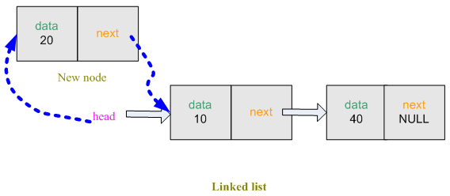
Figure: Insert at first

temp->data = info; // store data(first field)
temp->next=head; // store the address of the pointer head(second field)
head = temp; // transfer the address of 'temp' to 'head'

Node* inserttofront(List l,int info)
{
Node *temp;
temp = (Node*)malloc(sizeof(Node));
temp->data = info;
temp->Next=l;
l = temp;
return l;
}

Traverse the list
Now we want to see the information stored inside thelinkedlist. We create node*temp1. Transfer the address of*headto*temp1. So*temp1is also pointed at the front of thelinkedlist. Linkedlisthas 3 nodes.
We can get the data from first node usingtemp1->data. To get data from second node, we shift*temp1to the second node. Now we can get the data from second node.

while( temp1!=NULL )
{
cout<< temp1->data<<" ";// show the data in the list
temp1 = temp1->next; //tranfer address of 'temp->next' to 'temp'
}
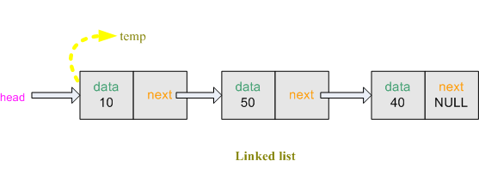
Figure: Traverse
This process will run until thelinkedlist’snext is NULL.

void traverse(List head )
{
Node *temp1=head;
while( temp1!=NULL )
{
cout<< temp1->data <<" ";
temp1 = temp1->Next;
}
}

Insert toback:
Insert data from back is very similar to the insert from front in thelinkedlist. Here the extra job is to find the last node of thelinkedlist.
node *temp1;
temp1 = head;
while(temp1->next!=NULL)
temp1 = temp1->next;
Now, Create a temporary nodenode *tempand allocate space for it. Then placeinfoto temp->data, so the first field of the nodenode *tempis filled. node *tempwill be the last node of thelinkedlist. For this reason,temp->nextwill be NULL. To create a connection betweenlinkedlistand the new node, the last node of the existinglinkedlistnode *temp1`s second fieldtemp1->nextis pointed tonode *temp.
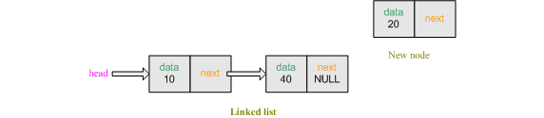
Figure: Insert at last
node *temp; // create a temporary node
temp = (node*)malloc(sizeof(node));
temp->data = info; // store data(first field)
temp->next = NULL; //second field will be null(last node)
temp1->next = temp; //'temp' node will be the last node

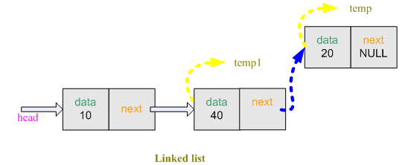

Node* insert_to_back(List head,int info)
{
Node *temp1;
temp1 = head;
while(temp1->Next!=NULL)
temp1 = temp1->Next;
Node *temp;
temp = (Node*)malloc(sizeof(Node));
temp->data = info;
temp->Next = NULL;
temp1->Next = temp;
return head;

}

Insert after specified number of nodes
Insert data in thelinkedlistafter specified number of node is a little bit complicated. But the idea is simple. Suppose, we want to add a node after 2nd position. So, the new node must be in 3rd position. The first step is to go the specified number of node. Let, node *temp1 is pointed to the 2nd node now.
cout<<"ENTER THE NODE NUMBER:";
cin>>node_number; //take the node number from user

node *temp1; // create a temporary node
temp1 = head;

for(int i = 1 ; i <node_number ; i++ )
{
temp1 = temp1->next; // go to the next node

if( temp1 == NULL )
{
cout<<node_number<<" node is not exist"<<endl;
break;
}
}
Now, Create a temporary nodenode *tempand allocate space for it. Then placeinfototemp->next, so the first field of the nodenode *tempis filled.
node *temp; // create a temporary node
temp = (node*)malloc(sizeof(node)); // allocate space for node
temp->data = info; // store data(first field)
To establish the connection between new node and the existinglinkedlist, new node’snextmust pointed to the 2nd node’s (temp1)next. The 2nd node’s (temp1) next must pointed to the new node(temp).

temp->next = temp1->next; //transfer address of temp1->next to temp->next
temp1->next = temp; //transfer address of temp to temp1->next

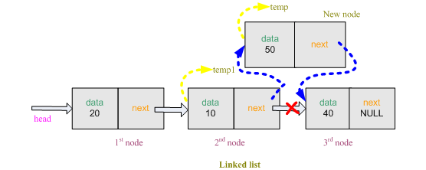
Figure: Insert after specified number of nodes
Node* insertAfter(List head,intinfo,intnode_no )
{
Node *temp1;
temp1 = head;
for(int i = 1 ; i <node_no ; i++ )
{
temp1 = temp1->Next;
if( temp1 == NULL )
{
cout<<node_no<<" node is not exist"<<endl;
break;
}
}
Node *temp;
temp = (Node*)malloc(sizeof(Node));
temp->Element = info;
temp->Next = temp1->Next;
temp1->Next = temp;
return head;
}

Delete from front
Delete a node fromlinkedlistis relatively easy. First, we create node*temp. Transfer the address of*headto*temp. So*tempis pointed at the front of thelinkedlist. We want to delete the first node. So transfer the address oftemp->nexttoheadso that it now pointed to the second node. Now free the space allocated for first node.
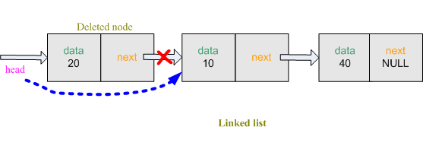
Figure: Delete at first node

Node* deletefront( List head )
{
Node *temp;
temp = head;
head = temp->Next;
free(temp);
return head;
}

Delete from back
The last node`snextof thelinkedlistalways pointed to NULL. So when we will delete the last node, the previous node of last nodeis now pointed at NULL. So, we will track last node and previous node of the last node in thelinkedlist. Create temporarynode * temp1and*old_temp.
// create a temporary node
node *temp1;
temp1 = head; //transfer the address of head to temp1
node *old_temp; // create a temporary node
while(temp1->next!=NULL) // go to the last node
{
old_temp = temp1; // transfer the address of 'temp1' to 'old_temp'
temp1 = temp1->next; // transfer address of 'temp1->next' to 'temp1'
}
Nownode *temp1is now pointed at the last node and*old_temp ispointed at the previous node of the last node. Now rest of the work is very simple. Previous node of the last nodeold_tempwill be NULL so it become the last node of thelinkedlist. Free the space allocated for last lode.

old_temp->next = NULL; //previous node of the last node is null
free(temp1);
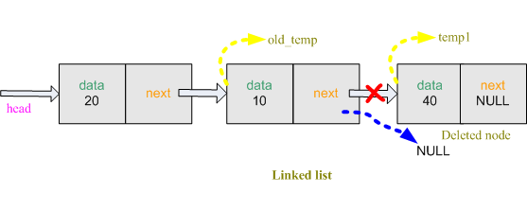
Figure: Delete at first last

Node* deletefromback(List head)
{
Node *temp1 = head;
Node *old_temp;
while(temp1->Next!=NULL)
{
old_temp = temp1;
temp1 = temp1-> Next;
}
old_temp-> Next = NULL;
free(temp1);
return head;
}

Delete specified number of node
To delete a specified node in thelinkedlist, we also require to find the specified node and previous node of the specified node. Create temporarynode * temp1, *old_tempand allocate space for it. Take the input from user to know the number of the node.

node *temp1;
temp1 = head;
node *old_temp;
old_temp = (node*)malloc(sizeof(node));
old_temp = temp1;
cout<<"ENTER THE NODE NUMBER:";
cin>>node_number; // take location
for(int i = 1 ; i <node_number ; i++ )
{
old_temp = temp1; // store previous node
temp1 = temp1->next; // store current node
}
Nownode *temp1is now pointed at the specified node and*old_temp is pointed at the previous node of the specified node. The previous node of the specified node must connect to the rest of thelinkedlistso we transfer the address oftemp1->nexttoold_temp->next.Now free the space allocated for the specified node.

old_temp->next = temp1->next;
free(temp1);
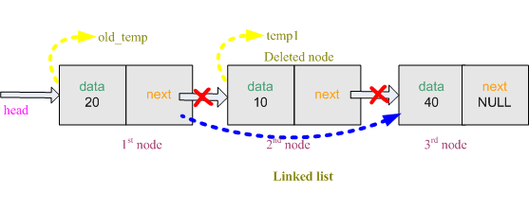

Sort nodes
Linkedlistsorting is very simple. It is just like ordinary array sorting. First we create two temporary nodenode*temp1, *temp2and allocate space for it. Transfer the address of first node totemp1and address of second node totemp2. Now check iftemp1->datais greater thantemp2->data. If yes then exchange the data. Similarly, we perform this checking for all the nodes.
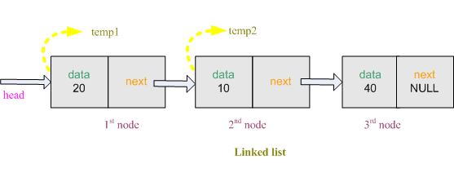

node *temp1; // create a temporary node
temp1 = (node*)malloc(sizeof(node));// allocate space for node
node *temp2; // create a temporary node
temp2 = (node*)malloc(sizeof(node));
int temp = 0; //store temporary data value

for( temp1 = head ; temp1!=NULL ; temp1 = temp1->next )
{
for( temp2=temp1->next ; temp2!=NULL ; temp2=temp2->next)
{
if( temp1->data > temp2->data )
{
temp = temp1->data;
temp1->data = temp2->data;
temp2->data = temp;
}
}
}

- malloc() : is a system function which allocates a block of memory in the "heap" and returns a pointer to the new block. The prototype for malloc() and other heap functions are in stdlib.h. The argument to malloc() is the integer size of the block in bytes. Unlike local ("stack") variables, heap memory is not automatically deallocated when the creating function exits. malloc() returns NULL if it cannot fulfill the request. (extra for experts) You may check for the NULL case with assert() if you wish just to be safe. Most modern programming systems will throw an exception or do some other automatic error handling in their memory allocator, so it is becoming less common that source code needs to explicitly check for allocation failures.

• free() : is the opposite of malloc(). Call free() on a block of heap memory to indicate to the system that you are done with it. The argument to free() is a pointer to a block of memory in the heap — a pointer which some time earlier was obtained via a call to malloc().

