SEMANTICS II
Sentence meaning
Sentence meaning involves more than the combined meanings of the individual morphemes and the words in a sentence. There are meaning relationships that hold over above the individual meanings of the words and morphemes in the sentence. Many such meaning relationships are involved in sentence semantics.
~~~~~~~~~~~~~~
These are:
- Meaning relations that hold between NPs in a sentence. These relations may be thought of as participant or role relations. Is a particular NP functioning as Agent, Experiencer , Location, Instrument or some other role?
~~~~~~~~~~~~~~
Words are synonyms; sentences are paraphrases
- Sameness in meaning despite difference in form. Is the paraphrase, as in
“They concealed the truth”, and
“The truth was concealed by them.”
Basically, similar or different from synonymy, as in “They concealed the truth”, “They hide the truth.”?
~~~~~~~~~~~~~~
Words may be homonyms; sentences may be ambiguous.
- Difference in meaning despite sameness of form. Is ambiguity, as in:
“ flying planes can be dangerous.” basically similar or different from homonymy?
~~~~~~~~~~~~~~
- Anomaly: “ This book has a headache”. Needs a special interpretation. Anomaly is a semantic deviance.
This violates selectional restrictions.
Fred’s children are rich, and he has no children.
~~~~~~~~~~~~~~
- Tautology.
This unicorn is a unicorn.
It gives no information unless a special meaning is inferred. (Nonsense)
~~~~~~~~~~~~~~
Case Grammar
( role relations)
Case grammar is an approach to grammar which stresses the semantic relationships in the sentence. In case grammar, the verb is regarded as the most important part of the sentence, and has a number of the semantic relationships with various noun phrases, in the sentence:
~~~~~~~~~~~~~~
Ahmad opened the door with a key.
The key opened the door.
The door opened.
~~~~~~~~~~~~~~
It seems clear that, at some level these three nouns Ahmad, key, and door had a special relationship with open: with a key and the key have different syntactic functions, but their semantic relationships with the verb “open” is the same in both sentences. The key is the instrument with which the action of the verb is performed.”
~~~~~~~~~~~~~~
“with a key” and “the key” are said to be in the Instrumental case. According to Fillmore, case is universal in languages and the following eight cases are sufficient to account for the relationships between verbs and nouns. These are:
~~~~~~~~~~~~~~
Agentive Source
Experiencer Goal
Instrumental Locative
Objective Temporal
~~~~~~~~~~~~~~
As the examples show, case relationships can be shown in different surface syntactic structures. In Fillmore’s view each deep structure sentence involves a predicator and a number of cases:
~~~~~~~~~~~~~~
S Predicator + Case₁ + Case₂ + Case₃ + - - - - - Case_{n}.

- Ahmad opened the door with a key.

open Agent Patient Instrument
_______________________
- A key opened the door.
open Agent Patient Instrument
~~~~~~~~~~~~~~
The door opened.

open Agent Patient Instrument
~~~~~~~~~~~~~~

Agent
Agent: The agent function is that of the doer responsible for an action or event taking place.
In sentences like:
- I hit the boy.
- I ran away.
- I laughed.
The role of Agent is limited to animates.

Force
Force: There is a difference in role between the animate doers, and inanimate doers.
For ex.:
- Lightening hit the boy.
(I willingly hit the boy.)

Instrument
Instrument: is the function expressing the means by which something is done, most explicitly, the thing used to achieve some end. For ex.
- Jack broke the icon with a hammer.
- I washed it by hand.
- The hammer broke the icon.
- I went on foot.

Experiencer
Is the role of the animate being affected by an event or characterized by a state.
For ex.
- I love my mother.
- That was obvious to me.
- That was pleasing to me.

Source
The place or direction from which something comes is the “ Source.” Usually the source is location:
- I walked from the market.
- She bought the apples from the farmer.
- That story annoyed me.

Goal
The direction to which something goes is the goal. Usually Goal is a location introduced by to:
- He walked to school.
- I walked home.
- The farmer sold the apples to her.

Path
In moving from one place to another, a “path” ( the route by which something goes) may be contextually assumed, or play a significant role.
For ex.:
- I walked home through the field.
- I walked home along the river.
- I drove home on the freeway.

Location
The role of place- in-which is “ Location” .
- They sat at home.
- Your shoes are under the bed.
- The house smells.

Possessor
A special kind of locative relation is that of possession. Possessor is a locational role.
For ex.
- This book belongs to me.
- He has a car.

Patient
It is characterized as the role of the being or thing that is affected by the location or event, that is simply present in it.
For ex.
- The door opened.
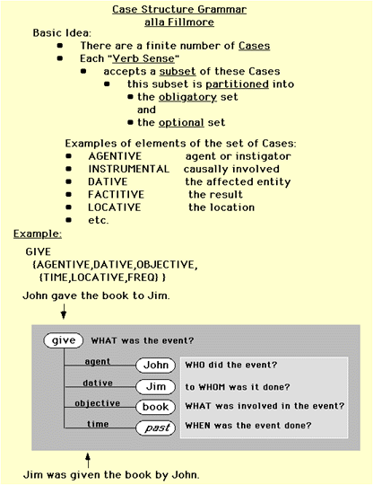
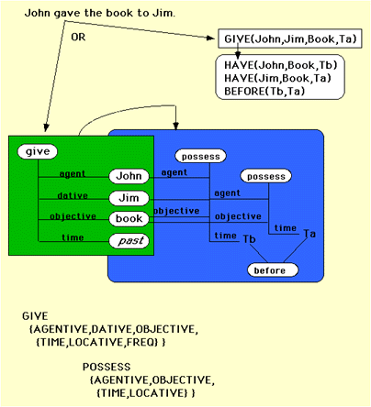
Exercise
Identify the role or roles of each underlined NP in the ollowing passage taken from Hemingway’s For Whom the Bell Tolls.
~~~~~~~~~~~~~~
In the late summer of that year we
TIME PATIENT
lived in a house in a village that looked
LOCATION LOCATION
across the river and the plain to the
PATH
mountains.
GOAL
~~~~~~~~~~~~~~~~~~~~~~~~~~~~
In the bed of the river there were
LOCATION
pebbles and boulders, dry and white in
PATIENT
the sun, and the water was clear and
PATIENT
swiftly moving and blue in the channels.
LOCATION

