Pragmatics I
Pragmatics
Meaning is not only derived from words, phrases and sentences. When we read or hear pieces of lang. we normally try to understand not only what the words mean, but what the writer or speaker of those words intend to convey. the study of “intended speaker meaning” is called pragmatics.


SALE
FALL BABY
FALL BABY SALE
The meaning of words
+
The context in which they occur

The writer’s or speaker’s intended meaning
… … … … … … … … … …
Context
There are different kinds of contexts or co-text.
- Co-text: (linguistic context) of a word is the set of other words used in the same phrase or sentence. This surrounding co-text has a strong effect on what we think the word means.
Steep bank Overgrown bank
~~~~~~~~~~~~~~
Steep bank
Overgrown bank
I went to the bank to cash a check
- Co-text: ( physical context) Our understanding of what we read and hear is tied to the time and place in which we encounter linguistic expressions.
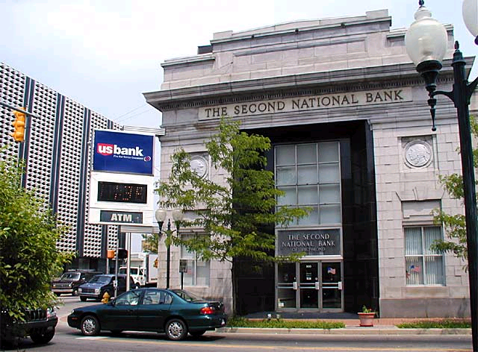
If you see the word BANK on the wall of a building, the “physical” location will influence your interpretation.
Semiotics
Semiotics is the study of sign and sign systems. Linguistic signs are one kind of sign. The three subdivisions of semiotics are,
Syntax means “the way signs arranged”.
Semantics means “what signs mean or signify”.
Pragmatics means “the relationship between signs and their users”.

Deictic expressions
Some words in the lang. can not be interpreted at all unless the physical context, especially the physical context of the speaker, is known.
These are words like here, there, this, that, now, then, yesterday, as well as most pronouns such as I, you, him, her, them. Some sentences are impossible to understand if we do not know who is speaking, about whom, where, and when.
For example
They will have to do that tomorrow; because they are not here now.
The sentence is vague because it contains a large number of deictic expressions which depend for their interpretations on the immediate physical context in which they uttered. Such expressions we can understand in terms of speaker’s intended meaning.
~~~~~~~~~~~~~~~~~~~~
I like working here; in this office; in this building; in this part of town; in this country.
Presuppositions
When a speaker uses a deictic expression like here, he assumes that this hearer knows which location is intended. Generally, speakers design their linguistic messages on the basis of the assumptions about what their hearers already know. What a speaker assumes is true or known by the hearer can be described as a presupposition.
~~~~~~~~~~~~~~~~~~~~
For ex.
Your brother is waiting outside for you.

When did you stop smoking cigar?

Such examples or questions with built- in presuppositions are very useful devices for lawyers and prosecutors.
For ex.
Okay, Mr. Smith, where did you buy the cocaine?

There is a presupposition that he did buy cocaine.
Testing presupposition
For ex.
My car is new.
My car is not new.
The presupposition remains the same the same: “ I have a car.”
Utterances
Pragmatics deals with utterance meaning and semantics deals with sentence meaning.
An utterance may be a sentence- instance, or sentence token; but cannot be a sentence. Utterances are the elements whose meaning we study in Pragmatics.

