Health Education I
Topic 2 - Activity and Personal Health
Chapter 3

What your doctor will tell you…
- Stop Smoking!
- Lose weight!
- Eat less fat!
- Wear your seatbelts!
- Exercise regularly!
The next big question is…
WILL YOU DO IT???

The truth is…
- It’s your lifestyle! It is your LIFE, therefore it should be your own personal decision on whether you will live healthy or not!
- It is BEST to know yourself and act accordingly!

Health Screening
- Early detection may lead to a longer lifespan.
- Examples of healt screening are knowing the following:
1.Age
2. Gender
3. Health risks
4. Family history and occupation
Early Detection
- If your age, gender, race, family history, health habits or exposure puts you at risk for a disease, use an early detection test, as long as the proposed test meets the following criteria:
1.The disease has a significant effect on the quality of life
2. Acceptable methods of treatment are available.
3. Treatment during the asymptomatic (no symptom) period significantly reduces disability or death.
4. Early treatment yields a superior result
5. Detection test are available at reasonable cost.
6. The incidence of the disease in the population is sufficient to justify the cost of screening.

Annual Medical Examination
- The typical medical examination includes a history, physical examination and test dictated by the patient’s age, gender and the findings of the exam.

Do you really need an annual medical examination????
Some say no, some say yes. The thing is, if you are in doubt about the condition of your health, by all means see your physician.

When to have a regular annual check –up?
1. At around 18-25 years of age
2. Every 5 years between ages 35-65
3. Every 2 years after age 65

Maximum Heart Rate
It is important to know if you want to get your target heart rate during exercise.
It can be calculated as:
HRmax= 220-Age

What is Target Heart Rate or THR?
Monitoring your Pulse rate (Heart Rate)
- Resting Heart Rate (RHR)
-the number of beats per minute at rest (best taken when you first wake up)
- Maximum Heart Rate (HR max)
- the highest number of beats in 1 minute.
- Recovery Heart Rate (RecHR)
- the number of beats per minute after 2-5 minutes of work-out.

TARGET HEART RATE or Target Pulse Rate
(using HR to determine exercise intensity)
Formula for Target HR = x% (HRmax-RHR) + RHR
- HRmax= Heart Rate maximum
- 50-70% level of exercise intensity to improve fitness
- RHR= Resting Heart Rate

RESULTS:
- HR during exercise= Below Target HR means not enough intensity
- HR during exercise=Above Target HR means over exercise or exhaustion

Sample Calculation
Given: X%=50%-70%; Age=18 RHR=80beats/minute
Target HR = x% (HRmax-RHR) + RHR
=.50(202-80)+80 (Subtract first)
=.50(122)+80 (Then multiply before adding)
=141
Target HR = .70(202-80)+80 (Subtract first)
=.70(122)+80 (Then multiply before adding)
=165.4
Target Heart Rate Range= 141- 166

Risk of Activity
Based on research, activity greatly reduces but doesn’t eliminate the risk associated with inherited or lifestyle diseases.
- Inactive person- risk rises 56 times above resting levels on the first start of an activity program.
- Active person – risk rises only 5 times and has 60% lower risk of heart attack.
- Minor musculoskeletal problems
- the risks are low for low-intensity and moderate-duration activity.
-overuse injuries are common when a person rapidly increases duration of activity.
- Major coronary events
- the risk is low for an asymptomatic adult

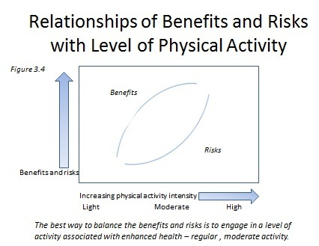

Be aware of these warning signs as you engage in physical activity:
Stop Signs – if any of these occurs, stop exercising.
- Abnormal heart action
- Pain or pressure in the middle of the chest, arm, throat during or after exercise
- Dizziness, lightheadedness, sudden loss of coordination

Yield Signs - suggested remedy.
- For persistent heart action – lower exercise intensity.
- For flare-up of bone or joint conditions – rest and resume exercise when the condition subsides.
Caution Signs
- Nausea or vomiting after exercise – wait at least 2-3 hours after eating before you exercise.
- Extreme breathlessness – exercise less vigorously.
- Prolonged fatigue – lower your intensity and increase it gradually over a period of weeks.
- Side stitch – lean forward while sitting and attempt to push the abdominal organs up against the diaphragm.

Special Considerations for Exercise
- Older Adults – should undertake exercises to develop and maintain muscular strength and endurance.
- Women :
Young – high volume vigorous prepubertal training may delay the onset of menstrual cycle.
Pregnant – should eliminate high impact aerobics, keeping the exercise heart rate below 140 bpm, and avoiding prolonged exposure to high temperature during activity.
Postmenopausal – should participate in activities that put a moderate degree of stress on the muscles and bones.
- Children – should avoid heavy training, prolonged hard work in the heat, and excess competition.
- People with Disabilities – Each disability carries its own restrictions, but each has potential as well.
- Racial Considerations – African-Americans with hypertension should undergo preexercise medical examination, follow dietary recommendations, and take prescribed medications.

Health and Wellness Continuum

What is Health?
Health Definitions
- It was defined in the past as the absence of disease.
- In 1980’s, it is the state of complete physical, mental, and emotional well-being and not merely the absence of disease or infirmity.

What is Wellness?
Wellness Definitions
- It defines movement toward an advanced state of health, also called optimal or high-level health.

The Health Continuum
Figure 3.5

Optimal (high level) health
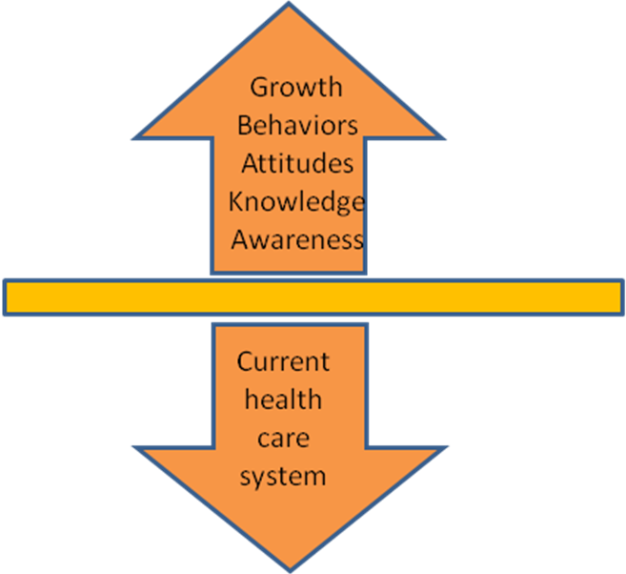
Wellness Healthy
model Absence of disease

Neither sick nor well
Treatment Signs and symptoms
model Illness/disease
Disability

Premature death

Health Risk Analysis
- Health risk analysis is a learning tool to identify positive and negative aspects of your health behavior.
- If you find that your risk of heart disease is high, you can take the following steps to lower the risk:
- Engage in regular, moderate physical activity, 30 minutes on most days.
- Eat less saturated and trans fat and more fresh fruit and vegetables.
- Eat soy protein and olive oil.
- Keep your body mass index below 25.
- Take a low-dose coated aspirin daily or every other day.
- Have one red wine daily or every other day.

