Wernicke-Geschwind Model
1. Repeating a spoken word
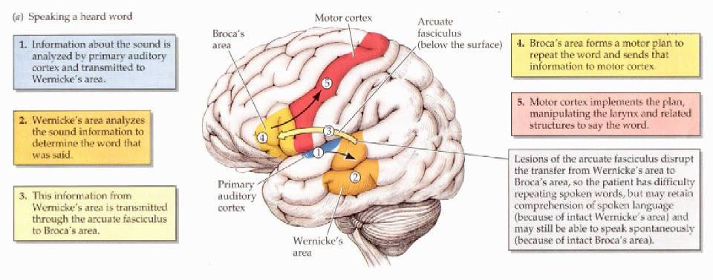

Wernicke-Geschwind Model
2. Repeating a written word
