Coordinate Noun Phrases

Our rules seem to be getting more and more complex. To the simple noun-phrase rule that we introduced earlier. We have added provisions for optional adjectives, prepositional phrases, and pronouns:
NP -----> { (Art) (Adj)+ N (PP) }
Prop

And we are not finished yet! At times a noun phrase can have a kind of collective membership:

The man and the woman greeted Donald.
The workers demanded higher pay and better benefits.
They struggled without food or a reliable source of water.

- The first sentence has only one verb phrase (greeted Donald), but two noun phrases seem to constitute its subject ( the man and the woman, joined by the word and). In the second sentence, two noun phrases joined by and constitute the sentence’s direct object. In the third sentence, two noun phrases joined by or act as the object of the preposition phrase without. The words and and or, which connect the noun phrases, are called COORDINATING CONJUNCTIONS ( Cco).
To account for the first sentence, we will say that the subject noun phrase ( the man and the woman) has as its constituents two different noun phrases joined by a coordinator.
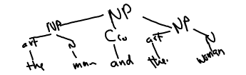
That is, one overall noun phrase ( the man and the woman) consists of two smaller individual phrases ( the man, the woman) linked together by a coordinating conjunction. Such a noun phrase is known as a COORDINATE NOUN PHRASE. The rule that would allow noun phrases with this structure is the following:
NP -----> NP Cco NP
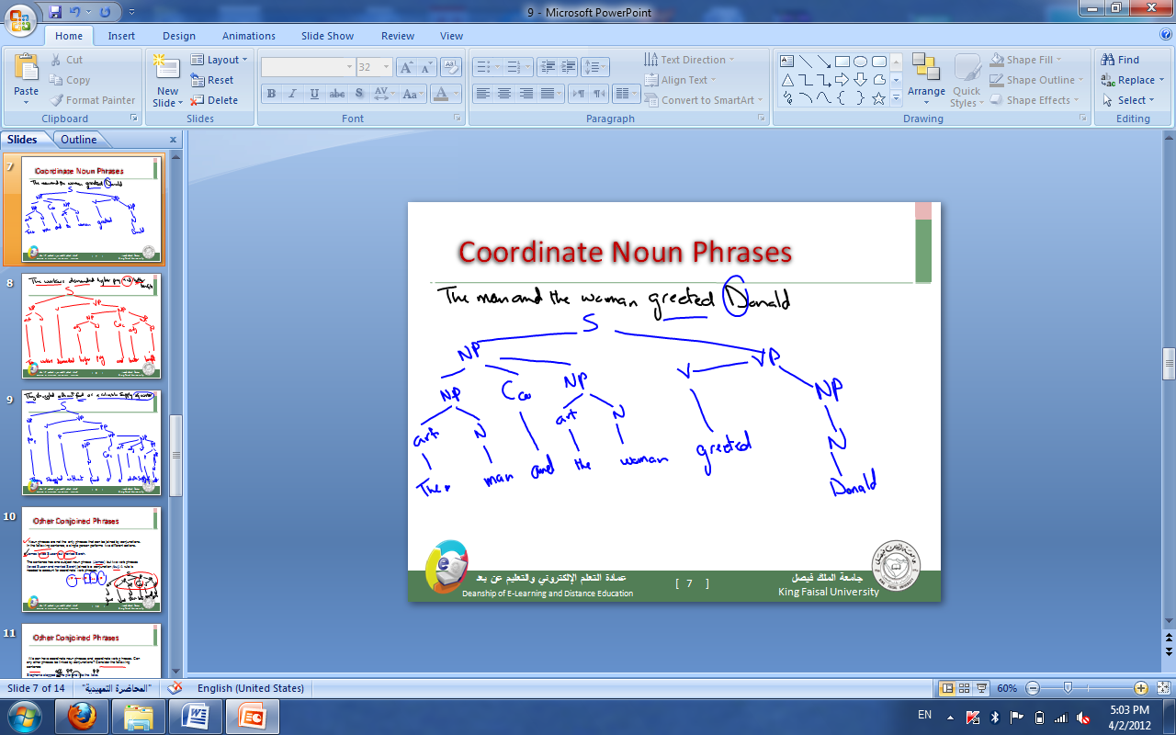

--------------------------------------------------------------------------------------------------

Other Conjoined Phrases

Noun phrases are not the only phrases that can be joined by conjunctions. In the following sentence, a single person performs two different actions.
James loved Susan but married Sarah.

The sentence has one subject noun phrase (James) but two verb phrases (loved Susan and married Sarah) joined b a conjunction (but). A rule is needed to account for coordinate verb phrases.

VP -----> VP Cco VP

We can have coordinate noun phrases and coordinate verb phrases. Can any other phrases be linked by conjunctions? Consider the following sentence:

Stephanie stepped of the pier and into the lake.

Here the coordinating conjunction and connects two prepositional phrases (off the pier and into the lake). Let us add the following rule to our grammar:

PP -----> PP Cco PP

Notice that we now have three quite similar rules for coordinate phrases:
NP -----> NP Cco NP
VP -----> VP Cco VP
PP -----> PP Cco PP

Let us simplify it to the following:
XP -----> XP Cco XP

Exercises

1. Draw trees for the following sentences.
The rain and the insects spoiled the party.
Tom did the work but failed the oral exam.
People from Austria and from Germany speak the same language.

