Lecture 5
Heart of Darkness
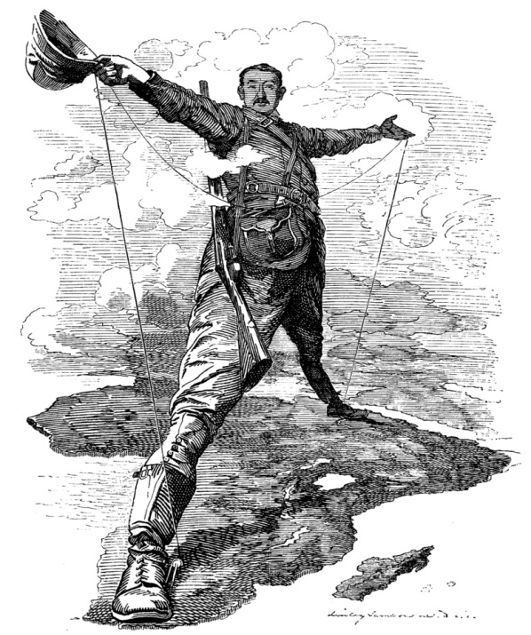
He was an ardent believer in imperialism and colonialism.
He is a great example of the way people thought about taking over other countries.
Marlow’s journey down the coast of Africa through his meeting with the chief accountant :
summery
The French steamer takes Marlow along the coast of Africa, stopping periodically to land soldiers and customshouse officers. Marlow finds his idleness vexing, and the trip seems vaguely nightmarish to him. At one point, they come across a French man-of-war shelling an apparently uninhabited forested stretch of coast. They finally arrive at the mouth of the Congo River, where Marlow boards another steamship bound for a point thirty miles upriver. The captain of the ship, a young Swede, recognizes Marlow as a seaman and invites him on the bridge. The Swede criticizes the colonial officials and tells Marlow about another Swede who recently hanged himself on his way into the interior.
Marlow disembarks at the Company’s station, which is in a terrible state of disrepair. He sees piles of decaying machinery and a cliff being blasted for no apparent purpose. He also sees a group of black prisoners walking along in chains under the guard of another black man, who wears a shoddy uniform and carries a rifle. He remarks that he had already known the “devils” of violence, greed,
Heart of Darkness
and desire, but that in Africa he became acquainted with the “flabby, pretending, weak-eyed devil of a rapacious and pitiless folly.”
Finally, Marlow comes to a grove of trees and, to his horror, finds a group of dying native laborers. He offers a biscuit to one of them; seeing a bit of white European yarn tied around his neck, he wonders at its meaning. He meets a nattily dressed white man, the Company’s chief accountant (not to be confused with Marlow’s friend the Accountant from the opening of the book). Marlow spends ten days here waiting for a caravan to the next station. One day, the chief accountant tells him that in the interior he will undoubtedly meet Mr. Kurtz, a first-class agent who sends in as much ivory as all the others put together and is destined for advancement. He tells Marlow to let Kurtz know that everything is satisfactory at the Outer Station when he meets him. The chief accountant is afraid to send a written message for fear it will be intercepted by undesirable elements at the Central Station.
The Belgian Congo

Heart of Darkness
Analysis :
Marlow’s description of his journey on the French steamer makes use of an interior/exterior motif that continues throughout the rest of the book. Marlow frequently encounters inscrutable surfaces that tempt him to try to penetrate into the interior of situations and places. The most prominent example of this is the French man-of-war, which shells a forested wall of coastline. To Marlow’s mind, the entire coastline of the African continent presents a solid green facade, and the spectacle of European guns firing blindly into that facade seems to be a futile and uncomprehending way of addressing the continent.
“The flabby, pretending, weak-eyed devil of a rapacious and pitiless folly” is one of the central images with which Marlow characterizes the behavior of the colonists. He refers back to this image at a number of key points later in the story. It is thus a very important clue as to what Marlow actually thinks is wrong about imperialism—Marlow’s attitudes are usually implied rather than directly stated.
Heart of Darkness
Marlow’s attitudes are usually implied rather than directly stated. Marlow distinguishes this devil from violence, greed, and desire, suggesting that the fundamental evil of imperialism is not that it perpetrates violence against native peoples, nor that it is motivated by greed. The flabby, weak-eyed devil seems to be distinguished above all by being shortsighted and foolish, unaware of what it is doing and ineffective.
The hand of the “flabby devil” is apparent in the travesties of administration and the widespread decay in the Company’s stations. The colonials in the coastal station spend all their time blasting a cliff for no apparent reason, machinery lies broken all around, and supplies are poorly apportioned, resting in abundance where they are not needed and never sent to where they are needed. Given the level of waste and inefficiency, this kind of colonial activity clearly has something other than economic activity at stake, but just what that something might be is not apparent. Marlow’s comments on the “flabby devil” produce a very ambivalent criticism of colonialism.
The Belgian Congo
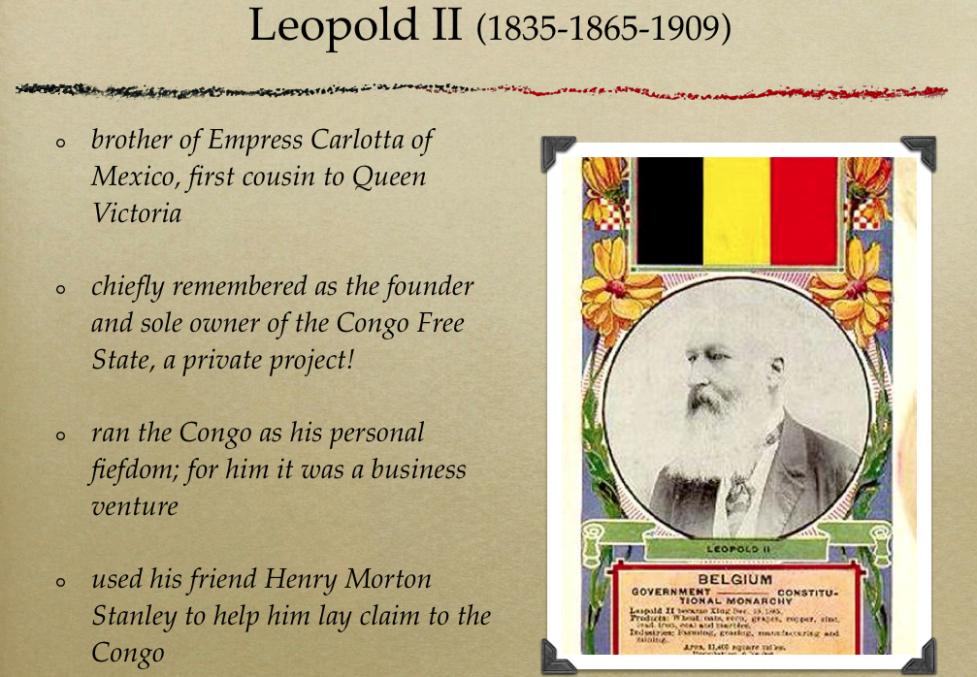
Heart of Darkness
Would Marlow approve of the violent exploitation and extortion of the Africans if it was done in a more clear-sighted and effective manner? This question is difficult to answer definitively.
On the other hand, Marlow is appalled by the ghastly, infernal spectacle of the grove of death, while the other colonials show no concern over it at all. For Marlow, the grove is the dark heart of the station. Marlow’s horror at the grove suggests that the true evils of this colonial enterprise are dehumanization and death. All Marlow can offer these dying men are a few pieces of biscuit, and, despite the fact that Marlow is “not particularly tender,” the situation troubles him.
In this section, Marlow finally learns the reason for the journey he is to take up the Congo, although he does not yet realize the importance this reason will later take on. The chief accountant is the first to use the name of the mysterious Mr. Kurtz, speaking of him in reverent tones and alluding to a conspiracy within the Company, the particulars of which Marlow never deciphers.
Heart of Darkness

Again, the name “Kurtz” provides a surface that conceals a hidden and potentially threatening situation.
It is appropriate, therefore, that the chief accountant is Marlow’s informant. In his dress whites, the man epitomizes success in the colonial world. His “accomplishment” lies in keeping up appearances, in looking as he would at home. Like everything else Marlow encounters, the chief accountant’s surface may conceal a dark secret, in this case the native woman whom he has “taught”—perhaps violently and despite her “distaste for the work”—to care for his linens. Marlow has yet to find a single white man with a valid “excuse for being there” in Africa. More important, he has yet to understand why he himself is there.
Marlow’s journey to the Central Station through the arrival of the Eldrado Exploring Expedition
summery
Summary :
Marlow travels overland for two hundred miles with a caravan of sixty men. He has one white companion who falls ill and must be carried by the native bearers, who start to desert because of the added burden. After fifteen days they arrive at the dilapidated Central Station. Marlow finds that the steamer he was to command has sunk. The general manager of the Central Station had taken the boat out two days before under the charge of a volunteer skipper, and they had torn the bottom out on some rocks. In light of what he later learns, Marlow suspects the damage to the steamer may have been intentional, to keep him from reaching Kurtz. Marlow soon meets with the general manager, who strikes him as an altogether average man who leads by inspiring an odd uneasiness in those around him and whose authority derives merely from his resistance to tropical disease. The manager tells Marlow that he took the boat out in a hurry
Heart of Darkness
to relieve the inner stations, especially the one belonging to Kurtz, who is rumored to be ill. He praises Kurtz as an exceptional agent and takes note that Kurtz is talked about on the coast.
The word ‘ivory’ rang in the air, was whispered, was sighed. You would think they were praying to it.
Marlow sets to work dredging his ship out of the river and repairing it, which ends up taking three months. One day during this time, a grass shed housing some trade goods burns down, and the native laborers dance delightedly as it burns. One of the natives is accused of causing the fire and is beaten severely; he disappears into the forest after he recovers. Marlow overhears the manager talking with the brickmaker about Kurtz at the site of the burned hut. He enters into conversation with the brickmaker after the manager leaves, and ends up accompanying the man back to his quarters, which are noticeably more luxurious than those of the other agents.
Heart of Darkness

Marlow realizes after a while that the brickmaker is pumping him for information about the intentions of the Company’s board of directors in Europe, about which, of course, Marlow knows nothing. Marlow notices an unusual painting on the wall, of a blindfolded woman with a lighted torch; when he asks about it, the brickmaker reveals that it is Kurtz’s work.
The brickmaker tells Marlow that Kurtz is a prodigy, sent as a special emissary of Western ideals by the Company’s directors and bound for quick advancement. He also reveals that he has seen confidential correspondence dealing with Marlow’s appointment, from which he has construed that Marlow is also a favorite of the administration. They go outside, and the brickmaker tries to get himself into Marlow’s good graces—and Kurtz’s by proxy, since he believes Marlow is allied with Kurtz. Marlow realizes the brickmaker had planned on being assistant manager, and Kurtz’s arrival has upset his chances.
Heart of Darkness
Seeing an opportunity to use the brickmaker’s influence to his own ends, Marlow lets the man believe he really does have influence in Europe and tells him that he wants a quantity of rivets from the coast to repair his ship. The brickmaker leaves him with a veiled threat on his life, but Marlow enjoys his obvious distress and confusion.
Marlow finds his foreman sitting on the deck of the ship and tells him that they will have rivets in three weeks, and they both dance around exuberantly. The rivets do not come, however. Instead, the Eldorado Exploring Expedition, a group of white men intent on “tear[ing] treasure out of the bowels of the land,” arrives, led by the manager’s uncle, who spends his entire time at the station talking conspiratorially with his nephew. Marlow gives up on ever receiving the rivets he needs to repair his ship, and turns to wondering disinterestedly about Kurtz and his ideals.
Heart of Darkness
Analysis :
As Marlow describes his caravan journey through the depopulated interior of the colony, he remarks ironically that he was becoming “scientifically interesting”—an allusion to his conversation with the company doctor in Brussels. Given this, it is curious that Marlow talks so little about the caravan journey itself. In part, this is because it’s not directly relevant to his story—during this time he is neither in contact with representatives of the Company nor moving directly toward Kurtz. Nonetheless, something about this journey renders Marlow a mystery even to himself; he starts to think of himself as a potential case study. Africa appears to him to be something that happens to a man, without his consent. One way to interpret this is that Marlow is disowning his own responsibility (and that of his fellow employees) for the atrocities committed by the Company on the natives. Because of its merciless environment and savage inhabitants, Africa itself is responsible for colonial violence.
The Belgian Congo
wealthy colony for Belgium
Lots of rubber, copper, and palm oil for export
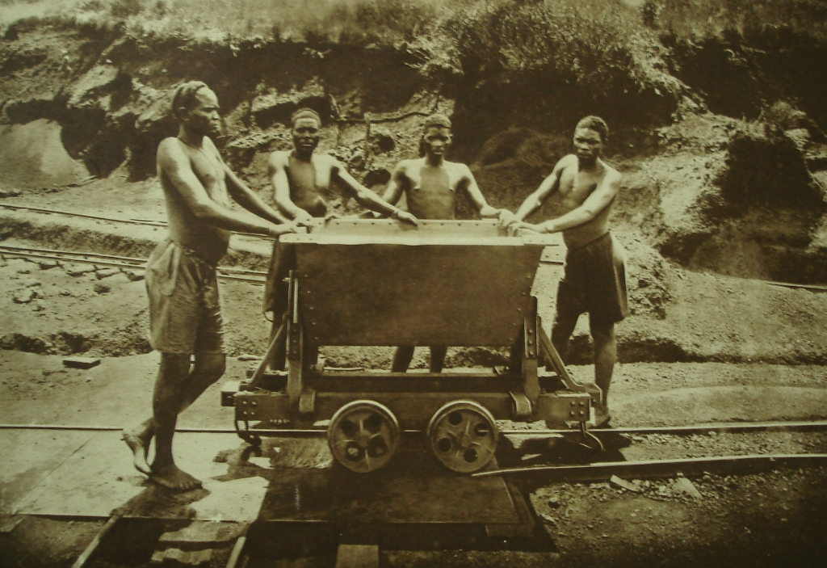
Heart of Darkness
Forced to deal with his ailing companion and a group of native porters who continually desert and abandon their loads, Marlow finds himself at the top of the proverbial slippery slope.
The men he finds at the Central Station allow him to regain his perspective, however. The goings-on here are ridiculous: for example, Marlow watches a man try to extinguish a fire using a bucket with a hole in it. The manager and the brickmaker, the men in charge, are repeatedly described as hollow, “papier-mâché” figures. For Marlow, who has just experienced the surreal horrors of the continent’s interior, the idea that a man’s exterior may conceal only a void is disturbing. The alternative, of course, is that at the heart of these men lies not a void but a vast, malevolent conspiracy. The machinations of the manager and the brickmaker suggest that, paradoxically, both ideas are correct: that these men indeed conceal bad intentions, but that these intentions, despite the fact that they lead to apparent evil, are meaningless in light of their context.
Heart of Darkness
The use of religious language to describe the agents of the Central Station reinforces this paradoxical idea. Marlow calls the Company’s rank and file “pilgrims,” both for their habit of carrying staves (with which to beat native laborers) and for their mindless worship of the wealth to be had from ivory.
“Ivory,” as it echoes through the air of the camp, sounds to Marlow like something unreal rather than a physical substance. Marlow suggests that the word echoes because the station is only a tiny “cleared speck,” surrounded by an “outside” that always threatens to close in, erasing the men and their pathetic ambitions. Over and over again in this section of the book human voices are hurled against the wilderness, only to be thrown back by the river’s surface or a wall of trees. No matter how evil these men are, no matter how terrible the atrocities they commit against the natives, they are insignificant in the vastness of time and the physical world. Some critics have objected to Heart of Darkness on the grounds that it brushes aside or makes excuses for racism and colonial
Heart of Darkness
violence, and that it even glamorizes them by making them the subject of Marlow’s seemingly profound ruminations.
On a more concrete level, the events of this section move Marlow ever closer to the mysterious Kurtz. Kurtz increasingly appeals to Marlow as an alternative, no matter how dire, to the repellent men around him. The painting in the brickmaker’s quarters, which Marlow learns is Kurtz’s work, draws Marlow in: the blindfolded woman with the torch represents for him an acknowledgment of the paradox and ambiguity of the African situation, and this is a much more sophisticated response than he has seen from any of the other Europeans he has encountered. To the reader, the painting may seem somewhat heavy-handed, with its overtly allegorical depiction of blind and unseeing European attempts to bring the “light” of civilization to Africa. Marlow, however, sees in it a level of self-awareness that offers a compelling alternative to the folly he has witnessed throughout the Company.

