Lecture 8
The Modern English Novel:
Heart of Darkness
Joseph Conrad 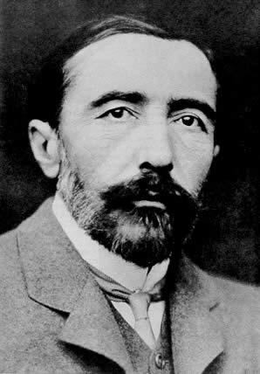
Characters
- Marlow
The protagonist of Heart of Darkness. Marlow is philosophical, independent-minded, and generally skeptical of those around him. He is also a master storyteller, eloquent and able to draw his listeners into his tale. Although Marlow shares many of his fellow Europeans’ prejudices, he has seen enough of the world and has encountered enough debased white men to make him skeptical of imperialism.
- Kurtz
The chief of the Inner Station and the object of Marlow’s quest. Among Kurtz’s many talents are his charisma and his ability to lead men. Kurtz is a man who understands the power of words, and his writings are marked by an eloquence that obscures their horrifying message. Although he remains an enigma even to Marlow, Kurtz clearly exerts a powerful influence on the people in his life.
Characters
His downfall seems to be a result of his willingness to ignore the hypocritical rules
that govern European colonial conduct: Kurtz has “kicked himself loose of the earth”
by fraternizing excessively with the natives and not keeping up appearances. Kurtz
has become wildly successful but he has also indulged his own evil desires and
alienated himself from his fellow white men.
General Manager:
The chief agent of the Company’s African territory and manager of the Central
Station. The General manager owes his success to a hardy constitution that allows
him to outlive all his competitors. He is average in appearance and unremarkable in
abilities, but he possesses a strange capacity to produce uneasiness in those around
him, which allows him to exert his control.
Characters
Pilgrims:
The bumbling, greedy agents of the Central Station. They carry long wooden staves,
reminding Marlow of traditional religious travelers. They all want to be appointed to
a station so that they can trade for ivory and earn a commission, but none of them
actually takes any effective steps toward achieving this goal. They are obsessed with
keeping up a veneer of civilization and proper conduct, and are motivated entirely by
self-interest. They hate the natives and treat them like animals.
Cannibals:
Natives hired as the crew of the steamer. They are a surprisingly reasonable and well-
tempered bunch. Marlow respects their restraint and calm acceptance of adversity.
The leader of the group, in particular, seems to be intelligent and capable of ironic
reflection upon his situation.
Characters
Russian trader:
A Russian sailor who has gone into the African interior as the trading representative
of a Dutch company. He is boyish in appearance and temperament, and seems to
exist wholly on the glamour of youth and the audacity of adventurousness. He is a
devoted disciple of Kurtz’s.
Kurtz’s African Mistress:
A fiercely beautiful woman loaded with jewelry who appears on the shore when
Marlow’s steamer arrives at and leaves the Inner Station. She seems to exert an undue
influence over both Kurtz and the natives around the station, and the Russian trader
points her out as someone to fear. Like Kurtz, she is an enigma: she never speaks to
Marlow, and he never learns anything more about her.
Characters
Kurtz’s Intended:
Kurtz’s naïve and long-suffering fiancée, whom Marlow goes to visit after Kurtz’s
death. Her unshakable certainty about Kurtz’s love for her reinforces Marlow’s belief
that women live in a dream world, well insulated from reality.
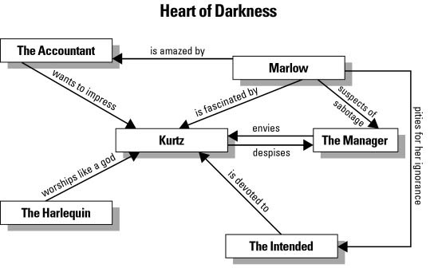
Kurtz
One of the most enigmatic characters in twentieth-century literature, Kurtz is a petty tyrant, a dying semi-god, an embodiment of Europe, and an assault on European values. These contradictory elements combine to make Kurtz so fascinating to Marlow — and so threatening to the Company.
Like Marlow, Kurtz also wished to travel to Africa in search of adventure — specifically, to complete great acts of "humanizing, improving, instructing" (as he explains in his initial report to the Company). Once he tasted the power that could be his in the jungle, however, Kurtz abandoned his philanthropic ideals and set himself up as a semi-god to the natives at the Inner Station. While he used to worry about the best ways to bring (as his painting demonstrates) the "light" of civilization to the Congo, he dies as a man believing that the Company should simply "Exterminate all the brutes!"
Kurtz is a dangerous man because he gives the lie to the Company's "humanistic" intentions in the Congo. He returns more ivory than all the other stations put together, and does so through the use of absolute force. This frightens men like the Manager, who complains of Kurtz's "unsound method" — although Kurtz is only doing what the Company as a whole is doing without hiding his actions behind a façade of good
Kurtz

intentions. Marlow remarks that "All Europe contributed to the making of Kurtz," and Kurtz's very existence proves this to be true: Like the Europeans involved in enterprises such as the Company, he epitomizes the greed and lust running wild that Marlow observes in the Congo. However, unlike the Company, Kurtz is not interested in his image or how he is perceived by "noxious fools" such as the Manager. While Brussels is a "whited sepulcher" of hypocrisy, Kurtz is completely open about his lusts. He tells the Manager he is "Not so sick as you'd like to believe." But this statement is applicable to all Europeans involved in imperialistic empire-building: While labeling Kurtz a morally "sick" man might seem comforting, he is actually an exaggeration of the impulses harbored in the hearts of men everywhere.
The Manager
As Kurtz (in some sense) embodies Europe, the Manager embodies the Company that he represents in the Congo. The Manager's primary concern is preserving his position within the Company, which he incorrectly assumes Kurtz wishes to steal from him. A scheming liar, the Manager sabotages Marlow's steamboat to prevent supplies from reaching Kurtz at the Inner Station.
Neither Marlow nor Kurtz believe his shows of concern for Kurtz's health: When he tells Kurtz that he has come to save him, Kurtz replies, "Save the ivory, you mean," and after Kurtz dies, Marlow feels the Manager's eyes on him as he leaves Kurtz's room, eager to learn of his rival agent's death. According to Marlow, the Manager "inspires uneasiness" and tries to use this ability to gain information about Kurtz and his activities from Marlow. A despicable man, the Manager has the power to make the Company a reputable operation, but refuses to do so for fear that this would impede the flow of ivory that comes out of Africa.
The accountant
Although he only appears in the novel for a short time, the Accountant is an important figure because he personifies the Company's goals and methods. The fact that he spends his days with his ledger in the middle of the jungle suggests the great importance the Company places on profits. Moreover, his immaculately white and spotless dress suggests the Company's desire to seem "morally spotless" to the rest of the world. When a dying man is brought into his hut, the Accountant complains, "The groans of this sick person distract my attention. And without that it is extremely difficult to guard against clerical errors in this climate." Like the Company, the Accountant wants men to die out of eyesight so he can focus his "attention" on preventing "clerical errors." Sickness and death are inevitable parts of business, and if one dwells on them they are liable to "distract" him from his main purpose: Tallying the profits. Ironically, these profits are supposed to be used to help the natives that the Company is destroying.
The Accountant also hints at the great hatred that the Whites have for the natives,
The accountant
as well as the fact that there are agents at the Central Station who will do anything to
further their own careers.
The Harlequin:
This Russian disciple of Kurtz is so named by Marlow because of the different-colored patches he wears on his clothes. The image of a clown in motley dress also suggests the Harlequin's position as Kurtz's "court jester." Despite the fact that Kurtz threatened to kill him, the Harlequin can only offer effusive praise of Kurtz's intellect, charisma, and wisdom. When Marlow first meets him, the Harlequin serves as a possible outcome of Marlow's journey: Will he remain his skeptical self or fall prey to the same "magic" that enraptured this man? The Harlequin says of Kurtz, "This man has enlarged my mind"; like Marlow, he finds Kurtz's voice fascinating, shocking, and compelling.
Kurtz’s fiancée
Kurtz's fiancée is marked — like the Harlequin — by her absolute devotion to Kurtz. When Marlow visits her after his return from Africa, he finds that she has been dressed in mourning for more than a year and still yearns for information about how her love spent his last days. However, she is actually devoted to an image of Kurtz instead of the man himself: She praises Kurtz's "words" and "example," assuming that these are filled with the nobility of purpose with which Kurtz began his career with the Company. Her devotion is so absolute that Marlow cannot bear to tell her Kurtz's real last words ("The horror! The horror!") and must instead tell her a lie that strengthens her already false impression of Kurtz.
On a symbolic level, the Intended is like many Europeans, who wish to believe in the greatness of men like Kurtz without considering the more "dark" and hidden parts of their characters. Like European missionaries, for example, who sometimes hurt the very people they were professing to save, the Intended is a
Kurtz’s fiancée
misguided soul whose belief in Marlow's lie reveals her need to cling to a fantasy-
version of the what the Europeans (i.e., the Company) are doing in Africa.
Kurtz’s Native Mistress :
The Congolese woman that rails against Kurtz's departure is a complete contrast to Kurtz's Intended. As the Intended is innocent and naïve, the native mistress is bold and powerful. Kurtz is a man of many lusts, and she embodies this part of his personality. She frightens the Harlequin because she finds him to be meddling with Kurtz too much; her threats to him eventually scare him into leaving the Inner Station.
Fresleven:
Although he is only mentioned in one section of the novel, Fresleven reflects the
power of the jungle on seemingly civilized men. Before he left for
Fresleven
Africa, Fresleven was described as a kind and gentle man; after being exposed to the Congo, however, he became savage and was killed in a meaningless quarrel with a native chief. The grass that Marlow saw growing through his bones suggests the power of the jungle over civilized men. Like the Harlequin, Fresleven is presented as one possible outcome for Marlow on his journey up the Congo River.

