4th Lecture
The sounds of language
- Introduction
- Phonetics
- Voiced and voiceless sounds
- Place of articulation: Bilabials / Labiodentals / Dentals / Alveolar / Palatals / Velars / Glottal
- Charting consonant sounds
- Manner of articulation : Stops / Fricatives / Affricates / Nasals / Liquids / Glides / Vowels / Diphthongs
- Subtle individual variation
- Introduction:
The sounds of spoken English do not match up, a lot of the time, with letters of written English.
If we cannot use the letters of the alphabet in a consistent way to represent the sounds we make, how do we go about describing the sounds of a language like English? One solution is to produce a separate alphabet with symbols that represent sounds. Such a set of symbols does exist and is called the phonetic alphabet (a set of symbols, each one representing a distinct sound segment)
- Phonetics:
Phonetics is the study of the characteristics of speech sounds.
Articulatory phonetics is the study of how speech sounds are produced.
Acoustic phonetics is the study of the physical properties of speech as sound waves.
Auditory phonetics is the study of the perception of speech sounds by the ear, also called “perceptual phonetics”.
- Voiced and voiceless sounds
In articulatory phonetics, we investigate how speech sounds are produced using the fairly complex oral equipment we have. We start with the air pushed out by the lungs up through the trachea /ˈtreɪkiə/ (or ‘windpipe’) to the larynx. Inside the larynx are your vocal cords, which take two basic positions.
1 When the vocal cords are spread apart, the air from the lungs passes between them unimpeded. Sounds produced in this way are described as voiceless.
2 When the vocal cords are drawn together, the air from the lungs repeatedly pushes them apart as it passes through, creating a vibration effect. Sounds produced in this way are described as voiced.

Place of articulation
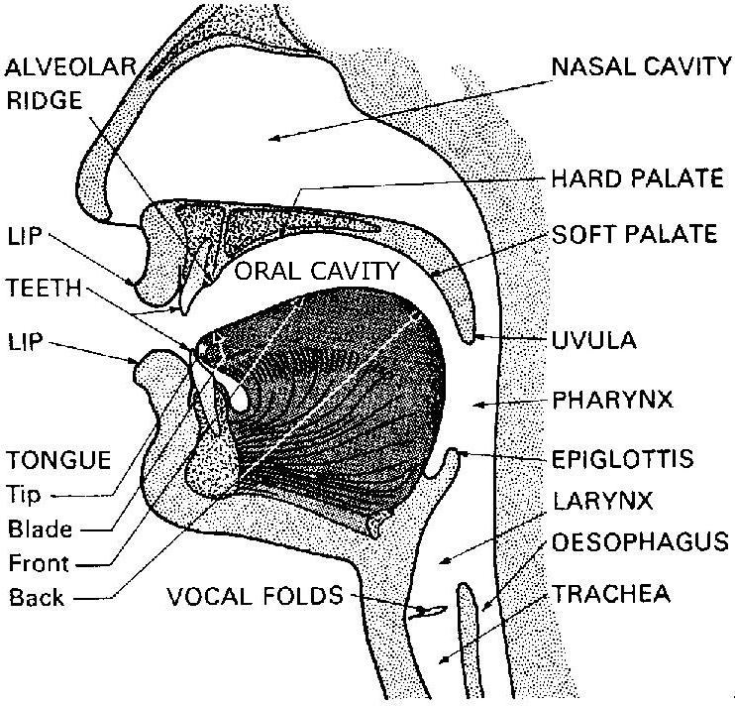

Place of articulation
Once the air leaves the lungs and passes through the larynx, it comes up and out through the mouth and/or the nose. Most consonant sounds are produced by using the tongue and other parts of the mouth to limit, in some way, the shape of the oral cavity through which the air is passing. The terms used to describe many sounds are those which denote the place of articulation of the sound: that is, the location inside the mouth at which the constriction takes place.

- Place of articulation
Bilabials: are sounds formed using both upper and lower lips. The lower lip articulates against the upper lip. [p] is voiceless, and [b], [m] and [w] are voiced.
Labiodentals: are sounds formed with the upper teeth and the lower lip. The lower lip articulates against the upper teeth. [f] is voiceless, and [v] is voiced.
Dentals: are sounds formed with the tongue tip behind the upper front teeth (also referred to as interdentals). The tongue tip articulates against the upper teeth. [θ] is voiceless, and [ð] is voiced.
Alveolar: are sounds formed with the front part of the tongue on the alveolar ridge, which is the rough, bony ridge immediately behind and above the upper teeth? The tongue tip and/or blade articulate against the teeth ridge. [t] and [s] are voiceless whereas [d], [z] and [n] are voiced. Other alveolar are [l] and [r].
Palatals (Alveopalatals): are sounds produced with the tongue and the palate. The tongue front articulates against the hard palate. [ʃ] and [tʃ] ] are voiceless whereas [ʒ], [dʒ] and [j] are voiced.
Velars: are sounds produced with the back of the tongue against the velum. The tongue back articulates against the soft palate. [k] is voiceless whereas [g] and [ŋ] are voiced.
Glottals: In fact there is only one sound that is produced without the active use of the tongue and other parts of the mouth. It is the voiceless sound [h]. The vocal folds themselves are the place of articulation.
- Charting consonant sounds
Having described in some detail the place of articulation of English consonant sounds, we can summarize the basic information in the accompanying chart. Along the top of the chart are the different labels for places of articulation and, under each, the labels −V (= voiceless) and +V (= voiced). Also included in this chart, on the left-hand side, is a set of terms used to describe ‘manner of articulation’ which we will discuss in the following section
Charting consonant sounds
 | Bilabial |  | Labio-dental |  | Dental |  | Alveolar |  | Palatal |  | Velar |  | Glottal
 | -V | +V | -V | +V | -V | +V | -V | +V | -V | +V | -V | +V | -V | +V
Stops | p | b |  |  |  |  | t | d |  |  | k | g
Fricatives |  |  | f | v | θ | ð | s | z | ʃ | ʒ
Affricates |  |  |  |  |  |  |  |  | tʃ | dʒ
Nasals |  | m |  |  |  |  |  | n |  |  |  | ŋ
Liquids |  |  |  |  |  |  |  | l, r
Glides |  | w |  |  |  |  |  |  |  | j |  |  | h
- Manner of articulation
So far, we have concentrated on describing consonant sounds in terms of where they are articulated. We can also describe the same sounds in terms of how they are articulated. Such a description is necessary if we want to be able to differentiate between some sounds which, in the preceding discussion, we have placed in the same category. For example, we can say that [t] and [s] are both voiceless alveolar sounds. How do they differ? They differ in their manner of articulation, that is, in the way they are pronounced. The [t] sound is one of a set of sounds called stops and the [s] sound is one of a set called fricatives
Stops: Of the sounds we have already mentioned, the set [p], [b], [t], [d], [k], [g] are all produced by some form of ‘stopping’ of the airstream (very briefly) then letting it go abruptly. This type of consonant sound, resulting from a blocking or stopping effect on the airstream, is called a stop (or a ‘plosive’).
Fricatives: The manner of articulation used in producing the set of sounds [f], [v], [θ], [d], [s], [z], [ʃ], [ʒ] involves almost blocking the airstream and having the air push through the very narrow opening. As the air is pushed through, a type of friction is produced and the resulting sounds are called fricatives.
Affricates: If you combine a brief stopping of the airstream with an obstructed release which causes some friction, you will be able to produce the sounds [tʃ] and [dʒ]. These are called affricates.
Nasals: Most sounds are produced orally, with the velum raised, preventing airflow from entering the nasal cavity. However, when the velum is lowered and the airstream is allowed to flow out through the nose to produce [m], [n], and [ŋ], the sounds are described as nasals.
Liquids: The initial sounds in led and red are described as liquids. They are both voiced. The [l] sound is called a lateral liquid and is formed by letting the airstream flow around the sides of the tongue as the tip of the tongue makes contact with the middle of the alveolar ridge. The [r] sound at the beginning of red is formed with the tongue tip raised and curled back near the alveolar ridge.
Glides: The sounds [w] and [j] are described as glides. They are both voiced and occur at the beginning of we, wet, you and yes. These sounds are typically produced with the tongue in motion (or ‘gliding’) to or from the position of a vowel and are sometimes called semi-vowels or approximants.
The sound [h], as in Hi or hello, is voiceless and can be classified as a glide because of the way it combines with other sounds. In some descriptions, it is treated as a fricative.
Vowels: While the consonant sounds are mostly articulated via closure or obstruction in the vocal tract, vowel sounds are produced with a relatively free flow of air. They are all typically voiced. To describe vowel sounds, we consider the way in which the tongue influences the ‘shape’ through which the airflow must pass. To talk about a place of articulation, we think of the space inside the mouth as having a front versus a back and a high versus a low area.
Manner of articulation
The vowel chart (Figure A below) fits into the middle of the mouth as shown in the simple cross-section of the head (Figure B).
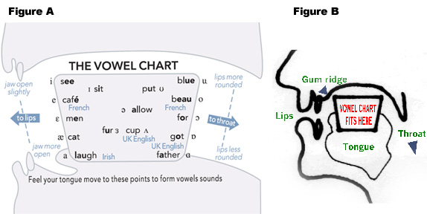
Manner of articulation
Below is a chart with a list of the sounds with some examples of familiar words
vowels
[i] eat, key, see | [ʌ] blood, putt, tough
[ɪ] hit, myth, women | [u] move, two, too
[e] great, tail, weight | [ʊ] could, foot, put
[ε] dead, pet, said | [o] no, road, toe
[æ] ban, laugh, sat | [ɔ] ball, caught, raw
[ə] above, sofa, support | [a] bomb, cot, swan
Diphthongs: are types of vowels where two vowel sounds are connected in a continuous, gliding motion. They are often referred to as gliding vowels.
[ai] buy, eye, my
[ɔi] boy, noise, void
[aʊ] cow, doubt, loud
- Subtle individual variation
Vowel sounds are notorious for varying between one variety of English and the next, often being a key element in what we recognize as different accents. The more we focus on the subtle differences of the actual articulation of each sound, the more likely we are to find ourselves describing the pronunciation of small groups or even individual speakers.

