Lecture 8
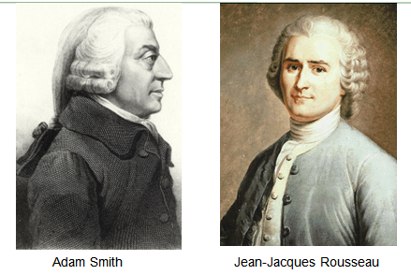

Adam Smith (5 June 1723 – 17 July 1790):
Leading figure in the Scottish Revolution-
Father of modern capitalism-
- Wrote The Wealth of Nations

Jean-Jacques Rousseau (28 June 1712 – 2 July 1778):
Writings influenced The French Revolution-
-Writings include Émile; Julie, ou la Nouvelle Héloïse; The Social Contract, Confessions
Supported a direct democracy form of government -

An Inquiry into the Nature and Causes of the Wealth of Nations
Smith's book is about material well-being. The Wealth of Nations is an influential statement of the case for laissez-faire, the thesis that government should not attempt to control or direct economic activity.

Chapter 1
- Economic advances are due to increased specialization of labor. The work of various kinds of philosophers, scientists and engineers are examples of this division of labor. More basic than advances in technology is the division of labor which enables technology itself to develop and progress. So specialization is the key to human material well-being.

Chapter 2
This chapter opens with the argument that the Division of Labour is not the consequence of somebodies wisdom, but results in the propensity of humans to to exchange goods. Smith finds no evidence of any animals in nature (except for humans) where any bartering goes on. The difference between humans and animals is that animals can exist independently in the wild, while humans need assistance from others, but can not expect this assistance out of good will alone. He then states that we do not get meat from a Butcher because we need the meat, but because the butcher is looking out for his own self-interest and wants what we have in return.

The Social Contract
He claimed that sovereignty belonged to the people and that the government was only a representative of the sovereign, charged with executing the general will. Although this is idea is commonplace today, it was shocking to contemporary readers of Rousseau's work.
The Social Contract influenced governments throughout Europe and helped to promote political reform and revolution. According to Rousseau, the clauses of the Social Contract can Be reduced to one: The total alienation of the individual in favor of the community.

Book 1
Because no man has a natural authority over other men and because force cannot establish right, all legitimate authority must depend upon convention. Rousseau goes on to refute Grotius, who argues that a state can be legitimate even if the people are slaves and the government is their master. Rousseau disputes his claim that the people can alienate their liberty and give themselves to a king. According to Rousseau, no one will give up his liberty without getting something in return.

People form societies when the obstacles faced in the state of nature become too taxing for any one person to overcome. Each person gives up his natural liberty – the freedom to do anything he desires - in exchange for the greater power of the entire community.
Because everyone gives himself and all of his rights to the community, the conditions of the social contract are equal for all those involved. The association of many individuals with the same interests creates a collective body with its own life and will. This body is called the "state" when it is passive, and the "sovereign" when it is active.

Influence
The works of Adam Smith formed the basis of modern capitalism.
The writings of Rousseau were influential on the founding fathers of the United States of America as well as the Abolitionist who were fighting to end slavery.

